3. Assessment of the Sablefish Stock in Alaska

Daniel R. Goethel, Cara J. Rodgveller, Katy B. Echave, S. Kalei Shotwell, Kevin A. Siwicke, Dana Hanselman, Patrick W. Malecha, Matt Cheng, Megan Williams, Kristen Omori, and Chris R. Lunsford

November 2022

Executive Summary

Summary of Changes to the Assessment

No changes were made to the assessment methodology for the 2022 sablefish (*Anoplopoma fimbria*) SAFE. However, the models used to estimate fishery whale depredation were rerun with new data, providing updated estimates for the first time since 2017. The 2021 SSC approved model (*21.12*) was utilized to develop catch advice. A full description of model *21.12* can be found in the 2021 SAFE document (<https://www.fisheries.noaa.gov/resource/data/2021-assessment-sablefish-stock-alaska>).

Changes to the Input Data

New data included in the assessment model were:

1. Relative abundance and length data from the 2022 longline survey;
2. Length data from the fixed gear fishery for 2021;
3. Length data from the trawl fisheries for 2021;
4. Age data from the longline survey and fixed gear fishery for 2021;
5. Updated catch for 2021;
6. Projected 2022 – 2024 catches;
7. Estimates of killer and sperm whale depredation in the fishery were updated for the entire time series, then projected for 2022 – 2024;
8. Fixed gear fishery catch-per-unit effort (CPUE) data from logbooks and observers were updated through 2021 (including the 2020 data that was not available for the 2021 SAFE) and the CPUE index was updated through 2021.

Changes to the Assessment Methodology

No changes were made to the assessment and model *21.12* was utilized as described in the 2021 SAFE. However, Francis data reweighting was performed to account for the new data available in 2022, which resulted in slightly different data weights from the 2021 model.

Summary of Results

The longline survey abundance index (relative population numbers, RPNs) increased by 17%, which followed a 9% increase in 2021 and a 32% increase in 2020 (Figure 3.4). The trawl survey biomass index has increased nearly five-fold since 2013, with a 40% increase from 2019 to 2021 (Figure 3.4). The age and length composition data from the fisheries (i.e., fixed gear and trawl) and surveys (i.e., longline and trawl) continue to indicate strong year classes in 2014, 2016, 2017, 2018, and now in 2019, as well.

Model *21.12* again demonstrated good fit to the abundance index data (Figure 3.10). However, patterns of underestimating recent year classes in the age composition data, particularly the fishery age compositions, continue to be present (Figure 3.16). Yet, no strong diagnostic or retrospective issues were noted, and the model demonstrated remarkably consistent estimation with the 2021 model (Figures 3.41, 3.42, and 3.44). Based on retrospective analysis, the model slightly underestimates terminal year spawning stock biomass (Figure 3.41), while high uncertainty exists for recent (i.e., 2017 – 2019) recruitment estimates (Figure 3.31). Moreover, the 2021 model estimated a much stronger 2018 year class compared to the 2017 year class, while these estimates were reversed in the 2022 model (Figure 3.33). Estimation uncertainty among these year classes is likely due to the 2021 trawl survey indicating a strong 2018 year class, whereas the newly available 2021 age compositions from the fixed gear fishery and longline survey appear to support a larger 2017 year class. Evidence regarding the strength of the 2019 year class appears stronger than for preliminary large estimates of the 2018 year class in the 2021 model, which was driven primarily by a single data source (i.e., the 2021 trawl survey).

As the 2016 year class enters the fully selected ages for the fixed gear fishery and longline survey, it is becoming clear that this recruitment event is likely the largest on record. Similarly, almost all of the 2014 – 2019 recruitment events appear to be of large magnitude and generally mimic late 1970s recruitment patterns, which led to strong biomass rebuilding in the 1980s. Based on the strength of these recent year classes, age-2+ biomass has almost tripled from a time series low of 228,000 t in 2015 to 665,000 t in 2022, sablefish population levels that have not been estimated since the early 1970s (Figure 3.30). Although growth in SSB has lagged compared to total biomass, given that recent year classes are not fully mature, SSB has still increased by 60% from the time series low of 84,000 t in 2017 to 134,000 t in 2022 (Figure 3.30). Thus, the current SSB is at 44% of the unfished SSB (i.e., SSB0) in 2022. However, the lack of sablefish greater than 10 years of age (i.e., the age when sablefish are greater than 90% mature) remains concerning for such an extremely long-lived species and needs to be carefully monitored. As recent year classes grow towards full maturity, the population age structure is beginning to expand. It is important that each of these cohorts can survive in large numbers to fully mature ages to ensure long-term productivity.

Sablefish are managed under Tier 3 of the NPFMC harvest control rule that primarily aims to maintain the population at *B40%*. Since projected female spawning biomass (combined areas) for 2023 is equivalent to *B52%*, sablefish is in sub-tier “a” of Tier 3. Spawning biomass is projected to increase rapidly in the near-term, and the maximum permissible value of *FABC* under Tier 3a is 0.081, which translates into a 2023 maximum permissible ABC (combined areas) of 40,861 t. The OFL fishing mortality rate is 0.096, which translates into a 2023 OFL (combined areas) of 47,857 t. Thus, current model projections indicate that the Alaskan sablefish stock is not subject to overfishing, not overfished, and not approaching an overfished condition.

**The Tier 3a maximum permissible ABC for 2023 is 40,861 t. After adjusting for whale depredation, the final author recommended ABC is 40,502 t.**

Summary Table

|  |  |  |  |  |
| --- | --- | --- | --- | --- |
|  | As estimated or  specified *last* year for (model 21.12): | | As estimated or  recommended *this* year for (model 21.12): | |
| **Quantity/Status** | 2022* | 2023* | 2023* | 2024* |
| *M* (natural mortality rate, estimated) | 0.100 | 0.100 | 0.105 | 0.105 |
| Tier | 3a | 3a | 3a | 3a |
| Projected total (age 2+) biomass (t) | 574,599 | 582,536 | 678,562 | 675,058 |
| Projected female spawning biomass (t) | 128,789 | 153,820 | 159,788 | 186,126 |
| *B100%* | 295,351 | 295,351 | 305,595 | 305,595 |
| *B40%* | 118,140 | 118,140 | 122,238 | 122,238 |
| *B35%* | 103,373 | 103,373 | 106,958 | 106,958 |
| *FOFL* | 0.094 | 0.094 | 0.096 | 0.096 |
| *maxFABC* | 0.080 | 0.080 | 0.081 | 0.081 |
| *FABC* | 0.080 | 0.080 | 0.081 | 0.081 |
| OFL (t) | 40,839 | 42,948 | 47,857 | 49,040 |
| **OFLw (t)\*\*** | **40,432** | **42,520** | **47,390** | **48,561** |
| max ABC (t) | 34,863 | 36,670 | 40,861 | 41,876 |
| ABC (t) | 34,863 | 36,670 | 40,861 | 41,876 |
| **ABCw (t)\*\*** | **34,521** | **36,318** | **40,502** | **41,539** |
| **Status** | As determined *last* year for: | | As determined *this* year for: | |
|  | 2020 | 2021 | 2021 | 2022 |
| Overfishing | No | n/a | No | n/a |
| Overfished | n/a | No | n/a | No |
| Approaching overfished | n/a | No | n/a | No |

*2021 SAFE projections for biomass and SSB were based on approximate estimated catches of 23,700 t in 2022 and 24,400 t in 2023 (based on the ratio of estimated catch to max ABC in 2021) used in place of maximum permissible ABC for 2022 and 2023. The same approach was utilized for the 2022 SAFE projections with specified catches of 33,600 t in 2023 and 34,000 t in 2024 (a yield ratio of 0.82 was assumed based on a 2022 estimated catch of 28,6300 t and an ABC of 34,863 t). Similarly, the 2024 ABC is based on removals equivalent to the 2023 specified catch. This was done in response to management requests for a more accurate two-year projection. SSB and biomass are slightly less than presented when the full ABC is removed.

**ABCw and OFLw are the final author recommended ABCs and OFLs after accounting for whale depredation.

Spatial Catch Apportionment

Based on biological rationale, the SSC adopted a five-year average survey apportionment method in 2020, which calculates a five-year moving average of the longline survey proportions of biomass in each region to apportion catch to management area. The apportionment values are updated yearly as new survey data is collected. In 2020, the SSC also instituted a four-year stair step approach to move from the fixed apportionment used prior to 2020 towards the five-year average survey apportionment. Assuming that the stair step approach continues in 2022, **the next step would be a 75% stair step from the 2020 fixed apportionment values towards the 2022 five-year average survey apportionment values** (apportioned ABCs are provided in the following table).

#### Apportionment Table (before whale depredation adjustments).

|  |  |  |  |  |  |  |  |
| --- | --- | --- | --- | --- | --- | --- | --- |
|  | **Area** | | | | | |  |
| **Method** | **AI** | **BS** | **WG** | **CG** | **WY\*** | **EY\*** | **ABC** |
| *2022 ABC+* | 6,486 | 5,305 | 3,821 | 10,008 | 3,179 | 6,064 | 34,863 |
| *Status Quo (Fixed at Current)\*\** | 7,650 | 6,231 | 4,411 | 11,795 | 4,069 | 6,705 | 40,861 |
| *Fixed\*\*\** | 5,392 | 3,987 | 4,408 | 13,939 | 4,689 | 8,446 | 40,861 |
| *25% Stair Step* | 6,558 | 5,475 | 4,450 | 12,616 | 4,116 | 7,646 | 40,861 |
| *50% Stair Step* | 7,725 | 6,963 | 4,492 | 11,294 | 3,543 | 6,844 | 40,861 |
| ***75% Stair Step****\*\*\*\** | **8,892** | **8,450** | **4,533** | **9,972** | **2,970** | **6,044** | **40,861** |
| *5-year Survey Avg.^* | 10,058 | 9,938 | 4,575 | 8,650 | 2,397 | 5,243 | 40,861 |
| *2024 ABC$* | 10,308 | 10,185 | 4,688 | 8,865 | 2,457 | 5,373 | 41,876 |

+This is the final 2022 ABC and associated regionally apportioned ABCs based on the 2021 SAFE. Other approaches in rows below utilize the 2023 ABC. Note that 2022 ABC is after the 95:5 hook and line : trawl split has been applied between WY and EY/SE, whereas all 2022 ABCs shown here are prior to this adjustment.

*Before the 95:5 hook and line : trawl split between WY and EY/SE shown below.

**Apportionment fixed (i.e., status quo) at the 2021 SSC recommended apportionment that used a 50% stair step from fixed apportionment to the 2021 5-year survey average apportionment.

*** Fixed at the 2013 assessment apportionment (Hanselman et al. 2012b).

****A 75% stair step from fixed apportionment to the 2022 5-year survey average apportionment. This represents the next incremental step in the 2020 SSC recommended 4-year stair step approach.

^The 5-year survey average is the biologically recommended long-term apportionment strategy. This approach does not utilize a stair step (i.e., it represents a 100% step).

$The 2024 ABC assumes a 100% stair step or full 5-year average survey apportionment.

### **Accounting for Whale Depredation**

For the final recommended ABC (ABCw), sperm and killer whale depredation in the longline fishery is accounted for by reducing the maximum ABC by the recent three-year average of depredation estimates by area and scaling area-specific estimates by the relative change in ABC (see the Whale Depredation Estimation section). The same procedure is applied to OFLs for 2023 and 2024 (OFLw). We continue to recommend this method of accounting for whale depredation in the fishery, because it occurs at the stock assessment level and does not create additional regulations or burden on in-season management.

The following tables assume the five-year average survey apportionment method, but assuming a continuation of the SSC recommended four-year stair step (i.e., a 75% step in 2023 with a subsequent 100% stair step in 2024).

#### Author recommended 2023 ABC (with whale depredation adjustments and assuming a 75% stair step).

|  |  |  |  |  |  |  |  |
| --- | --- | --- | --- | --- | --- | --- | --- |
| **Area** | **AI** | **BS** | **WG** | **CG** | **WY\*** | **EY\*** | **Total** |
| 2022 ABC | 6,486 | 5,305 | 3,821 | 10,008 | 3,179 | 6,064 | 34,863 |
| 2023 ABC | 8,892 | 8,450 | 4,533 | 9,972 | 2,970 | 6,044 | 40,861 |
| 2019 - 2021 avg. depredation | 6 | 21 | 51 | 52 | 63 | 147 | 340 |
| Ratio 2023:2022 ABC | 1.37 | 1.59 | 1.19 | 1.00 | 0.93 | 1.00 | 1.17 |
| Deduct 3 year adjusted average | -8 | -33 | -60 | -51 | -60 | -147 | -359 |
| **\*\*2023 ABCw** | 8,884 | 8,417 | 4,473 | 9,921 | 2,910 | 5,897 | 40,502 |
| Change from 2022 ABCw | 37% | 60% | 20% | 0% | -15% | 4% | 17% |

*Before 95:5 hook and line : trawl split between WY and EY/SE shown below.

**ABCw is the author recommended ABC that accounts for whale depredation.

#### Author recommended 2024 ABC (with whale depredation adjustments and a 100% stair step).

|  |  |  |  |  |  |  |  |
| --- | --- | --- | --- | --- | --- | --- | --- |
| **Area** | **AI** | **BS** | **WG** | **CG** | **WY\*** | **EY\*** | **Total** |
| 2022 ABC | 6,486 | 5,305 | 3,821 | 10,008 | 3,179 | 6,064 | 34,863 |
| 2024 ABC | 10,308 | 10,185 | 4,688 | 8,865 | 2,457 | 5,373 | 41,876 |
| 2019 - 2021 avg. depredation | 6 | 21 | 51 | 52 | 63 | 147 | 340 |
| Ratio 2024:2022 ABC | 1.59 | 1.92 | 1.23 | 0.89 | 0.77 | 0.89 | 1.20 |
| Deduct 3 year adjusted average | -9 | -40 | -62 | -46 | -50 | -131 | -337 |
| **\*\*2024 ABCw** | 10,299 | 10,145 | 4,626 | 8,819 | 2,407 | 5,243 | 41,539 |
| Change from 2022 ABCw | 59% | 93% | 24% | -12% | -30% | -7% | 20% |

*Before 95:5 hook and line : trawl split between WY and EY/SE shown below.

**ABCw is the author recommended ABC that accounts for whale depredation.

#### Author recommended 2023 – 2024 ABCs by sector in West Yakutat and East Yakutat/Southeast adjusted for the 95:5 hook-and-line : trawl split in the EGOA.

|  |  |  |
| --- | --- | --- |
| **Year** | **West Yakutat** | **E. Yakutat/ Southeast** |
| 2023 | 3,205 | 5,602 |
| 2024 | 2,669 | 4,981 |

*ABCs represent total regional ABC across gears, but with the 5% trawl allocation in EY/SE reallocated to WY.

#### Author recommended 2023 and 2024 OFLs (with whale depredation adjustments).

|  |  |  |
| --- | --- | --- |
| **Year** | **2023** | **2024** |
| OFL | 47,857 | 49,040 |
| 3-year Avg. Depredation | 340 | 340 |
| Inflation Factor (Projected % Increase) | 1.37 | 1.41 |
| Deduct 3-year Avg. | -467 | -479 |
| **\*OFLw** | 47,390 | 48,561 |
| % Change from 2022 OFLw | 17% | 14% |

*OFLw is the author recommended OFL that accounts for whale depredation.

Final Summary Tables by Region for the Groundfish Plan Team

#### Summary Table by Region

|  |  |  |  |  |  |  |
| --- | --- | --- | --- | --- | --- | --- |
| **Area** | **Year** | **Biomass(4+)\*** | **OFL\*\*** | **ABC#** | **TAC** | **Catch^** |
| GOA | 2021 | 390,000 | -- | 21,475 | 17,992 | 15,520 |
| 2022 | 240,600 | -- | 22,794 | 22,794 | 15,291 |
| 2023 | 317,000 | -- | 23,201 | -- | -- |
| 2024 | 309,000 | -- | 21,095 | -- | -- |
| BS | 2021 | 142,000 | -- | 3,396 | 3,396 | 4,169 |
| 2022 | 168,000 | -- | 5,264 | 5,264 | 4,548 |
| 2023 | 151,000 | -- | 8,417 | -- | -- |
| 2024 | 147,000 | -- | 10,145 | -- | -- |
| AI | 2021 | 175,000 | -- | 4,717 | 4,717 | 1,578 |
| 2022 | 121,200 | -- | 6,463 | 6,463 | 2,067 |
| 2023 | 153,000 | -- | 8,884 | -- | -- |
| 2024 | 149,000 | -- | 10,299 | -- | -- |

*Biomass represents the value projected by the model used to determine the ABC in that year, while regional biomass is based on the longline survey proportions by area in the terminal year of the associated model.

**The OFL is set for the entire Alaska management region, so no area specific OFLs are provided.

#The ABC is based on model *16.5* in 2020 (with reductions from max ABC based on the associated risk table). Model *21.12* and a 50%, 75%, and 100% stair step from fixed apportionment to the 5-year average survey apportionment were utilized, respectively for 2022, 2023, and 2024 ABCs. Also, these values are after the whale depredation adjustments described above.

^As of October 11, 2022 Alaska Fisheries Information Network, ([www.akfin.org](http://www.akfin.org)).

#### Final Whale Adjusted Catch Tables by Region

|  |  |  |  |  |  |  |  |  |
| --- | --- | --- | --- | --- | --- | --- | --- | --- |
| **Year** | **2022** | | | | **2023\*** | | **2024\*** | |
| Region | OFLw | ABCw | TAC | Catch** | OFLw | ABCw*** | OFLw | ABCw*** |
| BS | -- | 5,264 | 5,264 | 4,548 | -- | 8,417 | -- | 10,145 |
| AI | -- | 6,463 | 6,463 | 2,067 | -- | 8,884 | -- | 10,299 |
| GOA | -- | 22,794 | 22,794 | 15,291 | -- | 23,201 | -- | 21,095 |
| WGOA | -- | 3,727 | 3,727 | 2,264 | -- | 4,473 | -- | 4,626 |
| CGOA | -- | 9,965 | 9,965 | 6,294 | -- | 9,921 | -- | 8,819 |
| ***WYAK | -- | 3,437 | 3,437 | 2,462 | -- | 3,205 | -- | 2,669 |
| ***EY/SEO | -- | 5,665 | 5,665 | 4,271 | -- | 5,602 | -- | 4,981 |
| Total | 40,432 | 34,521 | 34,521 | 21,906 | 47,390 | 40,502 | 48,561 | 41,539 |

*Based on model 21.12 and assuming a 75% stair step from fixed apportionment towards 5-year average survey apportionment in 2023 and a 100% stair step in 2024.

**As of October 11, 2022 Alaska Fisheries Information Network, ([www.akfin.org](http://www.akfin.org)).

***After 95:5 trawl split shown above and after whale depredation methods described above.

## Responses to SSC and Plan Team Comments

### SSC Concerns Specific to the Sablefish Assessment

This section lists new or outstanding SSC comments specific to the 2021 Alaskan sablefish assessment and 2022 model updates presented during the fall meetings.

*Further, the SSC supports the continuation of the four-year stair-step approach to apportioning catch among regions (a 50% step from the 2021 apportionment toward the survey-based estimate)…The SSC also supports the application of a modification to the maximum ABC to account for whale depredation.*

Model *21.12* was updated for 2022 and projections were based on maximum ABC (after whale depredation corrections) with apportionment assuming a continuation of the four-year stair step approach (75% stair step from fixed apportionment to the current five-year average survey proportions).

*The SSC notes that although no additional buffer was warranted this year, there are continued concerns over ongoing changes in fishery dynamics associated with the transition to pots from longline gear and the potential for targeting of older/larger fish due to economic considerations. Following the SSC recommendation from October 2021, the SSC requests further consideration of alternative methods for constraining time-varying selectivity as an alternative to a single time-block. In particular, the SSC requests that the authors develop a method (e.g., random walk, autoregressive) that can allow the data to update the model structure and avoid annual evaluation of when bias in selectivity has reached a threshold beyond which it can no longer be ignored. Further, the SSC encourages consideration of adding a fleet to the model or to allow greater flexibility in the shape of the selectivity curve to better represent the growing importance of pot gear.*

Parametrization of selectivity in the sablefish assessment is an ongoing and long-term research priority along with explorations into adding an additional pot gear fleet in the model. A Ph.D. candidate (M. Cheng) at the University of Alaska-Fairbanks (UAF) is looking into these related issues for his dissertation. A manuscript that reparametrizes the sablefish assessment to include a pot fleet has been developed and will be submitted for review in 2023. A key component of these analyses was the development of a standardized CPUE index for the pot fleet as well as an index that combined pot and hook-and-line gear data. M. Cheng presented the results of his first dissertation chapter during the 2022 September groundfish Plan Team meetings, which focused on developing standardized CPUE indices for sablefish (see Figure A below). In 2023, it is expected that the sablefish assessment will adopt the standardization method developed by M. Cheng in place of the current nominal CPUE index, and utilize a combined index that includes both hook-and-line and pot gears. A sensitivity run using this combined and standardized index is available in the ‘Sensitivity Analysis’ section of the current document (see Figure 3.49). Additionally, the results of M. Cheng’s model runs with a separate pot gear fleet will be presented during the 2023 SAFE review process, while the 2023 sablefish assessment will explore alternate parametrizations based on the results of this work. Similarly, alternate selectivity parametrizations will be explored in the coming years as part of this Ph.D. work. Similarly, an ongoing AFSC project (led by J. Sullivan and C. Monahan) exploring the adaptation of the state-space Woods Hole Assessment Model (WHAM) for Alaskan species will similarly explore more flexible time-varying selectivity parametrizations and may eventually be adapted for sablefish.

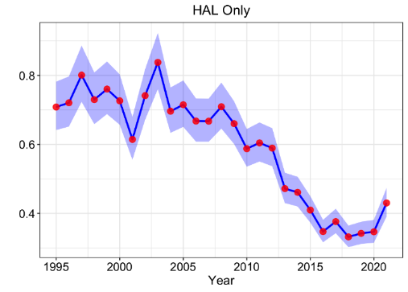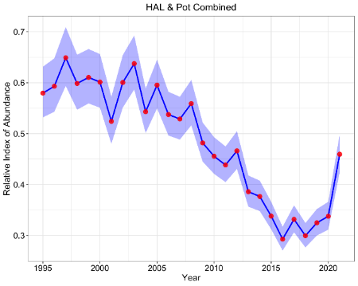

Figure A. Standardized sablefish CPUE indices utilizing only hook-and-line gear (HAL; left panel) and both HAL and pot gear (right panel; provided by Matt Cheng, UAF).

*Provide additional description of the specific mechanism for a change in survey availability. Explore whether this is due to changes in abundance within strata of the surveyed area or increased entry of smaller fish to the survey. This rationale is critically important for understanding whether design changes may be needed and/or whether further shifts in availability may occur in the future.*

No new analyses of changes in survey abundance by strata have been completed at this time, but the issue remains a high priority for understanding sablefish dynamics. Another year of data on sablefish abundance in the Bering Sea (during the 2023 longline survey) may help further elucidate the issue.

*Explore potential changes in historical weight-at-age further. The SSC finds it plausible that changes may have occurred despite sparse historical data.*

Since very limited historical data is available, no further analyses have been undertaken.

*Provide bubble plots of Pearson residuals for all age and length data including the sign and scale of residuals; this is standard practice to effectively evaluate tuning and lack of fit.*

These plots have not yet been developed. The lead author has spent extensive time rewriting much of the sablefish data preparation and graphics code to better align with AFSC reproducibility initiatives. By doing so, it will be much easier to develop new graphics in a timely manner and adopt existing figures from other assessment authors using similar coding best practices. New residual plots should be available during the 2023 assessment cycle, which will likely utilize one step ahead (OSA) residuals, given that Pearson residuals are no longer deemed best practice.

*Evaluate what information is available on the sex-ratio of the commercial catch. To the degree that dimorphic growth is present in this species, and the economic incentive to target larger fish, the current assumption of equal sex-ratio in the catch could be improved.*

While the catch is input as one quantity, the current configuration does not result in an equal proportion of fishing mortality among sexes due to the higher selectivity of younger female sablefish which results in an estimated population with more males. Although a high priority, additional methods to model sex-ratios have not yet been explored.

*Provide additional information on the uncertainty reported for maturity curves, particularly the confidence intervals exceeding 1.0 for the GAM. The SSC suggests that further research on skip spawning should be a high priority as this process, if prevalent, could be important to understanding stock dynamics and reference points.*

The confidence interval exceeding 1.0 was just a graphical error and has been fixed. Further research on skipped spawning is planned, but sample collection has been prevented due to COVID-19 and lack of funding in recent years. Research proposals led by C. Rodgveller aim to collect more skipped spawning information, pending funding.

*The SSC requests that the method for accounting for whale depredation be updated to reflect the additional years of data now available since its development. However, the SSC recognized that the contribution to the overall mortality appears to be low (given current methods) and therefore the priority of this work may be lower than some other issues.*

*The SSC appreciates the responsiveness of analysts to the SSC’s December 2021 request to update this [whale depredation] analysis and looks forward to seeing models using these updated values in December 2022. The SSC notes that there was a considerable decrease in total sablefish mortality due to whales in 2021, likely due to an increase in pot gear use and a decrease in hook-and-line gear, and that the overall magnitude of whale depredation remains low relative to TAC (less than 1%). The SSC agrees that in the future, particularly if pot gear catch continues to increase, it may be worth exploring ways to provide stability and simplicity in how the depredation estimates are applied and possibly update these estimates less frequently. (October 2022 SSC Meeting)*

Megan Williams (The Ocean Conservancy), who led these initial analyses in 2016, updated the fishery whale depredation estimates in 2022. The updated depredation estimates are provided in Figure 3.8. Total depredation estimates have decreased, even though the proportion of hook-and-line gear sets depredated along with the rate of depredation on whale impacted sets have both increased in recent years. It is likely that the increasing use of pots has led to reductions in overall depredation. It is worth noting that the increasing use of electronic monitoring (EM) has decreased the observations of depredation from observers, which is a critical element of the fishery depredation model. Similarly, exploratory analyses of the rate of depredation on the longline survey over time indicated a lack of trend (see Figure B below). Therefore, the survey correction factor for whale-depredated sets was not updated, because it had little influence on the Alaska-wide index used in the assessment model (see Figure 3.7).

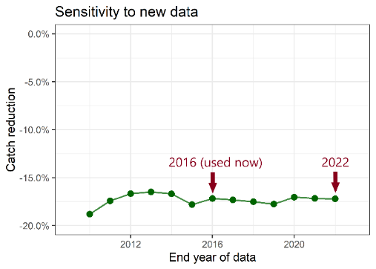

Figure B. Impact of new longline survey whale depredation data on the estimate of the survey whale depredation correction factor for whale-depredated sets (provided by Dana Hanselman). Note that depredated sets are *inflated* by the catch reduction factor and the index recalculated accounting for these inflated survey sets.

*This assessment has identified a broad spectrum in the age structure as a biological objective. The SSC suggests that specific hypotheses on why this is the case for sablefish would be helpful to review how important it is and to structure future research.*

Ongoing projects on skipped spawning and development of a sablefish management strategy evaluation (MSE) both aim to advance our knowledge regarding the importance of a diverse age structure. However, both projects have been delayed due to lack of funding, COVID impediments, and few qualified post-doctoral applicants (for the MSE project).

*The SSC supports the JGPT recommendation to evaluate how information available to the assessment (logbooks and biological information) may change as electronic monitoring and observer coverage for fixed gear may change in the future.*

Given the dynamic nature of the transition to EM, these analyses are pending further information regarding what data will be available from EM gear and how broadly EM will be utilized on the array of vessels that target sablefish.

*The SSC also supports the JGPT recommendation to improve the process for ensuring that CPUE information is included in the assessment in a timely manner.*

For 2022, the CPUE data were provided well in advance of data deadlines and the full CPUE index has again been incorporated into the assessment.

Plan Team Concerns Specific to the Sablefish Assessment

This section lists new or outstanding PT comments specific to the 2021 Alaskan sablefish assessment and 2022 model updates presented during the fall meetings.

*Matthew Cheng presented recent developments in standardizing fishery-dependent Catch-Per-Unit-Effort (CPUE) across gear types for sablefish. The Teams concluded that the combined hook-and-line and pot index should be considered for use in the 2023 assessment, but how to calculate uncertainty and how the assessment may deal with selectivity are currently unknown. The Teams noted that a bootstrap approach could be used to quantify the uncertainty in the CPUE index. The Teams also noted that the relative difference in catchability between hook-and-line and pot gear could be further evaluated through this analysis. The Teams commended Matt for his work and look forward to reviewing a possible sablefish assessment configuration that includes this combined gear index. (September 2022)*

As noted earlier, the 2023 assessment will likely utilize the combined standardized CPUE index developed by M. Cheng. Further work will be completed to better calculate uncertainty (e.g., using bootstrapping) and will be presented in September 2023 along with the new model approach.

*The model is disaggregated by sex, but a 50:50 sex ratio was assumed. The Teams suggested research into sexual dimorphism including an evaluation of whether the sex ratio has changed over time. Presently the proportions at length (and age) are by sex instead of over sexes. Dan pointed out this was already high on the priority list for research.*

As noted in the SSC responses, explorations into sex ratio have not yet been undertaken, but remains a research priority.

*The Team noted that maturity-at-age, including the influence of skip spawning, should remain a research priority.*

C. Rodgveller is planning maturity work that is contingent upon funding to obtain samples during winter spawning months.

*The Teams support development of methods to incorporate both EM and pot gear data into the assessment. Biological samples are not available from EM vessels, nor from trawl fishery bycatch. The Teams support discussions with FMA to determine if sampling from either fleet is possible. The Teams also suggested analyses which: examine historical catch data to see if there are any correlations between small fish and trawl catch during large recruitment events; incorporate uncertainty in catch by areas (i.e., the proportion of catch in each area); and the impact of using a fixed F ratio among the fleets.*

These priority discard issues have not yet been fully explored. As noted, M. Cheng (UAF) is focusing on better incorporating pot gear data into the assessment in his dissertation.

Introduction

For a full description of the sablefish resource and fishery dynamics, see Goethel et al. (2021; available at <https://www.fisheries.noaa.gov/resource/data/2021-assessment-sablefish-stock-alaska>).

Distribution

Sablefish (*Anoplopoma fimbria*) primarily inhabit the northeastern Pacific Ocean. They are found from northern Mexico to the Gulf of Alaska (GOA), westward to the Aleutian Islands (AI), and into the Bering Sea (BS). Their distribution continues into the northwestern Pacific Ocean, off the Siberian coast of Russian and the Kuril Islands in Japan (Wolotira et al. 1993; Zolotov, 2021).

Stock Structure

Sablefish have traditionally been treated as two populations based on differences in growth rate, size-at-maturity, and tagging studies (McDevitt 1990, Saunders et al. 1996, Kimura et al. 1998). The northern population inhabits Alaska and northern British Columbia waters and the southern population inhabits southern British Columbia, Washington, Oregon, and California waters, with mixing of the two populations occurring off southwest Vancouver Island and northwest Washington. However, recent genetic work by Jasonowicz et al. (2017) found no population sub-structure throughout their range along the US West Coast to Alaska, and suggested that observed differences in growth and maturation rates may be due to phenotypic plasticity or are environmentally driven. Significant stock structure among the federal Alaska population is unlikely given extremely high movement rates throughout their lives (Hanselman et al. 2015, Heifetz and Fujioka 1991, Maloney and Heifetz 1997, Kimura et al. 1998). The Alaskan sablefish assessment model assumes a single, homogenous population of sablefish across all Alaskan management areas, including the Bering Sea (BS), Aleutian Islands (AI), western Gulf of Alaska (WGOA), central Gulf of Alaska (CGOA), and eastern Gulf of Alaska (EGOA; including western Yakutat, WY, eastern Yakutat, EY, and the southeast GOA, SE).

Management Units

Sablefish are assessed as a single population in Federal waters off Alaska, because of their high movement rates. Sablefish are managed by discrete regions to distribute exploitation throughout their wide geographical range. There are four management areas in the GOA: Western, Central, West Yakutat, and East Yakutat/Southeast Outside; and two management areas in the Bering Sea and Aleutian Islands (BSAI): the BS and the AI regions. Amendment 8 to the GOA Fishery Management Plan established the West and East Yakutat management areas for sablefish, effective in 1980. Sablefish in Alaskan state waters are assessed and managed by the Alaska Department of Fish and Game (ADFG) independently from sablefish in Federal waters.

Population Dynamics by Life Stage

Early Life History

Alaskan sablefish spawn from January - April with a peak in February. Spawning is pelagic at depths of 300 - 500 m near the edges of the continental slope (Mason et al. 1983, McFarlane and Nagata 1988), with eggs developing at depth and larvae developing near the surface as far offshore as 180 miles (Wing 1997). Larval sablefish feed primarily on copepod nauplii and adult copepods (Grover and Olla 1990). Near the end of their first summer, pelagic juveniles less than 20 cm move inshore and spend the winter and following summer in inshore waters where they exhibit rapid growth, reaching 30-40 cm by the end of their second summer (Rutecki and Varosi 1997).

Juvenile Dynamics

Juvenile sablefish spend their first two to three years on the continental shelf of the GOA, and occasionally on the shelf of the southeast BS. Juvenile sablefish are pelagic and at least part of the population inhabits shallow near-shore areas for their first one to two years of life (Rutecki and Varosi 1997). After their second summer, they begin moving offshore to deeper water, typically reaching their adult habitat, the upper continental slope, at 4 to 5 years. This corresponds to the age range when sablefish start becoming reproductively viable (Mason et al. 1983, Rodgveller et al. 2016). In most years, juveniles have been found only in a few places, such as Saint John Baptist Bay near Sitka, Alaska. The BS shelf is also utilized by young sablefish, typically following years with strong recruitment events. For instance, there has been an increase in abundance of young sablefish in the Bering Sea in recent years concomitant with large recent year classes. Juvenile sablefish that settle on the BS shelf are generally hypothesized to return to the deeper waters of the GOA as they mature, resulting in a general counter clockwise ontogenetic movement pattern (Sasaki, 1985; Hanselman et al., 2015). However, this pattern may not hold for recent year classes as these cohorts may be settling and remaining in the BS and Western GOA regions, given the increasing proportion of biomass observed in the BSAI by the AFSC longline survey in recent years. In nearshore southeast Alaska, juvenile sablefish (20 - 45 cm) diets include fish such as Pacific herring and smelts and invertebrates, such as krill, amphipods, and polychaete worms (Coutré et al. 2015).

Adult Dynamics

Adult sablefish occur along the continental slope, shelf gullies, and in deep fjords, generally at depths greater than 200 m. Adult sablefish are highly mobile (annual movement probabilities among Alaskan regions range from 10 - 88%), though exact movement patterns and drivers are not well understood. Historically, it was believed that sablefish demonstrated an ontogenetic migration from nearshore shallow nursery areas (e.g., St. John Baptist Bay and to a lesser extent the eastern BS shelf) into deeper waters of the GOA, following a counterclockwise movement towards the southeast GOA (Sasaki, 1985). However, analysis of the Auke Bay Laboratory 40+ year time series of sablefish tagging data, along with other available tagging data, by Hanselman et al. (2015) indicated that movement probabilities were different between regions and did not demonstrate a consistent ontogenetic pattern. Adult sablefish are opportunistic feeders that prey on a variety of fish, shrimp, and cephalopod species (Sasaki, 1985; Brodeur and Livingston, 1988).

Population Trends in Nearby Regions Not Incorporated in the Assessment Model

Alaska Northern Southeast and Southern Southeast Inside Waters

Sablefish in the Northern Southeast Inside (NSEI) Subdistrict waters and Southern Southeast Inside (SSEI) Subdistrict waters of Alaska are treated as separate stocks from the federal population, but some migration into and out of Alaska federal and state waters has been confirmed with tagging studies (Hanselman et al. 2015). NSEI sablefish continue to demonstrate similar population trends as the greater GOA population. The last assessment showed large recruitments of 2013 – 2016 year classes that remain small and only partially mature in 2021 (Figure 3.1a). In SSEI waters, the longline survey CPUE had been declining from 2012 to 2015, but has seen an upward trend since that time (Figure 3.1b). Similar to the NSEI longline survey, there was a substantial increase (40%) from 2019 to 2020 for the SSEI longline survey CPUE and a smaller increase (7%) from 2020 to 2021. Although the biomass is increasing with the recruitment of 2013–2016 year classes, CPUE and abundance remain well below levels seen in the 1980s and 90s.

Canada

The estimated biomass trend for the British Columbia stock of sablefish is similar to that in Alaska, with strong increases in the mid-2010s, but the rate of growth appears to have leveled off recently (Figure 3.1c). Survey index values in both 2020 and 2021 were lower than the 2019 highpoint, but still high compared to years prior to 2018 (Figure 3.1c). Annual TACs for the BC Sablefish stock are set using a surplus production model fit to landings and three indices of abundance, including a random stratified trap survey, as part of a management procedure approach chosen through management strategy evaluation (Kendra Holt, pers. comm.).

United States West Coast (Washington, Oregon, and California)

After declines in abundance through the 1980s and 1990s, the west coast sablefish resource rebuilt slightly in the early 2000s corresponding to a large 2000 year class, as there was in Alaska, then remained stable for much of the late 2000s and early 2010s (Kapur et al., 2021). There was an emergence of several recent above average year classes in 2008, 2010, 2013, and 2016, which has led to strong upward trend in biomass since the late 2010s (Figure 3.1d).

Pacific Sablefish Transboundary Assessment Team (PSTAT)

Concurrent sablefish trends seen in Alaska, Canada, and the West Coast highlights the need to better understand the contribution to Alaska sablefish productivity from other areas. A Pacific Sablefish Transboundary Assessment Team (PSTAT) consisting of scientists from the U.S. (west coast and Alaska regions, including both federal and state scientists) and Canada has been working to better understand the dynamics, population trends, and biology of sablefish across the eastern Pacific Ocean (Fenske et al. 2019; <https://www.pacificsablefishscience.org/>). The group is developing spatially explicit tagging analyses and operating models to estimate connectivity among regions and eventually explore impacts of regional management measures on the coast wide population through management strategy evaluation (MSE). Additionally, age reading groups across agencies have addressed sablefish ageing discrepancies by developing standardized ageing criteria through the Committee of Age Reading Experts (CARE) group.

Fishery

Sablefish have been exploited since the end of the 19th century by U.S. and Canadian fishermen, and sablefish harvest was exclusively by U.S. and Canadian vessels until 1958, when Japanese longliners began operations in the eastern BS, at which point harvest increased rapidly (Table 3.1, Figures 3.2 and 3.3). As the fishing grounds in the eastern Bering were preempted by expanding Japanese trawl fisheries, the Japanese longline fleet expanded to the AI region and the GOA. Heavy fishing by foreign vessels during the 1970's led to a substantial population decline and implementation of fishery regulations in Alaska. Catch in the late 1970's was restricted to about one-fifth of the peak catch in 1972, due to the passage of the Fishery Conservation and Management Act (FCMA).

The U.S. longline fishery began expanding in 1982 in the GOA, and, by 1988 (when foreign fishing was banned in US waters), the U.S. harvested all sablefish taken in Alaska. From a year round fishery in 1983, the fishing season shrank to 10 days in 1994, warranting the “derby” fishery label. In 1995, Individual Fishery Quotas (IFQs) were implemented for hook-and-line vessels along with an 8-month season. Historically, the primary gear used for directed sablefish harvest in Alaska has been longline gear, which is fished on-bottom. However, since the early 2000s, pot fishing has been common in the BSAI using rigid pots. In response to consistent sperm whale depredation on hook and line gear, the NPFMC passed a regulation in 2015 to allow pot fishing in the GOA starting in 2017. Primarily driven by the increasing popularity of collapsible ‘slinky’ pots, which can be fished from smaller vessels with limited deck space, pot fishing for sablefish has rapidly increased throughout Alaska. Since 2021, the majority of removals by the fixed gear fleet was taken by pot gear (Table 3.1, Figure 3.2). Further details on the Alaskan sablefish fishery can be found in Appendix 3E.

Sablefish are also caught incidentally during directed trawl fisheries for other species groups, such as rockfish, deep-water flatfish, and, more recently, walleye pollock. In recent years, there have been rapid increases in sablefish trawl removals, primarily due to catch of large recent year classes in the BS (see Appendix 3D). However, the proportion of sablefish catch by trawl gears has declined back towards the time series mean value, decreasing from a recent time series high of 39% of total catch in 2020 to 23% in the last two years (Table 3.1, Figure 3.2).

Five minor state fisheries were established by the State of Alaska in 1995, when the Federal waters IFQ fishery was established, primarily to provide open-access fisheries to fishermen who could not participate in the IFQ fishery. State catch from the northern GOA and AI minor fisheries were included in the current assessment, because they are reported using the area code of the adjacent Federal waters in the Alaska Regional Office catch reporting system. Major state fisheries in the NSEI and SSEI are managed and assessed by the ADFG, and catch associated with these fisheries were not included in the current model.

## **Management Measures**

A summary of historical catch and management measures pertinent to sablefish in Alaska are shown in Table 3.2 and are summarized below.

Quota Allocation

Amendment 14 to the GOA Fishery Management Plan allocated the sablefish quota by gear type: 80% to fixed gear (including pots) and 20% to trawl in the Western and Central GOA, and 95% to fixed gear and 5% to trawl in the Eastern GOA, effective in 1985. Since 2000, Amendment 41 banned trawling in the EY/SE management area, thus, the 5% trawl allocation for the EY/SE area has been added to the WY trawl allocation since that time. Amendment 15 to the BS/AI Fishery Management Plan, allocated the sablefish quota by gear type, 50% to fixed gear and 50% to trawl in the eastern BS, and 75% to fixed gear and 25% to trawl gear in the Aleutians, effective in 1990.

IFQ Management

Amendment 20 to the GOA Fishery Management Plan and amendment 15 to the BSAI Fishery Management Plan established IFQ management for sablefish beginning in 1995. These amendments also allocated 20% of the fixed gear allocation of sablefish to a Community Development Quota (CDQ) reserve for the BS and AI.

Allowable Gear

In 1996 the prohibition on sablefish longline pot gear use was removed for the BS, except from 1 to 30 June (to prevent gear conflicts with trawlers). In 2017, sablefish pot fishing in the GOA was legalized in response to increased whale depredation.

Discards and Bycatch

Under current regulations, release of any sablefish by the sablefish IFQ fishery is prohibited, as long as there is remaining IFQ for persons onboard the fishing vessel. Unusually large year classes of sablefish since 2014 have led to increased fishery catches of small sablefish with lower economic value than larger market categories. The North Pacific Fishery Management Council (NPFMC) has considered motions to allow release of small sablefish in the directed fishery, but no changes to the full retention regulation have yet been made. The increasing utilization of pot gear, which can be retrofitted with escape rings to allow release of small sablefish before being taken on board, may reduce the need for changing the full retention regulation, although there are no gear configuration regulations at this time.

Sablefish discards in groundfish target fisheries are highest in the hook and line along with trawl gear types, primarily in the BSAI due to an influx of recent large year classes in the BS (Table 3.3; see Appendix 3D). Catch was highest in the Pollock (pelagic trawl) fishery from 2019 to 2021, with a peak of 3,396 t in 2020 from the Bering Sea. However, 2022 catches have been low. Generally, discards of sablefish in pot gear for non-sablefish target fisheries has been low (pot includes halibut and Pacific cod targeting; Table 3.3).

Bycatch of targeted groundfish in the sablefish fishery has consistently been dominated by GOA shortspine thornyhead, sharks, arrowtooth flounder, and shortraker and rougheye rockfish (Table 3.4). On average, 75% of the shortspine thornyhead are retained, while none of the shark species are retained. Every year the highest bycatch species in sablefish targeted fisheries are grenadiers, but the amount of grenadier has decreased each year since 2016 (Table 3.5). During the same period, the sablefish fishery has been increasingly adopting pot gear, which has less grenadier bycatch. Conversely, the predominant prohibited species catch (PSC) in the BSAI sablefish fisheries is golden king crab, of which nearly all are caught in pot gear (Table 3.6). Pacific halibut PSC is mostly in the GOA hook and line fishery.

Data

**Table A**. Data used in the 2022 model. Years in **bold** are data new to this assessment.

|  |  |  |
| --- | --- | --- |
| **Source** | **Data** | **Years** |
| Fixed gear fisheries | Catch | 1960 – **2022** |
| Trawl fisheries | Catch | 1960 – **2022** |
| Japanese longline fishery | Catch-per-unit-effort (CPUE) | 1964 – 1981 |
| U.S. fixed gear fishery | CPUE, length | 1990 – **2021** |
| Age | 1999 – **2021** |
| U.S. trawl fisheries | Length | 1990,1991,1999, 2005 – **2021** |
| Japan-U.S. cooperative longline survey | RPNs, length | 1979 - 1994 |
| Age | 1981, 1983, 1985, 1987, 1989, 1991, 1993 |
| Domestic longline survey | RPNs, length | 1990 – **2022** |
| Age | 1996 – **2021** |
| NMFS GOA trawl survey | Biomass index | 1984, 1987, 1990, 1993, 1996, 1999, 2003, 2005, 2007, 2009, 2011, 2013, 2015, 2017, 2019, 2021 |
| Lengths | 1984, 1987, 1990, 1993, 1996, 1999, 2003, 2005, 2007, 2009, 2011, 2013, 2015,2017, 2019, 2021 |

Fishery

Length, catch, and effort data were historically collected from the Japanese and U.S. longline and trawl fisheries, and are now collected from U.S. longline, trawl, and pot fisheries (Table 3.7). The Japanese data were collected by fishermen trained by Japanese scientists (L. L. Low, August 25, 1999, AFSC, pers. comm.). The U.S. fishery length and age data were collected by at-sea and plant observers. No age data were collected from the fisheries until 1999, because of the difficulty of obtaining representative samples from the fishery (and no trawl fishery age data is incorporated in the assessment).

Catch

The catches used in this assessment (Table 3.1) represent total catch (landings plus bycatch or discards assuming 100% mortality), and include catches from minor state-managed fisheries in the northern GOA and in the AI region (constituting about 1% of the average total catch). Because underreporting of catch was likely during the late 1980s (Kinoshita et al. 1995), discard estimates from 1994 to 1997 were applied back in time to inflate U.S. reported catches in all years prior to 1993 (2.9% for hook-and-line and 26.6% for trawl). Estimates of all removals not associated with a directed fishery, including research catches, are presented in Appendix 3B. The sablefish research removals are small relative to the fishery catch, but substantial compared to the research removals for many other species due to the annual AFSC longline survey that uses a cost-recovery design, where catch is sold to offset survey costs. Total removals from activities other than the directed fishery equate to less than 1% of the recommended ABC and represent a relatively low risk to the sablefish stock.

Lengths

Length compositions from the U.S. fixed gear (longline and pot) and U.S. trawl fisheries are both measured by sex (Table 3.7), and gear- and sex-specific proportions-at-length are fit in the assessment. Only years that have sample sizes of at least 300 per sex are included. The length compositions are weighted by catch (in numbers) in each Fisheries Management Plan (FMP) area to obtain a representative estimate of catch-at-length.

Ages

Age compositions from the U.S. fixed gear fishery are available since 1999 with adequate coverage and sample sizes (~1,200 otoliths aged yearly) to be fit in the assessment as sex-aggregated proportion-at-age (Table 3.7). The age compositions are weighted by the catch (in numbers) in each FMP area to obtain a representative estimate of catch-at-age.

Longline Fishery Catch Rate Index

Records of catch weight and effort for vessels that target sablefish are collected by observers and by vessel captains in voluntary and required logbooks (see Appendix 3E for a complete description of these data). A nominal longline fishery catch rate index is derived by scaling the mean CPUE by region to relative population weights from the AFSC longline survey and management area size. In the years when both logbook and observer CPUEs are available, the two sources are combined into one index by weighting each data set by the inverse of the associated coefficient of variation.

The number of sets observed in 2020 and 2021 were much lower than in previous years. These low sample sizes were likely due to: 1) an increase in pot fishing and electronic monitoring (EM) compared to trips using human observers and longline gear (i.e., the catch rate index is based only on longline gear at this time and EM data does not provide CPUE information for hook-and-line gear yet); 2) the observer deployment plan; and 3) the COVID-19 pandemic leading to a lower number of human observed trips for all fisheries in 2020. Work is ongoing to develop and incorporate catch rates from pot gear and EM data streams into the CPUE index, including a CPUE standardization methodology to better account for factors impacting catch rates. Standardized CPUE indices that combine data sources (e.g., longline and pot gear types) would alleviate data limitation issues and provide a more reliable CPUE time series (see ‘Sensitivity Runs’ for a demonstration of a model fit to a standardized index that incorporates both longline and pot gear).

Fishery-Independent Surveys

The model incorporates multiple survey indices, including the AFSC longline survey and the AFSC GOA bottom trawl survey (stations < 500m). Research catch removals are documented in Appendix 3B.

Longline Survey

Catch, effort, age, length, weight (since 1996), and maturity data are collected during sablefish longline surveys. Japan and the U.S. conducted a cooperative longline survey for sablefish in the GOA annually from 1978 to 1994, adding the AI region in 1980 and the eastern BS in 1982 (Sasaki 1985, Sigler and Fujioka 1988). Since 1987, the Alaska Fisheries Science Center has conducted annual longline surveys of the upper continental slope, referred to as domestic longline surveys, designed to continue the time series of the Japan-U.S. cooperative survey (Sigler and Zenger 1989). The domestic longline survey began annual sampling of the GOA in 1987, biennial sampling of the AI in 1996, and biennial sampling of the eastern BS in 1997 (Rutecki et al. 1997). Interactions between the fishery and survey are described in Appendix 3A.

Sablefish length data were randomly collected for all survey years. Since 1996, a random sample of otoliths collected during each survey has been aged in the years they were collected, with approximately one-half of the collected otoliths aged annually (~1,200).

Relative population abundance in numbers (RPNs) and weight (relative population weights, RPWs) indices are computed annually using survey catch rates from stations sampled on the continental slope and scaled to management area size. However, only the RPN index is fit in the assessment model, as these are believed to provide a better indication of incoming recruitment events (given that indices in weight often lag abundance). In the mid-1980s, both RPNs and RPWs were high during the Japan-U.S. cooperative survey, primarily due to strong recruitment in the late 1970s (Table 3.8). The lowest RPN and RPW values in the domestic survey time series occurred in 2015 (Table 3.8), but have been steadily increasing over the last seven years. The 2019 through 2022 survey catches represent the highest RPNs and RPWs observed in the time series and have each demonstrated consistent year over year increases. Although RPNs have been trending upwards in all regions (Figure 3.5), the most significant increases in recent years have been observed in the western GOA and BSAI (Figure 3.6). Despite not being included in the survey index calculations, gully entrances to the continental shelf in depths from 150 – 300 m (where the commercial fishery targets sablefish) are also sampled by the longline survey annually. Gully station trends tend to follow those of slope stations, but periodically provide earlier signals of strong recruitment year classes.

Trawl Survey

Trawl surveys of the upper continental slope to 500 m and occasionally to 700 – 1000 m (the latter corresponding to depths inhabited by adult sablefish) have been conducted biennially or triennially since 1984 in the GOA. Since the full range of adult sablefish habitat is not always sampled and adult sablefish may also outswim the net, trawl survey indices are developed primarily as an index of juvenile sablefish biomass using only consistently sampled depths down to 500 m. The GOA trawl survey index was at its lowest level of the time series in 2013, but has more than quadrupled since that time (Table 3.8), which corresponds with recent increases in the longline survey RPWs and RPNs (Figure 3.4).

Whale Depredation Estimation

Whale depredation on hook-and-line gear has been pervasive in both the fishery and on the longline survey. Two studies provided methods to account for depredation in longline survey indices (Hanselman et al., 2018) and the longline fishery (Peterson and Hanselman, 2016), and were adopted starting in the 2016 SAFE. Inflating longline survey estimates of abundance (RPNs) for sablefish depredation is done in tandem with correcting the ABC for whale depredation in the commercial fishery.

Longline Survey Depredation Estimation

Sets on the AFSC longline survey impacted by orca (*Orcinus orca*) depredation have always been removed from calculations, because of the significant and variable impacts orcas can have on catch rates as well as the straightforward identification of depredated sets. Orca depredation primarily occurs in the BS, AI, WG, and to a lesser extent in the CG (Table 3A.2 in Appendix 3A). Conversely, sperm whale (*Physeter macrocephalus*) depredation is more difficult to detect. Thus, sperm whale depredation is directly estimated using an Alaska-wide Generalized Linear Mixed Model (GLMM) with year, depth strata, station, management area, and total number of effective hooks as explanatory variables (Hanselman et al., 2018). The model estimates a depredation coefficient to inflate catches at survey stations with sperm whale depredation evidence, where the estimated inflation factor is 1.18 (i.e., 1/0.85). Exploratory analyses for 2022 demonstrated that depredation coefficients have been relatively stable over time (see Figure B in the ‘Responses to SSC and Plan Team Comments’ section), and, therefore, the value was not revised. Because sperm whale depredation only occurs on a subset of the stations (Table 3A.2 in Appendix 3A), the overall increase in the RPN index is modest (Figure 3.7). The correction by area is minimal, but generally most important in the CG, WY, and EY, where sperm whale depredation is highest.

Longline Fishery Depredation Estimation

Orcas have a long history of depredating on the commercial sablefish longline fishery, while sperm whales have become a source of depredation more recently. A two-step modeling approach was utilized to estimate total fishery depredation based on observer and high-resolution catch data (i.e., in 1/3° by 1/3° bins; Peterson and Hanselman, 2017). First, the impact on depredated sets (i.e., a CPUE reduction factor) was estimated using a Generalized Additive Mixed Modeling (GAMM) approach, which included depth, location (latitude, longitude), Julian day, grenadier CPUE, hook and line CPUE, whale depredation, year, and vessel as explanatory variables. Next, a Generalized Additive Model (GAM) with a zero-inflated Poisson distribution was used to determine the proportion of sets in an area depredated by whales, where significant covariates included sablefish catch, location (latitude, longitude), year, depth, set length, and average vessel lengths. The total depredation was then determined based on the number of sets depredated per grid, the reduction in catch per depredated set, and the total catch per grid.

Estimated depredation coefficients were updated in 2022 to incorporate additional years of data. Strong time trends were present in parameter estimates. Despite increasing depredation rates (i.e., the CPUE reduction factors), particularly by sperm whales in the EG, the overall estimates of depredation declined for sperm whales in most areas of the GOA over the last 3-5 years, with similar declines in orca depredation in the WG (Figure 3.8). Divergent trends in rates of depredation on hook and line gear compared to overall depredation is due to the rapid increase of catch by pot gear (i.e., composing more than half of the fixed gear catch in the last 2 years), which has no observed depredation. The increasing use of pot gear likely implies that depredation impacts in the fishery will continue to decline. However, anecdotal evidence of whale depredation on mesh based slinky pots has been noted by stakeholders and should be monitored.

Model estimated depredation is generally below 1,000 t per annum, often composing less than 1% of the total catch. The total depredation estimates are incorporated into the assessment as additional fixed gear catch, then used to adjust the recommended ABCs. Despite relatively low overall impact relative to total catch, the impact of depredation varies by area and species with orca depredation higher in western regions (primarily the WG) and sperm whale depredation more significant in the CG and EG (Figure 3.8).

Analytic approach

Model Structure

Model *21.12* as presented in the 2021 SAFE (full documentation and equations representing the modeled population dynamics are available at: <https://www.fisheries.noaa.gov/resource/data/2021-assessment-sablefish-stock-alaska>) is utilized for the 2022 sablefish assessment. The model was coded in the AD Model Builder software, a C++ based software for development and fitting of general nonlinear statistical models (Fournier et al. 2012), and is available for download on GitHub (<https://github.com/dgoethel/2022-AK-Sablefish-SAFE-Public>).

An age structured statistical catch-at-age (SCAA) framework is utilized, which tracks population numbers-at-age by sex. The model assumed a single Alaska-wide stock. Recruitment at age-2 is estimated as yearly deviations from an estimated average recruitment value for the entire model time series. Initial age structure in 1960 is derived based on estimated recruit deviations for each cohort in the initial age structure, which are then decremented based on natural mortality and the historic proportion of fixed gear fishing mortality up until the model start year. Primary demographic parameters are estimated outside the model and treated as fixed inputs, including maturity-, length-, and weight-at-age. Natural mortality is estimated as a time- and age-invariant parameter with a moderately informative prior. The model assumes two primary fishing fleets (i.e., the directed fixed gear fishery and the combined trawl gear fishery) with independent dynamics, each of which is assumed to operate homogenously across the entire model domain. The separability assumption is utilized to model each fishing fleet, where a yearly fishing mortality multiplier is estimated along with an age-based selectivity function (i.e., the fixed gear fishery assumes asymptotic selectivity, whereas the trawl fishery assumes dome-shaped selectivity). To allow fitting length data directly, predicted age compositions are converted to size compositions using input size-at-age transition matrices.

Three fishery-independent indices (i.e., the cooperative longline, domestic longline, and domestic Gulf of Alaska trawl surveys) are modeled along with two fishery-dependent CPUE indices (i.e., historic Japanese hook-and-line and domestic hook-and-line). The model predicts and directly fits a variety of data sources, including: fixed gear and trawl fishery catch (including discards assuming 100% mortality), separated by fleet; historic Japanese hook-and-line CPUE in weight; domestic hook-and-line fishery CPUE in weight; cooperative longline survey relative population numbers; domestic longline survey relative population numbers; domestic trawl survey biomass; age frequency compositions for the fixed gear fishing fleet, cooperative longline survey, and domestic longline survey; and length frequency compositions for the fixed gear fishery, trawl fishery, cooperative longline survey, domestic longline survey, and trawl survey.

Parameter estimation is handled through a statistical maximum likelihood estimation (MLE) framework by fitting (i.e., minimizing the differences between) the observed and predicted data sets. Stock status is determined through internal estimation of management reference points (e.g., *F40%* and *B40%*), while projections of future catch limits (e.g., ABC and OFL) are handled externally and described in the ‘Harvest Recommendations’ section.

Definitions

Spawning stock biomass (SSB) is the biomass of mature (based on input age-based maturity) females. Total biomass is the abundance of all sablefish age-2 and older multiplied by sex-specific input weight-at-age. Recruitment is the estimated number of age-2 sablefish. Fishing mortality is fully selected *F*, which is the instantaneous mortality at the age of maximum fishery selectivity.

Model Alternatives

Only the SSC approved model *21.12* is presented for 2022, which replaced model *16.5* during the 2021 assessment cycle. The primary differences between the two models are that model *21.12* included:

1. Updated growth and weight for the recent (post-1996) time block;
2. Revised age-based maturity estimates from recent histological maturity data;
3. Removal of catchability parameter priors;
4. An additional recent (2016 – terminal year) time block for the estimation of fixed gear fishery fleet catchability and selectivity parameters along with longline survey selectivity parameters;
5. Francis data reweighting.

Model Updates and Justification

There are no model updates. Model *21.12* is utilized with updated Francis reweighting to account for new data in 2022.

Parameters Estimated Outside the Assessment Model

Table B lists the parameters that are estimated independently of the assessment model and used as fixed inputs. Maturity and weight assume a single time block for the entire assessment period and were updated based on new data in 2021 (Table 3.9 provides the age-based biological inputs). Growth assumes two time blocks (pre- and post-1996) and was also updated in 2021. Although models that utilized consistent time blocks for growth and weight were tested in 2021, the estimated weight-at-age for the historic time block was deemed unreliable (i.e., due to the lack of weight data collected on the longline survey prior to 1996).

**Table B.** Maturity, growth, and weight equations used to define the biological inputs for the stock assessment model along with other fixed model inputs. All parameters are estimated independently and fixed in the assessment model. See Table 3.9 for the age-based biological inputs.

|  |  |  |  |  |
| --- | --- | --- | --- | --- |
| **Parameter name** | **Value** | | **Source** | |
| Time period | 1960 - 1995 | 1996 - Current | |  | |
| Length-at-age – females | $$L_{a}=75.5\left(1-e^{-0.208\left(a+3.62\right)}\right)+ ε_{a}$$ | $$L_{a}=81.2\left(1-e^{-0.17\left(a+3.28\right)}\right)+ ε_{a}$$ | | Echave (2021) | |
| Length-at-age – males | $$L_{a}=65.2\left(1-e^{-0.2\left(a+4.09\right)}\right)+ ε_{a}$$ | $$L_{a}=67.9\left(1-e^{-0.23\left(a+3.3\right)}\right)+ ε_{a}$$ | | Echave (2021) | |

|  |  |  |
| --- | --- | --- |
| Maturity-at-age – females | $$m_{a}=\frac{e^{(-5.1560+0.7331a)}}{1+e^{(-5.1560+0.7331a)}}$$ | Williams and Rodgveller (2021) |

|  |  |  |
| --- | --- | --- |
| Weight-at-age – females | $${ln\hat{W}}_{a}=ln(5.87)+3.02ln\left(1-e^{-0.17\left(a+2.98\right)}\right)+ ε_{a}$$ | Echave (2021) |
| Weight-at-age – males | $${ln\hat{W}}_{a}=ln(3.22)+3.02ln\left(1-e^{-0.27\left(a+2.41\right)}\right)+ ε_{a}$$ | Echave (2021) |
| Ageing error matrix | From known-age tag releases, extrapolated for older ages | Heifetz et al. (1999) |
| Recruitment variability (*σr*) | 1.2 | Sigler et al. (2002) |

Age and Size of Recruitment

Sablefish become susceptible to the longline survey and longline fishery around age-2, with a fork length of about 45 cm, while a higher proportion of young fish are susceptible to trawl gear compared to longline gear. Therefore, the model assumes recruitment at age-2, and age-based dynamics are then tracked from age-2 to age-31+, where the terminal age is a plus group (i.e., it accounts for the dynamics of all fish of that age and all older ages as a single unit).

Growth

Sablefish grow rapidly in early life and are currently estimated to reach maximum lengths and weights of 68 cm and 3.2 kg for males and 80 cm and 5.5 kg for females (Table 3.9; Echave, 2021).

Maturity

Maturity-at-age was determined using age-based logistic regression using recent histological data (Table 3.9).

Sex Ratio

Recruitment is considered to have a 50:50 sex ratio, but as fishing mortality impacts the two sexes differentially due to sex-specific selectivity, the sex-ratio of the population changes over time.

Maximum Age

Sablefish are long-lived and fish greater than 40 years old have been regularly recorded (Kimura et al. 1993) with the reported maximum age in Alaska being 94 years (Kimura et al. 1998). The current assessment accounts for age-based dynamics until age-31, at which point a plus group is assumed for all ages greater than 31.

Ageing Error and Age-Length Conversions

Sablefish are difficult to age, especially those older than eight years (Kimura and Lyons 1991), which is addressed by incorporating an ageing error matrix directly into the assessment based on known-age otoliths (Heifetz et al. 1999; Hanselman et al. 2012a). Differences in aging are accounted for by sex and allowed to vary before and after 1996. Age-length conversions are used to convert predicted catch-at-age in each data source to predicted catch-at-length, which enables fitting observed length compositions within the age-based assessment model. Age-length conversion matrices were constructed based on the two growth time blocks and assuming normal error using the standard deviations of the collected lengths-at-age.

Parameters Estimated Inside the Assessment Model

**Table C.** Summary of the parameters estimated within the assessment model.

|  |  |  |
| --- | --- | --- |
| **Parameter Name** | **Symbol** | **Number of Parameters** |
| Catchability | *q* | 7 |
| Mean recruitment | *μr* | 1 |
| Natural mortality | *M* | 1 |
| SSB-per-recruit levels | *F35%, F40%, F50%* | 3 |
| Recruitment deviations | *τy* | 90 |
| Average fishing mortality | *μf* | 2 |
| Fishing mortality deviations | *φy* | 126 |
| Fishery selectivity | *fsa* | 15 |
| Survey selectivity | *ssa* | 10 |
| Total |  | 255 |

Catchability

Catchability coefficients are separately estimated for the cooperative longline survey, the domestic longline survey, the NMFS GOA trawl survey, the Japanese longline fishery, the U.S. longline derby fishery (1990 – 1994), the U.S. longline IFQ fishery (1995 – 2015), and the recent U.S. longline IFQ fishery (2016 onwards; 7 parameters total).

Recruitment

Recruitment is parametrized as an average (*μr*; 1 parameter) with loosely constrained (standard deviation, *σr*, fixed at 1.2) yearly deviations (*τy*) for the years 1933 – 2021 (90 parameters). Deviations prior to the model start year (1960) are used to determine the age-specific initial abundance distribution in that year. Initial cohort strength for each age in 1960 is determined in the same way as other recruitment year classes, then each cohort is decremented for mortality prior to 1960 using the estimated natural mortality rate and assuming a fixed proportion (*Fhist*; 10%) of the average fixed gear fishery fishing mortality occurs each year prior to 1960. The recruitment value in the terminal year is set equal to the estimated median recruitment.

Fishing Mortality and Selectivity

The model treats the directed (fixed gear fisheries) and the primary non-directed (pelagic and non-pelagic trawl fisheries) as independent fleets. Each fleet (fixed gear and trawl) is modeled with its own fishing mortality and fishery selectivity parameters, where the separability assumption is utilized to separate the yearly fishing mortality from the age-specific selectivity. Yearly fishing mortality is estimated with an average fishing mortality parameter (*μf*) for each fleet (fixed gear and trawl; 2 parameters) and yearly deviations (*φy*; 1960 – 2022) from the average value and for each fishery (126 parameters).

Selectivity is modeled by sex and fishery, except for the Japanese longline fishery (1964 – 1981) for which a single sex-aggregated selectivity curve is estimated. Selectivity for the fixed-gear fishery is estimated separately for the “derby” fishery prior to 1995, the IFQ fishery from 1995 to 2015, and the recent IFQ fishery (2016 – present). A single time block is assumed for each fishery-independent survey, except for the domestic longline survey for which two time blocks are assumed (i.e., with a break in 2016).

Selectivity for the longline surveys and fixed-gear fisheries was modeled with a logistic function where sex-specific age at 50% selectivity (*a50%*) is estimated (i.e., 7 estimated parameters for the fixed gear fishing fleet, including a single parameter for the sex-aggregated Japanese fleet, and 6 for the longline survey fleets). Due to model instability, the other logistic selectivity parameter, which represents the difference in age at 50% selectivity and 95% selectivity, *δ* (i.e., controlling the slope of the curve), is shared among some similar gears and across sexes. The derby (i.e., first time block) fixed gear fishery and Japanese longline fishery have limited compositional data and a single *δ* parameter is estimated and shared for these fleets and across sexes. The other two (i.e., IFQ and recent) fixed gear fishery time blocks have independently estimated, sex-specific *δ* parameters. For the longline survey, sex-specific *δ* parameters are estimated, then shared across all time blocks (i.e., for the cooperative survey, the domestic survey, and the recent selectivity time block for the domestic survey). In total, there are an additional 7 estimated logistic *δ* selectivity parameters (i.e., 5 for the longline fisheries and 2 for the longline surveys).

Selectivity for the trawl fishery and trawl survey were allowed to be dome-shaped (right descending limb) and estimated with a two-parameter gamma-function and a one-parameter power function, respectively. The right-descending limb is incorporated because the trawl survey and fishery infrequently catch older fish (i.e., due to fishing at shallower depths). There are 3 total estimated parameters for the trawl fishery gamma functions (i.e., sex-specific *a50%* and a single *δ* parameter shared among sexes) and 2 estimated sex-specific parameters for the trawl survey power functions.

Natural Mortality

Age- and time-invariant natural mortality was estimated using a strong prior and a CV of 10%.

Spawning Biomass-per-Recruit (SPR) Parameters and Stock Status

Spawning biomass-based reference points (i.e., *F35%, F40%, F50%*) that achieve associated levels of unfished spawning biomass (i.e., 35%, 40%, and 50%) are calculated based on the relative fishing mortalities between fleets, fishery selectivity, the estimated natural mortality, and input biological parameters (i.e., sex ratio, weight-at-age, and maturity-at-age). The relative fishing mortalities are based on the terminal year ratio of fishing mortality rates between fleets, while selectivity and any time-varying biological parameters are taken from the most recent period. Spawning stock biomass is calculated by multiplying the *SPRX%* by the mean recruitment from 1979 (1977 year class) to the terminal year – 2.

Data Reweighting

Procedures to evaluate data weights based on the input variance were done following Francis (2011, 2017), which accounted for correlations among ages or length bins in the compositional data. Francis reweighting was undertaken as the final step in the model development and data fitting procedure. Following the methods of Francis (2011), the abundance index weights were fixed based on the input observed variance of each index and the compositional data weights were iteratively adjusted using a two-stage approach. In Stage 1, the model was run with equal input compositional data weights (i.e., all sources of age and length composition data fit in the model were given a weight of 1.0). Then, the compositional data weights were adjusted following Method TA1.8 and weighting assumption T3.4 of Francis (2011, Appendix Table A1, therein; i.e., using the assumption of a multinomial distribution and accounting for correlations among ages or length bins). In Stage 2, the model was then rerun with the new weights. The weights were iteratively adjusted until the difference between the current weights and the revised weights were minimized (i.e., the weights converged; for sablefish this usually took less than 10 iterations).

Uncertainty

Markov Chain Monte Carlo (MCMC) simulations were conducted to better characterize assessment uncertainty. The posterior distribution was computed based on one million draws from the posterior distribution. The chain was thinned to 5,000 parameter draws to remove serial correlation between successive draws, and a burn-in of 10% was removed from the beginning of the chain. Projections were then implemented assuming future recruitments varied as random draws from a lognormal distribution with the mean and standard deviation of the 1977 – 2019 year classes. The projected fishing mortality assumes the current yield ratio described in the ‘Catch Specification’section multiplied by the maximum ABC for each year. The uncertainty of the posterior distributions are also compared with the Hessian approximations for key parameters.

Model Diagnostic Analyses

Model Retrospective Analysis

Retrospective analysis is the examination of the consistency among successive estimates of the same parameters obtained as new data are added to a model. Retrospective analysis involves starting from some time period earlier in the model and successively adding data, then testing if there is a consistent bias in the outputs (NRC 1998). A retrospective bias implies that successive estimates show a consistent pattern of over- or under-estimation compared to the model using the complete set of data (i.e., the 2022 model in the current analysis). ‘Mohn’s rho’, *ρ*, is commonly calculated as a measure of overall retrospective bias. It is the mean of the relative ‘bias’ across all retrospective peels, where the estimate from the model run using the full time series of data (i.e., the 2022 model) is used as the reference value in the bias calculation. A five-year retrospective analysis was undertaken to examine whether any significant time trends in spawning biomass or recruitment were present.

Historical Assessment Retrospective Analysis

An historical assessment retrospective analysis addresses consistency across successive stock assessment applications with the actual data available in the model year, as opposed to peeling data years from the full time series of data as done in a normal retrospective analysis. Two versions of an historical retrospective analysis were conducted. The first, and more traditional approach, compared the actual assessment outputs from the model used as the basis of management advice for a given SAFE year (we term this the ‘all model’ historical retrospective). The second approach utilized the current assessment model, but applied to the data available at the time of the given SAFE (we term this the ‘current model’ historical retrospective). The ‘all model’ retrospective allows comparison of how model and data changes over time have altered perceptions of stock status and resultant management advice. The ‘current model’ retrospective provides insight into how the new, but also refined (e.g., updated QA/QC of data), data may have altered model outputs in successive years. Both types of historical retrospective analyses allow comparison of projected SSB to ‘realized’ SSB from subsequent model runs. Thus, by including projected SSB, the historical retrospective can compare the performance and reliability of projected future stock dynamics and whether ABCs were appropriate. Mohn’s rho was calculated based on the difference between the projected SSB from a two-year projection to the corresponding realized SSB in the 2022 model. For the ‘all model’ retrospective, we compared all model runs dating back to 2015. For the ‘current model’ retrospective, we assume a five-year peel and compare model *21.12* as applied to the available data from 2018 to 2022.

Profile Likelihoods

Understanding how the various data sets influence parameter estimates is important for assessing model reliability, data quality, and addressing potential data conflicts. Developing likelihood profiles allows exploration of how the likelihood response surface varies for different values of a given parameter, both for individual data types and for the total negative log-likelihood. A profile likelihood is developed by incrementally varying a given parameter in the model around the maximum likelihood estimate, then graphing values of the various data likelihoods that result when the model is rerun with the parameter fixed at the those values. A likelihood profile was developed for the primary scaling parameter, mean recruitment.

Incremental Influence of New Data

A data building analysis was developed to demonstrate how new data affected parameter estimates (e.g., the magnitude of the most recent year class). For this exercise, the 2022 catch data was added along with one additional new data source and the model was run. All steps included the catch data, because this was needed to adequately estimate fishing mortality in the terminal year. In the case of fishery independent surveys, the associated index was always added in combination with associated compositional data. Additional data sources that were added incrementally included: fixed gear fishery age compositions, fixed gear fishery length compositions, fixed gear fishery age and length compositions, fixed gear fishery age and length compositions along with CPUE, trawl fishery length compositions, longline survey index with associated age compositions, longline survey index with associated length compositions, and longline survey index with associated age and length compositions.

Index Sensitivity Analysis

It is important to understand the influence that a given abundance or biomass index has on model performance. This can help isolate the independent effects of a given survey on model results by removing each survey from the model one at a time, then comparing the results to the full model. An index sensitivity analysis was implemented by independently removing the CPUE index, the longline survey index, and the trawl survey index, then comparing across model runs. When a given fishery-independent index was removed, all associated age and length composition data were also removed from the model.

Sensitivity Runs

A handful of alternative model parametrizations were performed, primarily to illustrate differences in model estimates with the model used for management prior to 2021 (i.e., *16.5*). Two versions of model *16.5* were implemented, including the original version and an additional run with Francis reweighting applied (*16.5_Francis*). An alternate version of model *21.12* was also implemented, which replaced the nominal CPUE index with a standardized index that incorporated both pot and hook and line gear (*21.12_Standardized_CPUE*; see Figure A in the ‘Responses to SSC and Plan Team Comments’ section).

Results

Model Evaluation

The likelihood components and key parameter estimates from the 2022 model were compared with the 2021 model to elucidate how data fits and population trajectories have changed with the addition of new data (Table 3.10). Generally, there were no major changes in model fit to the data and parameter estimates were very consistent, though updated compositional data did lead to alterations in recent recruitment estimates and a slightly more optimistic estimate of SSB.

## Data Reweighting

Francis reweighting was applied after incorporating all of the new data for 2022. The updated ‘lambdas’ (overall weight) for each data source only varied slightly from the 2021 model (Table D). The fishery length compositions were deemphasized, whereas the trawl survey length compositions were given slightly increased weights.

**Table D.** Input or adjusted data weights (i.e., ‘lambdas’) for each data source after Francis data reweighting was applied. Note that the Francis reweighting method assumes fixed weights for the indices.

|  |  |  |
| --- | --- | --- |
| **Data Source** | 2021 | 2022 |
| Fixed Gear Catch | 50.000 | 50.000 |
| Trawl Catch | 50.000 | 50.000 |
| Longline Survey RPN | 0.448 | 0.448 |
| Coop Survey RPN | 0.448 | 0.448 |
| Fixed Gear Fishery CPUE | 0.448 | 0.448 |
| Japan Longline Fishery CPUE | 0.448 | 0.448 |
| Trawl Survey RPW | 0.448 | 0.448 |
| Fixed Gear Age Composition | 0.774 | 0.799 |
| Longline Survey Age Composition | 4.006 | 3.961 |
| Coop Longline Survey Age Composition | 1.209 | 1.142 |
| Fixed Gear Fishery Length Composition Males | 6.078 | 5.592 |
| Fixed Gear Fishery Length Composition Females | 5.340 | 5.099 |
| Trawl Fishery Size Composition Males | 0.299 | 0.272 |
| Trawl Fishery Size Composition Females | 0.383 | 0.372 |
| Longline Survey Size Composition Males | 1.514 | 1.389 |
| Longline Survey Size Composition Females | 1.633 | 1.658 |
| Coop Survey Size Composition Males | 1.070 | 1.086 |
| Coop Survey Size Composition Females | 1.454 | 1.622 |
| Trawl Survey Size Composition Males | 0.372 | 0.599 |
| Trawl Survey Size Composition Females | 0.410 | 0.773 |

## Goodness of fit

The component contributions to the total negative log-likelihood are provided in Figure 3.9. The longline survey age compositions constitute a large portion of the total likelihood, while the fixed gear fishery size composition data has the second highest contribution.

Predicted abundance indices generally track within the confidence intervals of the observations, except for a few years for the trawl survey biomass index (Figures 3.10). The model fits the overall population trends from the indices well, including the extreme rates of population growth in the last five years (Figure 3.10). However, the fit to the trawl survey data and the longline fishery CPUE has degraded slightly from the 2021 model. There is likely some model tension resulting from trying to fit the continued increases in the longline survey RPNs, which have generally outpaced similar increases in the trawl survey and fishery CPUE. Moreover, the recent CPUE data may not be a reliable indicator of recent population trends due to decreasing sample sizes and the lack of incorporation of pot gear data (see Appendix 3E). Additionally, given that the trawl survey is biennial, not having a 2022 data point to help anchor 2022 terminal year estimates likely causes reduced fits to the 2021 trawl survey data in the model.

Age compositions from the cooperative and domestic longline surveys were reasonably well predicted (Figures 3.11 – 3.14), matching fits from the 2021 model. Once again, fit to the observed decay of recent large year classes is good, but the model continues to underestimate the proportions at ages when these year classes reach their peak abundance in the longline survey (typically around ages four through six). Notably, the 2021 longline survey age compositions continue to be dominated by the 2016 year class. The 2017 year class also appears to be extremely large, which is indicated by the first reliable observations of this year class as it begins to enter the more strongly selected ages of the survey (e.g., age four in 2021; Figure 3.14).

Although the fit to the fixed gear fishery age compositions are slightly worse than the longline survey age compositions, the trends are similar (Figures 3.15 and 3.16). Like the survey age proportions, the fixed gear fishery age data has been dominated by young fish since 2016. More than 50% of the fish caught since 2017 have been age-6 or younger. The 2014 and 2016 year classes are now fully selected by the fixed gear fishery and both are primary contributors to fixed gear catches (Figure 3.16). Based on fit to both the longline survey and fixed gear fishery age compositions, the size of both of these year classes are likely being slightly underestimated in the model. The aggregate fit to the fixed gear fishery age compositions is generally mediocre (Figure 3.15), due to the reweighting procedure emphasizing fits to the length data over the age data. The proportion of fish at age-2 are overestimated, while those at ages 3-8 and in the age-31+ group are severely underestimated (Figure 3.15). There is also particularly poor fit to the plus group age compositions between 2012 and 2016 (Figure 3.16). This was due to an exceptionally high proportion of the catch coming from the AI and being age-30 or older. Examination of the origin of these older fish showed that this sudden change in fishery age composition was caused by a westward shift of the observed fishery into grounds that are not sampled by the longline survey, where there is an apparent abundance of older fish that are unknown to the model.

The aggregated fits to the cooperative and domestic longline survey length compositions show a tendency to overestimate fish in the 55cm to 65cm range, then underestimate the number of fish in the 65cm to 75cm range (Figures 3.17 and 3.18). Although fits to survey length compositions early in the time series was mediocre, it has improved over the last decade (Figures 3.19 and 3.20). The 2022 compositions are fit well and demonstrate a continued expansion of the size structure. The trawl survey length compositions are not particularly well fit, but this is due to noisier data given the lower sample sizes and potentially poor sampling of sablefish in the trawl survey (Figures 3.21 – 3.23). The length frequencies from the fixed gear fishery are predicted well in most years (Figures 3.24 – 3.26), which is not surprising given the relatively high weights given to fishery length compared to age compositions. The fixed gear fishery length compositions have been dominated by smaller fish over the last few years and this trend did not change in the 2021 data (Figures 3.25 and 3.26). Similar to trawl survey length compositions, the trawl fishery length compositions are only fit moderately well, and are noisier than the directed fishery length composition data (Figures 3.27 – 3.29).

Overall, there were no strong apparent residual trends in the fits to the survey or fishery compositional data. Fits to the length composition data are more variable than those to the age composition, but this is to be expected given variability inherent in size data and the lower sample sizes in the trawl data. Additionally, the model is able to reconcile the extreme recruitment events apparent from the compositional data with the slightly more subtle population growth observed in the various indices. A reasonable fit to all data sources is provided, despite slight variability in data signals that may have caused model tension when trying to fit all data sources.

Time Series Results

Biomass Trends

Sablefish abundance and biomass dropped throughout much of the 1960s and 1970s (Table 3.11, Figure 3.30), as the population began to be heavily exploited, with catches peaking at 53,080 t in 1972 (Table 3.1, Figure 3.3). The population recovered in the mid-1980s due to a series of strong year classes in the late 1970s. The population then subsequently decreased as these strong year classes were removed due to fishing and natural mortality. Despite a slight rebound in the early 2000s and consistent removals (fluctuating between 15,000 t and 20,000 t), the biomass continued to slowly decline to a time series low in 2015. A series of large year classes throughout the latter half of the 2010s, particularly the 2016 year class, have led to recent, rapid increases in total biomass, with the 2022 biomass estimated to be on par with the early 1970s (Figure 3.30). Based on longline survey catches by area, recent increases in biomass appear to be occurring in all areas, but are predominantly driven by extremely rapid increases in the BSAI along with more moderate increases in the Central GOA (Figure 3.6). SSB trends typically lag behind biomass increases by approximately five years, with less pronounced extremes because SSB only increases rapidly if a large year class continues to be abundant at fully mature ages (e.g., age-10+; Figure 3.30). SSB fluctuated at low levels for much of the 2000s, then declined to a time series low in 2016 before starting a steady and consistent rebuild (Table 3.11; Figure 3.30). The SSB in 2022 was estimated to be at 134,000 t, which was similar to values in the mid-1990s, though still much below time series highs in the late 1960s.

Recruitment Trends

The largest historical recruitment event was the 1977 year class, which was followed by a series of above average recruitment events through the early 1980s (Table 3.11, Figures 3.31 and 3.32). Above average year classes were again observed in 1997, 2000, and the mid-2010s. Starting in 2014, a series of very strong recruitment events has occurred that is similar to the year classes of the late 1970s and early 1980s. The 2014 and 2018 year classes appear to be of equivalent levels to the 1977 year class, while the 2016 year class looks to be the largest on record, and the 2017 and 2019 year classes are being estimated at similar (though slightly smaller) magnitudes (Figure 3.31). However, the size of recent strong recruitment events (e.g., the 2019 and to a lesser extent 2017 year classes) is relatively uncertain, given that they are informed by limited age and length composition data. Moreover, ageing error can lead to fluctuation in assignment of year class strength among consecutive large year classes, which is clearly observed in the switching of the strength of the 2017 and 2018 year classes between the 2021 and 2022 models (Figure 3.33). However, there is general agreement across the compositional data, which indicates that the 2017 and 2019 year classes are well above average.

Selectivity

Generally, selectivity has shifted towards younger fish for the longline survey and fixed gear fishery over time (Figure 3.34). Males tended to be selected at an older age than females in all fleets, likely because they are smaller at a given age. Selection of younger fish was higher during the derby fishery than the IFQ fishery, likely due to short open-access seasons leading to crowding of the fishing grounds, such that some fishermen were forced to fish shallower water where young fish reside (Sigler and Lunsford 2001). However, the trend appears to have reversed in the recent fishery selectivity time block, potentially due to changes in availability or the influence of pot gear that may have a higher selectivity on smaller fish if no escape rings are utilized. Compared to fixed gear, younger fish are more vulnerable and older fish are less vulnerable to trawl gear, because trawling often occurs on the continental shelf in shallower waters (< 300 m) where young sablefish reside. The trawl fishery selectivity is similar for males and females, but with a much larger proportion of younger females being selected (Figure 3.34). The trawl survey selectivity curves differ between males and females, where males stay selected by the trawl survey for more ages (Figure 3.40). These trawl selectivity patterns are consistent with the idea that sablefish move onto the shelf at 2 years of age and then gradually become less available to the trawl fishery and survey as they move offshore into deeper waters.

Fishing Mortality and Management Path

Fishing mortality was estimated to be high in the 1970s, relatively low in the early 1980s, then increased and remained relatively steady in the 1990s and 2000s (Figure 3.35). Over the last five years, fishing mortality has steadily declined and is on par with the low levels of the early 1980s. Recent management has generally constrained fishing mortality to below limit values, while biomass is above limit values indicating that the resource is not overfished and overfishing is not occurring (Figure 3.36).

Uncertainty

Results of MCMC runs indicate that MLE estimated terminal SSB is near the posterior mean and median and that there is relatively low uncertainty in recent estimates (Table 3.12, Figure 3.37). Similarly, MLE and MCMC estimates of parameters were similar and uncertainty did not vary widely, though, recent recruitment values tended to be higher with reduced uncertainty for MCMC posteriors compared to Hessian derived standard deviations (Table 3.12). The model estimates of projected spawning biomass for 2023 (159,788 t) and 2024 (180,372 t; based on the maximum permissible ABC) fall near the center of the posterior distribution of spawning biomass, with an extremely high probability of being above *B40%* in both years (Figures 3.38 and 3.39). The SSB is projected to continue to increase in the coming years before declining back towards *B40%*, though uncertainty in projected SSB is extremely high (Figure 3.37). Scatter plots of selected pairs of model parameters were produced to evaluate the shape of the posterior distribution (Figure 3.40). The plots indicate that the parameters are reasonably well defined by the data.

Comparison to Last Year’s Model

Despite a slight rescaling of the model towards higher average recruitment and productivity along with associated reference points (see Summary Table), model estimates are generally consistent between the 2021 and 2022 models (Tables 3.10 and 3.13). The 2021 model estimated the sablefish resource to be around 36% of B0, while the 2022 model provides the same estimate for 2021, demonstrating that the models are being scaled consistently and providing coherent estimates from one year to the next. The only major exception is the variability in recent recruitment estimates, primarily the flipping of the strength of the 2017 and 2018 year classes between the 2021 and 2022 models (Figure 3.33). However, this is not surprising given the lack of information in the composition data for estimates of year classes until they reach about four years of age. The new age composition data from 2021 in the 2022 model demonstrated that the 2017 year class is very large, which, when combined with aging error for young fish, led to the uncertainty in year class strength. Overall, the models are remarkably consistent, but do appear to be conservative, with a slight underestimation of recruitment and subsequent SSB from one model year to the next.

Model Diagnostic Analyses

Model Retrospective Analysis

The retrospective analysis indicated that the model is quite consistent, demonstrating a slight tendency to underestimate SSB (Mohn’s *ρ* = -0.02; Figure 3.41). Although variability exists in the estimates of year class strength, there is no consistent directional trend (Figure 3.42). Moreover, revised recruitment estimates as more data become available do not demonstrate the extreme trends of overestimating recruitment that led to concerning retrospective patterns and poor projections for model *16.5*.

### **Historical Assessment Retrospective Analysis**

Comparison of the SSB estimates and short-term projections from the models adopted for the provision of management advice since 2015 (i.e., the ‘all model’ historical retrospective) illustrates how the *16.5* models appear to have been overestimating population growth (Figure 3.43). Projections of SSB were typically overly optimistic due to extreme overestimation of recent recruitment events. Conversely, comparing the 2021 and 2022 models demonstrates the much stronger consistency in model *21.12*, and reiterates the slightly pessimistic nature of the model, which resulted in underestimates of projected SSB from the 2021 model.

Furthermore, applying the 2022 model configuration (i.e., model *21.12*) to the data available at the time of previous assessments (i.e., the ‘current model’ retrospective) demonstrated that the two-year projections appeared to be remarkably consistent (Figure 3.44). Once again, model *21.12* appears to be slightly underestimating SSB and associated ABCs.

Profile Likelihoods

A profile likelihood analysis for the log of the mean recruitment parameter demonstrated slight model tension between the indices and the compositional data (Figure 3.45). The indices were forcing the model towards slightly higher values, whereas the compositional (i.e., age and length) data indicated slightly lower values compared to the MLE estimate.

Incremental Influence of New Data

As new data were added to the model, there were no strong changes in model dynamics or population trajectories (Figure 3.46). As was expected, the biggest differences across model runs as new data points were added was the magnitude of recent recruitment events. As expected based on similar analysis in 2021, the longline survey composition data led to strong reductions in the 2018 year class estimate, while resulting in much larger estimates of the 2017 year class. Given that the 2018 year class estimate in the 2021 model was driven primarily by the 2021 trawl survey data and associated length compositions, it is not surprising that the 2022 model had strong reductions in the 2018 year class estimate when longline survey age composition became available to inform estimates. It is expected that similar issues will persist with the estimate of the 2019 year class, given that the extreme magnitude of this recruitment event are being driven primarily by limited length and age composition data and the 2021 trawl survey index. However, there is a much higher agreement across data sources regarding the magnitude of the 2019 year class in the 2022 model than there was with the 2018 year class in the 2021 model.

Index Sensitivity Analysis

Removal of the CPUE index had little impact on model results, while removal of the trawl survey index greatly reduced the estimate of the 2019 year class with little associated impact on SSB estimates (Figure 3.47). Conversely, removing the longline index greatly reduced both recruitment and SSB estimates, which is to be expected given that this is the primary data source informing model scale and productivity.

## **Sensitivity Run Results**

As expected, model *16.5* estimated extremely large recent recruitment events with the 2019 year class estimated to be twice as large as the estimate from model *21.12* (Figure 3.48). Despite higher recruitment, SSB was considerably lower. Yet, based on the strength of recent recruitment, ABCs for model *16.5* were almost 20,000 t higher, while fits to the indices were considerably worse than model *21.12* due to extreme overestimation of recent population growth. Applying Francis reweighting improved fits to the indices and led to more moderate recent recruitment estimates, but still recommended extreme ABCs. Replacing the nominal CPUE index with the standardized combined index (*21.12_standardized_CPUE*) had little impact on model results or performance (Figure 3.49).

Harvest Recommendations

## **Reference Fishing Mortality Rate**

Sablefish have been managed under Tier 3 of the NPFMC harvest control rules. Reference points were calculated using the average year class strength from 1977 – 2018. The updated point estimate of *B40%* is 122,238 t. Since projected female spawning biomass (combined areas) for 2023 is 159,788 t (equivalent to *B52%*), sablefish is in sub-tier “a” of Tier 3. The updated point estimates of *F40%,* and *F35%* from this assessment are 0.081 and 0.096, respectively. Thus, the maximum permissible value of *FABC* under Tier 3a is 0.081, which translates into a 2023 ABC (combined areas, before whale adjustments) of 40,861 t. The OFL fishing mortality rate is 0.096, which translates into a 2023 OFL (combined areas) of 47,857 t. Current model projections indicate that this stock is not subject to overfishing, not overfished, and not approaching an overfished condition.

## Population Projections

A standard set of projections is required by Amendment 56 for each stock managed under Tiers 1, 2, or 3. This set of projections encompasses seven harvest scenarios designed to satisfy the requirements of Amendment 56, the National Environmental Policy Act, and the MSFCMA.

For each scenario, the projections begin with the vector of 2022 numbers-at-age as estimated in the assessment. This vector is then projected forward to the beginning of 2022 using the schedules of natural mortality and selectivity described in the assessment and the best available estimate of total (at year end) catch for 2022. In each subsequent year, the fishing mortality rate is prescribed based on the spawning biomass in that year and the respective harvest scenario. In each year, recruitment is drawn from an inverse Gaussian distribution, whose parameters are defined by the maximum likelihood recruitment estimates from the assessment. Spawning biomass is computed in each year based on the time of peak spawning and the maturity and weight schedules described in the assessment. Total catch after 2022 is assumed to equal the catch associated with the respective harvest scenario in all years. This projection scheme is run 1,000 times to obtain distributions of possible future stock sizes, fishing mortality rates, and catches.

Five of the seven standard scenarios will be used in an Environmental Assessment prepared in conjunction with the final SAFE. These five scenarios, which are designed to provide a range of harvest alternatives that are likely to bracket the final TAC for 2023, are as follows (“*max* *FABC*” refers to the maximum permissible value of *FABC* under Amendment 56):

*Scenario 1*: In all future years, *F* is set equal to *max* *FABC*. (Rationale: Historically, TAC has been constrained by ABC, so this scenario provides a likely upper limit on future TACs.)

*Scenario 2*: In 2023 and 2024, *F* is set equal to the *F* associated with the specified catch, which is the whale corrected ABC multiplied by the fraction of the 2022 ABC that was harvested (i.e., a harvest ratio of 82% in 2022). For the remainder of the future years, maximum permissible ABC is used. (Rationale: the recommended ABC is routinely not fully utilized and this projection may provide a better indication of projected resource dynamics based on the fraction of the ABC utilized in recent years).

*Scenario 3*: In all future years, *F* is set equal to 50% of max *FABC*. (Rationale: This scenario provides a likely lower bound on *FABC* that still allows future harvest rates to be adjusted downward when stocks fall below reference levels.)

*Scenario 4*: In all future years, *F* is set equal to the 2017 – 2021 average *F*. (Rationale: For some stocks, TAC can be well below ABC, and recent average *F* may provide a better indicator of *FTAC* than *FABC*.)

*Scenario 5*: In all future years, *F* is set equal to zero. (Rationale: In extreme cases, TAC may be set at a level close to zero.)

Two other scenarios are needed to satisfy the MSFCMA’s requirement to determine whether a stock is currently in an overfished condition or is approaching an overfished condition. These two scenarios are as follows (for Tier 3 stocks, the *BMSY* level is defined as *B35%*):

*Scenario 6*: In all future years, *F* is set equal to *FOFL*. [Rationale: This scenario determines whether a stock is overfished. If the stock is expected to be, 1) above its *BMSY* level in 2022, or 2) above ½ of its *BMSY* level in 2022 and above its *BMSY* level in 2032 under this scenario, then the stock is not overfished.]

*Scenario 7*: In 2023 and 2024, *F* is set equal to *max* *FABC*, and in all subsequent years, *F* is set equal to *FOFL*. [Rationale: This scenario determines whether a stock is approaching an overfished condition. If the stock is, 1) above its *BMSY* level in 2024, or 2) above 1/2 of its *BMSY* level in 2024 and expected to be above its *BMSY* level in 2034 under this scenario, then the stock is not approaching an overfished condition.]

Spawning biomass, fishing mortality, and yield are tabulated for the seven standard projection scenarios (Table 3.14). In Scenario 2 (Specified Catch), we use pre-specified catches to increase accuracy of short-term projections in fisheries (such as sablefish) where the catch is usually less than the ABC. This was suggested to help management with setting more accurate preliminary ABCs and OFLs for 2023 and 2024. The methodology for determining these pre-specified catches is described below in the Specified Catch Estimation section***.***

Specified Catch Estimation

We have established a consistent methodology for estimating current year and future year catches in order to provide more accurate two-year projections of ABC and OFL for management. For current year catch, we apply an expansion factor to the official catch on or near October 1 based on the 3-year average of catch taken between October 1 and December 31 in the last three complete catch years (i.e., 2019 – 2021 for the 2022 catch). For catch projections in the next two years, we use the ratio of the terminal year catch to terminal year ABC to determine the fraction of the ABC to be removed in each projection year. This method results in slightly higher future ABCs due to the lower initial removals in the initial projection years.

Status Determination

In addition to the seven standard harvest scenarios, Amendments 48 to both the BSAI and GOA Groundfish Fishery Management Plans require projections of the likely OFL two years into the future. While Scenario 6 gives the best estimate of OFL for 2023, it does not provide the best estimate of OFL for 2024, because the mean 2024 catch under Scenario 6 is predicated on the 2023 catch being equal to the 2023 OFL, whereas the actual 2023 catch will likely be less than the 2023 OFL. A better approach is to estimate catches that are more likely to occur as described in the Specified Catch Estimation section*.* The executive summary contains the appropriate one- and two-year ahead projections for both ABC and OFL.

Under the MSFCMA, the Secretary of Commerce is required to report on the status of each U.S. fishery with respect to overfishing. This report involves the answers to three questions: 1) Is the stock being subjected to overfishing? 2) Is the stock currently overfished? 3) Is the stock approaching an overfished condition?

*Is the stock being subjected to overfishing?* The official catch estimate for the most recent complete year (2021) is 21,267 t. This is less than the 2021 OFL of 60,426 t. Therefore, the stock is not being subjected to overfishing.

Harvest Scenarios #6 and #7 (Table 3.14) are intended to determine the status of a stock with respect to its minimum stock size threshold (MSST). Any stock that is below its MSST is defined to be *overfished*. Any stock that is expected to fall below its MSST in the next two years is defined to be *approaching* an overfished condition. Harvest Scenarios #6 and #7 are used in these determinations as follows:

*Is the stock currently overfished?* This depends on the stock’s estimated spawning biomass in 2022:

1. If spawning biomass for 2022 is estimated to be below ½ *B35%*, the stock is below its MSST.
2. If spawning biomass for 2022 is estimated to be above *B35%*,the stock is above its MSST.
3. If spawning biomass for 2022 is estimated to be above ½ *B35%* but below *B35%*, the stock’s status relative to MSST is determined by referring to harvest Scenario #6 (Table 3.14). If the mean spawning biomass for 2032 is below *B35%*, the stock is below its MSST. Otherwise, the stock is above its MSST.

*Is the stock approaching an overfished condition?* This is determined by referring to harvest Scenario #7 (Table 3.14):

1. If the mean spawning biomass for 2024 is below 1/2 *B35%*, the stock is approaching an overfished condition.
2. If the mean spawning biomass for 2024 is above *B35%*, the stock is not approaching an overfished condition.
3. If the mean spawning biomass for 2024 is above 1/2 *B35%* but below *B35%*, the determination depends on the mean spawning biomass for 2034. If the mean spawning biomass for 2034 is below *B35%*, the stock is approaching an overfished condition. Otherwise, the stock is not approaching an overfished condition.

**Based on the above criteria and the results of the seven scenarios in Table 3.14, overfishing is not occurring, the stock is not overfished, and it is not approaching an overfished condition.**

### Alternative Projections

We also use an alternative projection approach that considers uncertainty from the whole model by running projections within the model. This projection propagates uncertainty throughout the entire assessment procedure and is based on 1,000,000 MCMC runs (burned-in and thinned) using the standard Tier 3 harvest control rules. The projection shows wide credible intervals on future spawning biomass (Figure 3.37), but results generally align with the standard AFSC projections.

Fishing Mortality to Achieve Previous Year’s OFL

For Tier 1 – 3 stocks, Species Information System (SIS) requirements necessitate provision of the fishing mortality rate from the current model that would have produced a catch for the previous year equivalent to the previous year’s OFL, as utilized for the provision of management advice.

The OFL for last year (2021) was specified as 60,426 t. The fishing mortality rate required to achieve the OFL would have been 0.21 based on the 2022 model.

Risk Table ABC Considerations

The risk table approach is used to highlight externalities to the assessment that may indicate potential issues that should be considered when managers are determining future ABC recommendations, but which are not directly accounted for in the assessment model. In particular, high risk table scores can be used justify setting an ABC below the maximum permissible ABC (as determined from standard projections and the NPFMC harvest control rules). Risk level is determined by evaluating the severity of four types of considerations: assessment; population dynamics; environmental and ecosystem; and fishery performance.

### Assessment Related Considerations

The sablefish assessment is data-rich and the quality of the data that goes into the model is generally considered to be quite high. For instance, it is one of the few stocks with a long-term dedicated survey (i.e., the longline survey) and multiple sources of age and size composition with high yearly sample sizes (e.g., > 1,000 otoliths aged per year for both the longline survey and fixed gear fishery; Table 3.7). Given the breadth and quality of data, there are minimal data concerns for sablefish.

The sablefish assessment is one of only a few assessments in the North Pacific that is fit to multiple abundance indices, including fishery CPUE data. All indices indicate rapid population growth, though the CPUE index has not demonstrated very strong increases, which is likely due to the lack of incorporation of pot data (i.e., the predominant source of catch in the fixed gear fishery in recent years; Figure 3.10). Similarly, the age and length composition data continue to indicate strong year classes in 2014, 2016, 2017, 2018, and a potentially strong, albeit uncertain, 2019 year class. However, indications of extremely large recent year classes from the composition data conflicts to a certain extent with signals of overall population growth from the indices of abundance. For examples, precisely fitting the age composition data leads to much larger recruitment estimates, which results in greatly overestimating the survey indices (see model *16.5* in the 2021 SAFE). These conflicting signals in the magnitude of recent recruitment events are an important source of model tension. Although there are clearly some diverging signals in the compositional and index data, there is general agreement that the population is increasing due to recent high recruitment. The proposed model is able to adequately balance fitting the two data sources, but until cohorts have been observed for a number of years in the compositional data, there is moderate uncertainty regarding their size.

Despite some data conflicts, the suite of diagnostic analyses implemented demonstrate that the proposed sablefish assessment is robust and consistent. No strong retrospective patterns exist, though SSB tends to be slightly underestimated as new data are added to the model. Similarly, estimates of the magnitude of the 2017 and 2018 year classes have switched between the 2021 and 2022 models, primarily due to new age composition data suggesting that the 2017 age class is of high magnitude, whereas the previous estimate of the 2018 year class was driven primarily by the 2021 trawl survey data. However, these issues are relatively minor and do not impact the general estimated population trends, which indicate rapid recruitment based on a number of large year classes over the last decade.

In summary, given the large quantities of data, the high quality of data, and general agreement in recent population trends in the sablefish indices, there were no major concerns about the data used in the sablefish assessment. The variety of data sources available for sablefish tend to show general agreement regarding population growth, and the proposed model is able to adequately fit all available data. Moreover, retrospective patterns and recruitment estimation difficulties associated with previous sablefish models (i.e., model *16.5*) have been greatly reduced. Although there is uncertainty in the magnitude of recent year classes, particularly the 2017, 2018, and 2019 year classes, there are no major assessment related concerns for sablefish at this time. **Therefore, we rated the assessment related concern as ‘level 1 – normal’.**

Population Dynamics Considerations

Given the continued strong recruitment of sablefish, there is long-term promise for the continued growth of the spawning stock biomass. However, projected rebuilding may be hampered if density-dependent mortality mechanisms exist or body condition declines during periods of high recruitment. Moreover, because recruitment in the early 2000s had been weak for over a decade, the population has seen a precipitous decline in older, fully mature fish (Figures 3.49 and 3.50). The resulting evenness of the age distribution of sablefish has dropped rapidly as has the diversity in the ages contributing to the overall SSB (Figure 3.49). Similarly, the sudden transition to a high recruitment regime occurred at historically low spawning stock biomass levels (Figure 3.32), which suggests that these recruitment events may be environmentally driven. As these recent year classes recruit to the fishery and begin to mature, both the fishery and population are now becoming reliant on their future success. The model projects that the 2014 – 2019 year classes will comprise over 60% of total SSB in 2023, despite none of these cohorts being fully mature. Unfortunately, the NPFMC harvest control rules do not recognize the potential importance of a well-distributed age composition in the population (i.e., all fish considered mature are treated equally in the model). Any impediments to these recent year classes reaching fully mature ages could negatively affect the population and future ABCs. Similarly, if the recent increase in productivity is associated with transient environmental or ecosystem conditions, then it is likely that the sablefish resource and fishery will be reliant on these handful of year classes for a decade or more, as has been the case with the slightly above average 2000 and 2008 cohorts.

Overall, productivity remains high. Thus, what was originally identified as an anomalous and unprecedented 2014 year class during the 2017 assessment appears to be a proven, consistent, and encouraging trend. Despite uncertainty associated with estimating the size of recent year classes and the lack of older, fully mature fish, large year classes (e.g., 2014 and 2016) are helping to expand the age structure and will likely reach fully mature ages at relatively high abundance. Thus, population trends are generally positive and indicate continued growth of the population. **Hence, we rate the population dynamics as a ‘level 1 – normal’.**

Environmental and Ecosystem Considerations

The following summarizes ecosystem information related to Alaskan sablefish based on the EBS (Siddon, 2022) and GOA (Ferriss and Zador, 2022) Ecosystem Status Reports (ESRs) along with the sablefish Ecosystem and Socioeconomic Profile (ESP; Appendix 3C).

#### Environmental Processes

The 2022 and predicted 2023 ocean temperatures are within known optimal ranges for sablefish life history stages. Summer bottom thermal conditions for adults in the GOA (250m along slope) increased to a high, similar to 2020 conditions (Appendix 3C: Summer Temperature 250 m GOA Survey indicator), and were slightly below average in the EBS shelf. Overall, there were above average surface temperatures in the GOA and slightly cooler, but still well above average, temperatures in the EBS (Appendix 3C: Spring Summer Temperature Surface GOA and SEBS Satellite indicator), which may be favorable for YOY survival. After an eight-year warm stanza, SST over the past year in the northern Bering Sea (NBS) and southeastern Bering Sea (SEBS) regions broadly returned to within a standard deviation of the 30-year baseline. Overall, the chlorophyll *a* concentration was higher, though still below average, in the GOA, and much higher, and well above average, in the SEBS (Appendix 3C: Spring Chlorophyll *a* Biomass and Peak GOA and SEBS Satellite indicators). Spring bloom dynamics suggest average to increased bottom-up productivity in the EBS and WGOA, which could influence the 2022 zooplankton prey base for smaller age-classes of sablefish.

#### Prey

Young-of-the-year (YOY) and juvenile sablefish are opportunistic feeders. The eastern GOA had above average densities of calanoid copepods and euphausiid larvae (AFSC SECM survey Icy Strait). However, reduced overall zooplankton availability was noted over the EBS shelf in spring and late-summer. YOY sablefish growth as measured in samples captured by rhinoceros auklets at Middleton Island was slightly below average in 2022; however, the predicted size on the median sample date that is used to predict growth was above the long-term average. GOA forage fish prey base appears to be relatively abundant, as indicated by continued elevated herring biomass in southeast Alaska. This is promising for young sablefish transitioning from nearshore nursery environments to adult habitat.

In the GOA, adult foraging conditions (on the continental slope) are less well known, but appear limited due to decreasing and below average female adult condition (Appendix 3C: Summer Sablefish Condition Female Adult GOA Survey indicator). However maturing sablefish condition, measured as the number of age-4 females in the longline survey, was highest since 2009, suggesting that the foraging environment has improved for the 2017 year class (Appendix 3C: Summer Sablefish Condition Female Age-4 GOA Survey indicator).

#### Competitors

Competition for sablefish is expected to be moderate. Potential competitors of sablefish include Pacific Ocean perch (POP) and pink salmon, for zooplankton prey for YOY, and adult Pacific cod, Pacific halibut, and arrowtooth flounder, for forage fish prey at depth. Competition for zooplankton prey is presumed to be reduced this year, given the lower, even-year, returns of pink salmon. Pacific Ocean perch has been steadily increasing in the GOA since the mid-2000s and remains abundant. Other adult apex groundfish are at relatively low abundance, and the spatial overlap with arrowtooth flounder as estimated by the incidental catch of sablefish in the arrowtooth fishery has declined to average in recent years (Appendix 3C: Annual Sablefish Incidental Catch Arrowtooth Target GOA Fishery indicator).

#### Predators

Predation pressure on YOY and juvenile sablefish may have increased in 2022, but predatory impacts on the population are assumed to remain moderate. In general, stocks of groundfish predators of sablefish in the GOA have generally remained low in the past few years, although arrowtooth flounder biomass slightly increased in the ADFG trawl survey catch off Kodiak. The relative abundance of Pacific cod as predators has increased over the southeastern Bering Sea shelf due to the southern shift in the center of gravity, suggesting potential increased risk of predation.

Overall, environmental and ecosystem indicators suggest generally warming, above average, water temperatures across Alaska (though still below average at depth in the BS), which could be favorable for survival of young sablefish. Foraging conditions for young sablefish appears above average, though adult condition continued to decrease indicating below average prey availability for adults (or continued competition among and within large recent sablefish year classes). Competition and predation did not demonstrate any strong changes from 2021, and were generally neutral, though increased overlap in the BS with Pacific cod (due to a more southerly distribution of cod) may lead to increased competition. Given that no major concerns are apparent for sablefish, the **environmental and ecosystem category was rated ‘1 – Normal’**.

### Fishery Performance Considerations

In recent years, there have been large changes to the mixture of gears contributing to sablefish removals that are not fully accounted for in the Alaska-wide assessment. For instance, there has been an increasing shift to pot gear in the Gulf of Alaska since its legalization in 2017, primarily to avoid whale depredation. During this period, there has also been quick adoption of recently developed collapsible ‘slinky’ pots, which are more easily utilized on smaller boats compared to traditional rigid pots. The rate of transition among pot gears is currently unknown and the difference in CPUE and selectivity is uncertain. While we are accounting for whale depredation, this shift in gear type is not presently being accounted for directly in the stock assessment model. Additionally, although hook-and-line CPUE has been depressed, pot fishing CPUE has been increasing. Therefore, the hook-and-line CPUE index used in the assessment does not demonstrate population growth as strongly as the fishery-independent indices, but there is high uncertainty in the CPUE index given reductions in sample sizes and the lack of incorporation of pot gear. At the same time, the rapid decline in overall market conditions, particularly due to the influx of small sablefish, may be contributing to differences in targeting and selectivity in all fisheries. For example, if fisheries are actively trying to avoid small fish and shifting effort onto larger, mature fish, then it may place additional pressure on the spawning stock and be hard to detect quickly, even if the model were using fully time-varying selectivity. However, it is unlikely that these concerns have a strong influence on the assessment model or the reliability of associated ABC projections, and it is expected that market conditions will improve in the near future as recent cohorts grow into more valuable market categories. **Thus, we rated the fishery performance category as ‘level 1 – normal’.**

Risk Table Summary

Overall, the highest score for sablefish in 2021 is a ‘Level 1 – normal’. Given the lack of major concerns for sablefish, no additional reductions in ABC are being recommended (though deductions for whale depredation are still incorporated). However, a few additional considerations are worth noting for future sablefish management. First, the projected maximum ABC would represent the third largest catch on record, coinciding with the extreme catch levels of the early 1970s. Following the high catches during the 1970s and associated periods of poor recruitment, biomass and SSB declined rapidly. However, the ABC has not been fully harvested in recent years, which may provide an additional precautionary buffer for the sablefish population. Moreover, given concerns regarding the contracted age structure, alternate metrics of spawning potential, which better emphasize fully mature age classes (e.g., the biomass of ages > 10), could help maintain a stronger spawning portfolio as recent cohorts mature. Maintaining a diverse spawning portfolio would help improve the resilience of the sablefish resource (Hixon et al., 2014; Lowerre-Barbieri et al., 2016; Licandeo et al., 2020). Similarly, given that sablefish are such a long-lived species along with the cyclic nature of sablefish dynamics, with historically rare, large recruitment evets, exploration of a capped (i.e., implementing a maximum cap on the ABC) management procedure (or an ‘inventory’ management strategy) for sablefish may be worthwhile. Compared to using a maximum yearly catch strategy, capped HCRs could aid in stabilizing long-term sablefish dynamics (i.e., help to prevent long-term cyclical declines as the resource transitions between high and low recruitment regimes; Licandeo et al., 2020). Development has begun on a closed-loop simulation framework based on sablefish, which will explore alternate SSB metrics and harvest strategies.

**Table E.** Sablefish risk table.

|  |  |  |  |
| --- | --- | --- | --- |
| **Assessment Related Considerations** | **Population Dynamics Considerations** | **Environmental and Ecosystem Considerations** | **Fishery Performance Considerations** |
| Level 1:  Normal | Level 1:  Normal | Level 1:  Normal | Level 1:  Normal |

Acceptable Biological Catch Recommendation

The maximum permissible ABCs of 40,861 t in 2023 and 41,876 t in 2024 are being recommended, which after whale adjustments result in an ABCw of 40,502 t and 41,539 t, respectively.

Area Allocation of Harvests

An apportionment method that tracks regional biomass or a best proxy thereof is likely the best defense against localized depletion or other conservation concerns (e.g., disproportionately targeting spawners in only a handful of regions or population strongholds). Based on a biological perspective, the five-year average survey apportionment method was recommended by the SSC in 2020, because it tracks biomass across management regions to the best of our current ability (i.e., by using estimates of regional biomass from the yearly longline survey that targets sablefish in primary adult habitat). Additionally, the rolling 5-year average serves as a buffer against survey uncertainty due to sampling variability and whale depredation. Also, it is important to emphasize that the recommended five-year average survey apportionment utilizes a moving five-year average. Thus, the apportionment values change each year as new survey data is added into the calculation. Therefore, as recent cohorts begin to age and redistribute, the apportionment values will similarly adjust. Unfortunately, accounting for the distribution of biomass does not address important issues related to the age distribution of harvest or allocation of removals across fishery sectors with different distributions. However, limited tools exist to determine the impact of spatiotemporally and demographically varying removals.

In 2020, the SSC also instituted a four-year stair step approach to move from the fixed apportionment used prior to 2020 towards the five-year average survey apportionment. The rationale for implementing a tiered approach was to avoid a sharp transition in the distribution of the ABC across regions. Assuming that the stair step approach will be continued in 2022, a 75% step from the 2020 fixed apportionment values towards the 2022 five-year average survey apportionment values would be implemented for the 2023 ABC. The area-specific ABCs based on the five-year survey average apportionment and the SSC recommended stair step are provided in the summary tables provided in the ‘Executive Summary’.

Overfishing Level (OFL)

Applying a full *F35%* harvest rate as prescribed for the OFL in Tier 3a and adjusting for projected whale depredation results in an OFLw of 47,390 t for the combined stock in 2023. Since 2020, the OFL is no longer apportioned by region.

Data Gaps and Research Priorities

There is little information on early life history of sablefish or recruitment processes. A better understanding of juvenile distribution, habitat utilization, and species interactions would improve knowledge regarding the processes that determine the productivity of the stock. Similarly, developing research models that better account for both resource and fishery spatial structure would be helpful tools for understanding resource distribution and the impacts of fishing on recent strong year classes. Several directions for future sablefish research are proposed and many projects are already ongoing:

1. Refine the fishery abundance index using standardization methods that better align with best practices for using CPUE data and incorporate pot gear data. This research has been completed by Matt Cheng (UAF) and will likely be incorporated into the 2023 assessment.
2. Consider new strategies for incorporating interannual variation in growth (e.g., through internal estimation of growth parameters) and maturity, including accounting for cohort effects and skipped spawning.
3. Investigate the appropriateness of the 50:50 sex ratio assumption and its impacts on assessment results.
4. Explore fitting sex-specific age compositions to help stabilize estimation of selectivity parameters, given the long time series of age composition data now available.
5. Re-examine selectivity assumptions (i.e., including alternate non-asymptotic functional forms and alternate time blocks), as well as, how these assumptions are impacted by decisions about data weighting; develop non-parametric selectivity functions and explore the use of state-space modeling frameworks.
6. Explore alternate model structures that account for changes in fleet structure and associated spatiotemporal changes in gear selectivity (e.g., increasing usage of pot gear, changes in targeting behavior, and differences in selectivity across management areas).
7. Develop stock assessment parametrizations that address time- and age-varying natural mortality.
8. Continue to explore the use of environmental data to aid in determining recruitment. Research along these lines is ongoing and includes development of a spatially explicit full life cycle model that incorporates larval individual-based modeling outputs to inform connectivity during early life history stages and ecosystem drivers of settlement success.
9. Continue work to refine spatial models of sablefish. A National Research Council (NRC) post-doctoral researcher (Craig Marsh) has been hired to advance spatial assessment models of sablefish and results are expected within the next two years.
10. Incorporation of the long time series of tag recaptures could help refine estimates of fishing and natural mortality, as well as, allow estimation of time-varying natural mortality parameters. Developing a tag-integrated assessment model will be a research priority in coming years.
11. Evaluate differences in condition (i.e., weight-at-length and energetic storage), maturity-at-age, and stock structure among management areas for spatial and temporal variation.
12. Continue work on developing a coast wide sablefish operating model through the Pacific Sablefish Transboundary Assessment Team (PSTAT).
13. Develop a sablefish closed loop simulation model to explore the potential benefits of alternate SSB-metrics and capped management procedures. This work has been started and a post-doctoral researcher is being sought to complete the research.

Acknowledgments

The authors wish to acknowledge the many additional contributors that help make this sablefish assessment possible each year. The SAFE document was greatly improved by numerous internal reviewers, particularly Melissa Haltuch. The feedback we receive from industry participants is vital in aiding our understanding of patterns in the fishery and the stock. The careful data collection by fishery observers and survey biologists is greatly appreciated and form the backbone of all of our assessments. Finally, we thank our excellent AFSC Age and Growth program, particularly Delsa Anderl and Jon Short.

Literature Cited

Brodeur, R.D., and Livingston, P.A. 1988. Food habits and diet overlap of various eastern Bering Sea fishes. NOAA Technical Memorandum. NMFS F/NWC 127. Accessed from [1 Nov. 2022]: <https://repository.library.noaa.gov/view/noaa/5781>

Coutré, K. M., A.H. Beaudreau, and P.W. Malecha. 2015. Temporal Variation in Diet Composition and Use of Pulsed Resource Subsidies by Juvenile Sablefish. Transactions of the American Fisheries Society, 144(4), 807-819.

Echave, K. 2021. Updated growth analysis for Alaska sablefish. Report for the Joint Plan Teams in September 2021. Anchorage, AK: North Pacific Fishery Management Council.

Fenske, K. H., A. M. Berger, B. Connors, J.M. Cope, S. P. Cox, M. A. Haltuch, D. H. Hanselman, M. Kapur, L. Lacko, C. Lunsford, C. Rodgveller, and B. Williams. 2019. Report on the 2018 International Sablefish Workshop. U.S. Dep. Commer., NOAA Tech. Memo. NMFS-AFSC-387, 107 p. Document available: <https://www.afsc.noaa.gov/Publications/AFSC-TM/NOAA-TM-AFSC-387.pdf>

Ferriss, B. and Zador, S. 2022. Ecosystem Status Report 2022: Gulf of Alaska, Stock Assessment and Fishery Evaluation Report, North Pacific Fishery Management Council, 1007 West Third, Suite 400, Anchorage, Alaska 99501.

[Fournier, D.A., H.J. Skaug, J. Ancheta, J. Ianelli, A. Magnusson, M.N. Maunder, A. Nielsen, and J. Sibert. 2012. AD Model Builder: using automatic differentiation for statistical inference of highly parameterized complex nonlinear models. Optim. Methods Softw. 27, 233-249.](http://tandfonline.com/doi/abs/10.1080/10556788.2011.597854)

Francis, R.I.C. 2011. Data weighting in statistical fisheries stock assessment models. Canadian Journal of Fisheries and Aquatic Sciences. 68: 1124-1138. doi:10.1139/F2011-025

Francis, R.I.C. 2017. Revisiting data weighting in fisheries stock assessment models. Fisheries Research. 192: 5-15. Doi: 10.1016/j.fishres.2016.06.006

Goethel, D.R.,Hanselman, D.H., Rodgveller, C., Echave, K.B., Williams, B.C., Shotwell, S.K., Sullivan, J.Y., Hulson, P.F., Malecha, P.W., Siwicke, K.A., and Lunsford, C.R. 2021. Assessment of the sablefish stock in Alaska. In Stock assessment and fishery evaluation report for the groundfish resources of the GOA and BS/AI as projected for 2021. North Pacific Fishery Management Council, 605 W 4th Ave, Suite 306 Anchorage, AK 99501.

Grover, J. J. and B. L. Olla. 1990. Food habits of larval sablefish Anoplopoma fimbria from the Bering Sea. Fish. Bull. 88: 811-814.

Hanselman, D. H., C.R. Lunsford, and C. Rodgveller. 2010. Assessment of the sablefish stock in Alaska. In Stock assessment and fishery evaluation report for the groundfish resources of the GOA and BS/AI as projected for 2011. North Pacific Fishery Management Council, 605 W 4th Ave, Suite 306 Anchorage, AK 99501.

Hanselman, D.H., W. Clark, J. Heifetz, and D. Anderl. 2012a. Statistical distribution of age readings of known-age sablefish (*Anoplopoma fimbria*). Fish. Res. 131: 1-8.

Hanselman, D.H., C. Lunsford, and C. Rodgveller. 2012b. Assessment of the sablefish stock in Alaska. In Stock assessment and fishery evaluation report for the groundfish resources of the GOA and BS/AI. North Pacific Fishery Management Council, 605 W 4th Ave, Suite 306 Anchorage, AK 99501. pp. 323-432.

Hanselman, D.H., J. Heifetz, K.B. Echave, and S.C. Dressel. 2015. Move it or lose it: Movement and mortality of sablefish tagged in Alaska. Canadian Journal of Fish and Aquatic Sciences. <http://www.nrcresearchpress.com/doi/abs/10.1139/cjfas-2014-0251>

Hanselman, D.H., B.J. Pyper, and M.J. Peterson. 2018. Sperm whale depredation on longline surveys and implications for the assessment of Alaska sablefish. Fish. Res.

Heifetz, J. and J. T. Fujioka. 1991. Movement dynamics of tagged sablefish in the northeastern Pacific Ocean. Fish. Res., 11: 355-374.

Heifetz, J., D. Anderl, N.E. Maloney, and T.L. Rutecki. 1999. Age validation and analysis of ageing error from marked and recaptured sablefish, Anoplopoma fimbria. Fish. Bull. 97: 256-263

Hixon, M.A., Johnson, D.W., and Sogard, S.M. 2014. BOFFFFs: on the importance of conserving old-growth age structure in fishery populations. ICES J. Mar. Sci. 71(8): 2171-2185. doi:10.1093/icesjms/fst200

Jasonowicz, A. J., F. W. Goetz, G. W. Goetz, and K. M. Nichols. 2017. Love the one you’re with: genomic evidence of panmixia in the sablefish (Anoplopoma fimbria). Can. J. Fish. Aquat. Sci. 74:377-387.

Kapur, M. S., Lee, Q., Correa, G. M., Haltuch, M., Gertseva, V., and Hamel, O. S. 2021. DRAFT Status of Sablefish (*Anoplopoma fimbria*) along the US West coast in 2021. Pacific Fisheries Management Council, Portland, Oregon. 136 p.

Kimura, D. K. and J. J. Lyons. 1991. Between-reader bias and variability in the age-determination process. Fish. Bull. 89: 53-60.

Kimura, D. K., A. M. Shimada, and S. A. Lowe. 1993. Estimating von Bertalanffy growth parameters of sablefish, Anoplopoma fimbria, and Pacific cod Gadus macrocephalus using tag-recapture data. Fish. Bull. 91: 271-280.

Kimura, D. K., A. M. Shimada, and F. R. Shaw. 1998. Stock structure and movement of tagged sablefish, Anoplopoma fimbria, in offshore northeast Pacific waters and the effects of El Niño-Southern Oscillation on migration and growth. Fish. Bull. 96: 462-481.

Kinoshita, R. K., A. Greig, and J. M. Terry. 1995. Economic status of the groundfish fisheries off Alaska, 1995. Available North Pacific Fishery Management Council, 605 W 4th Avenue, Suite 306, Anchorage, Alaska 99510.

Licandeo, R., Duplisea, D.E., Senay, C., Marentette, J.R., and McAllister, M.K. 2020. Management strategies for spasmodic stocks: a Canadian Atlantic redfish fishery case study. Can. J. Fish. Aquat. Sci. 77(4): 684-702. doi.org/10.1139/cjfas-2019-0210

Low, L. L., G. K. Tanonaka, and H. H. Shippen. 1976. Sablefish of the Northeastern Pacific Ocean and Bering Sea. Northwest Fisheries Science Center Processed Report. 115 p.

Lowerre-Barbieri, S., DeCelles, G., Pepin, P., Catalan, I.A., Muhling, B., Erisman, B., Cadrin, S.X., Ospina-Alvarez, A., Stachura, M.M., Tringali, M.D., Burnsed, S.W., and Paris, C.B. 2016. Reproductive resilience: a paradigm shift in understanding spawner-recruit systems in exploited marine fish. Fish. 18(2): 285-312. Doi: 10.1111/faf.12180

Maloney, N. E. and J. Heifetz. 1997. Movements of tagged sablefish, Anoplopoma fimbria, released in the eastern Gulf of Alaska. In M. Saunders and M. Wilkins (eds.). Proceedings of the International Symposium on the Biology and Management of Sablefish. pp 115-121. NOAA Tech. Rep. 130.

Mason, J. C. R. J. Beamish, and G. A. McFarlane. 1983. Sexual maturity, fecundity, spawning, and early life history of sablefish (Anoplopoma fimbria) off the Pacific coast of Canada. Can. J. Fish. Aquat. Sci. 40: 2126-2134.

McDevitt, S. A. 1990. Growth analysis of sablefish from mark-recapture data from the northeast Pacific. M.S. University of Washington. 87 p.

McFarlane, G. A. and W. D. Nagata. 1988. Overview of sablefish mariculture and its potential for industry. Alaska Sea Grant Report 88-4. PP. 105-120. University of Alaska Fairbanks, Fairbanks, Alaska 99775.

NRC (National Research Council). 1998. Improving fish stock assessments. National Academy Press, Washington, DC, 177 pp

Peterson, M.J. and D.H. Hanselman. 2017. Sablefish mortality associated with whale depredation in Alaska. ICES J. Mar. Sci. doi: 10.1093/icesjms/fsw239.

Rodgveller, C. J., J. W. Stark, K. B. Echave, and P.-J. Hulson. 2016. Age at maturity, skipped spawning, and fecundity of female sablefish (Anoplopoma fimbria) during the spawning season. Fish. Bull. 114:89-102.

Rutecki, T. L., M. F. Sigler and H. H. Zenger Jr. 1997. Data report: National Marine Fisheries Service longline surveys, 1991-97.

Rutecki, T.L. and E.R. Varosi. 1997. Distribution, age, and growth of juvenile sablefish, Anoplopoma fimbria, in Southeast Alaska. In M. Saunders and M. Wilkins (eds.). Proceedings of the International Symposium on the Biology and Management of Sablefish. pp 45-54. NOAA Tech. Rep. 130.

Sasaki, T. 1985. Studies on the sablefish resources in the North Pacific Ocean. Bulletin 22, (1-108), Far Seas Fishery Laboratory. Shimizu, 424, Japan.

Saunders, M. W., B. M. Leaman, V. Haist, R. Hilborn, and G. A. McFarlane. 1996. Sablefish stock assessment for 1996 and recommended yield options for 1997. Unpublished report available Department of Fisheries and Oceans, Biological Sciences Branch, Pacific Biological Station, Nanaimo, British Columbia, V9R 5K6.

Siddon, E.C., 2022. Ecosystem Status Report 2022: Eastern Bering Sea, Stock Assessment and Fishery Evaluation Report, North Pacific Fishery Management Council, 1007 West Third, Suite 400, Anchorage, Alaska 99501.

Sigler, M. F. and J. T. Fujioka. 1988. Evaluation of variability in sablefish, Anoplopoma fimbria, abundance indices in the Gulf of Alaska using the bootstrap method. Fish. Bull. 86: 445-452.

Sigler, M. F. and C. R. Lunsford. 2001. Effects of individual quotas on catching efficiency and spawning potential in the Alaska sablefish fishery. Can. J. Fish. Aquat. Sci. 58: 1300-1312.

Sigler, M. F. and H. H. Zenger. 1989. Assessment of Gulf of Alaska sablefish and other groundfish based on the domestic longline survey, 1987. NOAA Tech. Memo. NMFS F/NWC-169. 54 p.

Sigler, M.F., C.R. Lunsford, J.T. Fujioka, and S.A. Lowe. 2002. Alaska sablefish assessment for 2003. In Stock assessment and fishery evaluation report for the groundfish fisheries of the Bering Sea and Aleutian Islands. pp. 449-514. North Pacific Fishery Management Council, 605 W 4th Avenue, Suite 306, Anchorage, AK 99510.

Wing, B. L. 1997. Distribution of sablefish, Anoplopoma fimbria, larvae in the Eastern Gulf of Alaska. In M. Saunders and M. Wilkins (eds.). Proceedings of the International Symposium on the Biology and Management of Sablefish. pp 13-26. NOAA Tech. Rep. 130.

Wolotira, R. J. J., T. M. Sample, S. F. Noel, and C. R. Iten. 1993. Geographic and bathymetric distributions for many commercially important fishes and shellfishes off the west coast of North America, based on research survey and commercial catch data, 1912-1984. NOAA Tech. Memo. NMFS-AFSC-6. 184 pp.

Yasumiishi, E.M., Shotwell, S.K., Hanselman, D.H., Orsi, J.A., and Fergusson, E.A. 2015. Using salmon survey and commercial fishery data to index nearshore rearing conditions and recruitment of Alaskan sablefish. Marine and Coastal Fisheries: Dynamics, Management, and Ecosystem Science. 7(1): 316-324.

Zolotov, A.O. 2021. The long-term dynamics of sablefish (Anoplopoma fimbria) stocks in the western Bering Sea and prospects for their commercial exploitation. Russian Journal of Marine Biology. 47(7): 563-582.

Tables

Table 3.1. Alaska sablefish total catch (t) including landed catch and discard estimates. Discards were estimated for U.S. fisheries before 1993 by multiplying reported catch by 2.9% for fixed gear and 26.9% for trawl gear (1994 - 1997 averages), because discard estimates were unavailable. Eastern GOA includes West Yakutat and East Yakutat / Southeast. 2022 catches are as of October 10, 2022 (from www.akfin.org). The 2022 catch value is incomplete and does not include specified catch as incorporated in the assessment model. The values in this table are not adjusted for whale depredation. Abbreviations are: Bering Sea (BS), Aleutian Islands (AI), Western Gulf of Alaska (WGOA), Central Gulf of Alaska (CGOA), Eastern Gulf of Alaska (EGOA), West Yakutat (WY), East Yakutat/Southeast Outside (EY/SEO), Unknown (UNK), Hook and Line (HAL).

|  | **By Area** | | | | | | | | | **By Gear** | | | |
| --- | --- | --- | --- | --- | --- | --- | --- | --- | --- | --- | --- | --- | --- |
| **Year** | **Total** | **BS** | **AI** | **WGOA** | **CGOA** | **EGOA** | **WY** | **EY/SEO** | **UNK** | **HAL** | **Pot** | **Trawl** | **Proportion Trawl** |
| 1960 | 3,054 | 1,861 | 0 | 0 | 0 | 1,193 |  |  | 0 | 3,054 |  | 0 | 0.00 |
| 1961 | 16,078 | 15,627 | 0 | 0 | 0 | 451 |  |  | 0 | 16,078 |  | 0 | 0.00 |
| 1962 | 26,379 | 25,989 | 0 | 0 | 0 | 390 |  |  | 0 | 26,379 |  | 0 | 0.00 |
| 1963 | 16,901 | 13,706 | 664 | 266 | 1,324 | 941 |  |  | 0 | 10,557 |  | 6,344 | 0.38 |
| 1964 | 7,273 | 3,545 | 1,541 | 92 | 955 | 1,140 |  |  | 0 | 3,316 |  | 3,957 | 0.54 |
| 1965 | 8,733 | 4,838 | 1,249 | 764 | 1,449 | 433 |  |  | 0 | 925 |  | 7,808 | 0.89 |
| 1966 | 15,583 | 9,505 | 1,341 | 1,093 | 2,632 | 1,012 |  |  | 0 | 3,760 |  | 11,823 | 0.76 |
| 1967 | 19,196 | 11,698 | 1,652 | 523 | 1,955 | 3,368 |  |  | 0 | 3,852 |  | 15,344 | 0.80 |
| 1968 | 30,940 | 14,374 | 1,673 | 297 | 1,658 | 12,938 |  |  | 0 | 11,182 |  | 19,758 | 0.64 |
| 1969 | 36,831 | 16,009 | 1,673 | 836 | 4,214 | 14,099 |  |  | 0 | 15,439 |  | 21,392 | 0.58 |
| 1970 | 37,858 | 11,737 | 1,248 | 1,566 | 6,703 | 16,604 |  |  | 0 | 22,729 |  | 15,129 | 0.40 |
| 1971 | 43,468 | 15,106 | 2,936 | 2,047 | 6,996 | 16,382 |  |  | 0 | 22,905 |  | 20,563 | 0.47 |
| 1972 | 53,080 | 12,758 | 3,531 | 3,857 | 11,599 | 21,320 |  |  | 15 | 28,538 |  | 24,542 | 0.46 |
| 1973 | 36,926 | 5,957 | 2,902 | 3,962 | 9,629 | 14,439 |  |  | 37 | 23,211 |  | 13,715 | 0.37 |
| 1974 | 34,545 | 4,258 | 2,477 | 4,207 | 7,590 | 16,006 |  |  | 7 | 25,466 |  | 9,079 | 0.26 |
| 1975 | 29,979 | 2,766 | 1,747 | 4,240 | 6,566 | 14,659 |  |  | 1 | 23,333 |  | 6,646 | 0.22 |
| 1976 | 31,684 | 2,923 | 1,659 | 4,837 | 6,479 | 15,782 |  |  | 4 | 25,397 |  | 6,287 | 0.20 |
| 1977 | 21,404 | 2,718 | 1,897 | 2,968 | 4,270 | 9,543 |  |  | 8 | 18,859 |  | 2,545 | 0.12 |
| 1978 | 10,394 | 1,193 | 821 | 1,419 | 3,090 | 3,870 |  |  | 1 | 9,158 |  | 1,236 | 0.12 |
| 1979 | 11,814 | 1,376 | 782 | 999 | 3,189 | 5,391 |  |  | 76 | 10,350 |  | 1,463 | 0.12 |
| 1980 | 10,444 | 2,205 | 275 | 1,450 | 3,027 | 3,461 |  |  | 26 | 8,396 |  | 2,048 | 0.20 |
| 1981 | 12,604 | 2,605 | 533 | 1,595 | 3,425 | 4,425 |  |  | 22 | 10,994 |  | 1,610 | 0.13 |
| 1982 | 12,048 | 3,238 | 964 | 1,489 | 2,885 | 3,457 |  |  | 15 | 10,204 |  | 1,844 | 0.15 |
| 1983 | 11,715 | 2,712 | 684 | 1,496 | 2,970 | 3,818 |  |  | 35 | 10,155 |  | 1,560 | 0.13 |
| 1984 | 14,109 | 3,336 | 1,061 | 1,326 | 3,463 | 4,618 |  |  | 305 | 10,292 |  | 3,817 | 0.27 |
| 1985 | 14,465 | 2,454 | 1,551 | 2,152 | 4,209 | 4,098 |  |  | 0 | 13,007 |  | 1,457 | 0.10 |
| 1986 | 28,892 | 4,184 | 3,285 | 4,067 | 9,105 | 8,175 |  |  | 75 | 21,576 |  | 7,316 | 0.25 |
| 1987 | 35,163 | 4,904 | 4,112 | 4,141 | 11,505 | 10,500 |  |  | 2 | 27,595 |  | 7,568 | 0.22 |
| 1988 | 38,406 | 4,006 | 3,616 | 3,789 | 14,505 | 12,473 |  |  | 18 | 29,282 |  | 9,124 | 0.24 |
| 1989 | 34,829 | 1,516 | 3,704 | 4,533 | 13,224 | 11,852 |  |  | 0 | 27,509 |  | 7,320 | 0.21 |
| 1990 | 32,115 | 2,606 | 2,412 | 2,251 | 13,786 | 11,030 |  |  | 30 | 26,598 |  | 5,518 | 0.17 |
| 1991 | 26,447 | 1,209 | 2,190 | 1,931 | 11,178 | 9,938 | 4,069 | 5,869 | 89 | 23,349 | 0 | 3,097 | 0.12 |
| 1992 | 23,900 | 613 | 1,553 | 2,221 | 10,355 | 9,158 | 4,408 | 4,750 | 142 | 20,977 | 13 | 2,910 | 0.12 |
| 1993 | 25,417 | 669 | 2,078 | 740 | 11,955 | 9,976 | 4,620 | 5,356 | 0 | 22,912 | 0 | 2,506 | 0.10 |
| 1994 | 23,580 | 694 | 1,727 | 539 | 9,377 | 11,243 | 4,493 | 6,750 | 0 | 20,614 | 29 | 2,938 | 0.12 |
| 1995 | 20,692 | 930 | 1,119 | 1,747 | 7,673 | 9,223 | 3,872 | 5,352 | 0 | 18,062 | 18 | 2,613 | 0.13 |
| 1996 | 17,393 | 648 | 764 | 1,649 | 6,773 | 7,558 | 2,899 | 4,659 | 0 | 15,147 | 59 | 2,187 | 0.13 |
| 1997 | 14,607 | 552 | 781 | 1,374 | 6,234 | 5,666 | 1,930 | 3,735 | 0 | 12,975 | 1 | 1,632 | 0.11 |
| 1998 | 13,874 | 563 | 535 | 1,432 | 5,922 | 5,422 | 1,956 | 3,467 | 0 | 12,386 | 1 | 1,487 | 0.11 |
| 1999 | 13,587 | 675 | 683 | 1,488 | 5,874 | 4,867 | 1,709 | 3,159 | 0 | 11,566 | 37 | 1,985 | 0.15 |
| 2000 | 15,570 | 742 | 1,049 | 1,587 | 6,173 | 6,020 | 2,066 | 3,953 | 0 | 13,402 | 149 | 2,019 | 0.13 |
| 2001 | 14,065 | 864 | 1,074 | 1,588 | 5,518 | 5,021 | 1,737 | 3,284 | 0 | 12,057 | 225 | 1,783 | 0.13 |
| 2002 | 14,748 | 1,144 | 1,119 | 1,865 | 6,180 | 4,441 | 1,550 | 2,891 | 0 | 11,993 | 512 | 2,243 | 0.15 |
| 2003 | 16,411 | 1,012 | 1,118 | 2,118 | 6,994 | 5,170 | 1,822 | 3,347 | 0 | 13,671 | 680 | 2,060 | 0.13 |
| 2004 | 17,520 | 1,041 | 955 | 2,173 | 7,310 | 6,041 | 2,241 | 3,801 | 0 | 15,042 | 822 | 1,656 | 0.09 |
| 2005 | 16,585 | 1,070 | 1,481 | 1,930 | 6,706 | 5,399 | 1,824 | 3,575 | 0 | 13,741 | 1,288 | 1,556 | 0.09 |
| 2006 | 15,551 | 1,078 | 1,151 | 2,151 | 5,921 | 5,251 | 1,889 | 3,362 | 0 | 13,218 | 1,087 | 1,246 | 0.08 |
| 2007 | 15,958 | 1,182 | 1,169 | 2,101 | 6,004 | 5,502 | 2,074 | 3,429 | 0 | 13,087 | 1,636 | 1,235 | 0.08 |
| 2008 | 14,552 | 1,141 | 899 | 1,679 | 5,495 | 5,337 | 2,016 | 3,321 | 0 | 12,490 | 940 | 1,122 | 0.08 |
| 2009 | 13,062 | 916 | 1,100 | 1,423 | 4,967 | 4,656 | 1,831 | 2,825 | 0 | 11,370 | 635 | 1,057 | 0.08 |
| 2010 | 11,936 | 752 | 1,048 | 1,354 | 4,512 | 4,270 | 1,579 | 2,692 | 0 | 10,422 | 510 | 1,005 | 0.08 |
| 2011 | 12,987 | 707 | 1,027 | 1,395 | 4,922 | 4,936 | 1,902 | 3,034 | 0 | 11,251 | 556 | 1,180 | 0.09 |
| 2012 | 13,872 | 744 | 1,205 | 1,352 | 5,328 | 5,243 | 2,033 | 3,210 | 0 | 12,259 | 511 | 1,102 | 0.08 |
| 2013 | 13,611 | 635 | 1,082 | 1,358 | 5,187 | 5,349 | 2,102 | 3,246 | 0 | 12,134 | 439 | 1,037 | 0.08 |
| 2014 | 11,546 | 314 | 813 | 1,194 | 4,736 | 4,489 | 1,671 | 2,817 | 0 | 10,195 | 326 | 1,025 | 0.09 |
| 2015 | 10,933 | 210 | 422 | 998 | 4,626 | 4,677 | 1,866 | 2,811 | 0 | 9,721 | 122 | 1,090 | 0.10 |
| 2016 | 10,224 | 531 | 340 | 1,052 | 4,195 | 4,106 | 1,651 | 2,455 | 0 | 8,701 | 187 | 1,336 | 0.13 |
| 2017 | 12,268 | 1,150 | 588 | 1,181 | 4,838 | 4,510 | 1,694 | 2,816 | 0 | 8,464 | 1,531 | 2,272 | 0.19 |
| 2018 | 14,249 | 1,536 | 664 | 1,389 | 5,778 | 4,881 | 1,861 | 3,019 | 0 | 8,690 | 1,778 | 3,780 | 0.27 |
| 2019 | 16,552 | 3,162 | 663 | 1,533 | 6,280 | 4,915 | 1,802 | 3,113 | 0 | 8,268 | 3,130 | 5,154 | 0.31 |
| 2020 | 19,035 | 5,329 | 1,232 | 1,462 | 6,041 | 4,971 | 1,835 | 3,137 | 0 | 5,813 | 5,730 | 7,493 | 0.39 |
| 2021 | 21,267 | 4,169 | 1,578 | 1,994 | 7,325 | 6,201 | 2,329 | 3,872 | 0 | 4,644 | 11,771 | 4,853 | 0.23 |
| 2022 | 21,906 | 4,548 | 2,067 | 2,264 | 6,294 | 6,733 | 2,462 | 4,271 | 0 | 3,047 | 13,918 | 4,941 | 0.23 |

Table 3.2. Summary of management measures with time series of catch, ABC, OFL, and TAC. All values are in tons.

|  |  |  |  |  |  |  |  |  |  |  |  |
| --- | --- | --- | --- | --- | --- | --- | --- | --- | --- | --- | --- |
| **Year** | **Catch** | **OFL** | **ABC** | **TAC** |  | **Management measure** | | | | | |
| 1980 | 10,444 |  |  | 18,000 |  | Amendment 8 to the Gulf of Alaska Fishery Management Plan established the West and East Yakutat management areas for sablefish. | | | | | |
| 1981 | 12,604 |  |  | 19,349 |  |  |  |  |  |  |  |
| 1982 | 12,048 |  |  | 17,300 |  |  |  |  |  |  |  |
| 1983 | 11,715 |  |  | 14,480 |  |  |  |  |  |  |  |
| 1984 | 14,109 |  |  | 14,820 |  |  |  |  |  |  |  |
| 1985 | 14,465 |  |  | 13,480 |  | Amendment 14 of the GOA FMP allocated sablefish quota by gear type: 80% to fixed gear and 20% to trawl gear in WGOA and CGOA and 95% fixed to 5% trawl in the EGOA. | | | | | |
| 1986 | 28,892 |  |  | 21,450 |  | Pot fishing banned in Eastern GOA. | | | | | |
| 1987 | 35,163 |  |  | 27,700 |  | Pot fishing banned in Central GOA. | | | | | |
| 1988 | 38,406 |  | 44,200 | 36,400 |  |  |  |  |  |  |  |
| 1989 | 34,829 |  | 37,100 | 32,200 |  | Pot fishing banned in Western GOA. | | | | | |
| 1990 | 32,115 |  | 33,400 | 33,200 |  | Amendment 15 of the BSAI FMP allocated sablefish quota by gear type: 50% to fixed gear in and 50% to trawl in the EBS, and 75% fixed to 25% trawl in the Aleutian Islands. | | | | | |
| 1991 | 26,447 |  | 28,800 | 28,800 |  |  |  |  |  |  |  |
| 1992 | 23,900 | 34,070 | 25,200 | 25,200 |  | Pot fishing banned in Bering Sea (57 FR 37906). | | | | | |
| 1993 | 25,417 | 33,250 | 25,000 | 25,000 |  |  |  |  |  |  |  |
| 1994 | 23,580 | 35,860 | 28,840 | 28,840 |  |  |  |  |  |  |  |
| 1995 | 20,692 | 25,730 | 25,300 | 25,300 |  | Amendment 20 to the Gulf of Alaska Fishery Management Plan and 15 to the Bering Sea/Aleutian Islands Fishery Management Plan established IFQ management for sablefish beginning in 1995. These amendments also allocated 20% of the fixed gear allocation of sablefish to a CDQ reserve for the Bering Sea and Aleutian Islands. | | | | | |
| 1996 | 17,393 | 22,800 | 19,580 | 19,380 |  | Pot fishing ban repealed in Bering Sea except from June 1-30. | | | | | |
| 1997 | 14,607 | 45,560 | 17,195 | 16,820 |  | Maximum retainable allowances for sablefish were revised in the Gulf of Alaska. The percentage depends on the basis species. | | | | | |
| 1998 | 13,874 | 27,840 | 16,800 | 16,800 |  |  |  |  |  |  |  |
| 1999 | 13,587 | 24,700 | 15,900 | 15,420 |  |  |  |  |  |  |  |
| 2000 | 15,570 | 21,500 | 17,230 | 17,230 |  |  |  |  |  |  |  |
| 2001 | 14,065 | 20,700 | 16,900 | 16,900 |  |  |  |  |  |  |  |
| 2002 | 14,748 | 26,100 | 17,300 | 17,300 |  |  |  |  |  |  |  |
| 2003 | 16,411 | 28,900 | 20,890 | 20,890 |  |  |  |  |  |  |  |
| 2004 | 17,520 | 30,800 | 23,000 | 22,550 |  |  |  |  |  |  |  |
| 2005 | 16,585 | 25,400 | 21,000 | 21,000 |  |  |  |  |  |  |  |
| 2006 | 15,551 | 25,300 | 21,000 | 20,660 |  |  |  |  |  |  |  |
| 2007 | 15,958 | 23,746 | 20,100 | 20,100 |  |  |  |  |  |  |  |
| 2008 | 14,552 | 21,310 | 18,030 | 18,030 |  | Pot fishing ban repealed in Bering Sea for June 1-30 (74 FR 28733). | | | | | |
| 2009 | 13,062 | 19,000 | 16,080 | 16,080 |  |  | | | | | |
| 2010 | 11,936 | 18,030 | 15,230 | 15,230 |  |  | | | | | |
| 2011 | 12,987 | 18,950 | 16,040 | 16,040 |  |  | | | | | |
| 2012 | 13,872 | 20,400 | 17,240 | 17,240 |  |  | | | | | |
| 2013 | 13,611 | 19,180 | 16,230 | 16,230 |  |  | | | | | |
| 2014 | 11,546 | 16,225 | 13,722 | 13,722 |  |  | | | | | |
| 2015 | 10,933 | 16,128 | 13,657 | 13,657 |  | NPFMC passes Amendment 101 to allow pot fishing in the GOA | | | | | |
| 2016 | 10,224 | 13,396 | 11,795 | 11,795 |  | Whale depredation accounted for in survey and fishery | | | | | |
| 2017 | 12,268 | 15,428 | 13,083 | 13,083 |  | Pot fishing begins in the GOA | | | | | |
| 2018 | 14,249 | 29,507 | 14,957 | 14,957 |  |  | | | | | |
| 2019 | 16,552 | 32,798 | 15,068 | 15,068 |  |  | | | | | |
| 2020 | 19,035 | 50,481 | 22,009 | 18,293 |  | TAC smaller than ABC based on AP recommendation  OFL changed to Alaska-wide | | | | | |
| 2021 | 21,267 | 60,426 | 29,588 | 26,104 |  |  | | | | | |
| 20221 | 21,906 | 40,432 | 34,521 | 34,521 |  |  | | | | | |

1Catch is as of Oct. 10, 2022 (Source: www.akfin.org).

Table 3.3. Discarded catch of sablefish (t), percent of total catch discarded, and total catch (t) by gear type (HAL = hook-and-line; NPT = non-pelagic trawl; PTR = pelagic trawl) by FMP area for 2016 – 2022. The discard rate is the total discards divided by the total catch by year and gear. Source: NMFS Alaskan Regional Office Catch Accounting System via AKFIN (www.akfin.org), accessed on November 4, 2022. Discards are included in the assessment model catch assuming 100% mortality.

|  |  |  |  |  |  |  |  |  |  |  |
| --- | --- | --- | --- | --- | --- | --- | --- | --- | --- | --- |
|  |  |  | **BSAI** |  |  | **GOA** |  | **Alaska-wide** | | |
| **Year** | **Gear** | **Discard** | **Rate** | **Catch** | **Discard** | **Rate** | **Catch** | **Discard** | **Rate** | **Catch** |
| 2016 | HAL | 77 | 19% | 406 | 636 | 8% | 8,295 | 712 | 8% | 8,700 |
| NPT | 5 | 2% | 269 | 178 | 17% | 1,018 | 182 | 14% | 1,287 |
| POT | 1 | 1% | 179 | 9 | 100% | 9 | 10 | 5% | 187 |
| PTR | 1 | 6% | 18 | 0 | 0% | 32 | 1 | 2% | 49 |
| Tot | 84 | 10% | 871 | 822 | 9% | 9,352 | 906 | 9% | 10,224 |
| 2017 | HAL | 53 | 18% | 298 | 585 | 7% | 8,166 | 639 | 8% | 8,464 |
| NPT | 121 | 17% | 717 | 484 | 33% | 1,454 | 604 | 28% | 2,171 |
| POT | 25 | 4% | 634 | 14 | 2% | 898 | 38 | 3% | 1,531 |
| PTR | 10 | 11% | 91 | 0 | 0% | 11 | 10 | 10% | 102 |
| Tot | 209 | 12% | 1,739 | 1,083 | 10% | 10,529 | 1,292 | 11% | 12,268 |
| 2018 | HAL | 74 | 21% | 348 | 586 | 7% | 8,343 | 660 | 8% | 8,690 |
| NPT | 202 | 25% | 802 | 1,607 | 63% | 2,567 | 1,810 | 54% | 3,369 |
| POT | 41 | 6% | 656 | 28 | 2% | 1,122 | 68 | 4% | 1,778 |
| PTR | 102 | 26% | 395 | 6 | 39% | 16 | 108 | 26% | 411 |
| Tot | 419 | 19% | 2,200 | 2,228 | 18% | 12,048 | 2,646 | 19% | 14,249 |
| 2019 | HAL | 181 | 40% | 455 | 626 | 8% | 7,813 | 807 | 10% | 8,268 |
| NPT | 1,026 | 67% | 1,524 | 1,264 | 54% | 2,347 | 2,289 | 59% | 3,871 |
| POT | 28 | 4% | 623 | 632 | 25% | 2,507 | 660 | 21% | 3,130 |
| PTR | 403 | 33% | 1,223 | 4 | 7% | 60 | 406 | 32% | 1,283 |
| Tot | 1,637 | 43% | 3,825 | 2,525 | 20% | 12,727 | 4,162 | 25% | 16,552 |
| 2020 | HAL | 231 | 55% | 419 | 440 | 8% | 5,393 | 671 | 12% | 5,813 |
| NPT | 1,005 | 57% | 1,766 | 1,243 | 54% | 2,284 | 2,248 | 55% | 4,050 |
| POT | 32 | 3% | 980 | 136 | 3% | 4,750 | 168 | 3% | 5,730 |
| PTR | 1,919 | 56% | 3,396 | 0 | 0% | 46 | 1,919 | 56% | 3,443 |
| Tot | 3,187 | 49% | 6,561 | 1,819 | 15% | 12,474 | 5,005 | 26% | 19,035 |
| 2021 | HAL | 315 | 56% | 567 | 354 | 9% | 4,077 | 669 | 14% | 4,644 |
| NPT | 1,214 | 56% | 2,170 | 460 | 29% | 1,585 | 1,674 | 45% | 3,755 |
| POT | 50 | 3% | 1,931 | 193 | 2% | 9,840 | 243 | 2% | 11,771 |
| PTR | 662 | 61% | 1,081 | 0 | 0% | 17 | 662 | 60% | 1,098 |
| Tot | 2,241 | 39% | 5,748 | 1,007 | 6% | 15,519 | 3,249 | 15% | 21,267 |
| 2022 | HAL | 174 | 48% | 361 | 201 | 7% | 2,798 | 374 | 12% | 3,159 |
| NPT | 1,147 | 37% | 3,075 | 481 | 31% | 1,571 | 1,628 | 35% | 4,646 |
| POT | 46 | 2% | 3,036 | 152 | 1% | 11,400 | 198 | 1% | 14,436 |
| PTR | 26 | 11% | 250 | 0 | 0% | 76 | 26 | 8% | 326 |
| Tot* | 1,393 | 21% | 6,722 | 834 | 5% | 15,845 | 2,227 | 10% | 22,567 |
| Mean | HAL | 158 | 37% | 408 | 490 | 8% | 6,412 | 647 | 10% | 6,820 |
| NPT | 674 | 37% | 1,475 | 817 | 40% | 1,832 | 1,491 | 41% | 3,307 |
| POT | 32 | 3% | 1,148 | 166 | 19% | 4,361 | 198 | 6% | 5,509 |
| PTR | 446 | 29% | 922 | 2 | 7% | 37 | 448 | 28% | 959 |
| Tot | 1,310 | 33% | 3,952 | 1,474 | 12% | 12,642 | 2,784 | 16% | 16,595 |

*The total catch for 2022 varies slightly from other tables due to the later data pull date for this table.

Table 3.4. Mean bycatch (t) of FMP groundfish species in the targeted sablefish fishery from 2015 – 2022 by gear type. D =Discarded, R = Retained. Source: NMFS Alaskan Regional Office Catch Accounting System via AKFIN (www.akfin.org), accessed on October 16, 2022.

|  |  |  |  |  |  |  |  |  |  |  |  |  |
| --- | --- | --- | --- | --- | --- | --- | --- | --- | --- | --- | --- | --- |
|  | **Hook and Line** | | | **Pot** | | | **Trawl** | | | **Total** | | |
| **Species Group** | D | R | Total | D | R | Total | D | R | Total | D | R | Total |
| Shark | 461 | 0 | 461 | 3 | 0 | 3 | 6 | 0 | 7 | 470 | 0 | 470 |
| GOA Thornyhead Rockfish | 100 | 301 | 402 | 1 | 2 | 3 | 7 | 15 | 22 | 108 | 319 | 427 |
| Arrowtooth Flounder | 140 | 6 | 146 | 106 | 2 | 108 | 103 | 25 | 128 | 349 | 33 | 382 |
| Shortraker | 189 | 70 | 259 | 2 | 3 | 5 | 9 | 4 | 12 | 200 | 76 | 276 |
| Rougheye Rockfish | 98 | 77 | 175 | 3 | 8 | 10 | 0 | 2 | 2 | 101 | 87 | 188 |
| BSAI and GOA Skate, Other | 147 | 1 | 148 | 0 | 0 | 0 | 5 | 0 | 5 | 152 | 1 | 153 |
| GOA Skate, Longnose | 136 | 4 | 140 | 0 | 0 | 0 | 1 | 0 | 1 | 137 | 5 | 141 |
| Other Rockfish | 28 | 20 | 48 | 1 | 1 | 2 | 2 | 18 | 20 | 30 | 39 | 70 |
| Pacific Cod | 31 | 13 | 44 | 4 | 6 | 10 | 0 | 12 | 12 | 36 | 31 | 67 |
| Pollock | 1 | 0 | 1 | 0 | 0 | 0 | 20 | 16 | 36 | 21 | 16 | 37 |
| GOA Deep Water Flatfish | 8 | 0 | 8 | 3 | 0 | 3 | 15 | 4 | 19 | 27 | 4 | 31 |
| BSAI Kamchatka Flounder | 1 | 0 | 1 | 7 | 0 | 7 | 3 | 20 | 23 | 10 | 20 | 30 |
| GOA Skate, Big | 24 | 0 | 24 | 0 | 0 | 0 | 1 | 1 | 1 | 24 | 1 | 25 |
| Pacific Ocean Perch | 1 | 0 | 1 | 0 | 0 | 0 | 2 | 20 | 22 | 4 | 20 | 24 |
| BSAI Greenland Turbot | 1 | 1 | 2 | 3 | 0 | 3 | 0 | 15 | 15 | 5 | 16 | 21 |
| BSAI Other Flatfish | 1 | 0 | 1 | 0 | 0 | 0 | 2 | 12 | 14 | 3 | 12 | 15 |
| GOA Demersal Shelf Rockfish | 2 | 12 | 14 | 0 | 0 | 0 | 0 | 0 | 0 | 2 | 13 | 14 |
| Flathead Sole | 0 | 0 | 0 | 0 | 0 | 0 | 3 | 11 | 13 | 3 | 11 | 14 |
| GOA Rex Sole | 0 | 0 | 0 | 0 | 0 | 0 | 7 | 1 | 7 | 7 | 1 | 7 |
| Sculpin | 6 | 0 | 6 | 0 | 0 | 0 | 0 | 0 | 0 | 6 | 0 | 6 |
| GOA Shallow Water Flatfish | 3 | 0 | 3 | 1 | 0 | 1 | 1 | 1 | 2 | 5 | 1 | 6 |
| Octopus | 2 | 0 | 2 | 1 | 0 | 1 | 0 | 0 | 0 | 4 | 0 | 4 |
| GOA Dusky Rockfish | 1 | 0 | 1 | 0 | 0 | 0 | 0 | 0 | 0 | 1 | 1 | 2 |

Table 3.5. Bycatch of nontarget species and HAPC biota in the targeted sablefish fishery. Source: NMFS AKRO Blend/Catch Accounting System via AKFIN, October 16, 2022.

|  |  |  |  |  |  |  |  |  |  |  |  |
| --- | --- | --- | --- | --- | --- | --- | --- | --- | --- | --- | --- |
| **Group Name** | **2014** | **2015** | **2016** | **2017** | **2018** | **2019** | **2020** | **2021** | **2022** |  | |
| Benthic urochordata | 0.0 | 0.5 | 0.0 | 0.9 | 0.3 | 0.1 | 0.0 | 0.1 | 0.0 |  | |
| Brittle star unidentified | 0.6 | 2.1 | 0.3 | 0.6 | 0.6 | 0.4 | 0.3 | 0.3 | 1.0 |  | |
| Corals Bryozoans | 5.1 | 4.5 | 5.6 | 2.1 | 9.5 | 3.4 | 1.2 | 1.5 | 0.2 |  | |
| Eelpouts | 0.8 | 0.2 | 1.1 | 2.4 | 7.6 | 0.2 | 0.1 | 0.5 | 9.6 |  | |
| Grenadiers | 6,928 | 6,783 | 8,667 | 6,113 | 5,216 | 3,650 | 1,935 | 964 | 521 |  | |
| Invertebrate unidentified | 0.1 | 0.5 | 0.2 | 0.9 | 0.5 | 0.4 | 0.1 | 0.1 | 0.1 |  | |
| Misc. crabs | 6.4 | 3.4 | 5.1 | 4.7 | 3.9 | 2.9 | 4.1 | 3.9 | 4.7 |  | |
| Misc. fish | 19.2 | 15.7 | 6.9 | 21.4 | 29.1 | 141.8 | 46.1 | 29.1 | 73.1 |  |
| Scypho jellies | 5.5 | 0.2 | 0.2 | 0.0 | 0.6 | 0.7 | 0.3 | 0.3 | 0.6 |  |
| Sea anemone unidentified | 2.9 | 12.4 | 1.7 | 1.9 | 15.4 | 1.8 | 1.1 | 2.6 | 2.9 |  |
| Sea pens whips | 2.0 | 2.7 | 1.2 | 1.1 | 0.4 | 0.6 | 0.6 | 0.2 | 0.0 |  |
| Sea star | 10.3 | 9.0 | 6.4 | 19.9 | 14.0 | 5.8 | 7.7 | 3.8 | 12.1 |  |
| Snails | 3.7 | 3.3 | 0.2 | 2.8 | 2.9 | 7.9 | 2.9 | 3.7 | 2.7 |  |
| Sponge unidentified | 1.7 | 3.5 | 0.5 | 0.6 | 0.3 | 0.3 | 0.3 | 0.3 | 0.3 |  |
| State-managed Rockfish | 0.1 | 0.1 | 0.2 | 0.4 | 0.0 | 0.0 | 0.0 | 0.1 | 0.0 |  |
| Urchins, dollars, cucumbers | 0.8 | 2.5 | 0.2 | 0.2 | 1.1 | 1.3 | 0.5 | 0.3 | 1.4 |  |

Table 3.6. Prohibited Species Catch (PSC) estimates (in tons for halibut and numbers of animals for crab and salmon) by year and fisheries management plan (BSAI or GOA) for the sablefish fishery. HAL is hook and line gear; NPT is non-pelagic trawl gear. Source: NMFS Alaska Regional Office Catch Accounting System PSCNQ via AKFIN (www.akfin.org), accessed on October 6, 2022.

|  |  |  |  |  |  |  |  |
| --- | --- | --- | --- | --- | --- | --- | --- |
| **BSAI** | | | | | | | |
|  | **Year** | **Bairdi** | **Chinook** | **Golden KC** | **Halibut** | **Opilio** | **Red KC** |
| **HAL** | 2015 | - | 9 | 177 | 23 | - | 206 |
|  | 2016 | 22 | 0 | 49 | 7 | 27 | 5 |
|  | 2017 | 9 | 0 | 0 | 2 | 12 | 2 |
|  | 2018 | 8 | 0 | 0 | 5 | 17 | 10 |
|  | 2019 | 6 | 0 | 3 | 2 | 21 | 0 |
|  | 2020 | 2 | 0 | 0 | 4 | 12 | 0 |
|  | 2021 | 4 | 0 | 42 | 11 | 29 | 0 |
|  | 2022 | 15 | 0 | 3 | 0 | 45 | 2 |
|  | Mean | 8 | 1 | 34 | 7 | 20 | 28 |
| **Pot** | 2015 | - | - | 29,038 | 1 | 26 | - |
|  | 2016 | 142 | - | 11,696 | 1 | 14 | 18 |
|  | 2017 | 689 | - | 16,034 | 8 | 465 | 51 |
|  | 2018 | 469 | - | 38,162 | 8 | 239 | 1,060 |
|  | 2019 | 171 | - | 4,927 | 6 | 122 | 6 |
|  | 2020 | 139 | - | 5,465 | 5 | 375 | 18 |
|  | 2021 | 685 | - | 28,750 | 10 | 846 | - |
|  | 2022 | 1,202 | - | 1,609 | 9 | 1,201 | - |
|  | Mean | 437 | - | 16,960 | 6 | 411 | 144 |
| **NPT** | 2015 | - | - | - | - | - | - |
|  | 2016 | - | - | - | - | - | - |
|  | 2017 | - | - | - | - | - | - |
|  | 2018 | 56 | 98 | 743 | 22 | - | 22 |
|  | 2019 | - | - | 38 | - | - | - |
|  | 2020 | - | - | - | - | - | - |
|  | 2021 | - | - | 135 | - | - | - |
|  | 2022 | 69 | - | 618 | 171 | - | 171 |
|  | Mean | 16 | 12 | 192 | 24 | - | 24 |

|  |  |  |  |  |  |  |  |
| --- | --- | --- | --- | --- | --- | --- | --- |
| **Gulf of Alaska** | | | | | | | |
|  | **Year** | **Bairdi** | **Chinook** | **Golden KC** | **Halibut** | **Opilio** | **Red KC** |
| HAL | 2015 | 165 | - | 25 | 38 | - | 12 |
|  | 2016 | 0 | - | 110 | 39 | 0 | 0 |
|  | 2017 | 20 | - | 68 | 71 | - | - |
|  | 2018 | - | - | 77 | 70 | - | - |
|  | 2019 | 58 | - | - | 88 | - | - |
|  | 2020 | - | - | - | 48 | - | - |
|  | 2021 | 10 | - | - | 17 | - | 0 |
|  | 2022 | 16 | 3 | - | 52 | - | - |
|  | Mean | 34 | 0 | 35 | 53 | - | 1 |
| Pot | 2015 | - | - | - | - | - | - |
|  | 2016 | - | - | - | - | - | - |
|  | 2017 | - | - | - | - | - | - |
|  | 2018 | - | - | - | - | - | - |
|  | 2019 | - | - | - | - | - | - |
|  | 2020 | 11 | - | - | - | - | - |
|  | 2021 | - | - | - | - | - | - |
|  | 2022 | 147 | - | - | - | - | - |
|  | Mean | 20 | - | - | - | - | - |
| NPT | 2015 | 25 | - | - | - | - | - |
|  | 2016 | - | - | - | 47 | - | - |
|  | 2017 | 150 | - | - | 26 | - | - |
|  | 2018 | 2,712 | - | - | - | - | - |
|  | 2019 | - | - | - | - | - | - |
|  | 2020 | 1,657 | - | - | - | - | - |
|  | 2021 | 1,535 | - | 711 | - | - | - |
|  | 2022 | 1,099 | - | - | - | - | - |
|  | Mean | 897 | - | 89 | 9 | - | - |

Table 3.7. Sample sizes for age and length data for Alaska sablefish. Japanese fishery data are from Sasaki (1985), U.S. fishery data are from the observer databases, and longline survey data are from longline survey databases. Trawl survey data are from AKFIN. All fish were sexed before measurement, except for the Japanese fishery data.

|  |  |  |  |  |  |  |  |  |  |  |  |
| --- | --- | --- | --- | --- | --- | --- | --- | --- | --- | --- | --- |
|  | **Length** | | | | | | | | **Age** | | |
| **Year** | **U.S. Trawl Survey (GOA)** | **Japanese Fishery** | | | **U.S. Fishery** | | **Cooperative Longline Survey** | **Domestic Longline Survey** | **Cooperative Longline Survey** | **Domestic Longline Survey** | **U.S. Fixed Gear Fishery** |
| **Trawl** | | **Longline** | **Trawl** | **Fixed** |
| 1963 |  |  | 30,562 | |  |  |  |  |  |  |  |
| 1964 |  | 3,337 | 11,377 | |  |  |  |  |  |  |  |
| 1965 |  | 6,267 | 9,631 | |  |  |  |  |  |  |  |
| 1966 |  | 27,459 | 13,802 | |  |  |  |  |  |  |  |
| 1967 |  | 31,868 | 12,700 | |  |  |  |  |  |  |  |
| 1968 |  | 17,727 |  | |  |  |  |  |  |  |  |
| 1969 |  | 3,843 |  | |  |  |  |  |  |  |  |
| 1970 |  | 3,456 |  | |  |  |  |  |  |  |  |
| 1971 |  | 5,848 | 19,653 | |  |  |  |  |  |  |  |
| 1972 |  | 1,560 | 8,217 | |  |  |  |  |  |  |  |
| 1973 |  | 1,678 | 16,332 | |  |  |  |  |  |  |  |
| 1974 |  |  | 3,330 | |  |  |  |  |  |  |  |
| 1975 |  |  |  | |  |  |  |  |  |  |  |
| 1976 |  |  | 7,704 | |  |  |  |  |  |  |  |
| 1977 |  |  | 1,079 | |  |  |  |  |  |  |  |
| 1978 |  |  | 9,985 | |  |  |  |  |  |  |  |
| 1979 |  |  | 1,292 | |  |  | 19,349 |  |  |  |  |
| 1980 |  |  | 1,944 | |  |  | 40,949 |  |  |  |  |
| 1981 |  |  |  | |  |  | 34,699 |  | 1,146 |  |  |
| 1982 |  |  |  | |  |  | 65,092 |  |  |  |  |
| 1983 |  |  |  | |  |  | 66,517 |  | 889 |  |  |
| 1984 | 12,964 |  |  | |  |  | 100,029 |  |  |  |  |
| 1985 |  |  |  | |  |  | 125,129 |  | 1,294 |  |  |
| 1986 |  |  |  | |  |  | 128,718 |  |  |  |  |
| 1987 | 9,610 |  |  | |  |  | 102,639 |  | 1,057 |  |  |
| 1988 |  |  |  | |  |  | 114,239 |  |  |  |  |
| 1989 |  |  |  | |  |  | 115,067 |  | 655 |  |  |
| 1990 | 4,969 |  |  | | 1,204 | 32,936 | 78,794 | 101,530 |  |  |  |
| 1991 |  |  |  | | 655 | 28,182 | 69,653 | 95,364 | 902 |  |  |
| 1992 |  |  |  | | 1 | 20,929 | 79,210 | 104,786 |  |  |  |
| 1993 | 7,168 |  |  | | 1 | 21,943 | 80,596 | 94,699 | 1,178 |  |  |
| 1994 |  |  |  | | 386 | 11,914 | 74,153 | 70,431 |  |  |  |
| 1995 |  |  |  | | 87 | 17,735 |  | 80,826 |  |  |  |
| 1996 | 4,615 |  |  | | 170 | 14,416 |  | 72,247 |  | 1,176 |  |
| 1997 |  |  |  | | 6 | 20,330 |  | 82,783 |  | 1,214 |  |
| 1998 |  |  |  | | 37 | 8,932 |  | 57,773 |  | 1,191 |  |
| 1999 | 4,281 |  |  | | 447 | 28,070 |  | 79,451 |  | 1,186 | 1,141 |
| 2000 |  |  |  | | 471 | 32,208 |  | 62,513 |  | 1,236 | 1,152 |
| 2001 |  |  |  | | 422 | 30,315 |  | 83,726 |  | 1,214 | 1,003 |
| 2002 |  |  |  | | 527 | 33,719 |  | 75,937 |  | 1,136 | 1,059 |
| 2003 | 5,003 |  |  | | 463 | 36,077 |  | 77,678 |  | 1,128 | 1,185 |
| 2004 |  |  |  | | 717 | 31,199 |  | 82,767 |  | 1,185 | 1,145 |
| 2005 | 4,901 |  |  | | 2,541 | 36,213 |  | 74,433 |  | 1,074 | 1,164 |
| 2006 |  |  |  | | 898 | 32,497 |  | 78,625 |  | 1,178 | 1,154 |
| 2007 | 3,773 |  |  | | 2142 | 29,854 |  | 73,480 |  | 1,174 | 1,115 |
| 2008 |  |  |  | | 2,268 | 23,414 |  | 71,661 |  | 1,184 | 1,164 |
| 2009 | 3,934 |  |  | | 1,897 | 24,674 |  | 67,978 |  | 1,197 | 1,126 |
| 2010 |  |  |  | | 1,634 | 24,530 |  | 75,010 |  | 1,176 | 1,159 |
| 2011 | 2,114 |  |  | | 1,877 | 22,659 |  | 87,498 |  | 1,199 | 1,190 |
| 2012 |  |  |  | | 2,533 | 22,203 |  | 63,116 |  | 1,186 | 1,165 |
| 2013 | 1,249 |  |  | | 2,674 | 16,093 |  | 51,586 |  | 1,190 | 1,157 |
| 2014 |  |  |  | | 2,210 | 19,524 |  | 52,290 |  | 1,183 | 1,126 |
| 2015 | 3,472 |  |  | | 2,320 | 20,056 |  | 52,110 |  | 1,191 | 1,176 |
| 2016 |  |  |  | | 1,630 | 12,857 |  | 63,434 |  | 1,197 | 1,169 |
| 2017 | 4,157 |  |  | | 2,625 | 12,345 |  | 67,721 |  | 1,190 | 1,190 |
| 2018 |  |  |  | | 3,306 | 13,269 |  | 69,218 |  | 1,188 | 1,174 |
| 2019 | 7,867 |  |  | | 2,620 | 13,537 |  | 102,725 |  | 1,193 | 1,140 |
| 2020 |  |  |  | | 9,421 | 9,122 |  | 104,723 |  | 1,186 | 1,188 |
| 2021 | 8,556 |  |  | | 7,681 | 15,762 |  | 91,559 |  | 1,189 | 1,183 |
| 2022 |  |  |  | |  |  |  | 76,836 |  |  |  |

Table 3.8. Sablefish abundance index values for Alaska federal waters (depths 200 – 1,000 m) from the Japan-U.S. Cooperative Longline Survey, Domestic Longline Survey, and Japanese and U.S. longline fisheries. Relative population number equals CPUE in numbers weighted by respective strata areas (in 1000s of fish). Relative population weight equals CPUE in weight multiplied by strata areas. NMFS trawl survey biomass estimates (kilotons) are from the Gulf of Alaska at depths < 500 m.

|  | **Relative Population Number** | | **Relative Population Weight/Biomass** | | | | |
| --- | --- | --- | --- | --- | --- | --- | --- |
| **Year** | **Coop. LL Survey** | **Dom. LL Survey** | **Jap. LL Fishery** | **Coop. LL Survey\*** | **Dom. LL Survey\*** | **U.S. Fishery** | **NMFS Trawl Survey** |
| 1964 |  |  | 1,452 |  |  |  |  |
| 1965 |  |  | 1,806 |  |  |  |  |
| 1966 |  |  | 2,462 |  |  |  |  |
| 1967 |  |  | 2,855 |  |  |  |  |
| 1968 |  |  | 2,336 |  |  |  |  |
| 1969 |  |  | 2,443 |  |  |  |  |
| 1970 |  |  | 2,912 |  |  |  |  |
| 1971 |  |  | 2,401 |  |  |  |  |
| 1972 |  |  | 2,247 |  |  |  |  |
| 1973 |  |  | 2,318 |  |  |  |  |
| 1974 |  |  | 2,295 |  |  |  |  |
| 1975 |  |  | 1,953 |  |  |  |  |
| 1976 |  |  | 1,780 |  |  |  |  |
| 1977 |  |  | 1,511 |  |  |  |  |
| 1978 |  |  | 942 |  |  |  |  |
| 1979 | 413 |  | 809 | 1,075 |  |  |  |
| 1980 | 388 |  | 1,040 | 968 |  |  |  |
| 1981 | 460 |  | 1,343 | 1,153 |  |  |  |
| 1982 | 613 |  |  | 1,572 |  |  |  |
| 1983 | 621 |  |  | 1,595 |  |  |  |
| 1984 | 685 |  |  | 1,822 |  |  | 294 |
| 1985 | 903 |  |  | 2,569 |  |  |  |
| 1986 | 838 |  |  | 2,456 |  |  |  |
| 1987 | 667 |  |  | 2,068 |  |  | 271 |
| 1988 | 707 |  |  | 2,088 |  |  |  |
| 1989 | 661 |  |  | 2,178 |  |  |  |
| 1990 | 450 | 642 |  | 1,454 | 2,103 | 1,201 | 214 |
| 1991 | 386 | 580 |  | 1,321 | 2,031 | 1,066 |  |
| 1992 | 402 | 499 |  | 1,390 | 1,718 | 908 |  |
| 1993 | 395 | 550 |  | 1,318 | 1,842 | 904 | 250 |
| 1994 | 366 | 477 |  | 1,288 | 1,846 | 822 |  |
| 1995 |  | 489 |  |  | 1,759 | 1,243 |  |
| 1996 |  | 507 |  |  | 1,941 | 1,201 | 145 |
| 1997 |  | 478 |  |  | 1,850 | 1,341 |  |
| 1998 |  | 475 |  |  | 1,678 | 1,130 |  |
| 1999 |  | 527 |  |  | 1,788 | 1,326 | 104 |
| 2000 |  | 456 |  |  | 1,576 | 1,139 |  |
| 2001 |  | 535 |  |  | 1,780 | 1,118 | 238 |
| 2002 |  | 551 |  |  | 1,895 | 1,143 |  |
| 2003 |  | 517 |  |  | 1,710 | 1,219 | 189 |
| 2004 |  | 540 |  |  | 1,663 | 1,360 |  |
| 2005 |  | 542 |  |  | 1,654 | 1,313 | 179 |
| 2006 |  | 571 |  |  | 1,844 | 1,216 |  |
| 2007 |  | 509 |  |  | 1,627 | 1,281 | 111 |
| 2008 |  | 461 |  |  | 1,530 | 1,380 |  |
| 2009 |  | 415 |  |  | 1,399 | 1,132 | 107 |
| 2010 |  | 459 |  |  | 1,528 | 1,065 |  |
| 2011 |  | 556 |  |  | 1,680 | 1,053 | 84 |
| 2012 |  | 445 |  |  | 1,294 | 1,096 |  |
| 2013 |  | 421 |  |  | 1,292 | 908 | 60 |
| 2014 |  | 484 |  |  | 1,467 | 969 |  |
| 2015 |  | 386 |  |  | 1,201 | 852 | 67 |
| 2016 |  | 495 |  |  | 1,373 | 661 |  |
| 2017 |  | 562 |  |  | 1,399 | 647 | 119 |
| 2018 |  | 611 |  |  | 1,260 | 542 |  |
| 2019 |  | 900 |  |  | 1,798 | 799 | 211 |
| 2020 |  | 1,187 |  |  | 2,614 | 698 |  |
| 2021 |  | 1,298 |  |  | 2,888 | 768 | 291 |
| 2022 |  | 1,517 |  |  | 3,580 |  |  |

*Indices were extrapolated for survey areas not sampled every year, including Aleutian Islands 1979, 1995, 1997, 1999, 2001, 2003, 2005, 2007, 2009, 2011, 2013, 2015, 2017, 2019, and 2021 or Bering Sea 1979-1981, 1995, 1996, 1998, 2000, 2002, 2004, 2006, 2008, 2009, 2010, 2012, 2014, 2016, 2018, 2020, and 2022.

Table 3.9. Sablefish length (fork length, cm), weight (kg), and proportion mature by age and sex. Time period refers to the time blocks for which the given inputs are utilized in the model.

|  |  |  |  |  |  |  |  |  |
| --- | --- | --- | --- | --- | --- | --- | --- | --- |
|  |  | **Fork length (cm)** | | | | **Weight (kg)** | | **Proportion Mature** |
|  | **Time Period** | **1960 – 1995** | | **1996 – 2022** | | **1960 – 2022** | | **1960 – 2022** |
|  | **Sex** | **Male** | **Female** | **Male** | **Female** | **Male** | **Female** | **Female** |
| **Age** | 2 | 48.9 | 52.2 | 47.9 | 48.0 | 1.1 | 1.1 | 0.02 |
| 3 | 52.2 | 56.6 | 52.0 | 53.2 | 1.4 | 1.6 | 0.05 |
| 4 | 54.9 | 60.1 | 55.3 | 57.6 | 1.8 | 2.0 | 0.09 |
| 5 | 57.0 | 63.0 | 57.9 | 61.3 | 2.1 | 2.5 | 0.18 |
| 6 | 58.7 | 65.4 | 60.0 | 64.4 | 2.3 | 2.9 | 0.31 |
| 7 | 60.0 | 67.3 | 61.6 | 67.0 | 2.5 | 3.3 | 0.49 |
| 8 | 61.1 | 68.9 | 62.9 | 69.2 | 2.7 | 3.6 | 0.67 |
| 9 | 61.9 | 70.1 | 64.0 | 71.1 | 2.8 | 3.9 | 0.81 |
| 10 | 62.6 | 71.2 | 64.8 | 72.7 | 2.9 | 4.2 | 0.90 |
| 11 | 63.1 | 72.0 | 65.4 | 74.0 | 3.0 | 4.4 | 0.95 |
| 12 | 63.6 | 72.7 | 66.0 | 75.1 | 3.0 | 4.7 | 0.98 |
| 13 | 63.9 | 73.2 | 66.4 | 76.1 | 3.1 | 4.8 | 0.99 |
| 14 | 64.2 | 73.7 | 66.7 | 76.9 | 3.1 | 5.0 | 0.99 |
| 15 | 64.4 | 74.0 | 66.9 | 77.6 | 3.1 | 5.1 | 1.00 |
| 16 | 64.6 | 74.3 | 67.1 | 78.1 | 3.2 | 5.2 | 1.00 |
| 17 | 64.7 | 74.6 | 67.3 | 78.6 | 3.2 | 5.3 | 1.00 |
| 18 | 64.8 | 74.8 | 67.4 | 79.0 | 3.2 | 5.4 | 1.00 |
| 19 | 64.9 | 74.9 | 67.5 | 79.4 | 3.2 | 5.5 | 1.00 |
| 20 | 65.0 | 75.0 | 67.6 | 79.7 | 3.2 | 5.5 | 1.00 |
| 21 | 65.0 | 75.1 | 67.7 | 79.9 | 3.2 | 5.6 | 1.00 |
| 22 | 65.1 | 75.2 | 67.7 | 80.1 | 3.2 | 5.6 | 1.00 |
| 23 | 65.1 | 75.3 | 67.8 | 80.3 | 3.2 | 5.7 | 1.00 |
| 24 | 65.2 | 75.4 | 67.8 | 80.4 | 3.2 | 5.7 | 1.00 |
| 25 | 65.2 | 75.4 | 67.8 | 80.6 | 3.2 | 5.7 | 1.00 |
| 26 | 65.2 | 75.4 | 67.9 | 80.7 | 3.2 | 5.8 | 1.00 |
| 27 | 65.2 | 75.5 | 67.9 | 80.8 | 3.2 | 5.8 | 1.00 |
| 28 | 65.2 | 75.5 | 67.9 | 80.8 | 3.2 | 5.8 | 1.00 |
| 29 | 65.2 | 75.5 | 67.9 | 80.9 | 3.2 | 5.8 | 1.00 |
| 30 | 65.2 | 75.5 | 67.9 | 80.9 | 3.2 | 5.8 | 1.00 |
| 31+ | 65.2 | 75.5 | 67.9 | 81.0 | 3.2 | 5.8 | 1.00 |

Table 3.10. Model comparison by contribution to the objective function (negative log-likelihood values) and key parameters of the final 2021 (*21.12*) and 2022 (*21.12*) models. *a50%* is the age at fifty percent selectivity. *σr* is the recruitment variability term (i.e., the variance controlling the estimation of recruit deviations).

|  |  |  |  |  |
| --- | --- | --- | --- | --- |
| **Model Year** | **2021** | | **2022** | |
| **Likelihood Components** | Value | % of -lnL | Value | % of -lnL |
| Catch | 5 | 0.7% | 5 | 0.6% |
| Dom. LL survey RPN | 36 | 5.1% | 33 | 4.5% |
| Coop. LL survey RPN | 11 | 1.5% | 11 | 1.5% |
| Dom. LL fishery RPW | 5 | 0.7% | 11 | 1.5% |
| Jap. LL fishery RPW | 11 | 1.6% | 11 | 1.5% |
| NMFS trawl survey | 14 | 2.0% | 15 | 2.0% |
| Dom. LL survey ages | 145 | 20.4% | 156 | 20.7% |
| Dom. LL fishery ages | 39 | 5.5% | 44 | 5.9% |
| Dom. LL survey lengths | 93 | 13.0% | 93 | 12.4% |
| Coop LL survey ages | 21 | 3.0% | 21 | 2.7% |
| Coop LL survey lengths | 53 | 7.4% | 57 | 7.6% |
| NMFS trawl lengths | 35 | 4.9% | 48 | 6.4% |
| Dom. LL fishery lengths | 201 | 28.3% | 203 | 27.0% |
| Dom. trawl fish. lengths | 41 | 5.7% | 43 | 5.7% |
| Data likelihood | 711 |  | 752 |  |
| Objective function value | 753 |  | 795 |  |
| **Key parameters** | **2021** | | **2022** | |
| Number of parameters | 252 | | 255 | |
| *SSB2021* (kt) |  | 107 | 112 | |
| *SSB40%*(kt) | 118 | | 122 | |
| *SSB1960* (kt) | 202 | | 209 | |
| *SSB100%* (kt) | 295 | | 306 | |
| *SPR%* 2021 | 36.4% | | 36.6% | |
| *F40%* | 0.08 | | 0.08 | |
| *F40%* (Tier 3b adjusted) | 0.08 | | 0.08 | |
| *ABC* (kt) Terminal Year + 1 | 34.84 | | 40.84 | |
| *qDomestic LL Survey* | 7.23 | | 6.73 | |
| *qCoop LL survey* | 5.17 | | 4.83 | |
| *qDomestic LL Fishery* | 4.23 | | 3.92 | |
| *qTrawl Survey* | 1.11 | | 1.02 | |
| *a50%* (Domestic LL survey) | 3.86 | | 3.87 | |
| *a50%* (LL IFQ Fishery) | 4.35 | | 4.34 | |
| Avg. Year Class Strength (1977 - 2018) | 20.37 | | 22.71 | |
| *σr* | 1.20 | | 1.20 | |

Table 3.11. Estimates (MLE mean) of sablefish recruits (age-2), total biomass (2+), and spawning biomass from model *21.12* along with lower and upper lower 95% credible intervals (2.5%, 97.5%) from MCMC. Recruits are in millions and biomass is in kt. The estimate for the 2020 year class (terminal year 2022 recruitment event) is omitted, because it is fixed to the estimated mean recruitment value (*μr*) with no deviation parameter estimated.

|  |  |  |  |  |  |  |  |  |  |
| --- | --- | --- | --- | --- | --- | --- | --- | --- | --- |
|  | **Recruits (Age-2; millions)** | | | **Total Biomass (kt)** | | | **Spawning Biomass (kt)** | | |
| Year | Mean | 2.5% | 97.5% | Mean | 2.5% | 97.5% | Mean | 2.5% | 97.5% |
| 1977 | 10.8 | 1.2 | 33.4 | 337.8 | 284.6 | 437.9 | 131.8 | 108.8 | 196.8 |
| 1978 | 12.0 | 1.1 | 40.5 | 319.6 | 267.9 | 409.3 | 123.7 | 101.2 | 178.9 |
| 1979 | 70.8 | 20.8 | 129.7 | 378.0 | 312.0 | 490.6 | 122.2 | 99.8 | 169.1 |
| 1980 | 48.7 | 3.4 | 104.4 | 425.8 | 356.7 | 535.9 | 121.1 | 99.7 | 161.7 |
| 1981 | 17.5 | 1.6 | 67.6 | 446.1 | 375.3 | 560.4 | 122.7 | 102.1 | 158.6 |
| 1982 | 51.5 | 7.4 | 104.4 | 496.3 | 410.0 | 622.2 | 126.7 | 106.1 | 160.0 |
| 1983 | 40.0 | 5.8 | 99.2 | 538.2 | 460.3 | 667.7 | 136.2 | 115.1 | 170.0 |
| 1984 | 31.3 | 4.8 | 60.8 | 569.9 | 488.1 | 696.5 | 151.1 | 128.5 | 186.2 |
| 1985 | 6.6 | 0.9 | 24.8 | 568.2 | 488.6 | 693.3 | 168.4 | 143.8 | 206.4 |
| 1986 | 20.9 | 2.5 | 43.6 | 572.0 | 492.9 | 688.8 | 185.4 | 159.2 | 224.9 |
| 1987 | 13.8 | 3.3 | 30.3 | 549.3 | 475.1 | 659.4 | 193.7 | 166.7 | 234.7 |
| 1988 | 4.2 | 0.6 | 11.8 | 505.9 | 437.5 | 607.4 | 194.4 | 167.3 | 236.0 |
| 1989 | 5.5 | 0.9 | 14.9 | 456.3 | 393.9 | 549.8 | 188.0 | 160.7 | 229.5 |
| 1990 | 11.0 | 2.4 | 22.2 | 414.3 | 357.2 | 500.7 | 177.4 | 150.6 | 217.1 |
| 1991 | 22.4 | 10.9 | 35.4 | 391.0 | 335.0 | 473.4 | 165.1 | 139.2 | 202.9 |
| 1992 | 5.4 | 0.9 | 14.9 | 358.4 | 306.4 | 436.0 | 152.4 | 128.2 | 186.7 |
| 1993 | 23.7 | 15.4 | 34.4 | 348.5 | 298.5 | 422.7 | 140.1 | 117.3 | 172.0 |
| 1994 | 5.5 | 1.0 | 12.9 | 322.3 | 275.0 | 392.5 | 127.3 | 106.3 | 156.3 |
| 1995 | 6.8 | 1.5 | 14.0 | 298.4 | 254.4 | 361.2 | 116.6 | 97.1 | 143.2 |
| 1996 | 10.7 | 3.4 | 19.8 | 281.0 | 239.1 | 341.3 | 109.1 | 90.6 | 134.0 |
| 1997 | 19.8 | 10.4 | 30.8 | 277.6 | 236.1 | 336.7 | 104.0 | 86.4 | 127.4 |
| 1998 | 8.1 | 1.3 | 19.0 | 266.7 | 225.5 | 323.1 | 100.0 | 83.5 | 122.2 |
| 1999 | 34.5 | 22.9 | 50.2 | 285.0 | 242.4 | 346.3 | 96.6 | 80.8 | 117.7 |
| 2000 | 14.8 | 2.4 | 29.5 | 287.9 | 244.3 | 350.1 | 93.5 | 78.4 | 113.4 |
| 2001 | 14.8 | 1.8 | 28.9 | 288.1 | 244.2 | 347.3 | 90.5 | 75.9 | 109.6 |
| 2002 | 40.9 | 27.5 | 60.7 | 317.7 | 270.9 | 385.9 | 90.1 | 75.7 | 109.1 |
| 2003 | 12.0 | 2.1 | 23.3 | 320.7 | 272.1 | 387.9 | 91.4 | 76.8 | 110.7 |
| 2004 | 9.2 | 2.0 | 19.9 | 315.6 | 268.5 | 380.8 | 93.5 | 78.5 | 113.3 |
| 2005 | 11.2 | 3.8 | 19.6 | 308.1 | 262.0 | 373.0 | 96.1 | 80.5 | 116.6 |
| 2006 | 6.9 | 1.2 | 14.7 | 294.9 | 251.2 | 356.3 | 99.4 | 83.4 | 120.7 |
| 2007 | 9.6 | 3.6 | 17.9 | 283.4 | 241.5 | 342.5 | 102.4 | 85.9 | 124.2 |
| 2008 | 9.2 | 2.1 | 17.7 | 270.1 | 229.3 | 326.2 | 103.2 | 86.6 | 125.2 |
| 2009 | 14.5 | 5.9 | 25.3 | 263.7 | 224.9 | 318.1 | 102.2 | 86.1 | 124.0 |
| 2010 | 21.4 | 11.3 | 33.3 | 268.0 | 228.8 | 324.4 | 99.8 | 84.0 | 121.0 |
| 2011 | 8.6 | 1.7 | 19.0 | 262.2 | 224.2 | 316.1 | 96.8 | 81.6 | 116.9 |
| 2012 | 11.9 | 4.0 | 19.6 | 257.7 | 220.9 | 309.7 | 93.0 | 78.4 | 112.3 |
| 2013 | 3.8 | 0.7 | 10.1 | 243.3 | 208.9 | 291.5 | 89.4 | 75.1 | 107.9 |
| 2014 | 7.2 | 1.5 | 13.8 | 230.9 | 197.7 | 275.4 | 86.7 | 72.8 | 104.6 |
| 2015 | 14.6 | 7.8 | 23.4 | 228.4 | 197.2 | 270.9 | 85.5 | 71.9 | 103.1 |
| 2016 | 48.4 | 36.3 | 63.7 | 265.3 | 230.0 | 312.5 | 84.8 | 71.5 | 101.6 |
| 2017 | 22.3 | 9.2 | 37.2 | 284.3 | 248.5 | 332.0 | 84.4 | 71.3 | 100.3 |
| 2018 | 91.6 | 69.3 | 120.7 | 377.3 | 330.1 | 442.3 | 84.8 | 71.8 | 100.0 |
| 2019 | 77.7 | 55.2 | 113.4 | 470.1 | 414.1 | 550.5 | 88.0 | 75.0 | 103.0 |
| 2020 | 44.2 | 9.8 | 74.8 | 531.5 | 468.3 | 616.2 | 96.2 | 82.9 | 111.6 |
| 2021 | 90.5 | 55.9 | 136.6 | 636.8 | 562.6 | 740.1 | 111.8 | 97.4 | 128.5 |
| 2022 |  |  |  | 664.8 | 582.5 | 765.7 | 133.8 | 117.0 | 152.9 |

Table 3.12. Key parameter estimates along with their uncertainty including 95% Bayesian credible intervals (BCI) from MCMC analysis. Recruitment year classes are in millions of fish and SSB is in kilotons (kt).

|  |  |  |  |  |  |  |  |
| --- | --- | --- | --- | --- | --- | --- | --- |
| **Parameter** | **** (MLE)** | **** (MCMC)** | **Median (MCMC)** | **** (MLE)** | **** (MCMC)** | **BCI Lower** | **BCI Upper** |
| *qDomestic_LL_Srvy* | 6.73 | 6.69 | 6.66 | 0.60 | 0.59 | 5.60 | 7.93 |
| *qCoop_LL_Srvy* | 4.83 | 4.79 | 4.78 | 0.43 | 0.43 | 3.99 | 5.65 |
| *qTrawl_Srvy* | 1.02 | 0.89 | 0.88 | 0.14 | 0.15 | 0.64 | 1.22 |
| *M* | 0.10 | 0.11 | 0.11 | 0.01 | 0.01 | 0.09 | 0.12 |
| *F40%* | 0.08 | 0.09 | 0.09 | 0.02 | 0.02 | 0.05 | 0.15 |
| 2022 SSB (kt) | 133.79 | 134.53 | 134.42 | 12.31 | 9.20 | 116.57 | 152.94 |
| 2014 Year Class | 48.42 | 49.15 | 48.96 | 15.79 | 7.06 | 36.23 | 63.80 |
| 2016 Year Class | 91.59 | 93.08 | 92.34 | 24.91 | 13.23 | 69.17 | 120.80 |
| 2017 Year Class | 77.71 | 82.13 | 81.49 | 15.21 | 15.15 | 55.20 | 113.66 |
| 2018 Year Class | 44.17 | 41.13 | 40.87 | 25.69 | 16.47 | 9.64 | 74.13 |
| 2019 Year Class | 90.55 | 93.90 | 93.01 | 20.44 | 20.67 | 55.91 | 137.24 |

Table 3.13. Comparison of the 2021 model (*21.12*) estimates (2021 SAFE) and the 2022 model (*21.12*) estimates (2022 SAFE). Recruitment is in millions of fish, while SSB and Biomass are in kilotons.

|  |  |  |  |  |  |  |  |  |  |
| --- | --- | --- | --- | --- | --- | --- | --- | --- | --- |
| Year | **2021 SAFE** | **2022 SAFE** |  | **2021 SAFE** | **2022 SAFE** |  | **2021 SAFE** | **2022 SAFE** |  |
| Recruitment | Recruitment | Difference (%) | Spawning Biomass | Spawning Biomass | Difference (%) | Total Biomass | Total Biomass | Difference (%) |
| 1977 | 9.6 | 10.8 | 13% | 126.1 | 131.8 | 4% | 317.8 | 337.8 | 6% |
| 1978 | 10.5 | 12.0 | 15% | 117.6 | 123.7 | 5% | 299.2 | 319.6 | 7% |
| 1979 | 69.1 | 70.8 | 2% | 115.9 | 122.2 | 5% | 357.0 | 378.0 | 6% |
| 1980 | 42.5 | 48.7 | 15% | 114.5 | 121.1 | 6% | 399.4 | 425.8 | 7% |
| 1981 | 16.1 | 17.5 | 9% | 115.9 | 122.7 | 6% | 418.7 | 446.1 | 7% |
| 1982 | 49.0 | 51.5 | 5% | 119.6 | 126.7 | 6% | 467.3 | 496.3 | 6% |
| 1983 | 38.2 | 40.0 | 5% | 128.7 | 136.2 | 6% | 508.6 | 538.2 | 6% |
| 1984 | 23.0 | 31.3 | 36% | 142.9 | 151.1 | 6% | 533.0 | 569.9 | 7% |
| 1985 | 6.9 | 6.6 | -5% | 159.5 | 168.4 | 6% | 532.1 | 568.2 | 7% |
| 1986 | 21.3 | 20.9 | -2% | 175.8 | 185.4 | 5% | 538.1 | 572.0 | 6% |
| 1987 | 11.0 | 13.8 | 26% | 183.3 | 193.7 | 6% | 514.9 | 549.3 | 7% |
| 1988 | 4.2 | 4.2 | 0% | 183.3 | 194.4 | 6% | 473.8 | 505.9 | 7% |
| 1989 | 5.3 | 5.5 | 4% | 176.2 | 188.0 | 7% | 426.7 | 456.3 | 7% |
| 1990 | 11.9 | 11.0 | -8% | 165.4 | 177.4 | 7% | 388.5 | 414.3 | 7% |
| 1991 | 19.3 | 22.4 | 16% | 153.3 | 165.1 | 8% | 364.9 | 391.0 | 7% |
| 1992 | 5.8 | 5.4 | -7% | 141.2 | 152.4 | 8% | 335.1 | 358.4 | 7% |
| 1993 | 20.9 | 23.7 | 13% | 129.7 | 140.1 | 8% | 324.8 | 348.5 | 7% |
| 1994 | 5.5 | 5.5 | 1% | 117.8 | 127.3 | 8% | 300.6 | 322.3 | 7% |
| 1995 | 6.2 | 6.8 | 11% | 107.9 | 116.6 | 8% | 278.0 | 298.4 | 7% |
| 1996 | 10.1 | 10.7 | 5% | 101.1 | 109.1 | 8% | 262.2 | 281.0 | 7% |
| 1997 | 18.3 | 19.8 | 9% | 96.5 | 104.0 | 8% | 259.0 | 277.6 | 7% |
| 1998 | 8.1 | 8.1 | -1% | 93.0 | 100.0 | 8% | 249.9 | 266.7 | 7% |
| 1999 | 31.1 | 34.5 | 11% | 89.9 | 96.6 | 7% | 266.2 | 285.0 | 7% |
| 2000 | 13.8 | 14.8 | 7% | 87.1 | 93.5 | 7% | 269.1 | 287.9 | 7% |
| 2001 | 13.6 | 14.8 | 8% | 84.3 | 90.5 | 7% | 269.2 | 288.1 | 7% |
| 2002 | 37.1 | 40.9 | 10% | 84.1 | 90.1 | 7% | 295.9 | 317.7 | 7% |
| 2003 | 11.9 | 12.0 | 1% | 85.3 | 91.4 | 7% | 299.4 | 320.7 | 7% |
| 2004 | 7.9 | 9.2 | 17% | 87.2 | 93.5 | 7% | 294.3 | 315.6 | 7% |
| 2005 | 10.9 | 11.2 | 3% | 89.6 | 96.1 | 7% | 287.8 | 308.1 | 7% |
| 2006 | 6.0 | 6.9 | 16% | 92.5 | 99.4 | 8% | 275.1 | 294.9 | 7% |
| 2007 | 8.9 | 9.6 | 9% | 95.1 | 102.4 | 8% | 264.1 | 283.4 | 7% |
| 2008 | 8.5 | 9.2 | 8% | 95.8 | 103.2 | 8% | 251.6 | 270.1 | 7% |
| 2009 | 13.4 | 14.5 | 8% | 94.9 | 102.2 | 8% | 245.8 | 263.7 | 7% |
| 2010 | 20.0 | 21.4 | 7% | 92.8 | 99.8 | 8% | 250.0 | 268.0 | 7% |
| 2011 | 8.6 | 8.6 | 0% | 90.1 | 96.8 | 7% | 245.5 | 262.2 | 7% |
| 2012 | 10.8 | 11.9 | 11% | 86.7 | 93.0 | 7% | 241.5 | 257.7 | 7% |
| 2013 | 3.7 | 3.8 | 3% | 83.3 | 89.4 | 7% | 228.4 | 243.3 | 7% |
| 2014 | 7.3 | 7.2 | -1% | 80.9 | 86.7 | 7% | 217.6 | 230.9 | 6% |
| 2015 | 12.7 | 14.6 | 15% | 80.0 | 85.5 | 7% | 214.6 | 228.4 | 6% |
| 2016 | 49.4 | 48.4 | -2% | 79.6 | 84.8 | 6% | 253.9 | 265.3 | 4% |
| 2017 | 17.4 | 22.3 | 28% | 79.6 | 84.4 | 6% | 269.3 | 284.3 | 6% |
| 2018 | 93.9 | 91.6 | -2% | 80.5 | 84.8 | 5% | 365.7 | 377.3 | 3% |
| 2019 | 55.6 | 77.7 | 40% | 84.0 | 88.0 | 5% | 436.5 | 470.1 | 8% |
| 2020 | 69.9 | 44.2 | -37% | 92.6 | 96.2 | 4% | 523.6 | 531.5 | 2% |
| 2021 |  |  |  | 107.5 | 111.8 | 4% | 552.5 | 636.8 | 15% |

Table 3.14. Sablefish spawning biomass (tons), fishing mortality, and yield (tons) for the seven projection harvest scenarios (columns) outlined in the ‘Population Projections’ section. Abundance is projected by drawing from the 1977 – 2018 year classes. The ‘Specified Catch’ scenario uses the proportion of the ABC utilized in 2022 (based on projected catch through the end of the year) to set the realized yield for 2023 and 2024.

|  |  |  |  |  |  |  |  |  |
| --- | --- | --- | --- | --- | --- | --- | --- | --- |
| **Year** | **Maximum Permissible F** | **Specified Catch** | **Half Maximum F** | **5-year Average F** | **No Fishing** | **Overfished** | **Approaching Overfished** | |
| *Spawning Stock Biomass (mt)* | | | | | | | |
| 2022 | 133,791 | 133,791 | 133,791 | 133,791 | 133,791 | 133,791 | 133,791 | |
| 2023 | 159,788 | 159,788 | 159,788 | 159,788 | 159,788 | 159,788 | 159,788 | |
| 2024 | 183,462 | 186,126 | 190,796 | 187,246 | 198,425 | 180,915 | 183,462 | |
| 2025 | 203,210 | 209,312 | 219,763 | 211,669 | 237,678 | 197,614 | 203,210 | |
| 2026 | 216,015 | 222,427 | 242,800 | 229,571 | 272,949 | 207,201 | 212,996 | |
| 2027 | 220,649 | 227,058 | 257,494 | 239,118 | 300,604 | 208,842 | 214,551 | |
| 2028 | 218,059 | 224,176 | 263,768 | 240,757 | 319,308 | 203,787 | 209,156 | |
| 2029 | 210,770 | 216,390 | 263,671 | 236,800 | 330,334 | 194,662 | 199,523 | |
| 2030 | 201,353 | 206,374 | 259,797 | 229,859 | 336,056 | 183,979 | 188,259 | |
| 2031 | 191,526 | 195,925 | 254,107 | 221,794 | 338,511 | 173,339 | 177,036 | |
| 2032 | 182,147 | 185,954 | 247,731 | 213,617 | 338,993 | 163,489 | 166,643 | |
| 2033 | 173,630 | 176,897 | 241,323 | 205,871 | 338,330 | 154,749 | 157,419 | |
| 2034 | 166,110 | 168,898 | 235,225 | 198,800 | 337,026 | 147,187 | 149,432 | |
| 2035 | 159,579 | 161,950 | 229,592 | 192,482 | 335,383 | 140,777 | 142,643 | |
| *Fishing Mortality* | | | | | | | |
| 2022 | 0.061 | 0.061 | 0.061 | 0.061 | 0.061 | 0.061 | 0.061 | |
| 2023 | 0.081 | 0.066 | 0.041 | 0.060 | - | 0.096 | 0.096 | |
| 2024 | 0.081 | 0.065 | 0.041 | 0.060 | - | 0.096 | 0.096 | |
| 2025 | 0.081 | 0.081 | 0.041 | 0.060 | - | 0.096 | 0.096 | |
| 2026 | 0.081 | 0.081 | 0.041 | 0.060 | - | 0.096 | 0.096 | |
| 2027 | 0.081 | 0.081 | 0.041 | 0.060 | - | 0.096 | 0.096 | |
| 2028 | 0.081 | 0.081 | 0.041 | 0.060 | - | 0.096 | 0.096 | |
| 2029 | 0.081 | 0.081 | 0.041 | 0.060 | - | 0.096 | 0.096 | |
| 2030 | 0.081 | 0.081 | 0.041 | 0.060 | - | 0.096 | 0.096 | |
| 2031 | 0.081 | 0.081 | 0.041 | 0.060 | - | 0.096 | 0.096 | |
| 2032 | 0.081 | 0.081 | 0.041 | 0.060 | - | 0.096 | 0.096 | |
| 2033 | 0.081 | 0.081 | 0.041 | 0.060 | - | 0.095 | 0.095 | |
| 2034 | 0.081 | 0.081 | 0.041 | 0.060 | - | 0.095 | 0.095 | |
| 2035 | 0.081 | 0.081 | 0.041 | 0.060 | - | 0.094 | 0.094 | |
| *Yield (mt)* | | | | | | | |
| 2022 | 28,630 | 28,630 | 28,630 | 28,630 | 28,630 | 28,630 | 28,630 | |
| 2023 | 40,861 | 33,555 | 20,785 | 30,491 | - | 47,857 | 40,861 | |
| 2024 | 41,358 | 33,964 | 21,770 | 31,416 | - | 47,853 | 41,358 | |
| 2025 | 40,887 | 41,932 | 22,246 | 31,597 | - | 46,757 | 47,878 | |
| 2026 | 39,756 | 40,711 | 22,325 | 31,230 | - | 44,961 | 45,972 | |
| 2027 | 38,228 | 39,082 | 22,112 | 30,492 | - | 42,789 | 43,681 | |
| 2028 | 36,509 | 37,260 | 21,702 | 29,533 | - | 40,484 | 41,257 | |
| 2029 | 34,755 | 35,406 | 21,175 | 28,470 | - | 38,220 | 38,881 | |
| 2030 | 33,108 | 33,667 | 20,613 | 27,420 | - | 36,153 | 36,713 | |
| 2031 | 31,638 | 32,114 | 20,065 | 26,445 | - | 34,349 | 34,818 | |
| 2032 | 30,330 | 30,733 | 19,538 | 25,546 | - | 32,776 | 33,168 | |
| 2033 | 29,170 | 29,509 | 19,037 | 24,725 | - | 31,393 | 31,727 | |
| 2034 | 28,155 | 28,442 | 18,574 | 23,987 | - | 30,118 | 30,430 | |
| 2035 | 27,279 | 27,527 | 18,162 | 23,348 | - | 28,927 | 29,215 | |

Figures

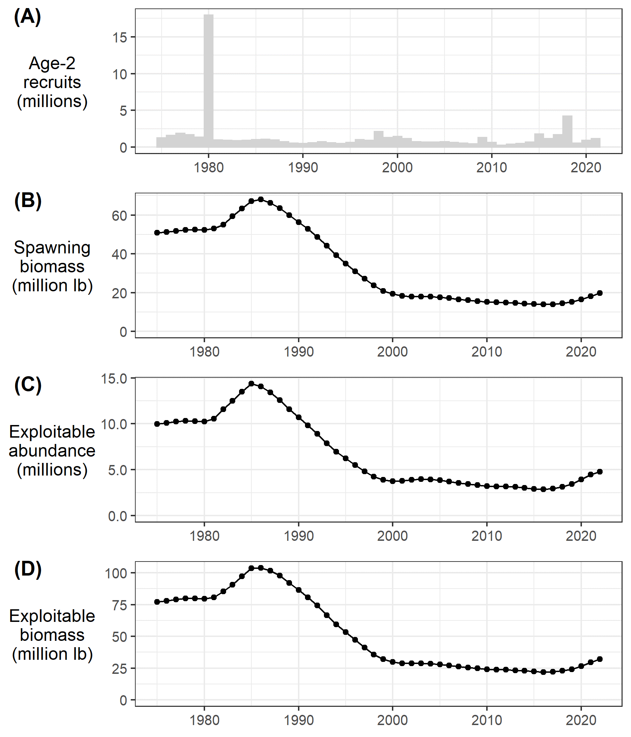

Figure 3.1a. Model predictions for the ADFG Northern Southeast Inside (NSEI) sablefish stock assessment (reproduced here with permission from Phil Joy, pers. comm.) of (A) age-2 recruitment (millions) and (B) female spawning stock biomass (million pounds).

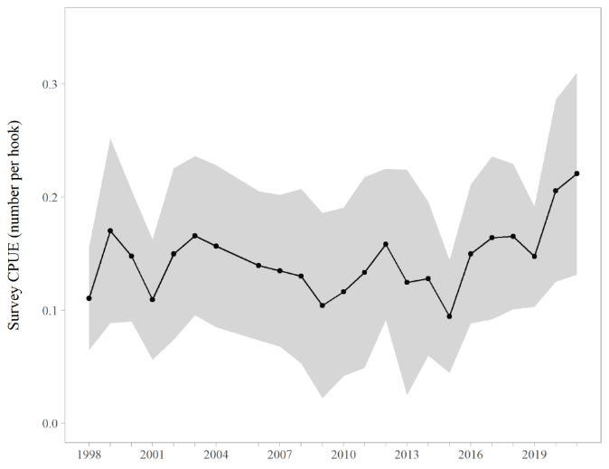

Figure 3.1b. Southern Southeast Inside (SSEI) sablefish longline survey catch-per-unit-effort (CPUE) in individuals per hook from 1998 to 2021 (except 2005; reproduced here with permission from Ehresmann and Olson, 2022).

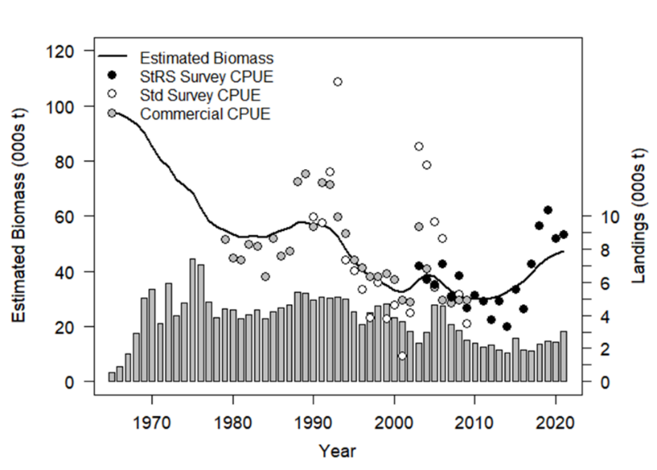

**British Columbia**

Figure 3.1c. Observed landings, commercial CPUE, and survey CPUE, as well as estimated biomass from a surplus production model of British Columbia sablefish (reproduce here with permission from Kendra Holt, DFO Canada, pers. comm.).



Figure 3.1d. Time series of total biomass relative to the unfished biomass for west coast USA sablefish (reproduced here with permission from Kapur et al. 2021).

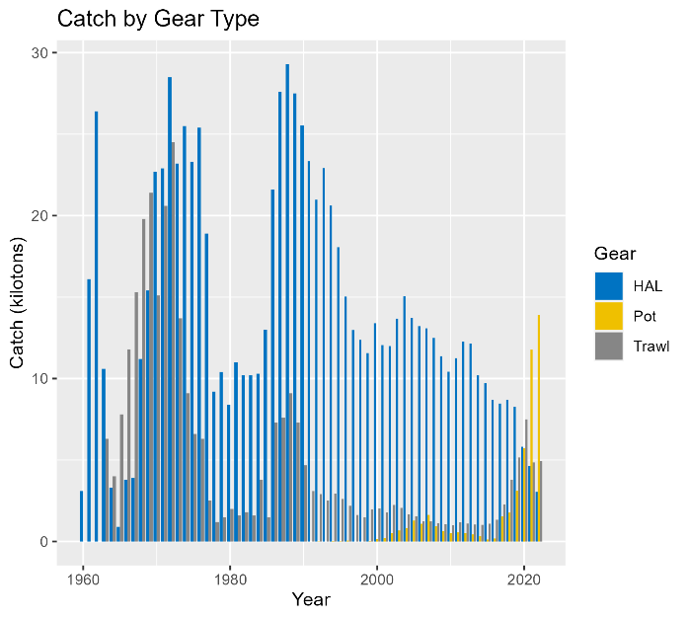

Figure 3.2. Sablefish catch (kt) by gear type. Note that hook and line (HAL) and pot gear catch are combined into a single ‘fixed gear’ fleet in the model.

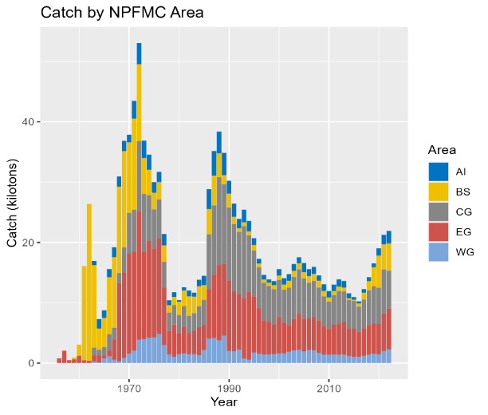

Figure 3.3. Sablefish total catch (kt) summed across all fleets by North Pacific Fishery Management Council area.

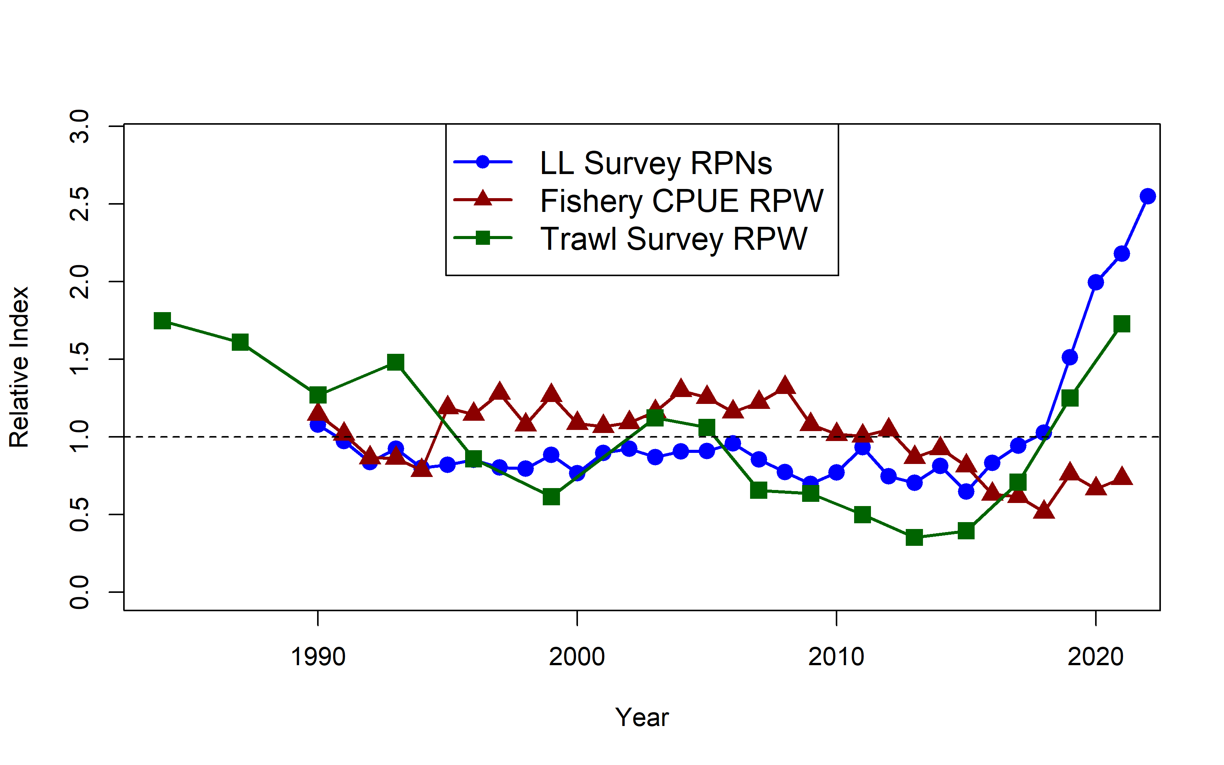

Figure 3.4. Comparison of the three indices used in the stock assessment model including the AFSC longline survey RPNs, the fixed gear fishery CPUE, and the NMFS trawl survey RPWs. Each index is relativized to the associated mean value for the time series.

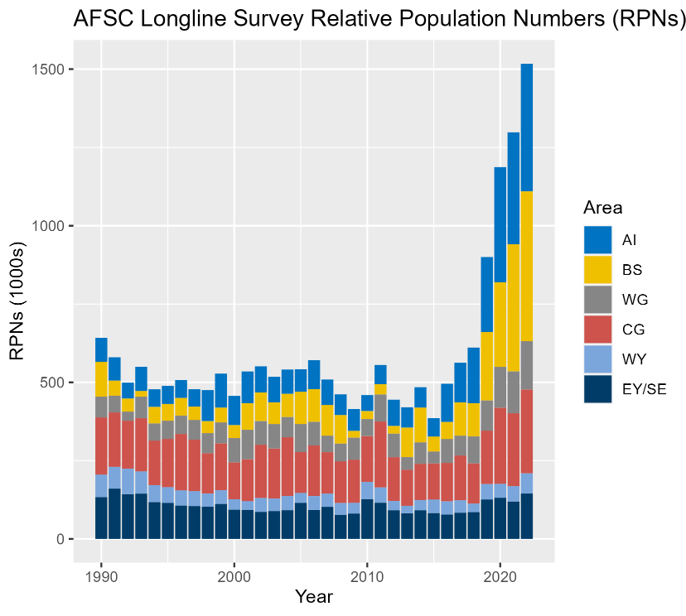

Figure 3.5. Relative abundance (relative population number in thousands) by region from the domestic (U.S.) longline survey.

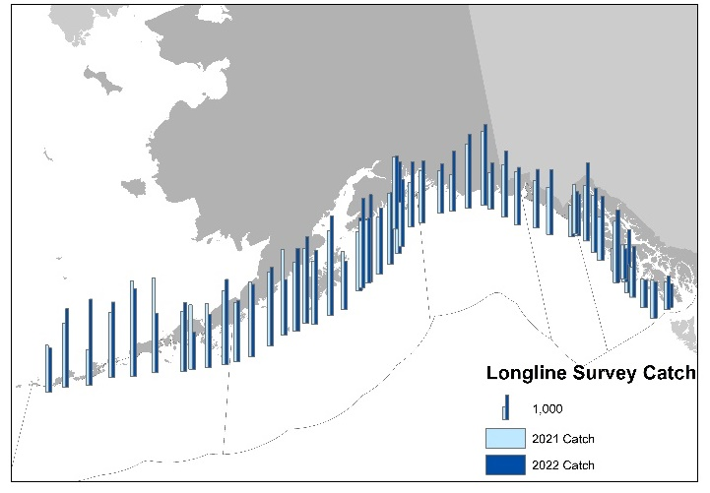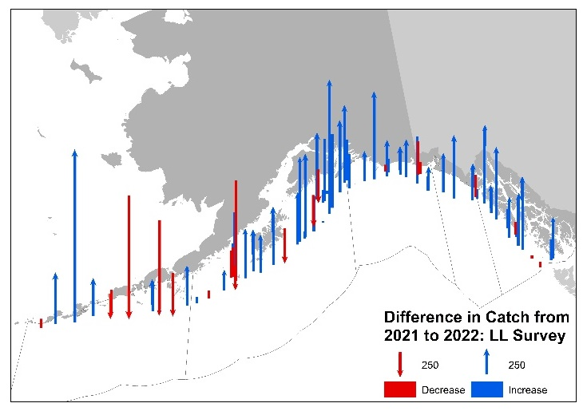

Figure 3.6. Comparison of the 2021 and 2022 longline survey in the Gulf of Alaska. Left panel is in numbers of fish; right panel is the difference in numbers of fish from 2021 in the 2022 survey. Numbers are not corrected for sperm whale depredation.

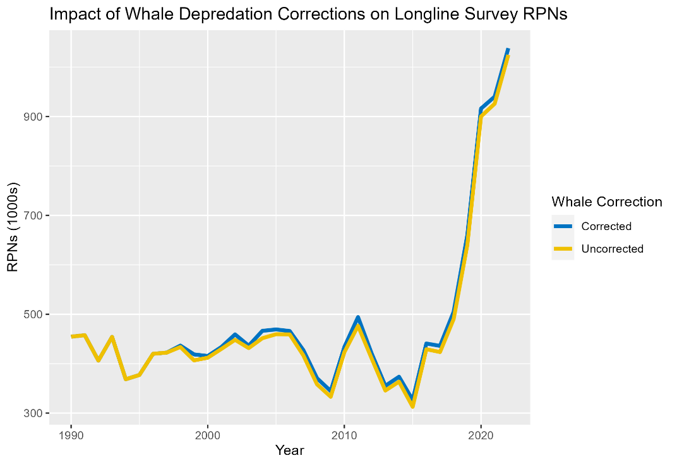

Figure 3.7. Longline survey relative population numbers (1000s of fish) with (blue line) and without (yellow line) corrections for sperm whale depredation.

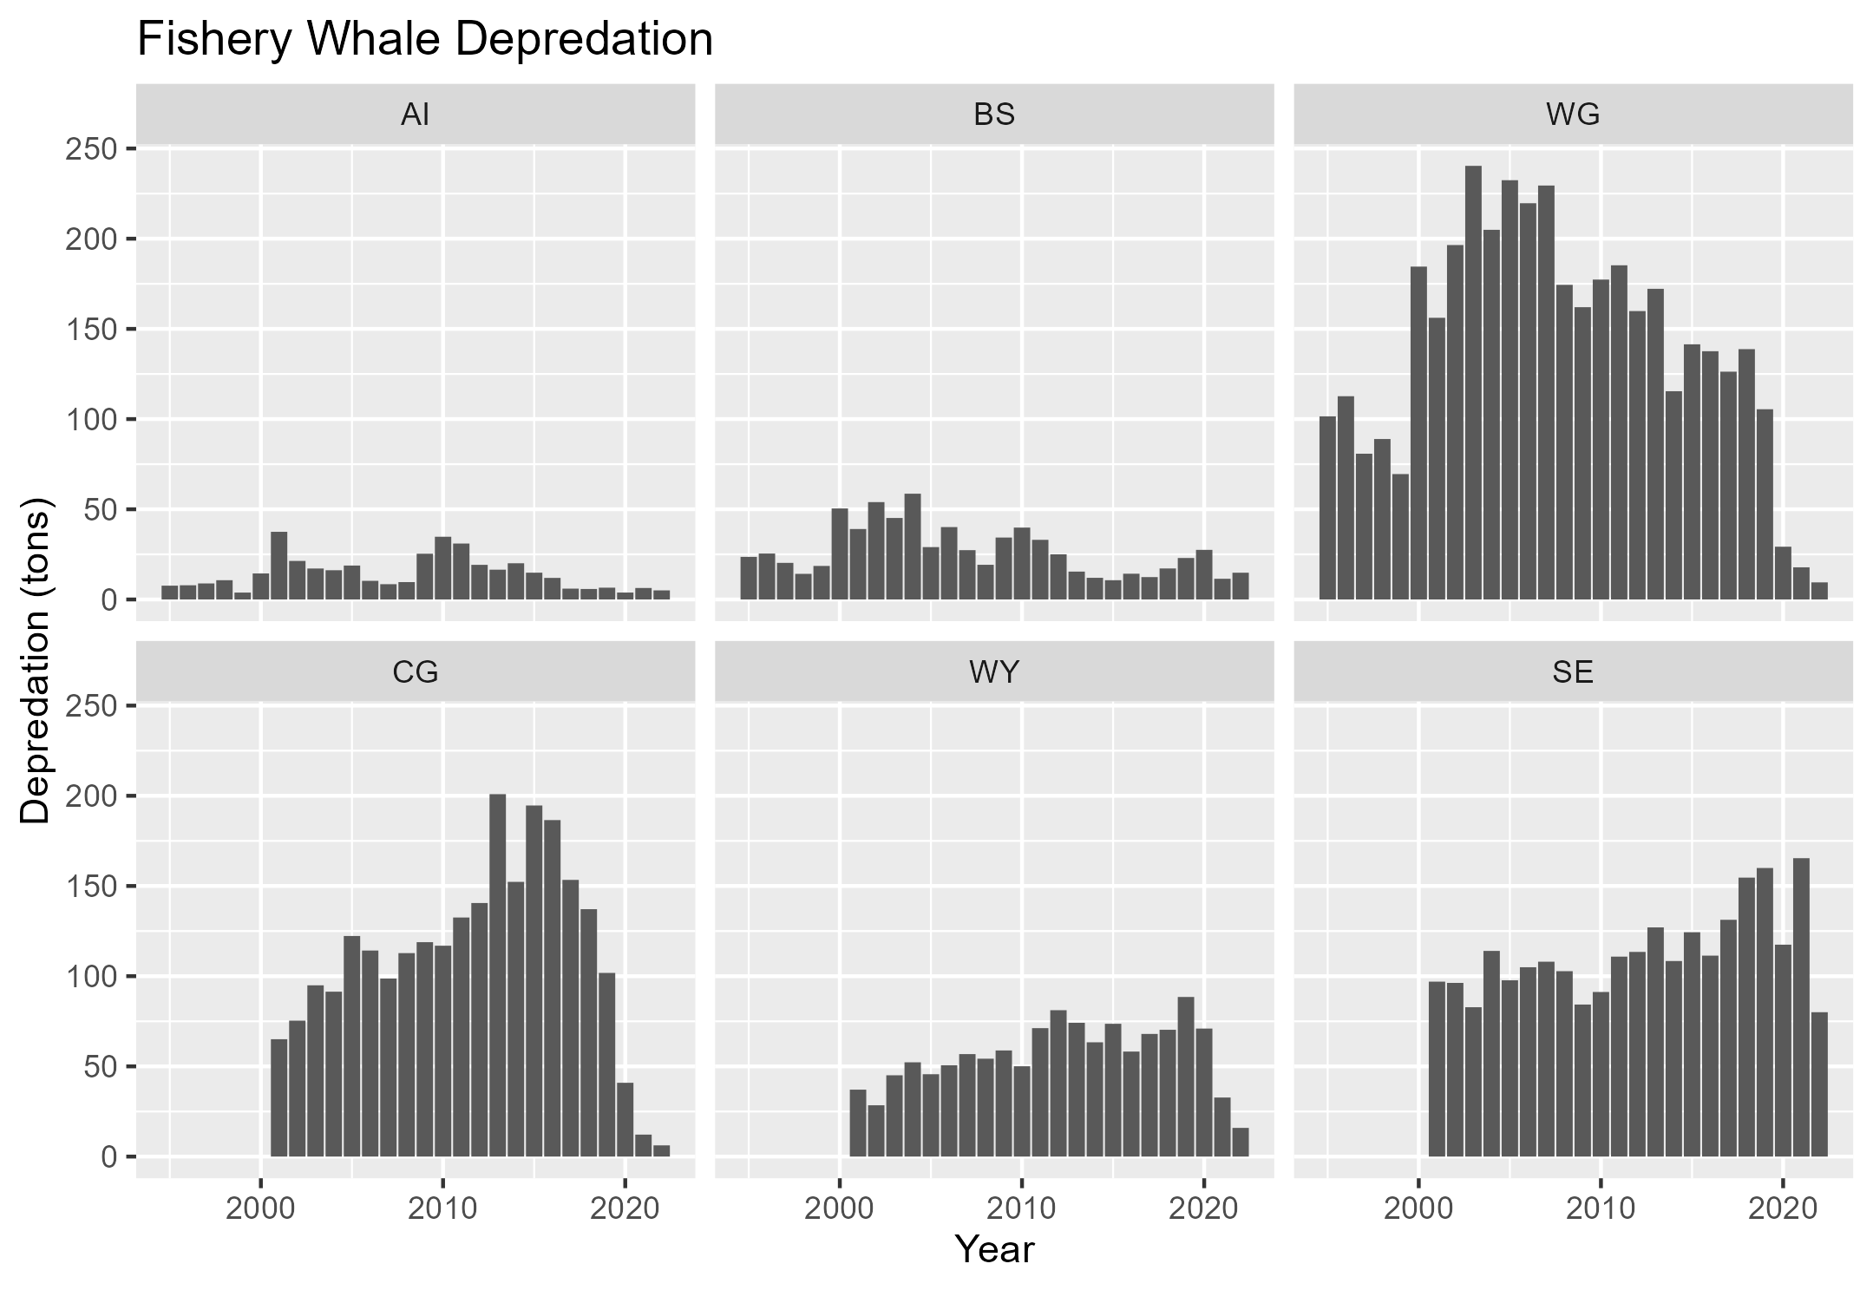

Figure 3.8. Estimated whale depredation in the sablefish fixed gear fishery. Depredation estimates reflect catch removals (tons) by region due to orcas (top row) and sperm whales (bottom row), which are added to the total catch for the sablefish assessment. 2022 is not a complete estimate, because it does not take into account projected catch through the end of 2022. Abbreviations are: Aleutian Islands (AI), Bering Sea (BS), Western Gulf of Alaska (WG), Central Gulf of Alaska (CGOA), Western Yakutat (WY), and East Yakutat/Southeast (SE).

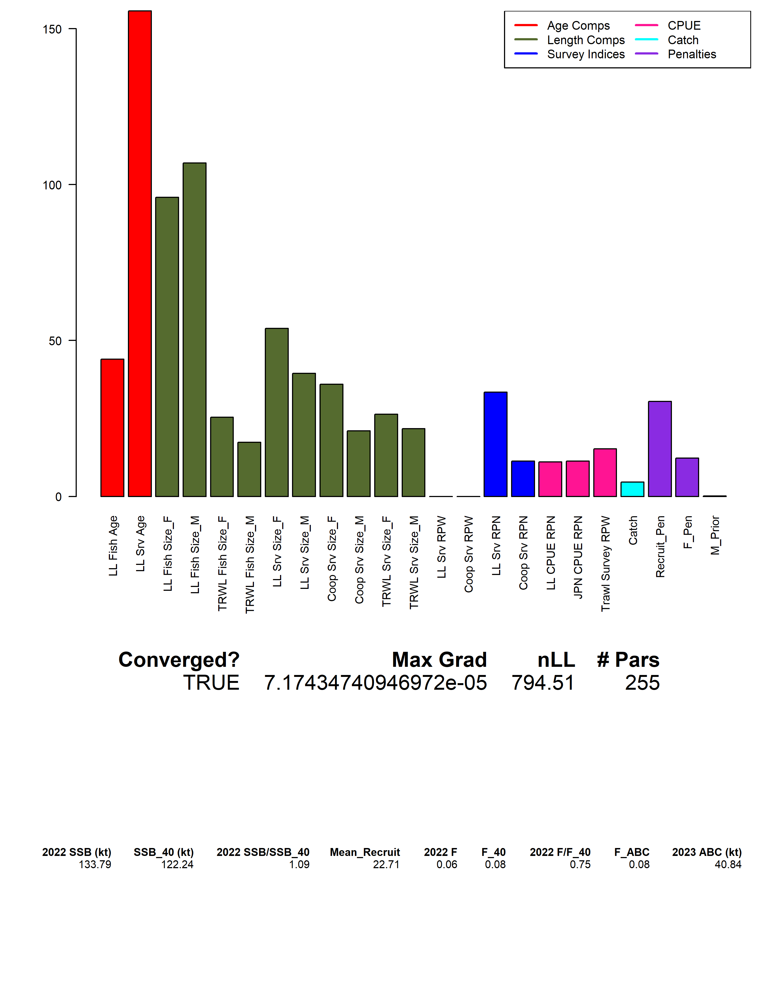

Figure 3.9. Contributions to the total negative log-likelihood by data component.

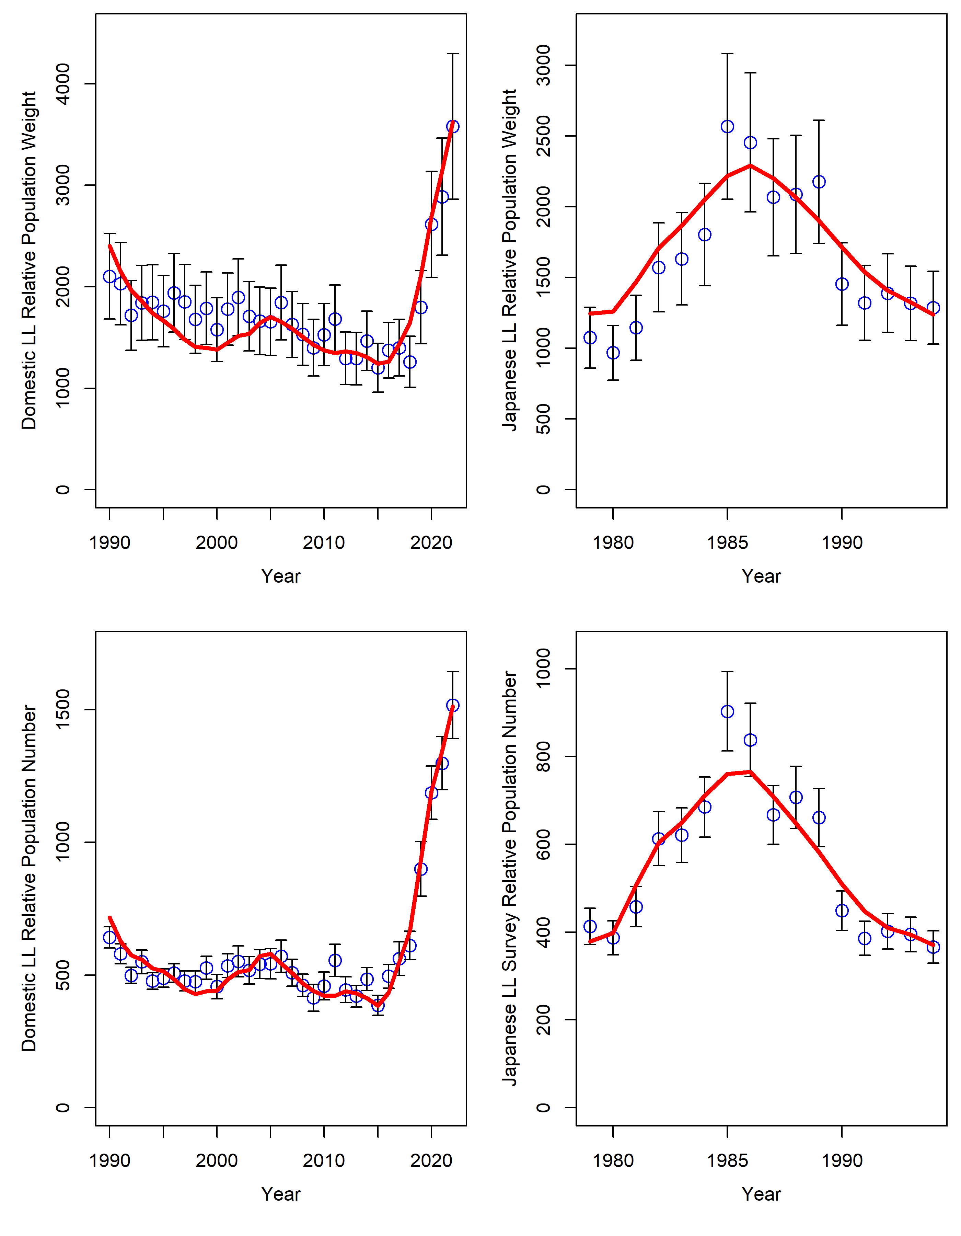

Figure 3.10a. Observed and predicted sablefish relative population weight (top) and numbers (bottom) for 1990 – 2022 for the U.S. domestic longline survey (left panels) and for years 1979 – 1994 for the U.S.-Japan cooperative survey (right panels). Points are observed estimates with approximate 95% confidence intervals. Solid red line is the model predicted value. The relative population weights are not fit in the model, but are presented for comparison.

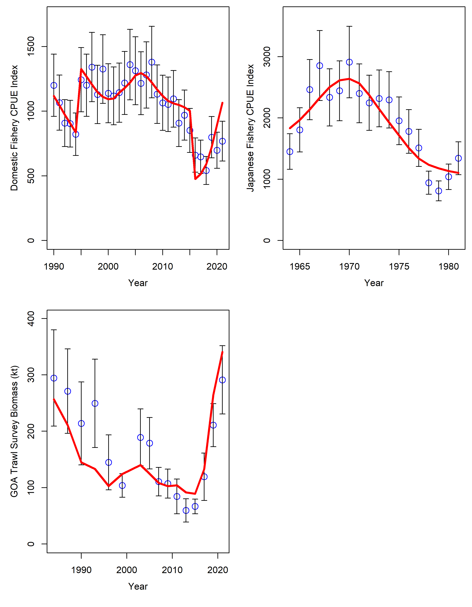

Figure 3.10b. Observed and predicted sablefish abundance indices. Fishery CPUE indices are in the top two panels. The GOA trawl survey is in the bottom left panel. Points are the observed values with approximate 95% confidence intervals, while solid red lines are the model the predicted values.

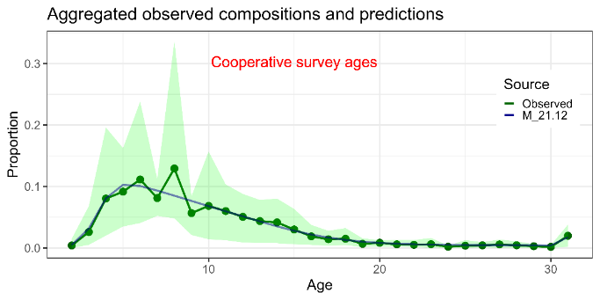

Figure 3.11. Mean observed (green line) cooperative longline survey age compositions aggregated across years along with the average fit of the model (blue line). The green bands are the 90% empirical confidence intervals.

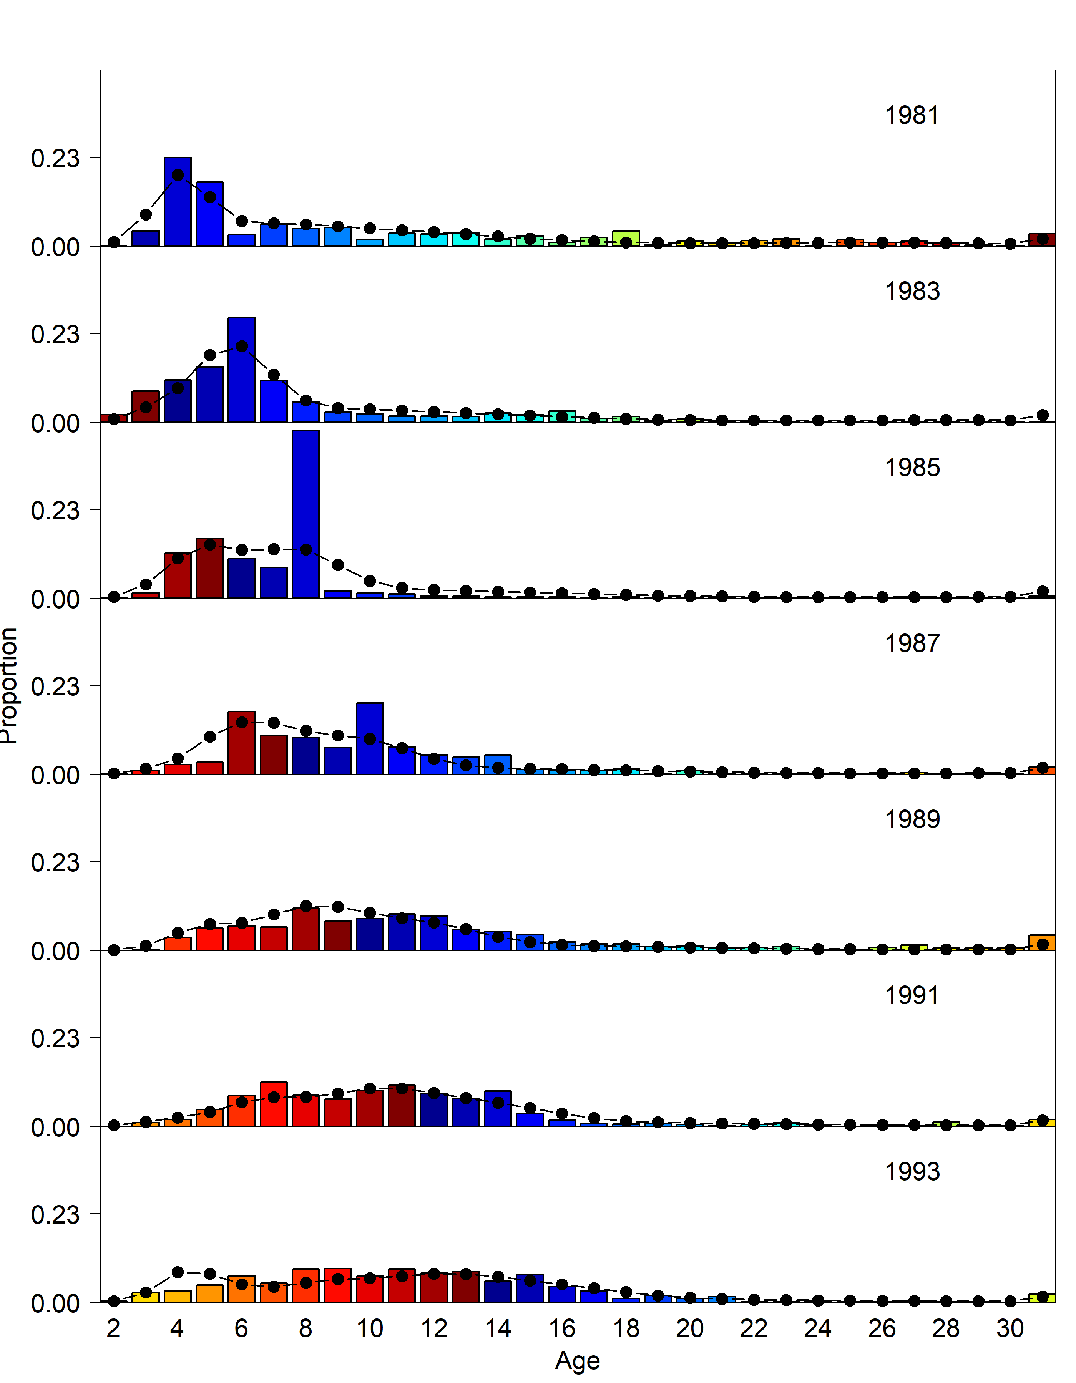

Figure 3.12. Japanese longline survey age compositions. Bars are observed frequencies and the line is predicted frequencies.

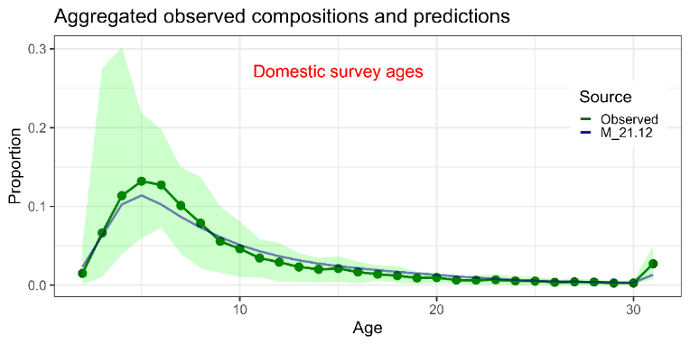

Figure 3.13. Mean observed (green line) domestic longline survey age compositions aggregated across years along with the average fit of the model (blue line). The green bands are the 90% empirical confidence intervals.

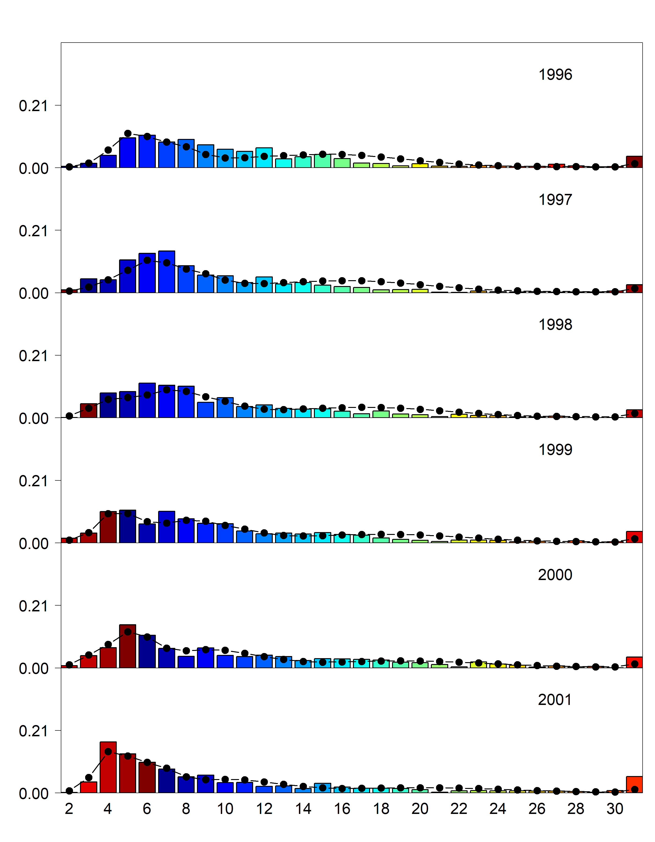

Figure 3.14. Domestic longline survey age compositions. Bars are observed frequencies and lines are predicted frequencies.

sable29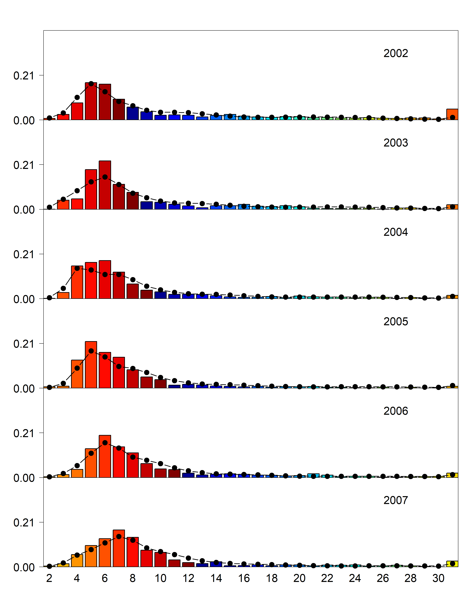

Figure 3.14 (cont.). Domestic longline survey age compositions. Bars are observed frequencies and lines are predicted frequencies.

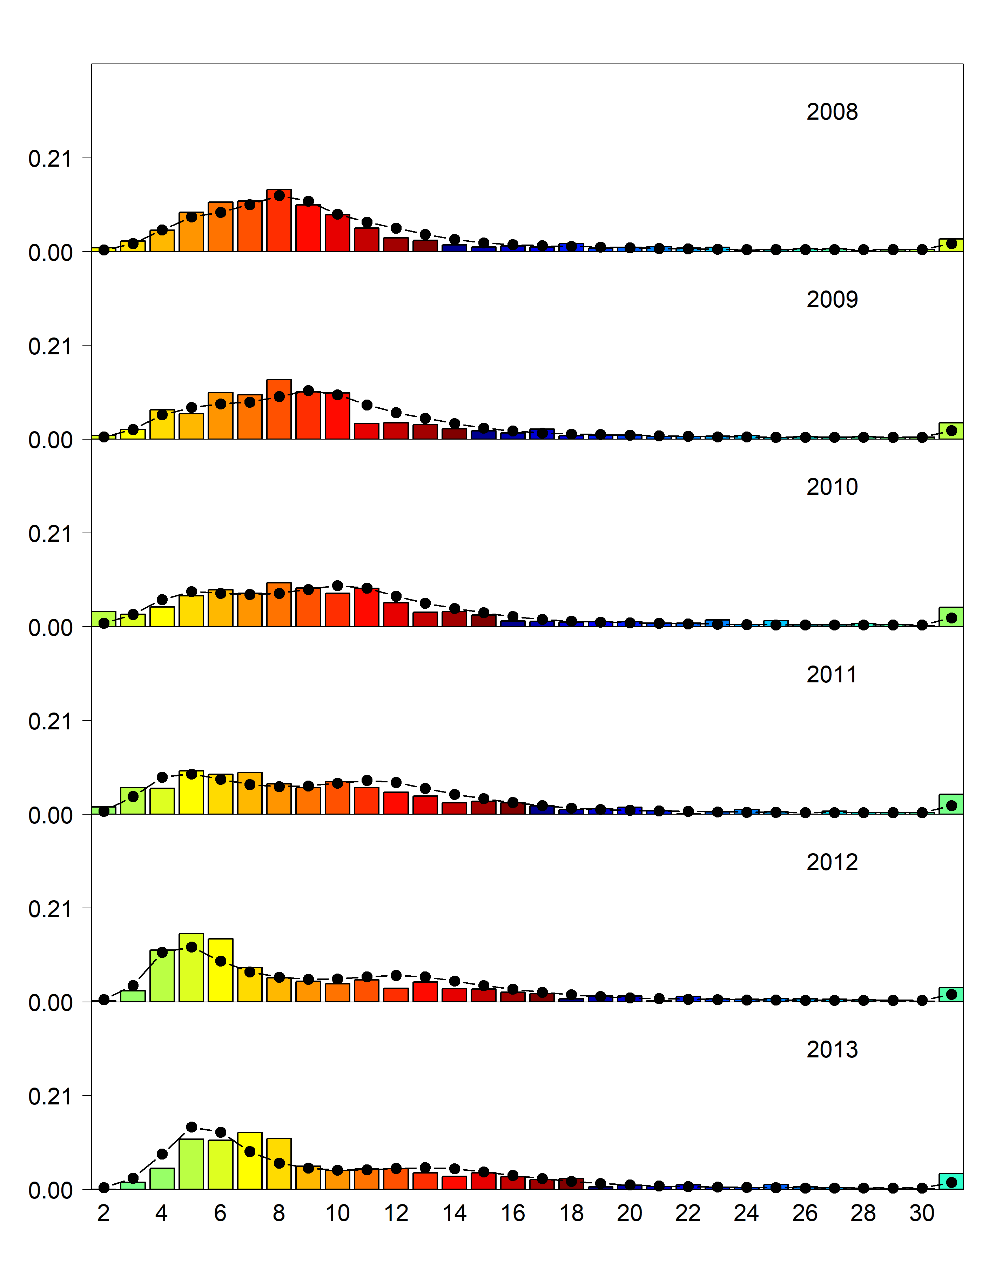Figure 3.14 (cont.). Domestic longline survey age compositions. Bars are observed frequencies and lines are predicted frequencies.

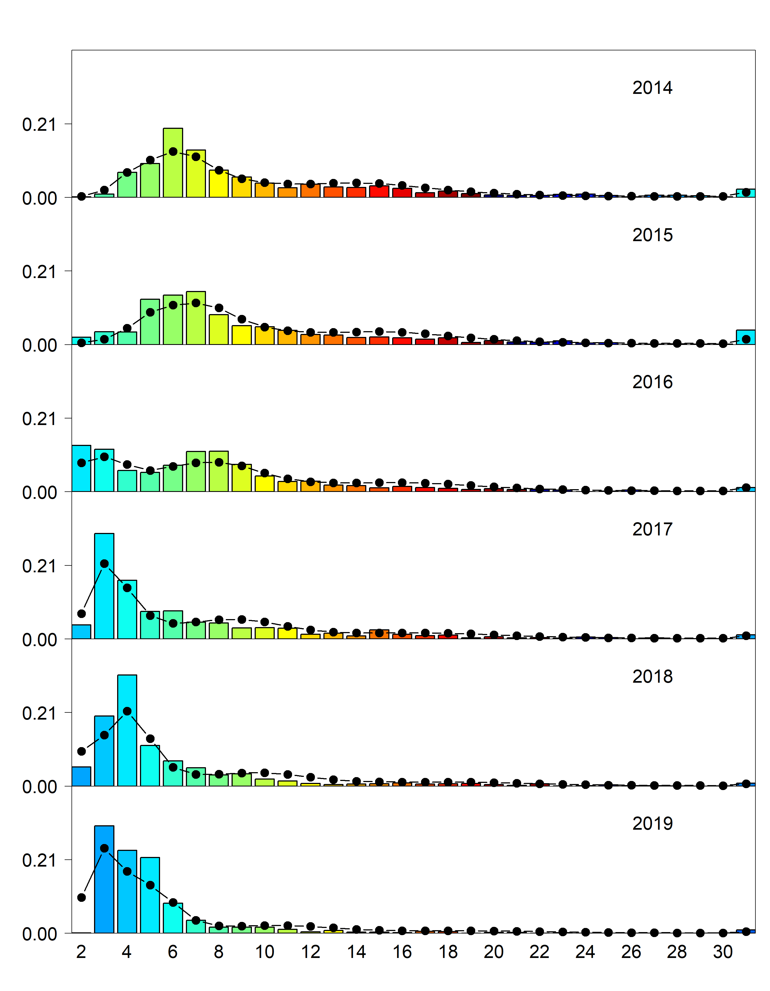

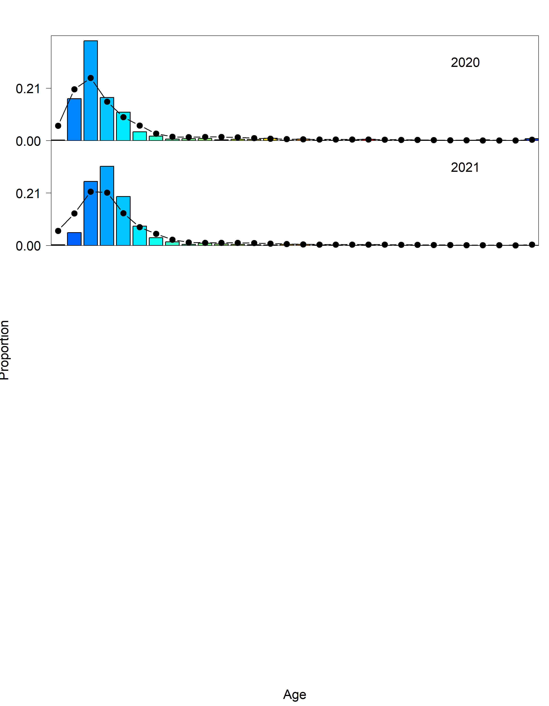

Figure 3.14 (cont.). Domestic longline survey age compositions. Bars are observed frequencies and lines are predicted frequencies.

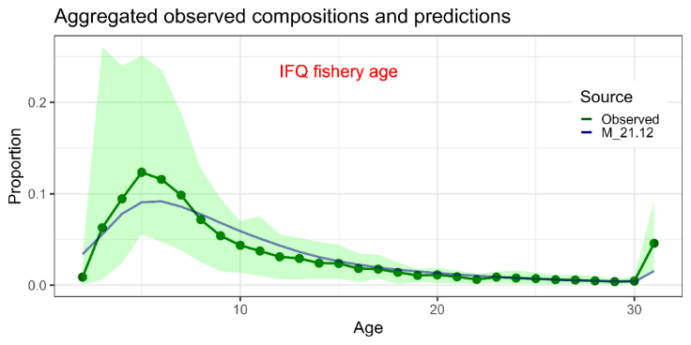

Figure 3.15. Mean observed (green line) domestic fixed gear fishery age compositions aggregated across years along with the average fit of the model (blue line). The green bands are the 90% empirical confidence intervals.

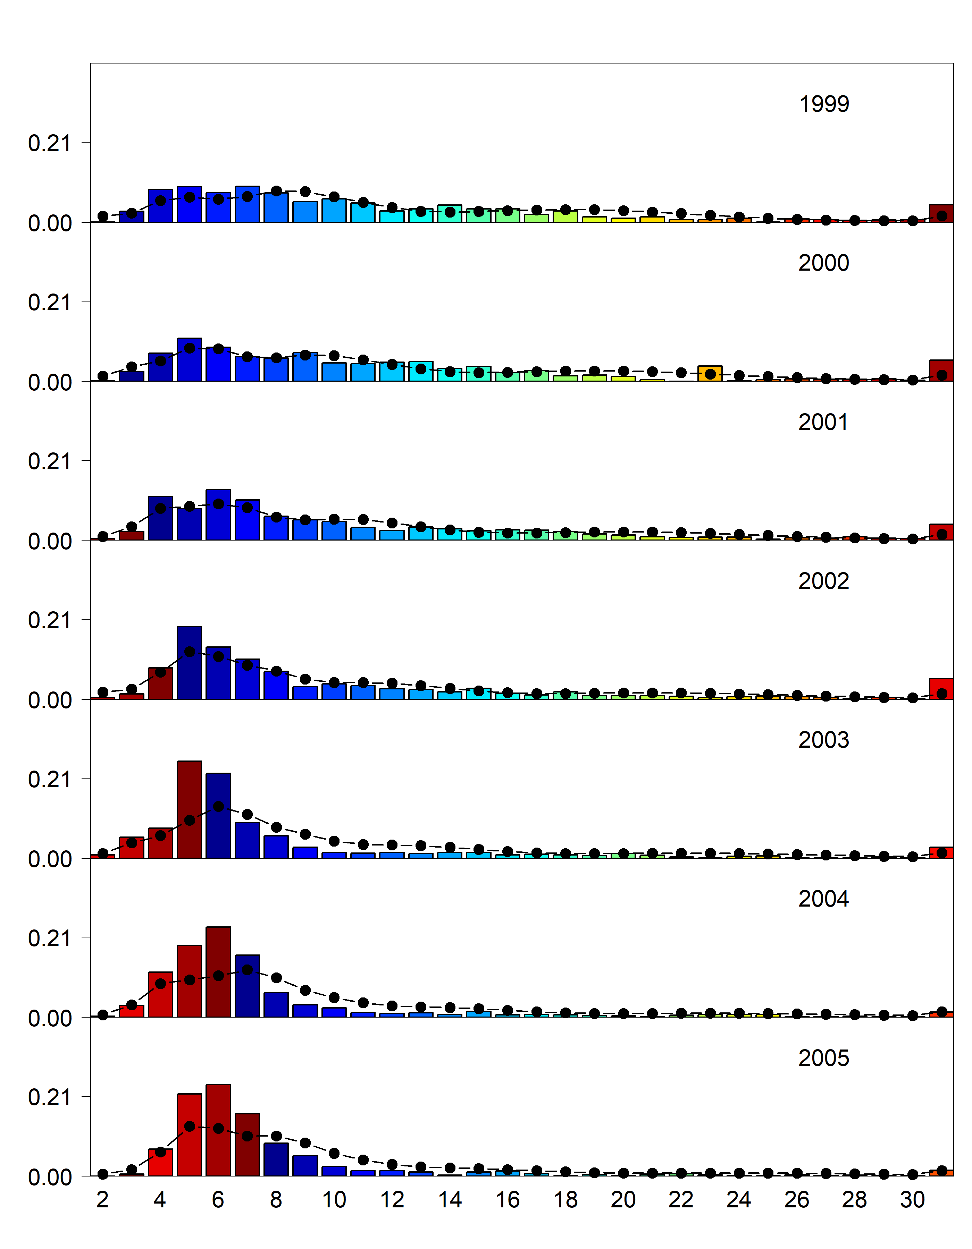

Figure 3.16. Domestic fixed gear fishery age compositions. Bars are observed frequencies and lines are predicted frequencies.

sable29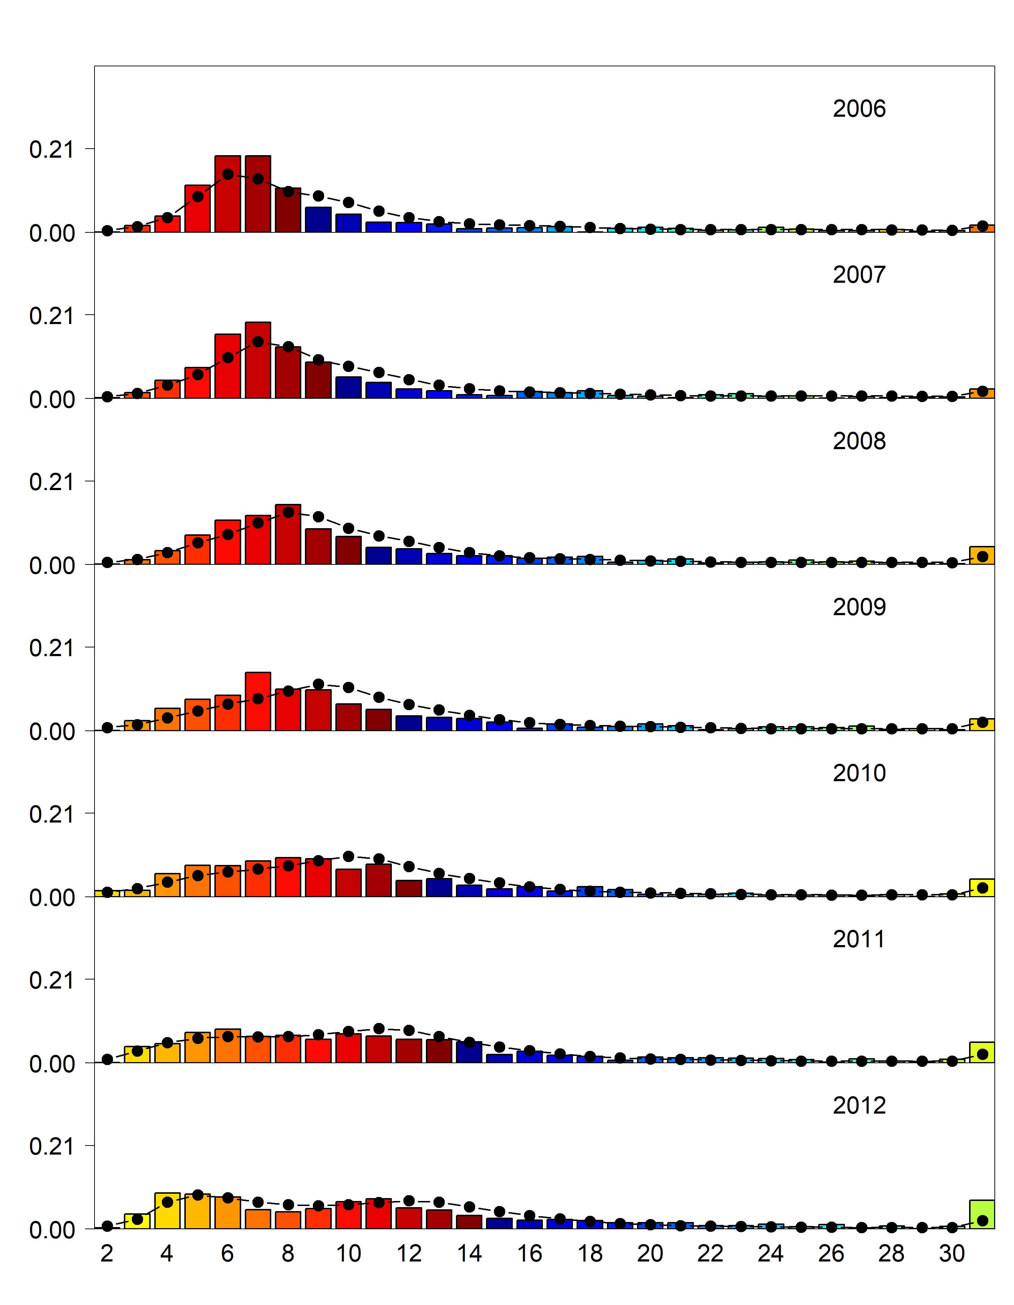

Figure 3.16 (cont.). Domestic fixed gear fishery age compositions. Bars are observed frequencies and lines are predicted frequencies.

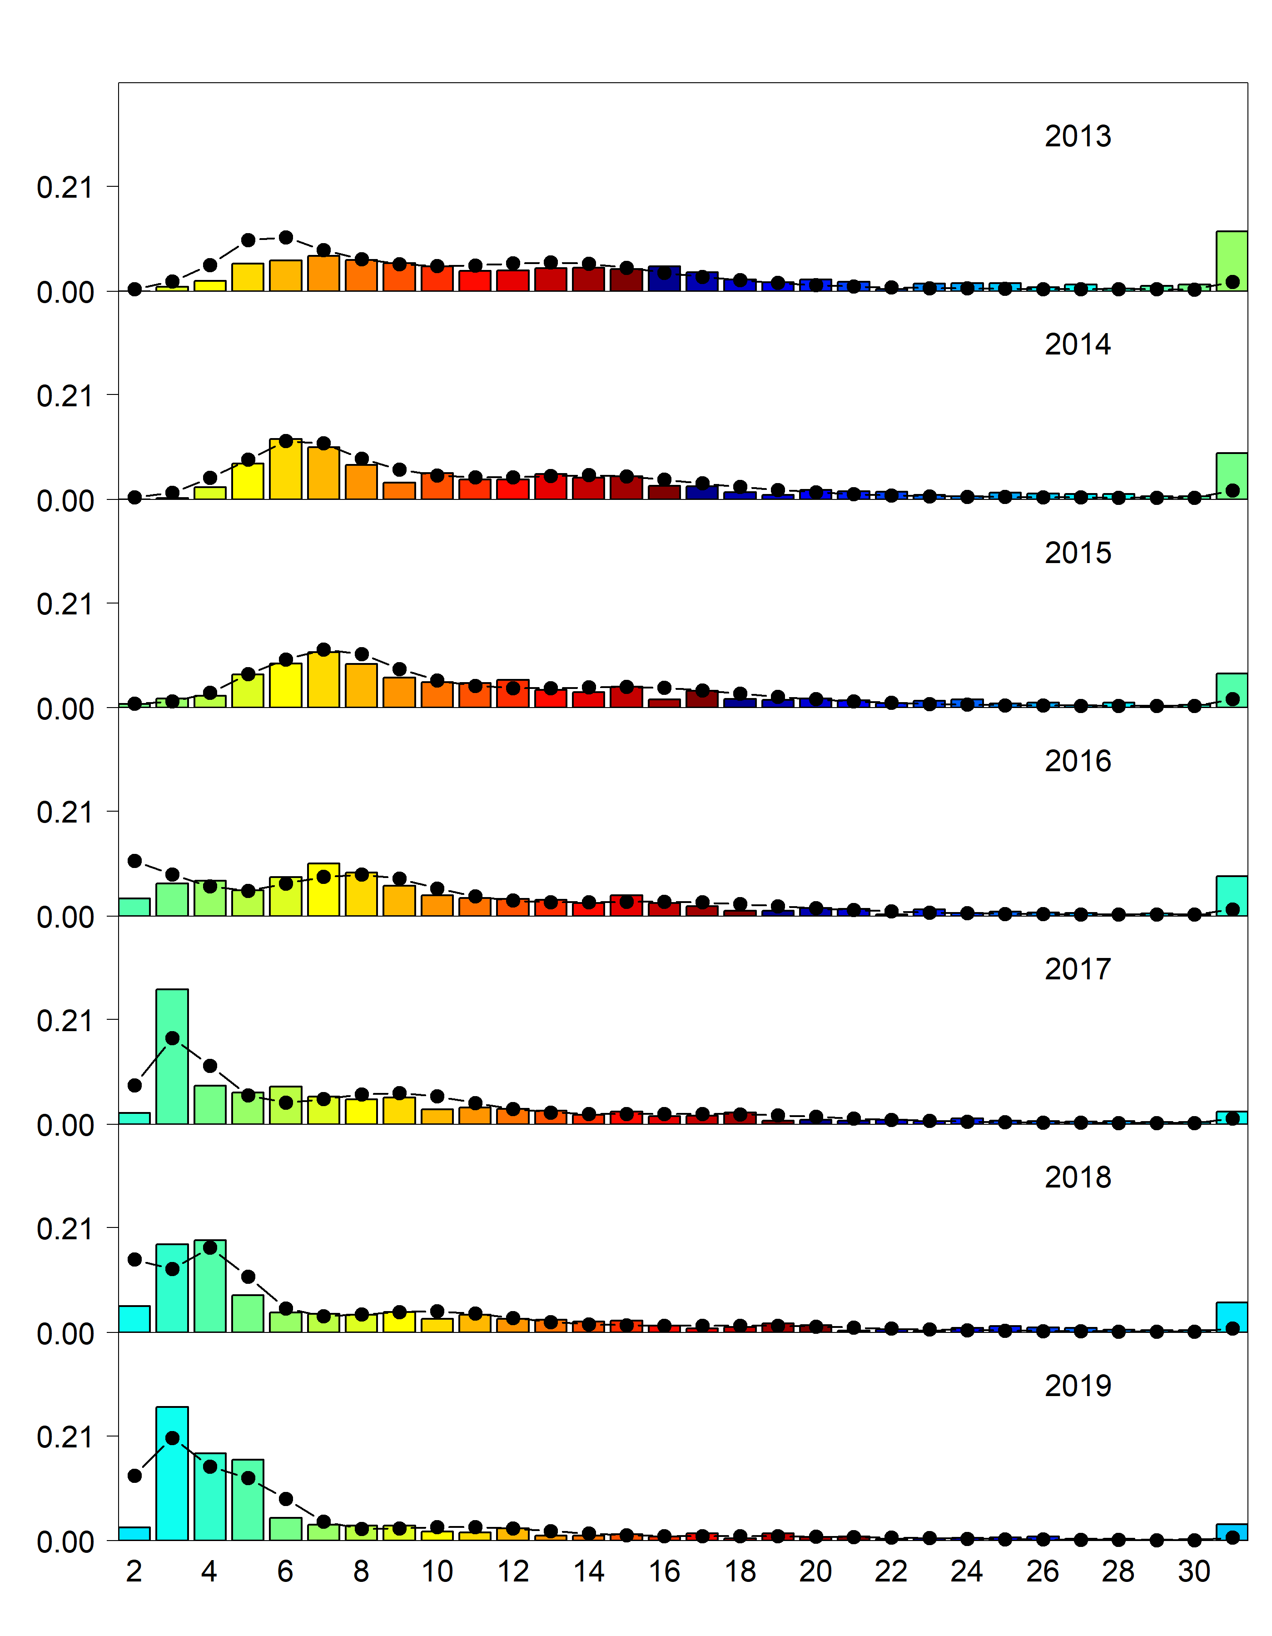

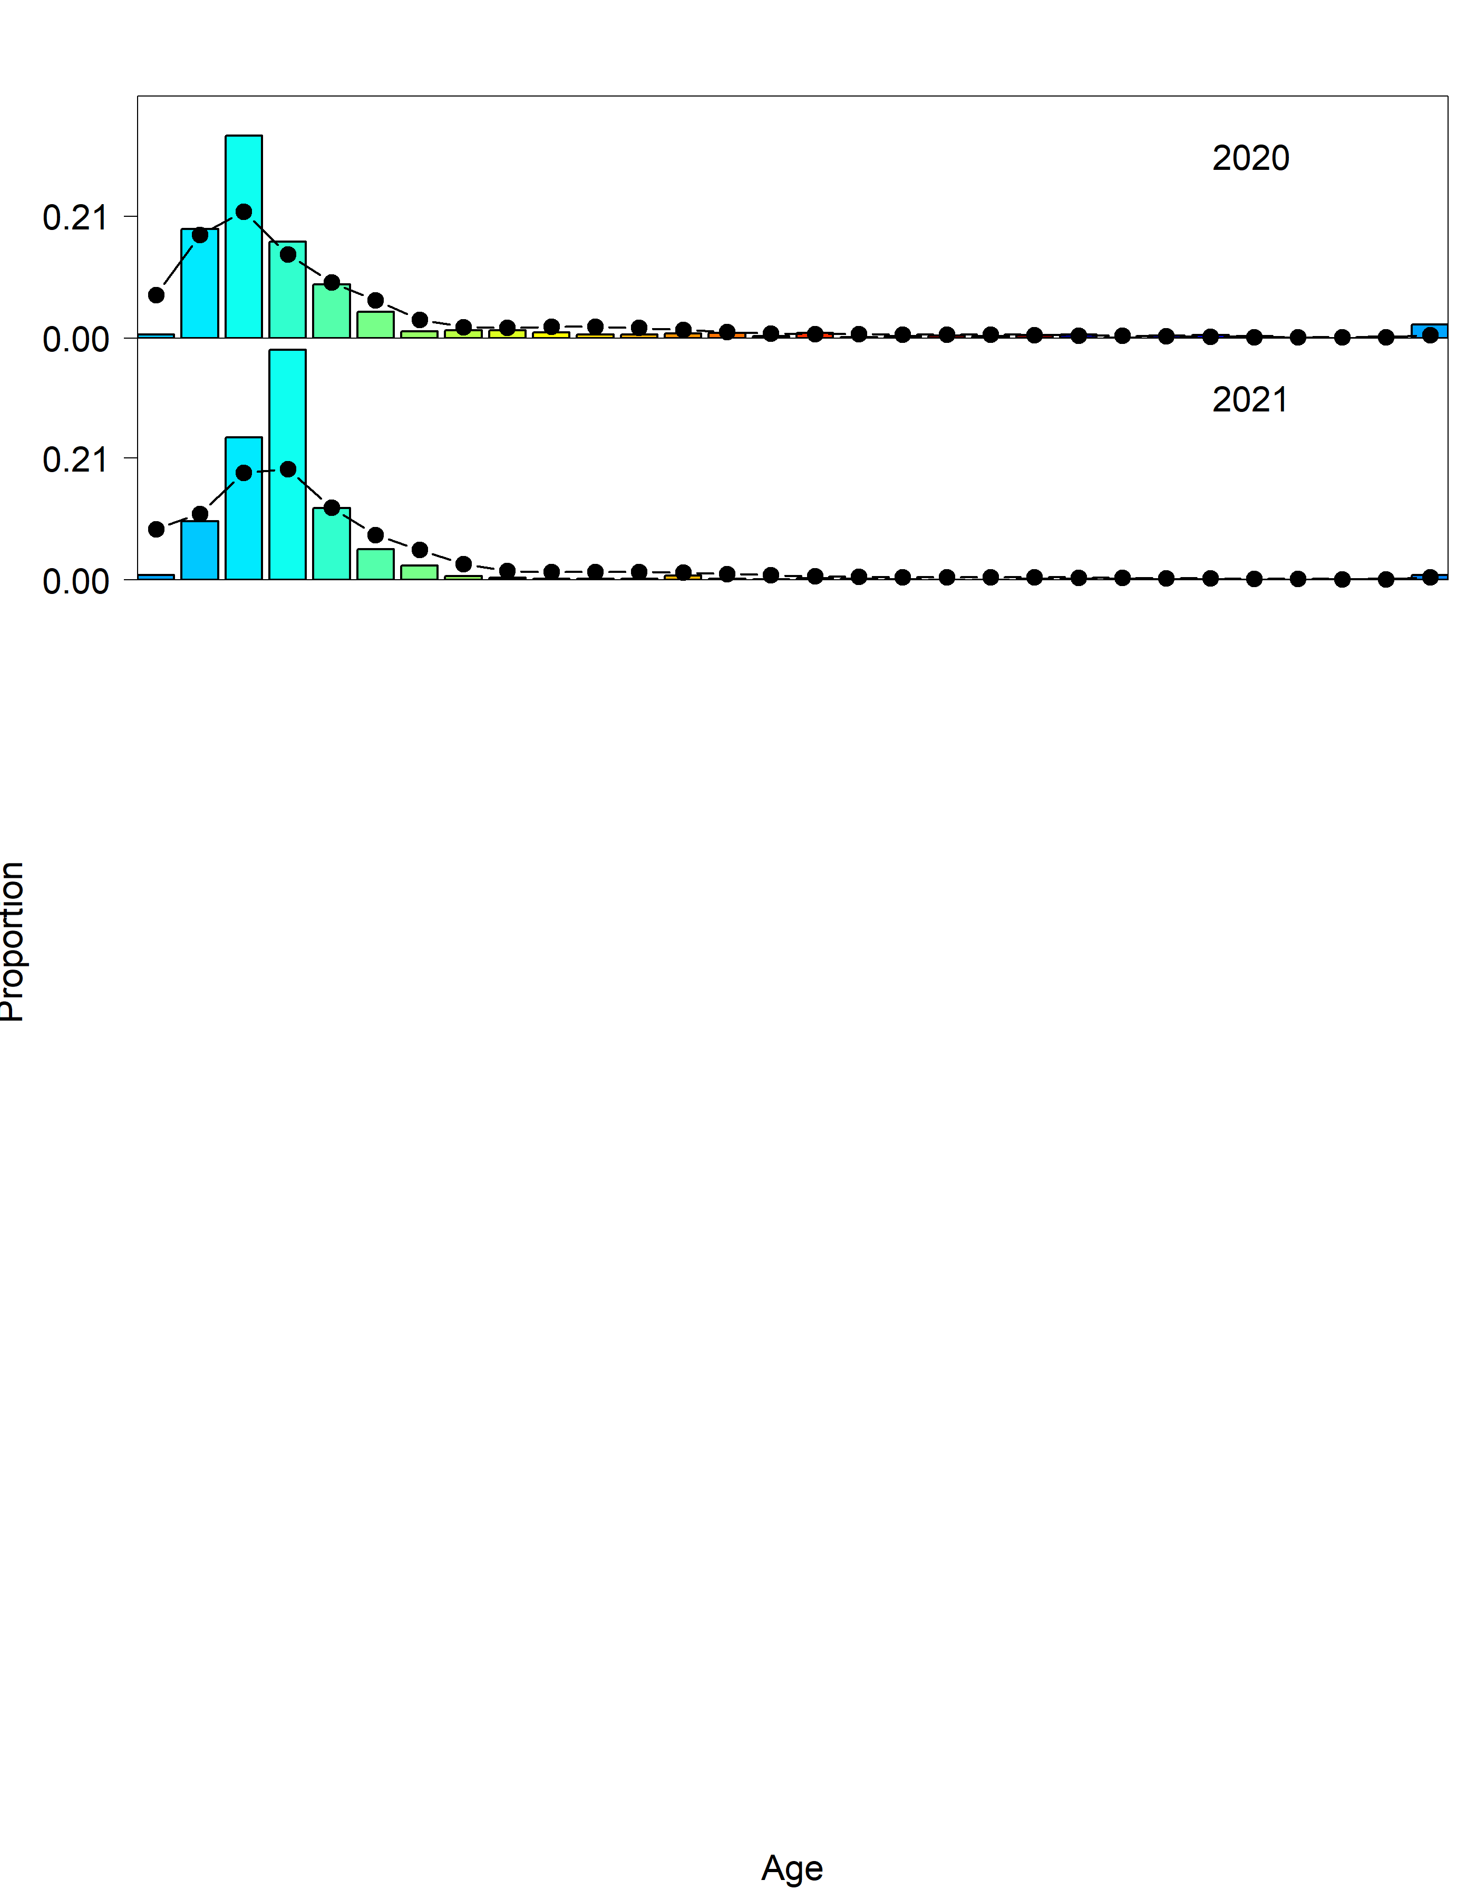

Figure 3.16 (cont.). Domestic fixed gear fishery age compositions. Bars are observed frequencies and lines are predicted frequencies.

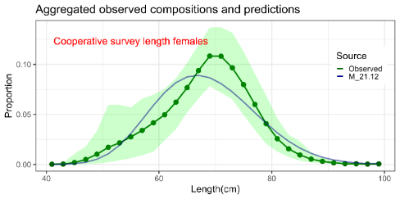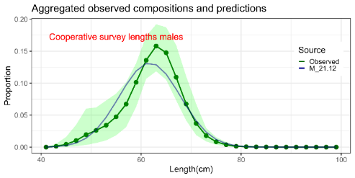

Figure 3.17. Mean observed (green line) cooperative longline survey length compositions aggregated across years along with the average fit of the model (blue line). The green bands are the 90% empirical confidence intervals. Fit to female length compositions are provided in the left panel and fit to male length compositions are provided in the right panel.

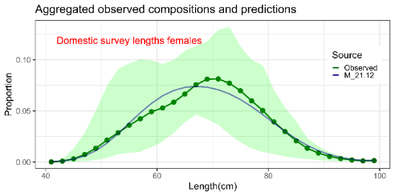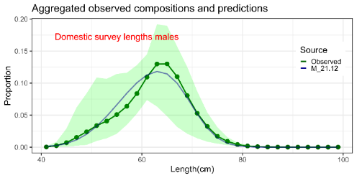

Figure 3.18. Mean observed (green line) domestic longline survey length compositions aggregated across years along with the average fit of the model (blue line). The green bands are the 90% empirical confidence intervals. Fit to female length compositions are provided in the left panel and fit to male length compositions are provided in the right panel.

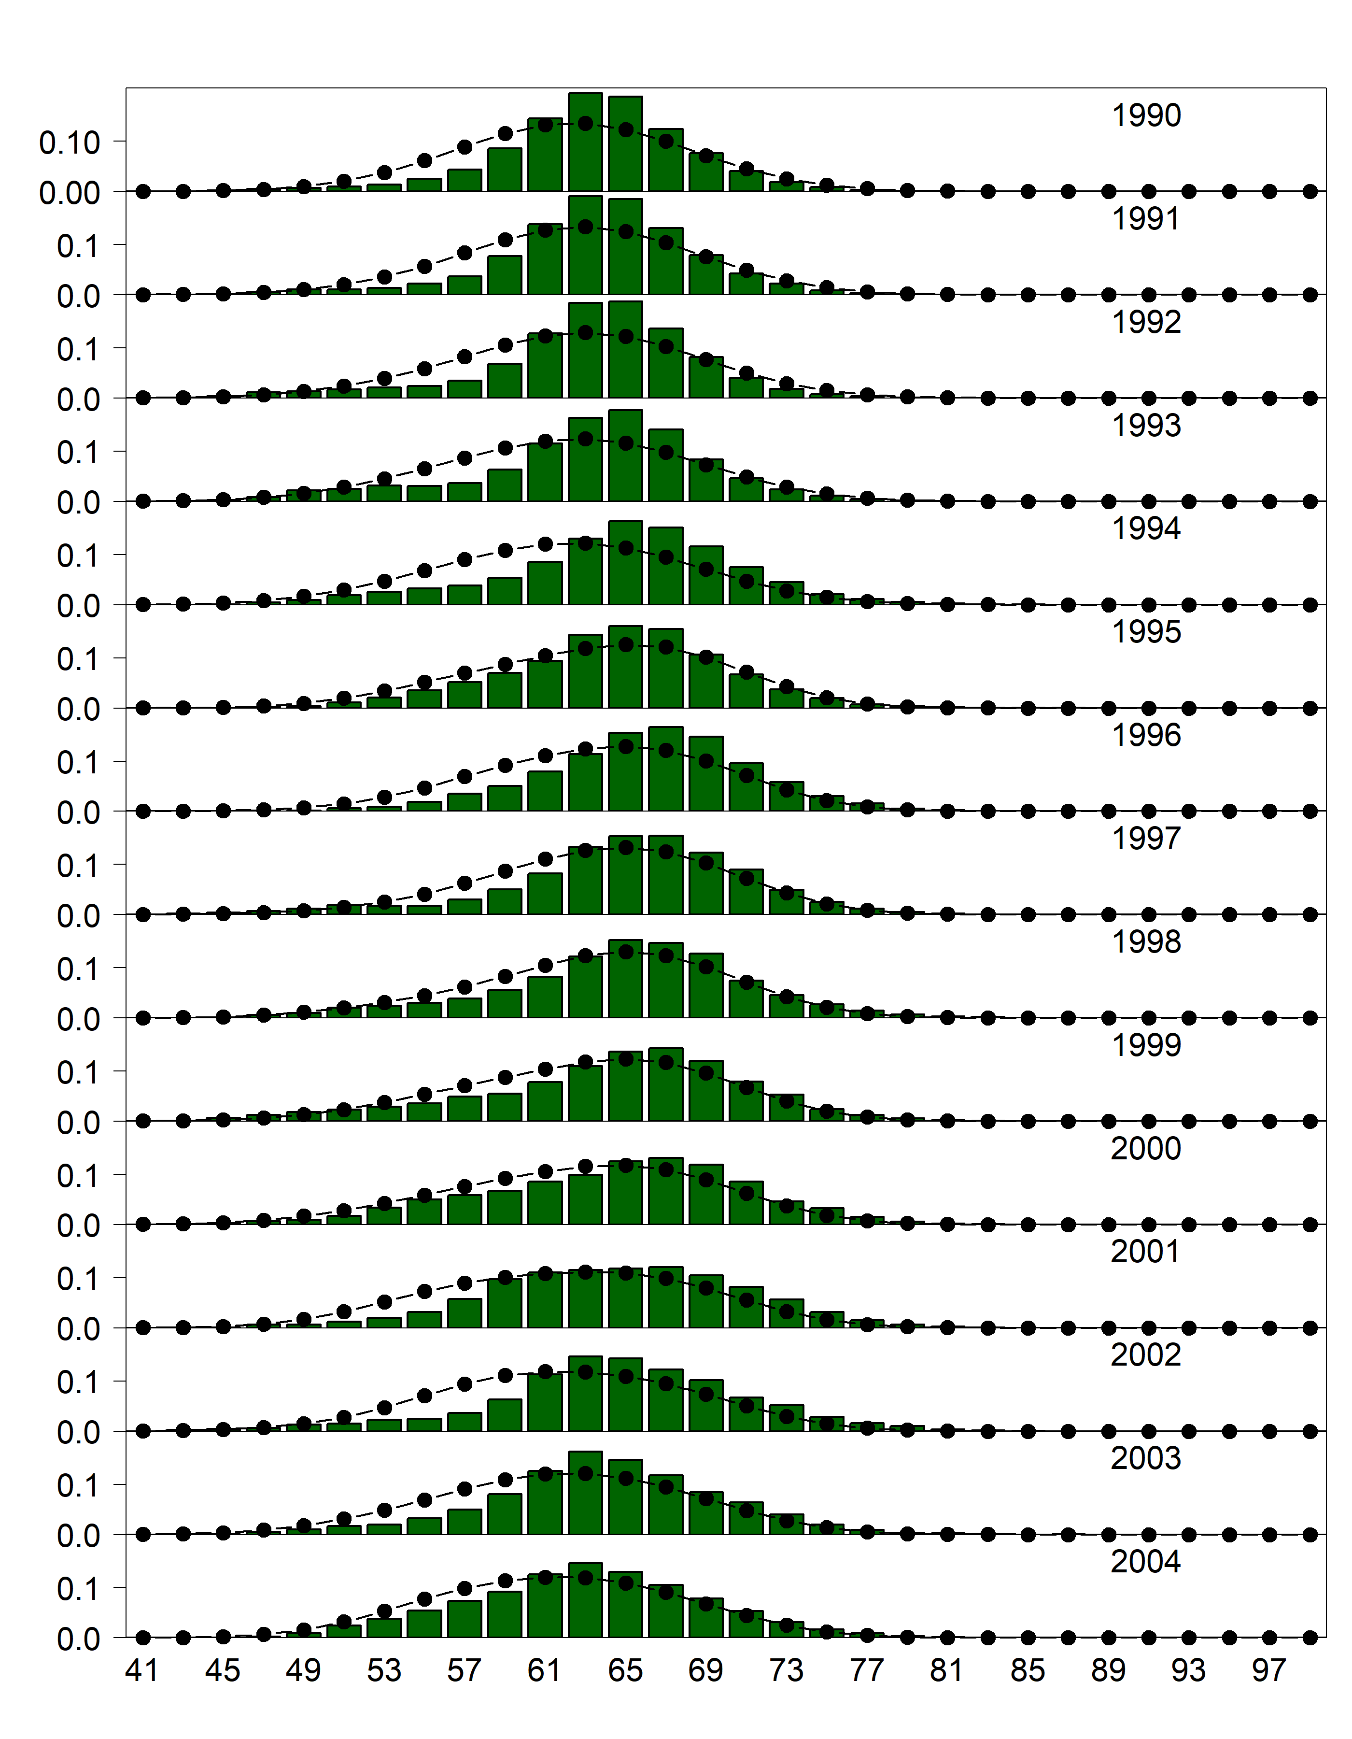

Figure 3.19. Domestic longline survey length (cm) compositions for males. Bars are observed frequencies and lines are predicted frequencies.

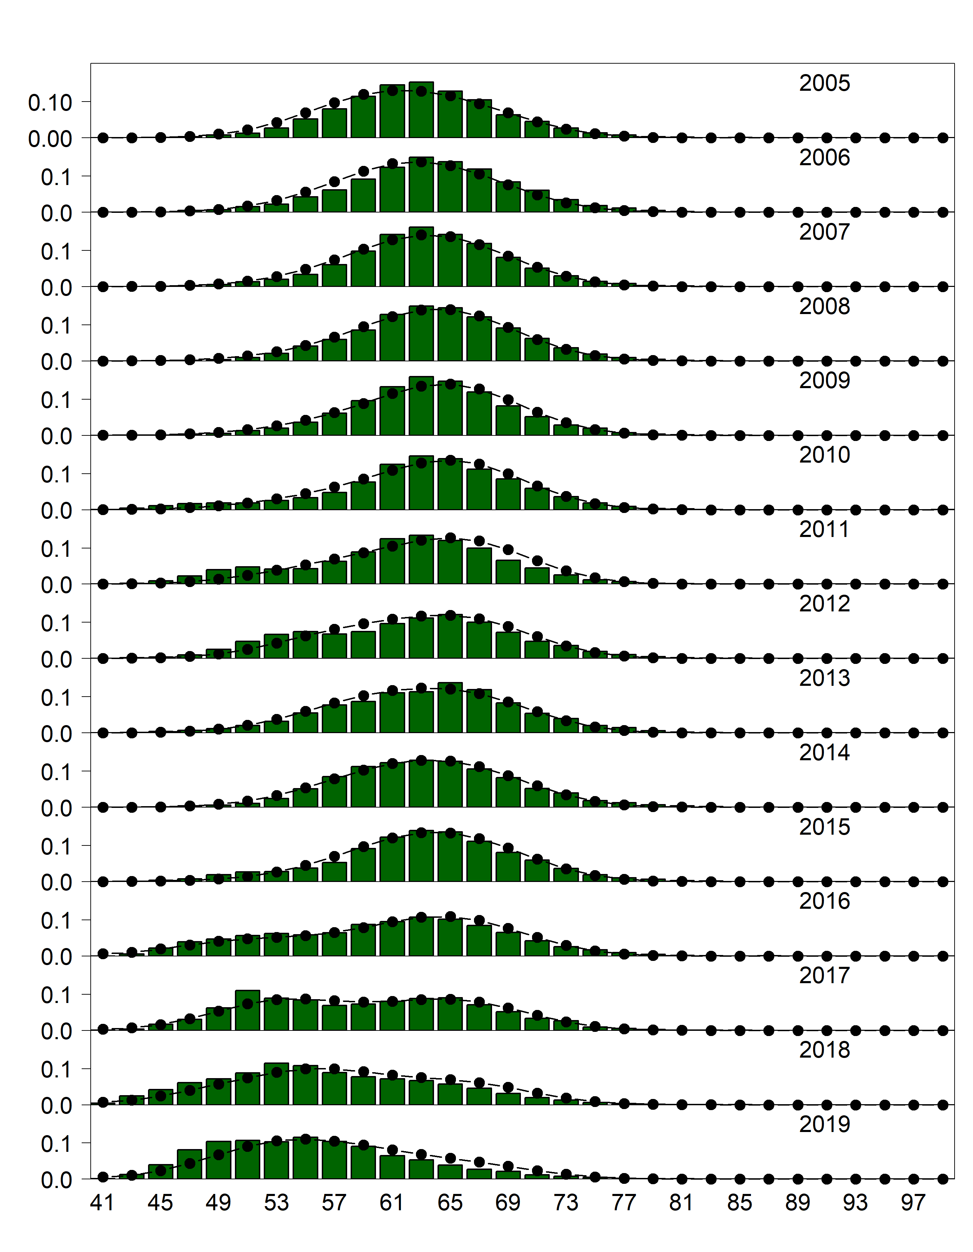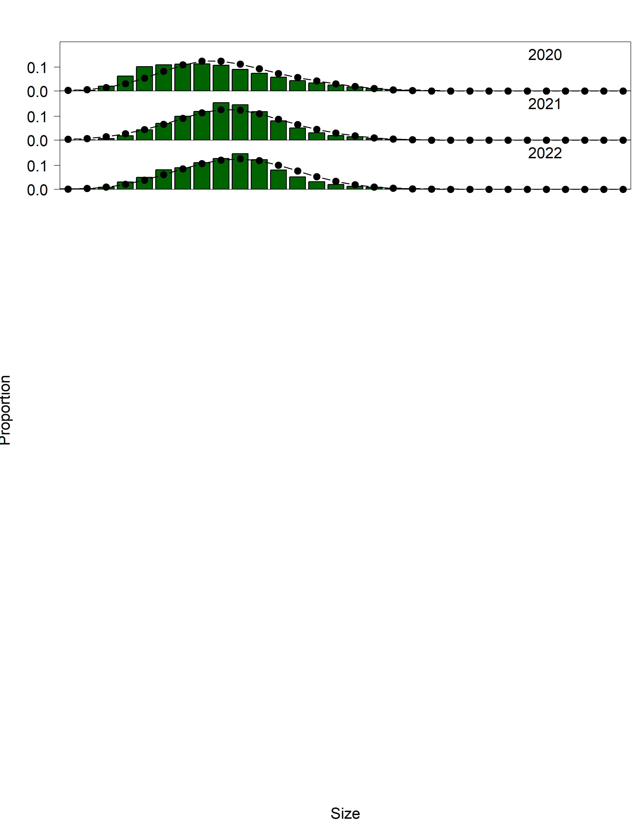

Figure 3.19. (Cont.). Domestic longline survey length (cm) compositions for males. Bars are observed frequencies and lines are predicted frequencies.

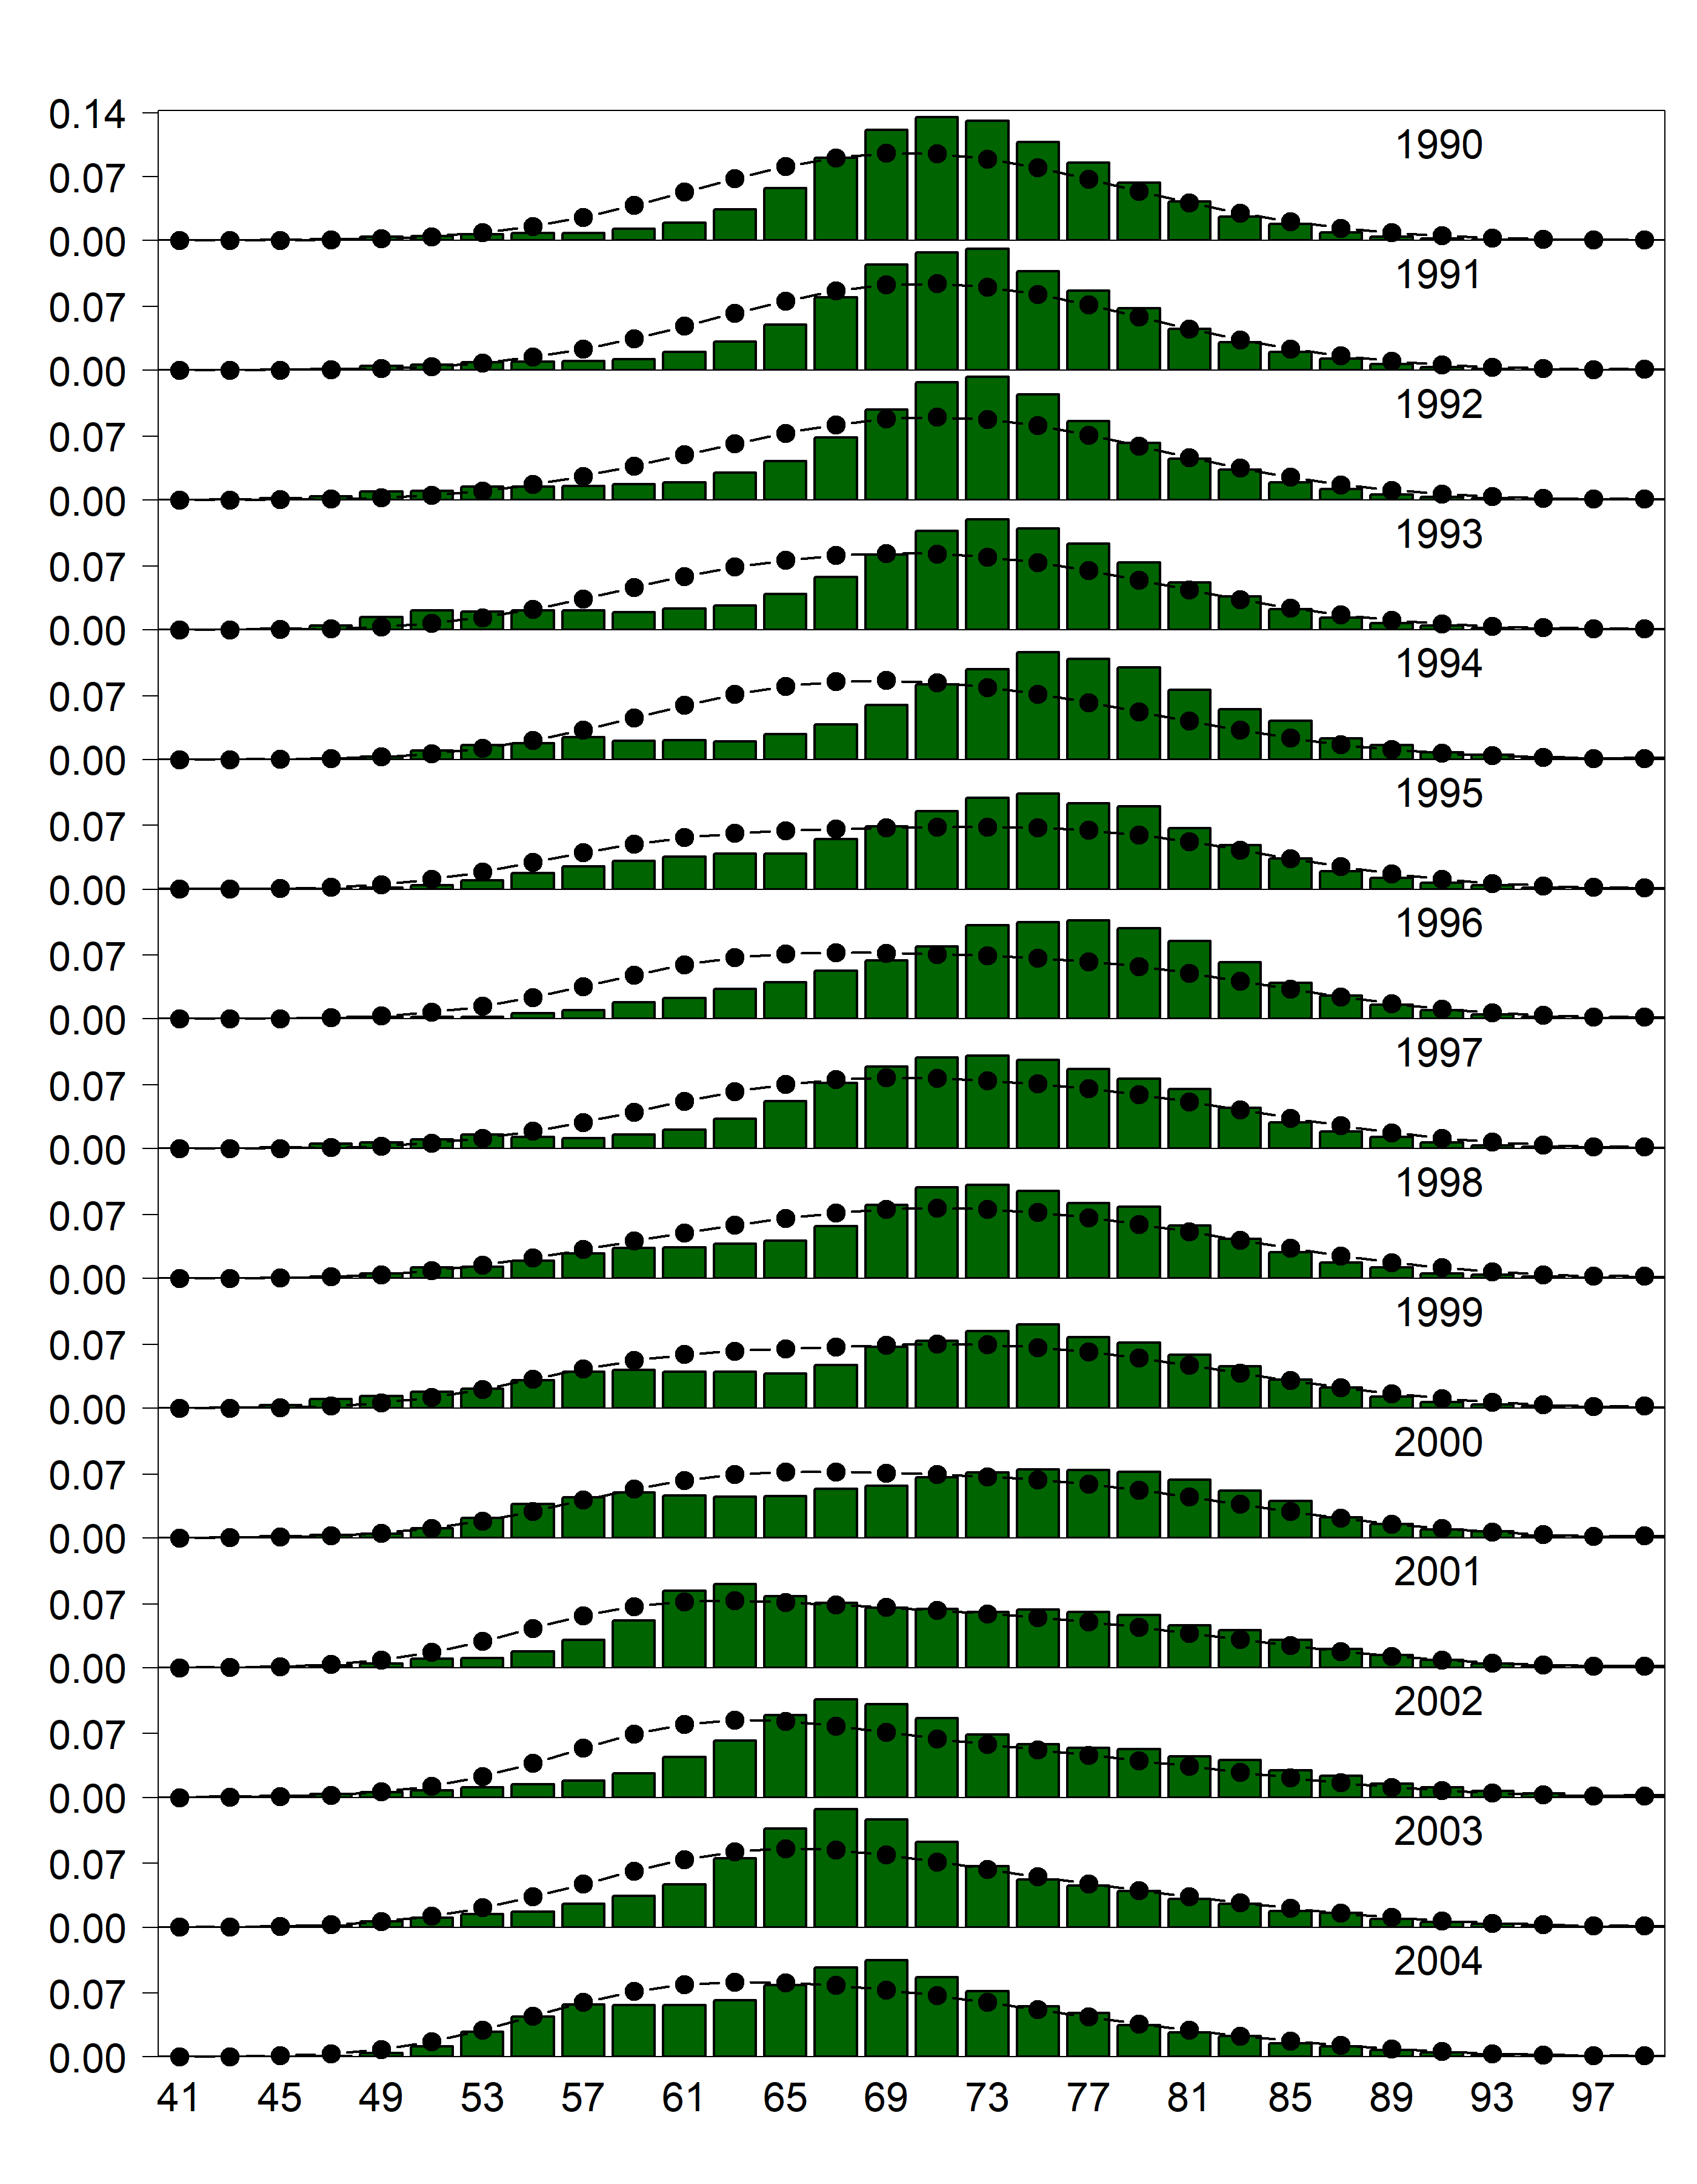

Figure 3.20. Domestic longline survey length (cm) compositions for females. Bars are observed frequencies and lines are predicted frequencies.

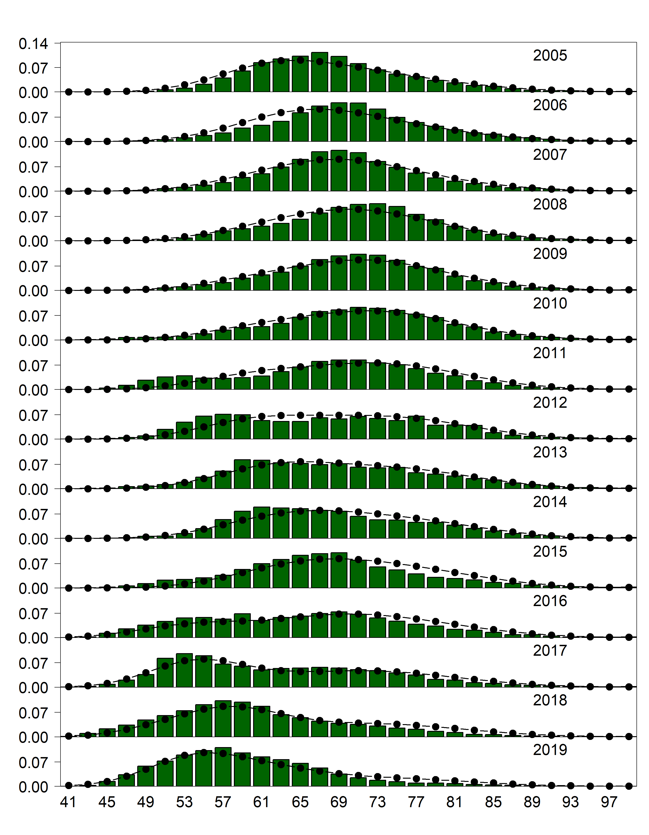

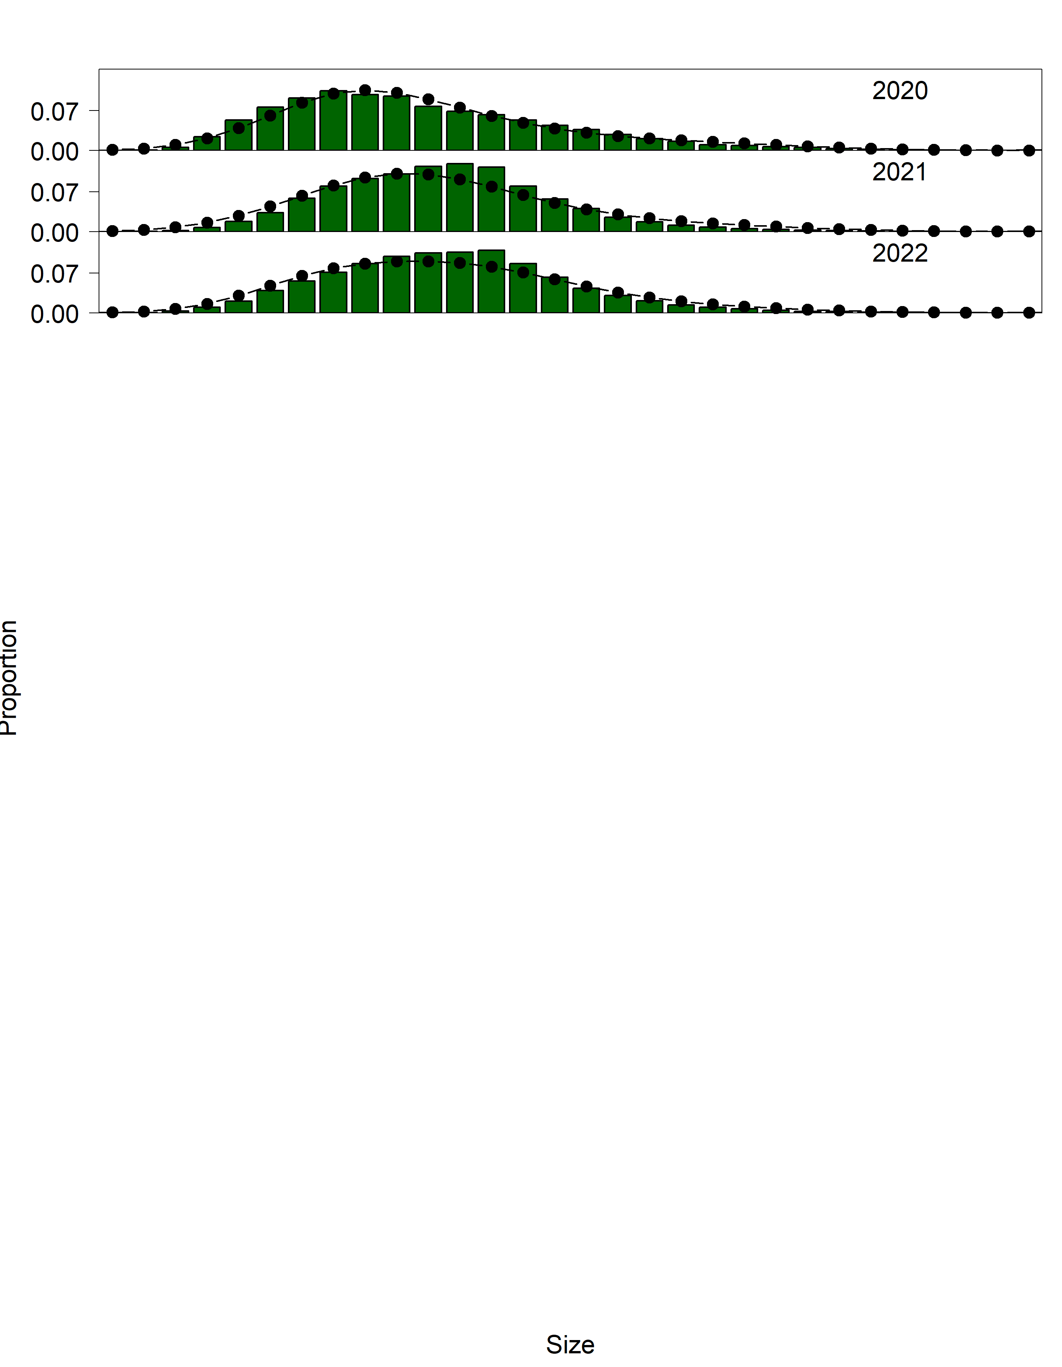

Figure 3.20 (cont.). Domestic longline survey length (cm) compositions for females. Bars are observed frequencies and lines are predicted frequencies.

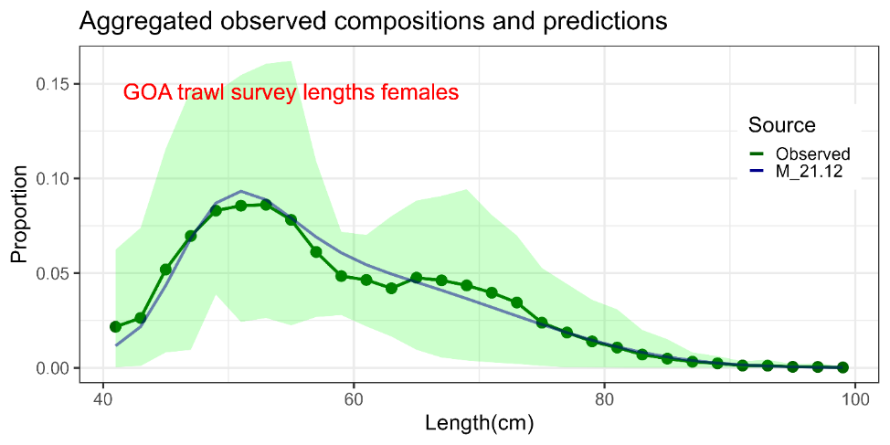

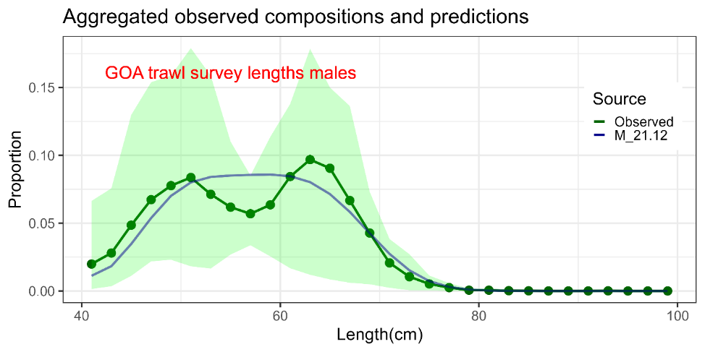

Figure 3.21. Mean observed (green line) Gulf of Alaska trawl survey length compositions aggregated across years along with the average fit of the model (blue line). The green bands are the 90% empirical confidence intervals. Fit to female length compositions are provided in the top panel and fit to male length compositions are provided in the bottom panel.

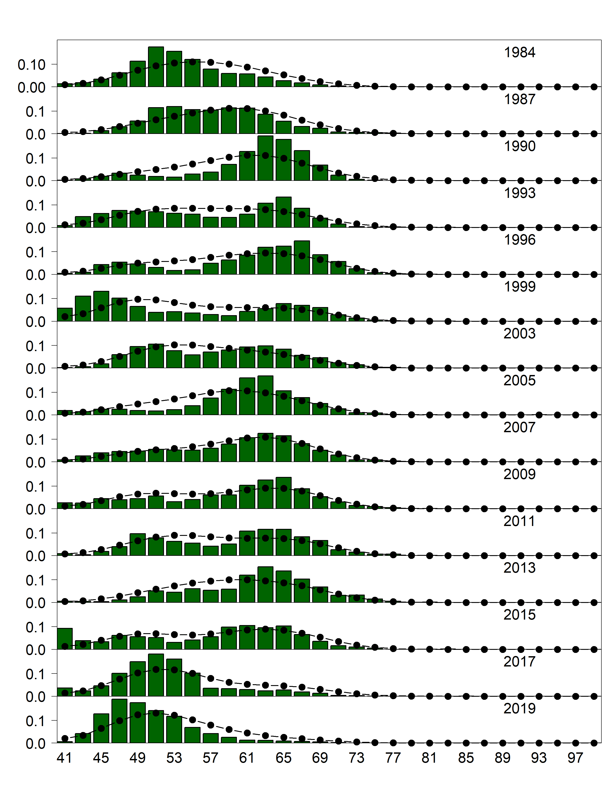

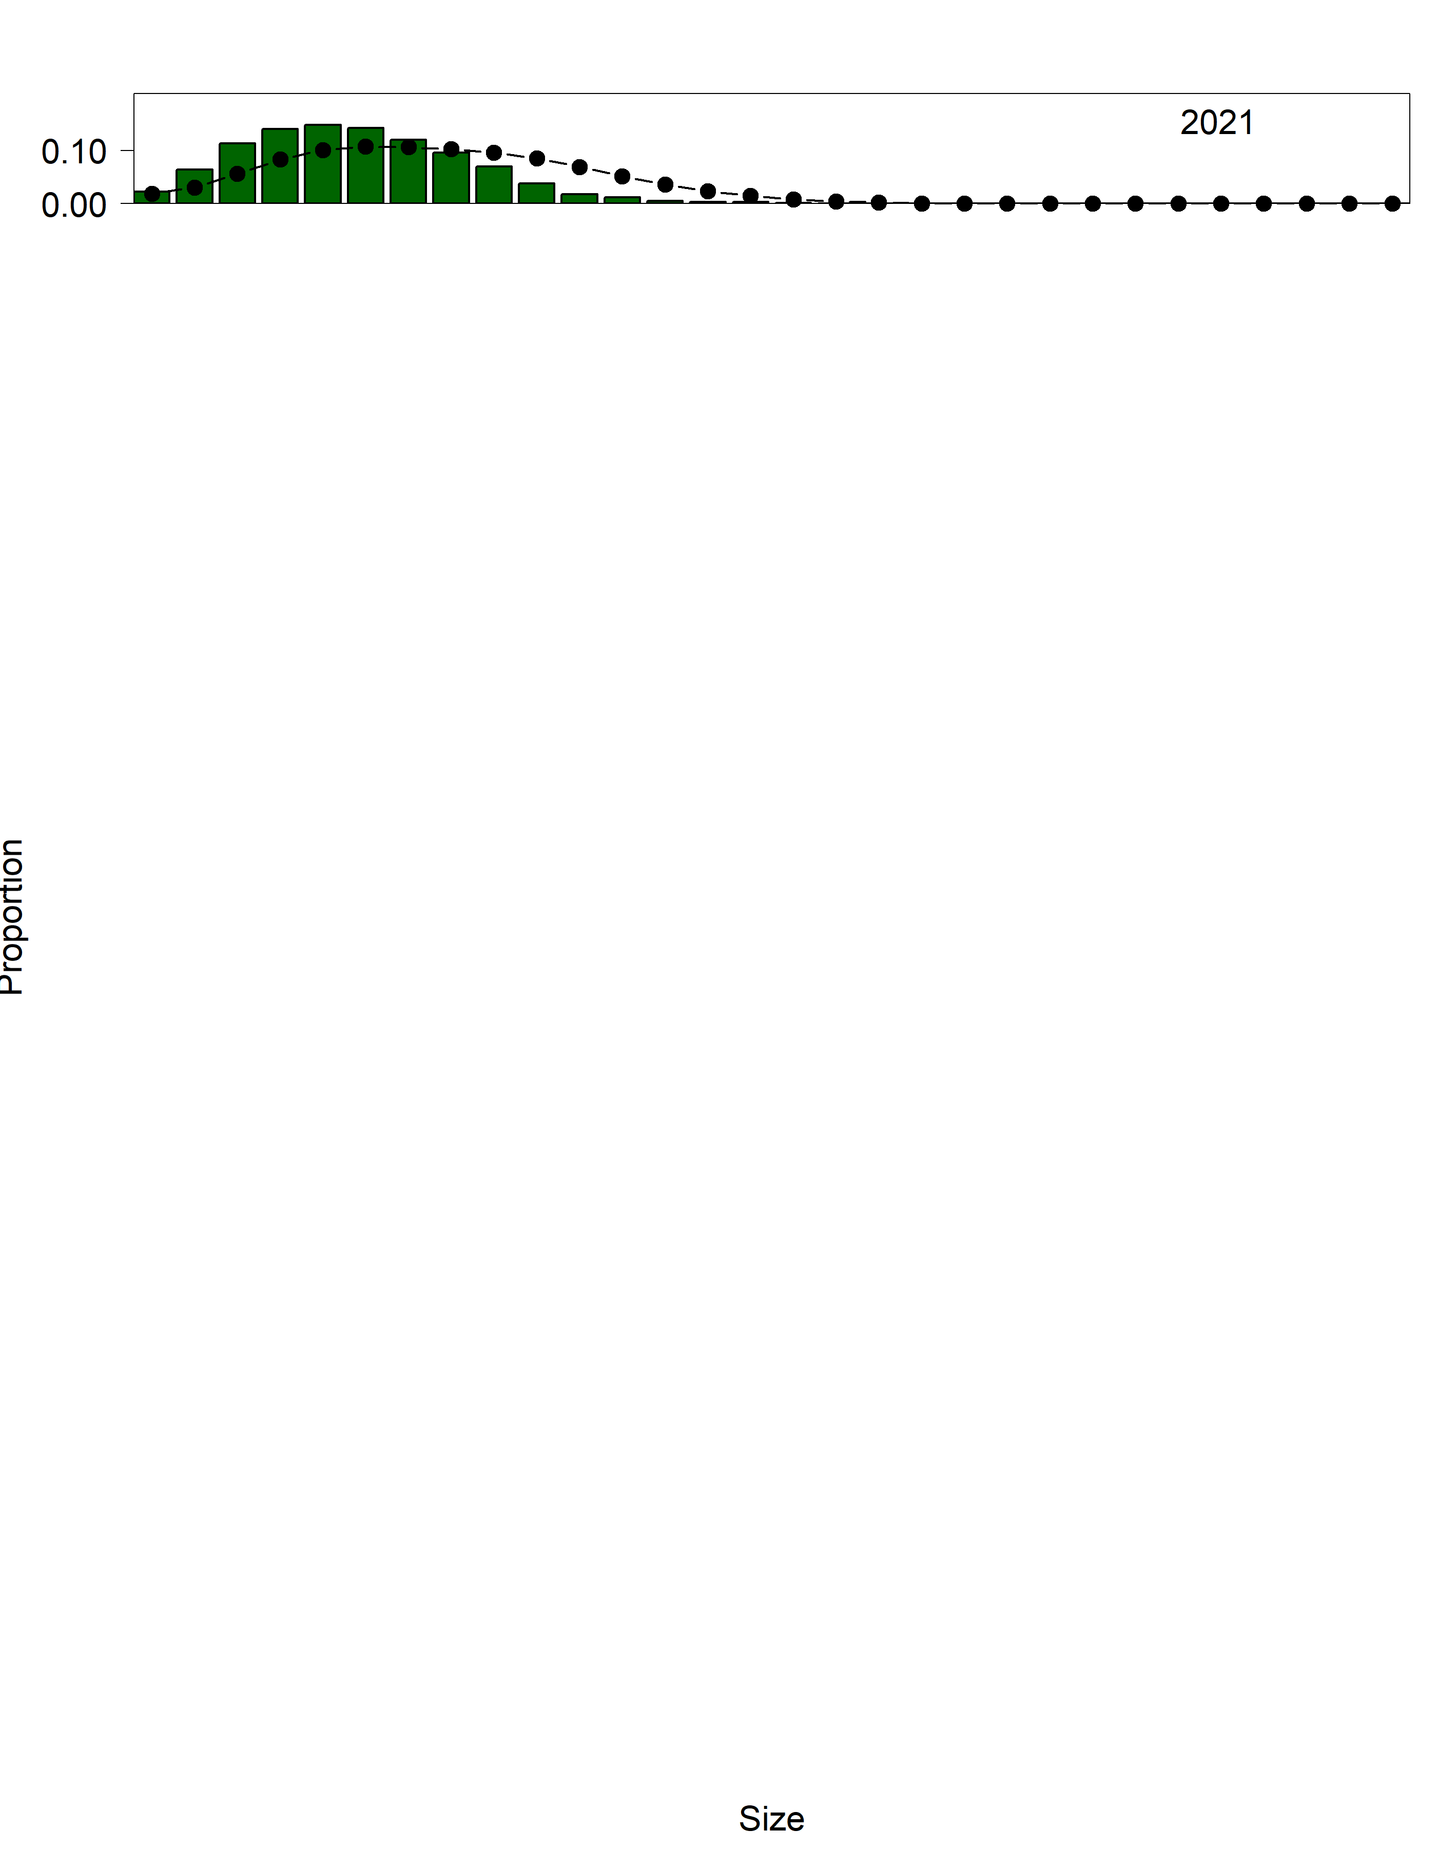

Figure 3.22. Gulf of Alaska bottom trawl survey length (cm) compositions for male sablefish at depths < 500 m. Bars are observed frequencies and lines are predicted frequencies.

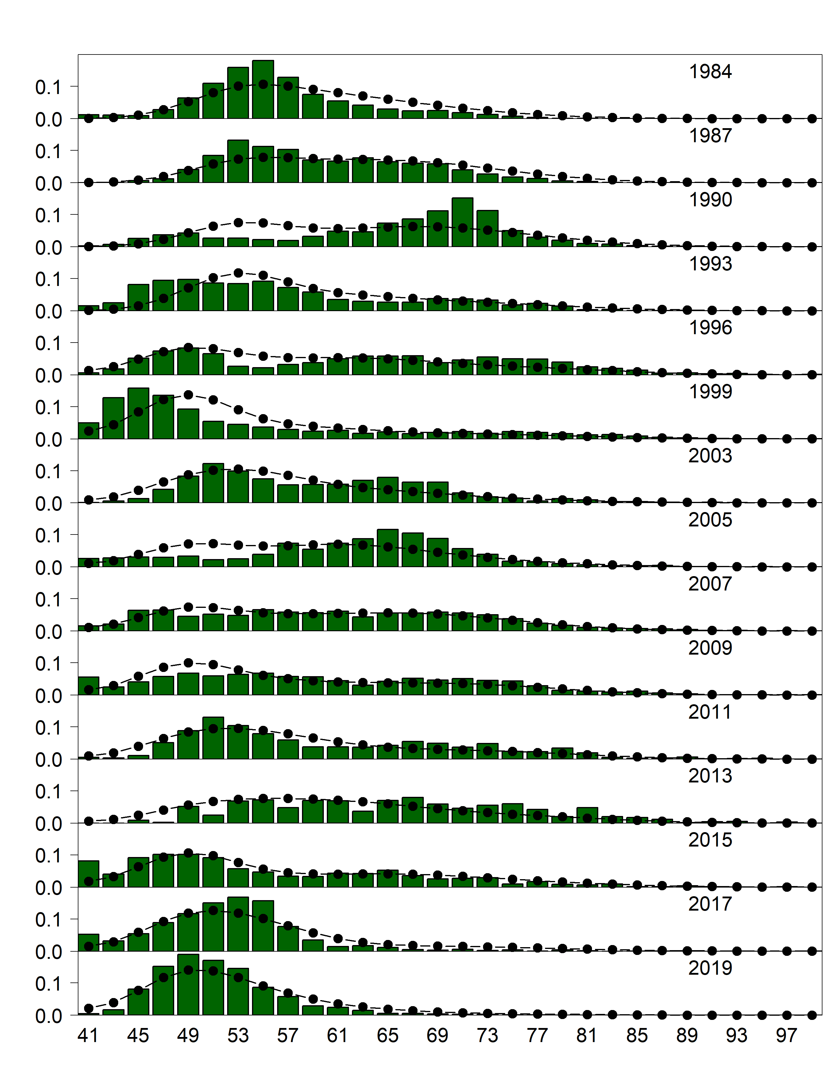

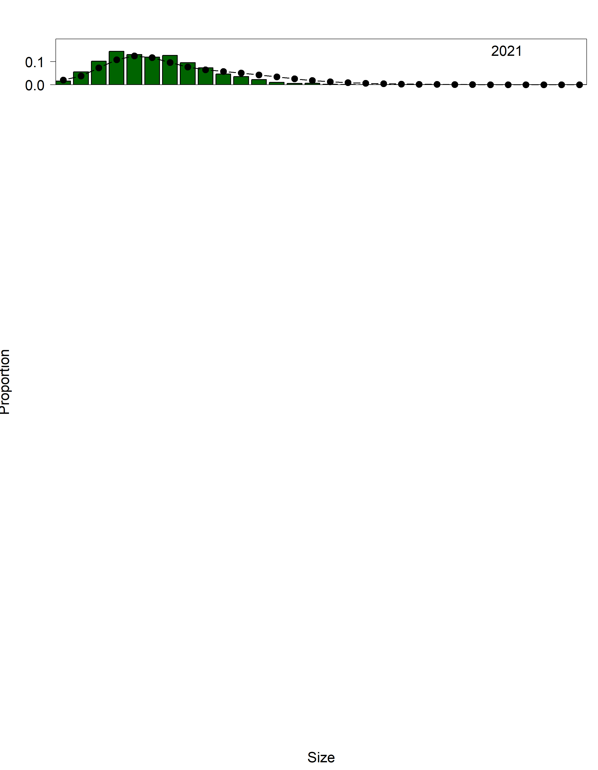

Figure 3.23. Gulf of Alaska bottom trawl survey length (cm) compositions for female sablefish at depths < 500 m. Bars are observed frequencies and lines are predicted frequencies.

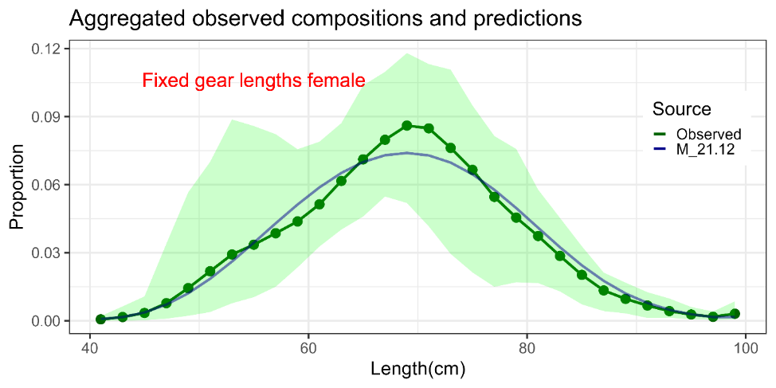

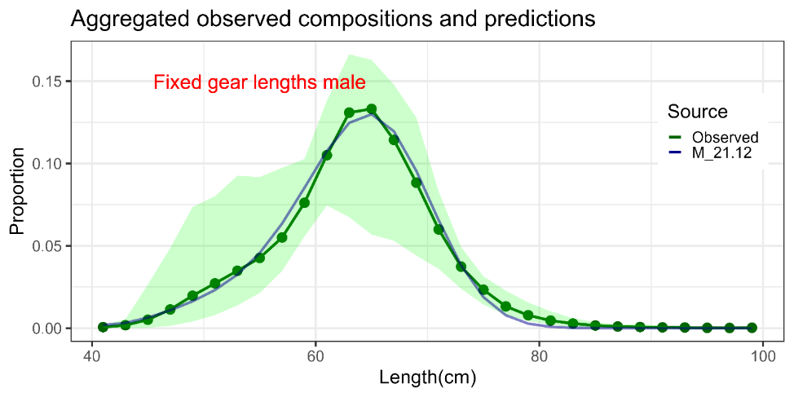

Figure 3.24. Mean observed (green line) domestic fixed gear fishery length compositions aggregated across years along with the average fit of the model (blue line). The green bands are the 90% empirical confidence intervals. Fit to female length compositions are provided in the top panel and fit to male length compositions are provided in the bottom panel.

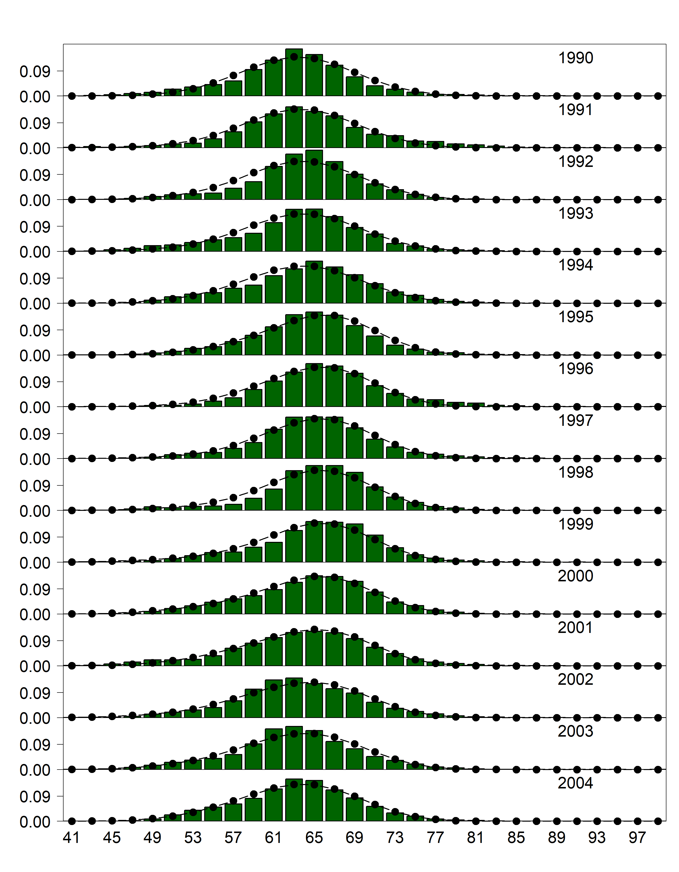

Figure 3.25. Domestic fixed gear fishery length (cm) compositions for males. Bars are observed frequencies and lines are predicted frequencies.

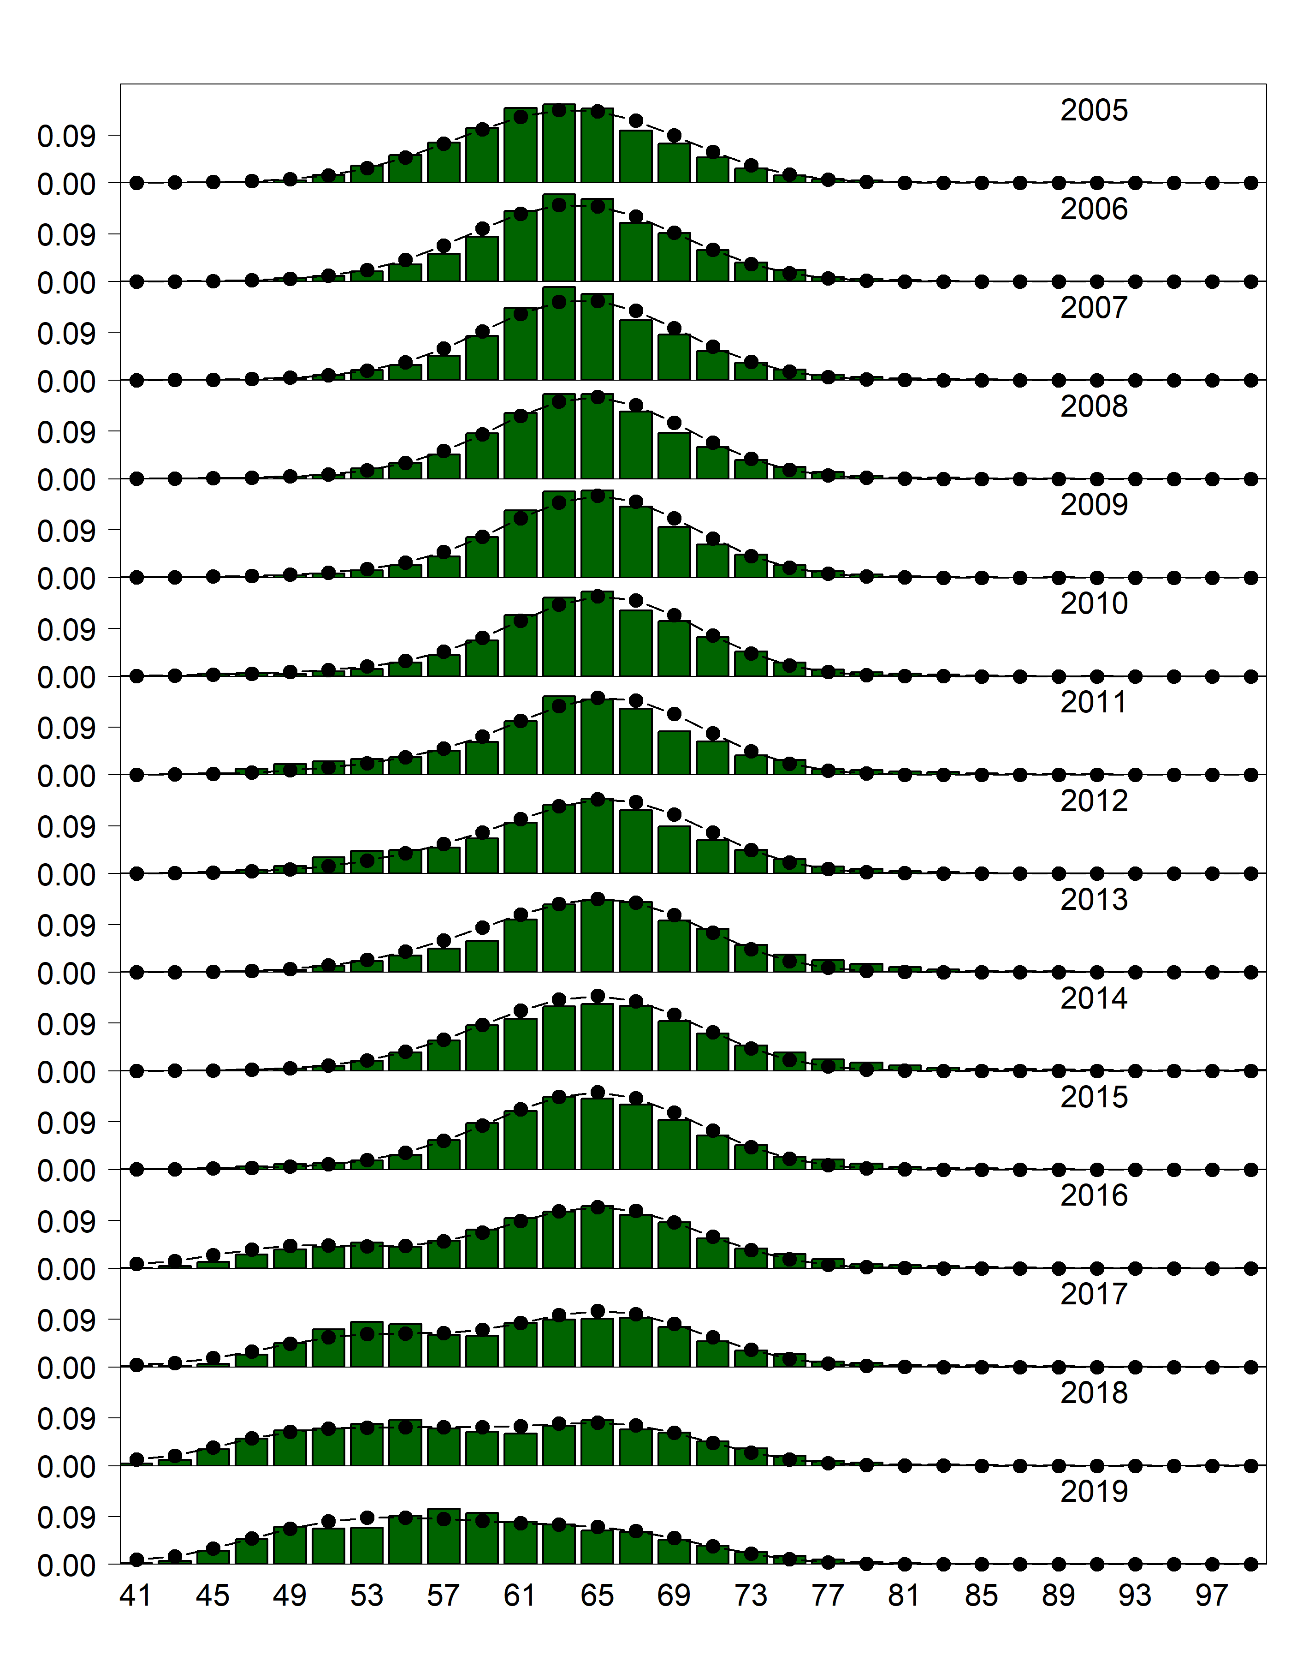

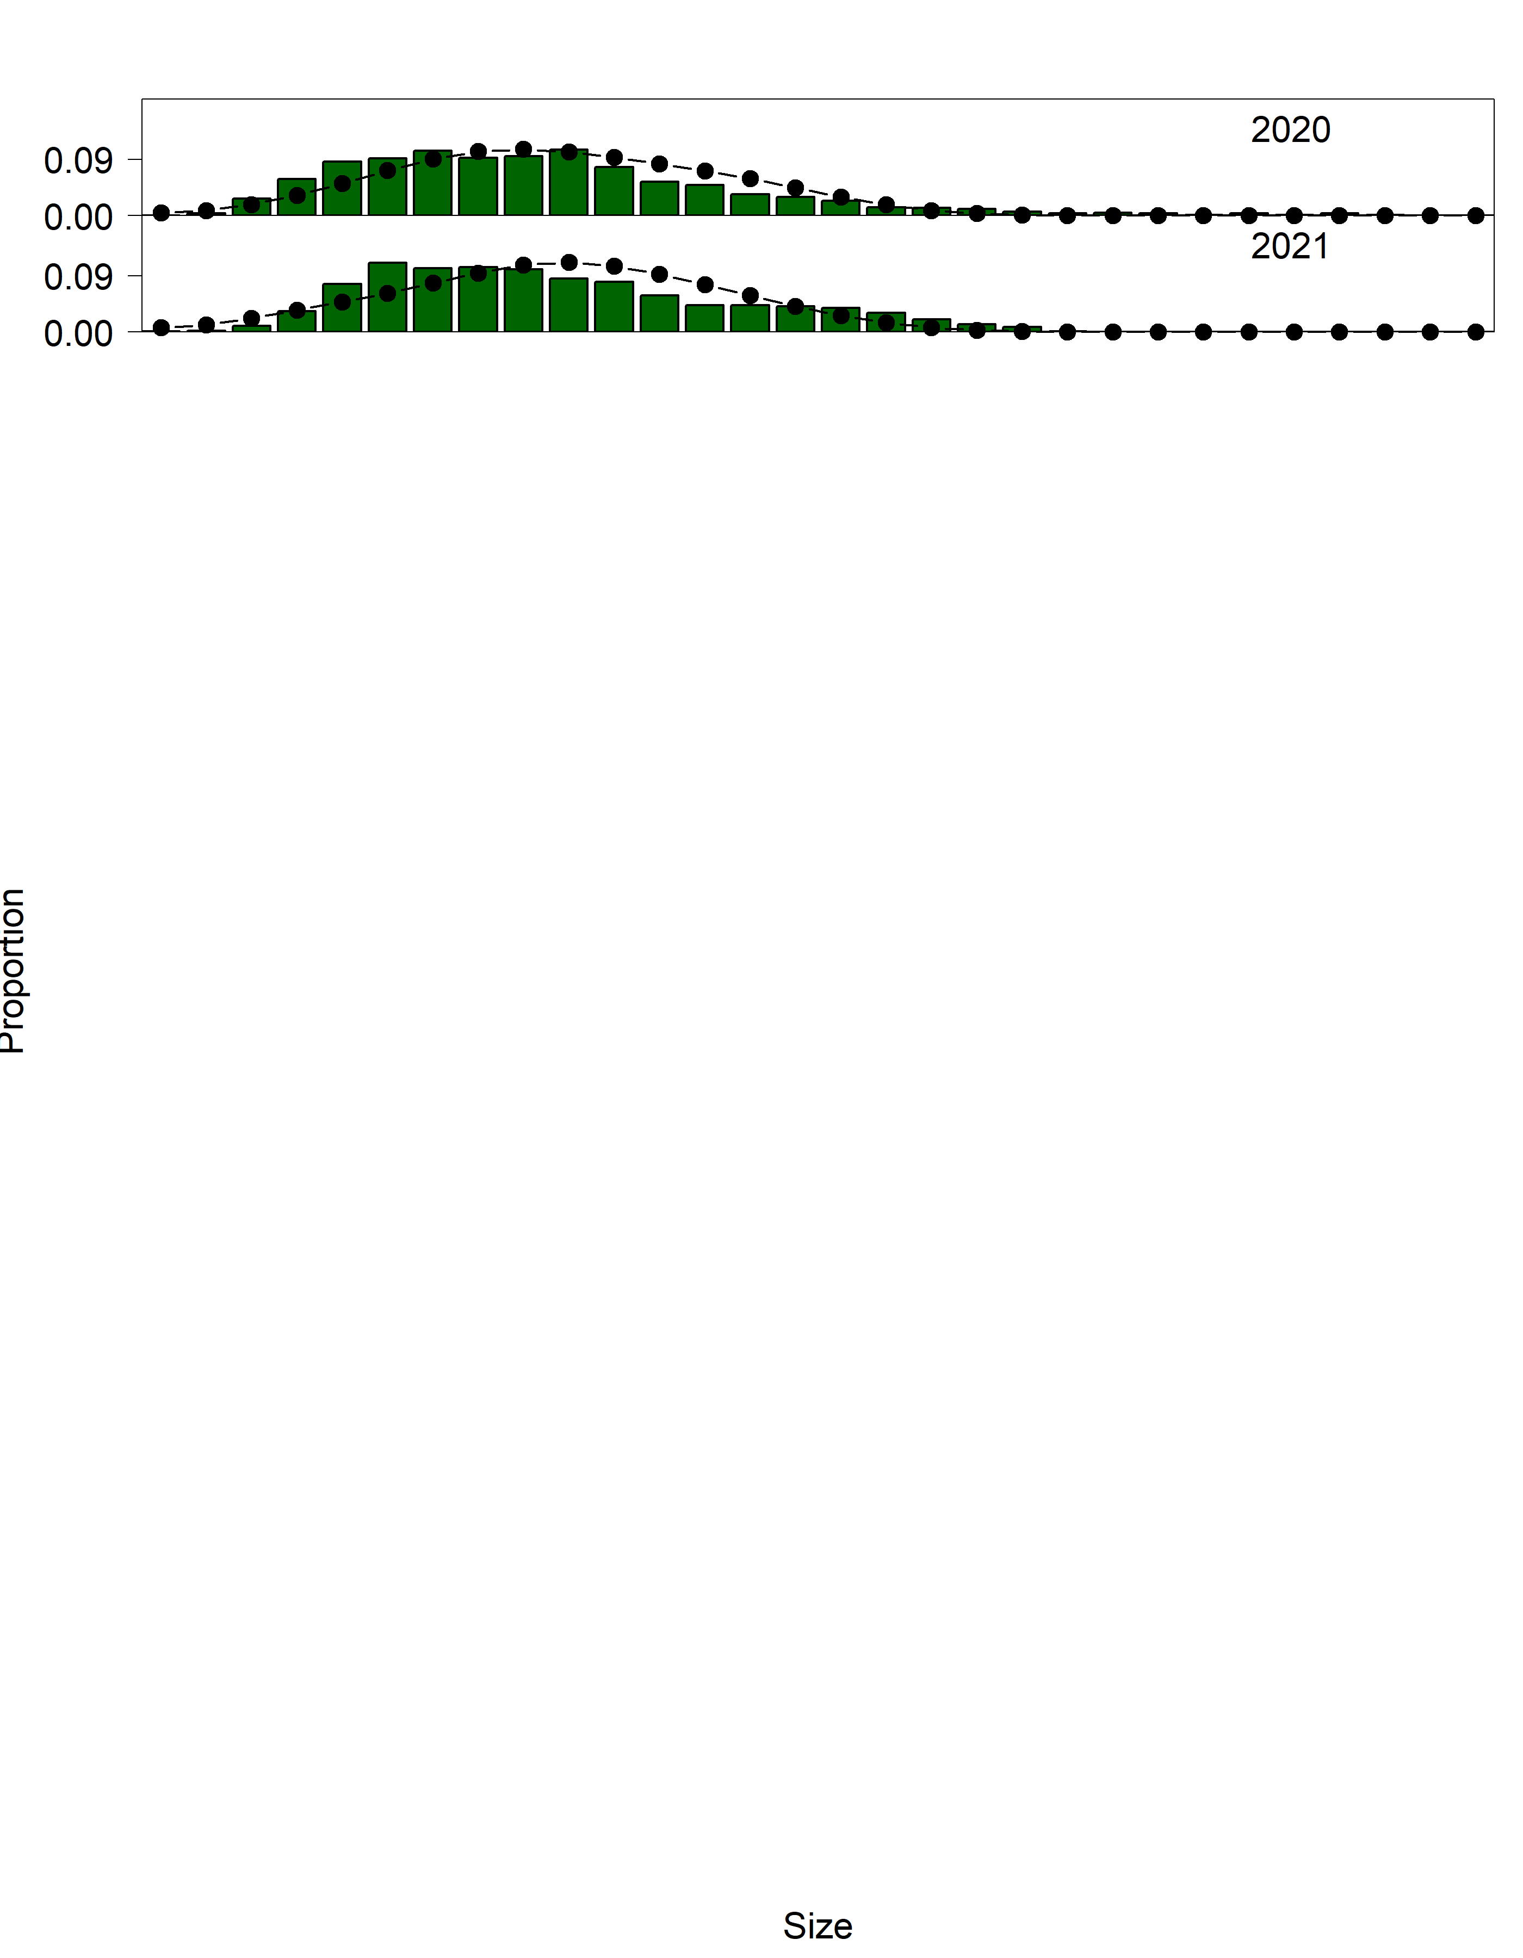

Figure 3.25 (Cont.). Domestic fixed gear fishery length (cm) compositions for males. Bars are observed frequencies and lines are predicted frequencies.

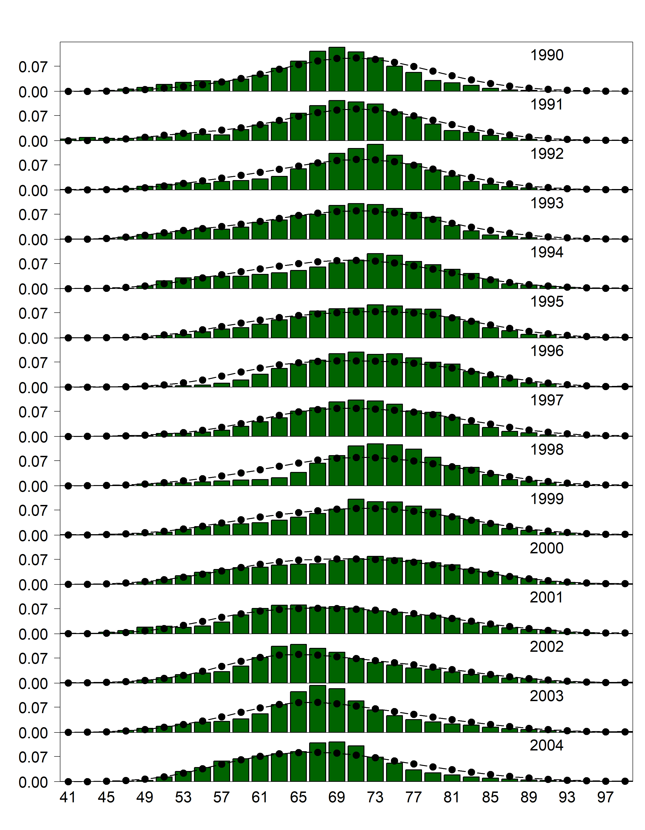

Figure 3.26. Domestic fixed gear fishery length (cm) compositions for females. Bars are observed frequencies and lines are predicted frequencies.

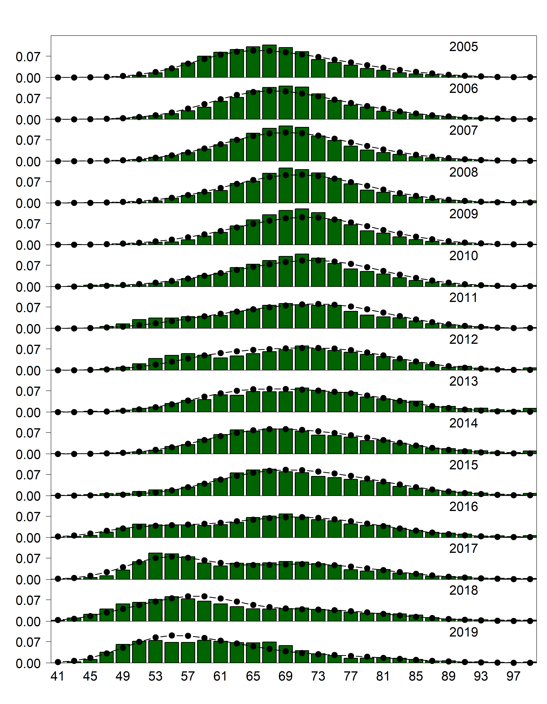

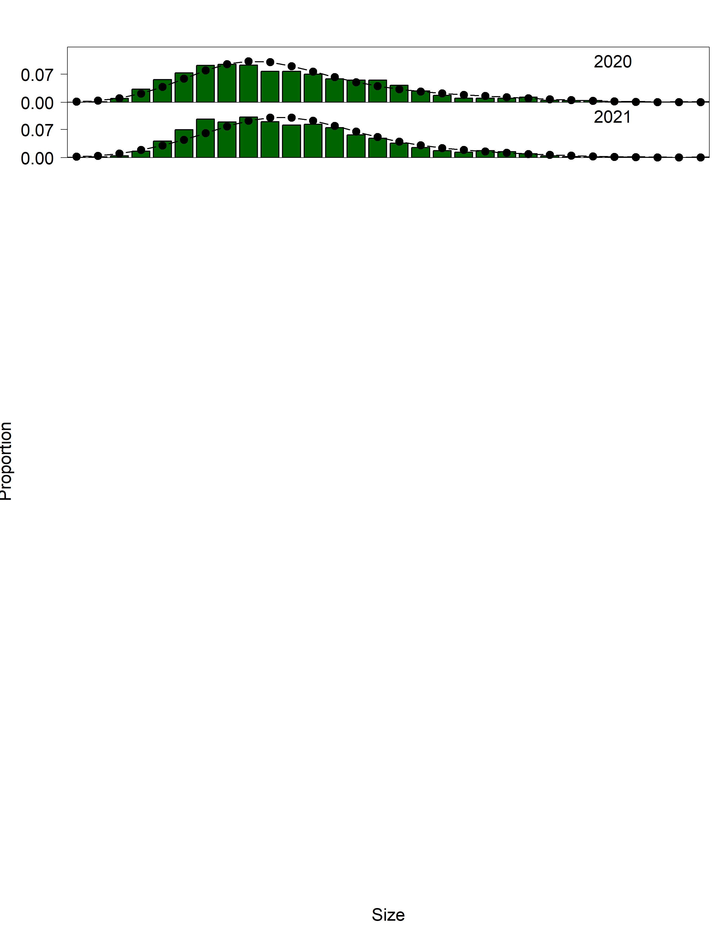

Figure 3.26 (cont.). Domestic fixed gear fishery length (cm) compositions for females. Bars are observed frequencies and lines are predicted frequencies.

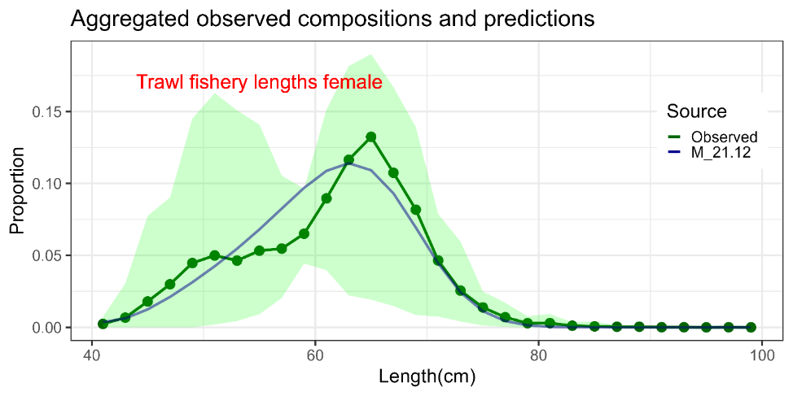

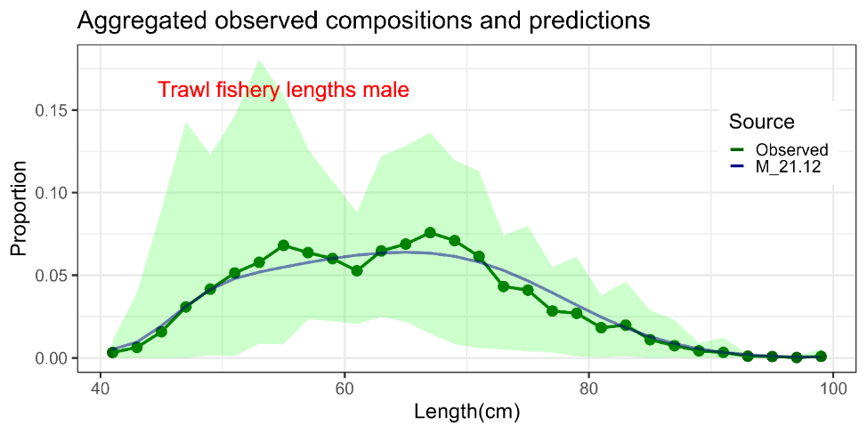

Figure 3.27. Mean observed (green line) domestic trawl fishery length compositions aggregated across years along with the average fit of model (blue line). The green bands are the 90% empirical confidence intervals. Fit to female length compositions are provided in the top panel and fit to male length compositions are provided in the bottom panel.

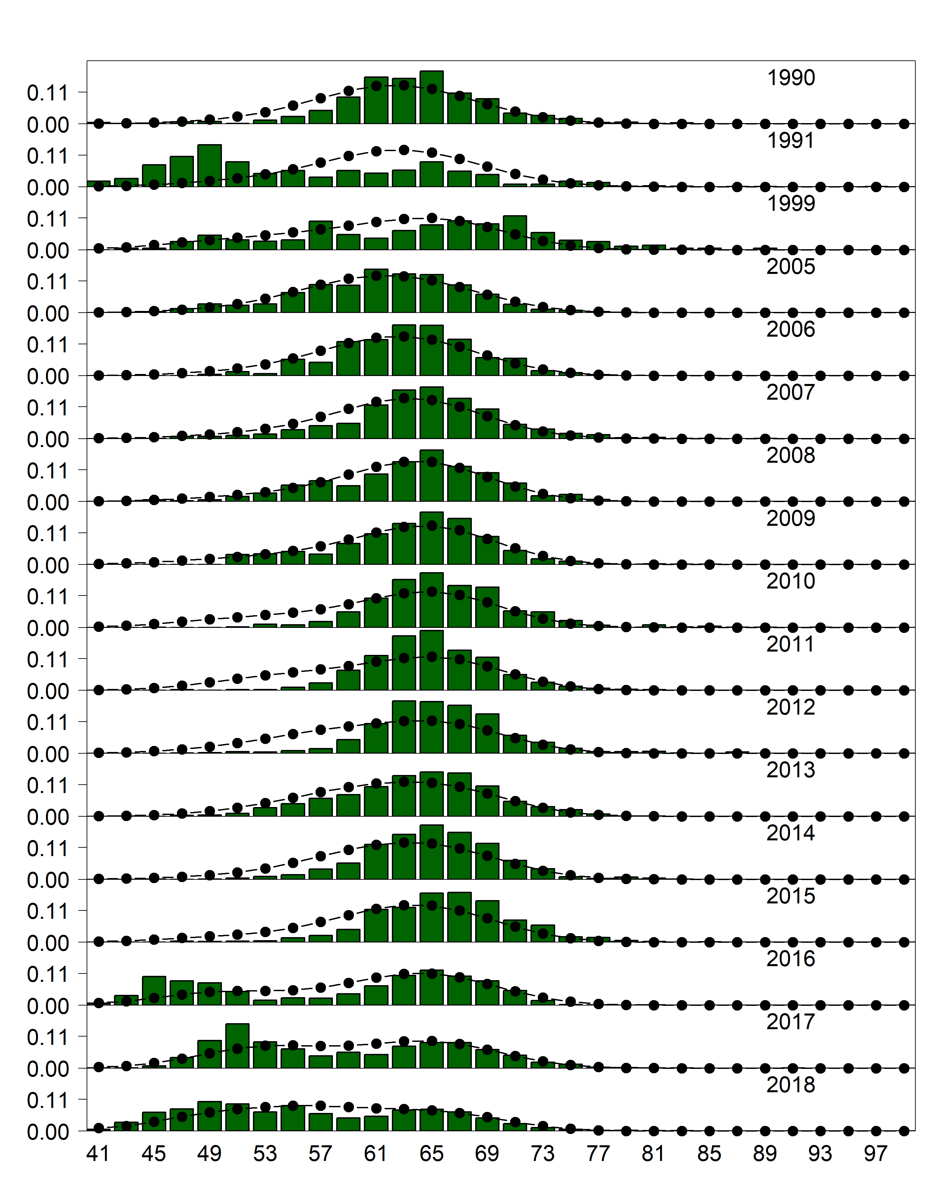

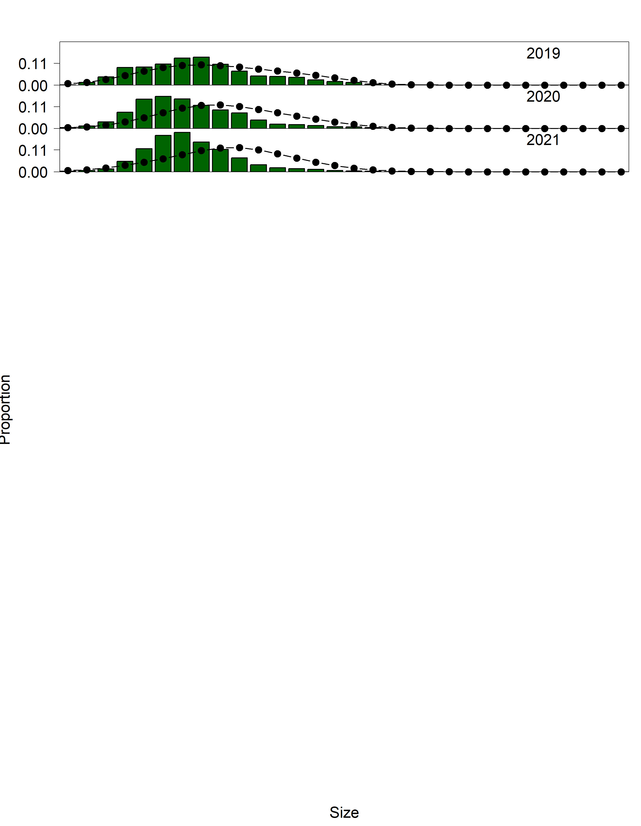

Figure 3.28. Domestic trawl gear fishery length (cm) compositions for males. Bars are observed frequencies and lines are predicted frequencies.

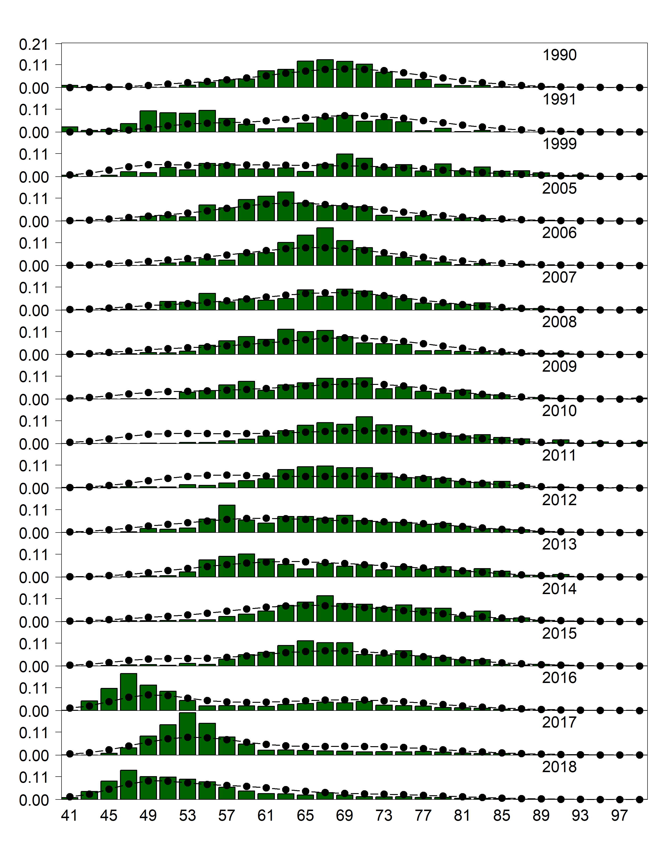

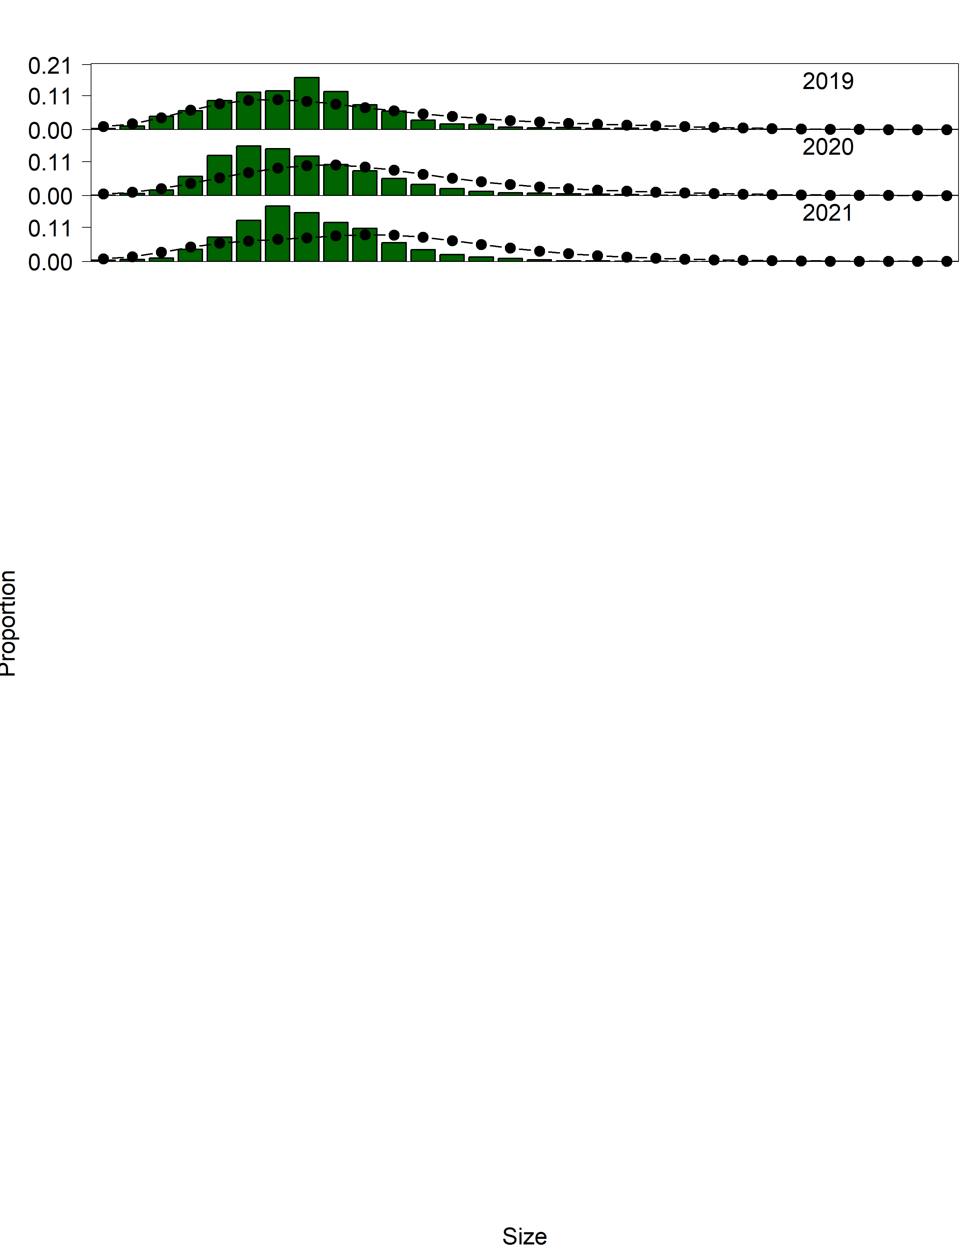

Figure 3.29. Domestic trawl gear fishery length (cm) compositions for females. Bars are observed frequencies and lines are predicted frequencies.

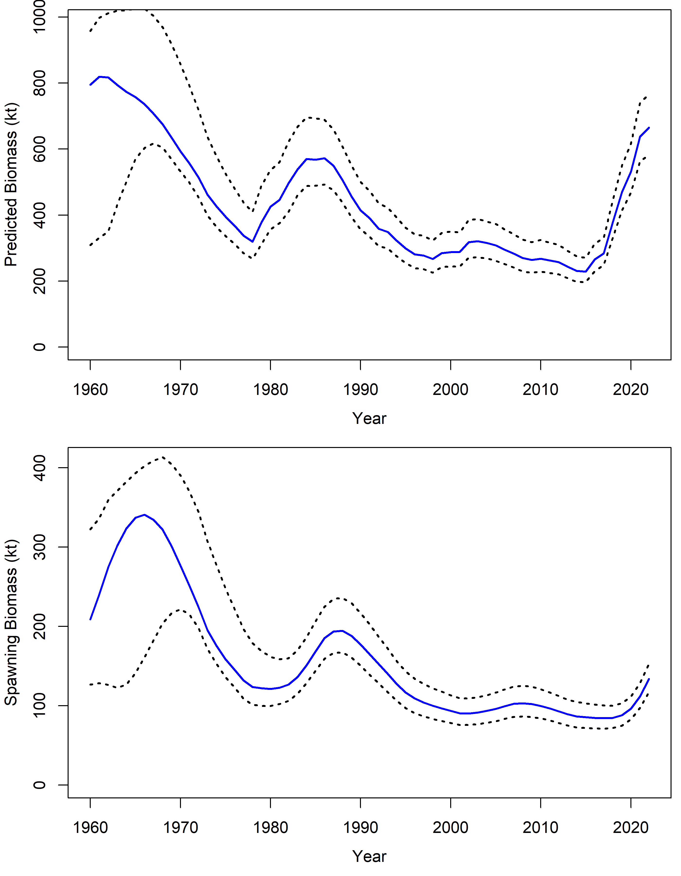

Figure 3.30. Estimated sablefish total biomass (top panel) and spawning biomass (bottom panel) with 95% MCMC credible intervals. Values are in kilotons.

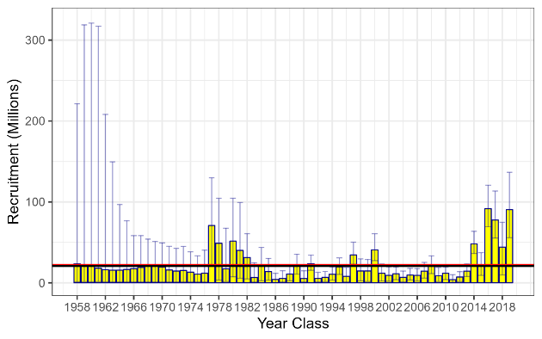

Figure 3.31. Estimated recruitment of age-2 sablefish (millions of fish) with 95% credible intervals from MCMC by year class (recruitment year minus two). Red line is overall mean, while black line is mean from recruitments from year classes between 1977 and 2019. Credible intervals are based on MCMC posteriors. The estimate for the 2020 year class (terminal year 2022 recruitment event) is omitted, because it is fixed to the estimated mean recruitment value (*μr*) with no deviation parameter estimated.

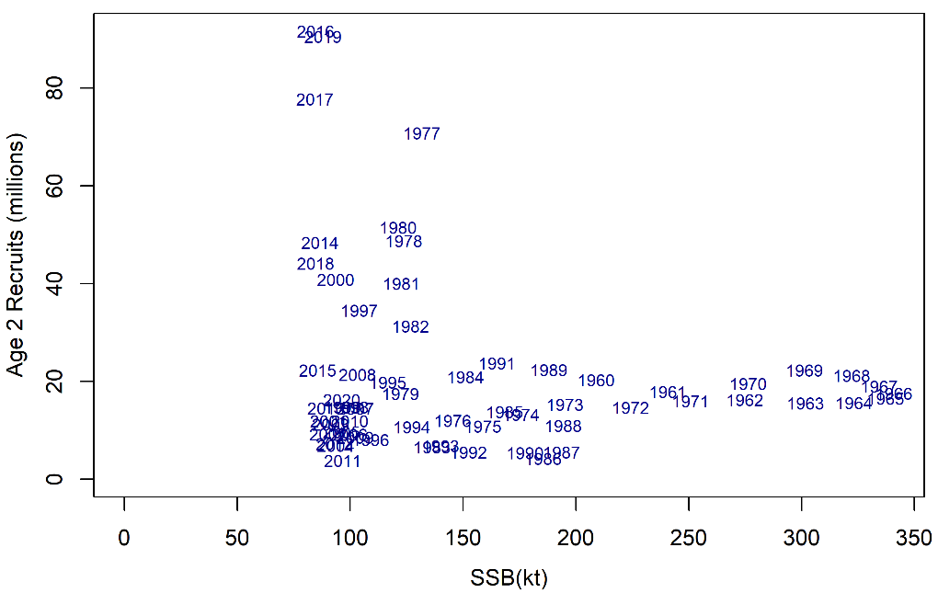

Figure 3.32. Age-2 recruits (millions of fish) and corresponding spawning stock biomass (kilotons) for each year class (identified by plotted year text).

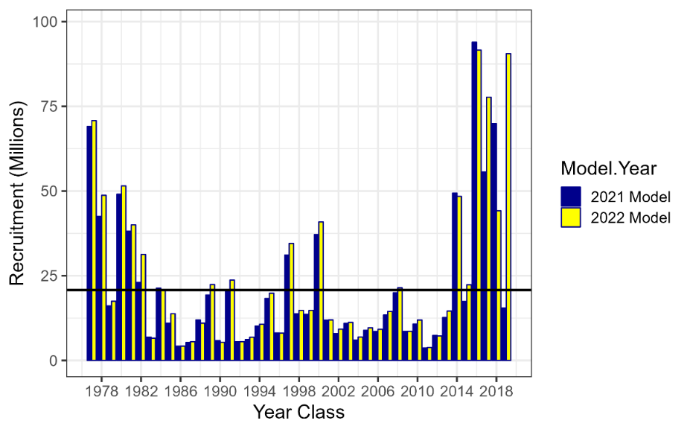

Figure 3.33. Estimated recruitment by year class (1977 – 2019) in number of age-2 fish (millions of fish) for the 2021 and 2022 models. Black line is mean recruitment from the 2022 model for 1977 to 2019 year classes. Note that the 2019 yearclass for the 2021 model is equivalent to the estimated mean recruitment value (*μr*) given that no recruit deviation is estimated in the terminal year.

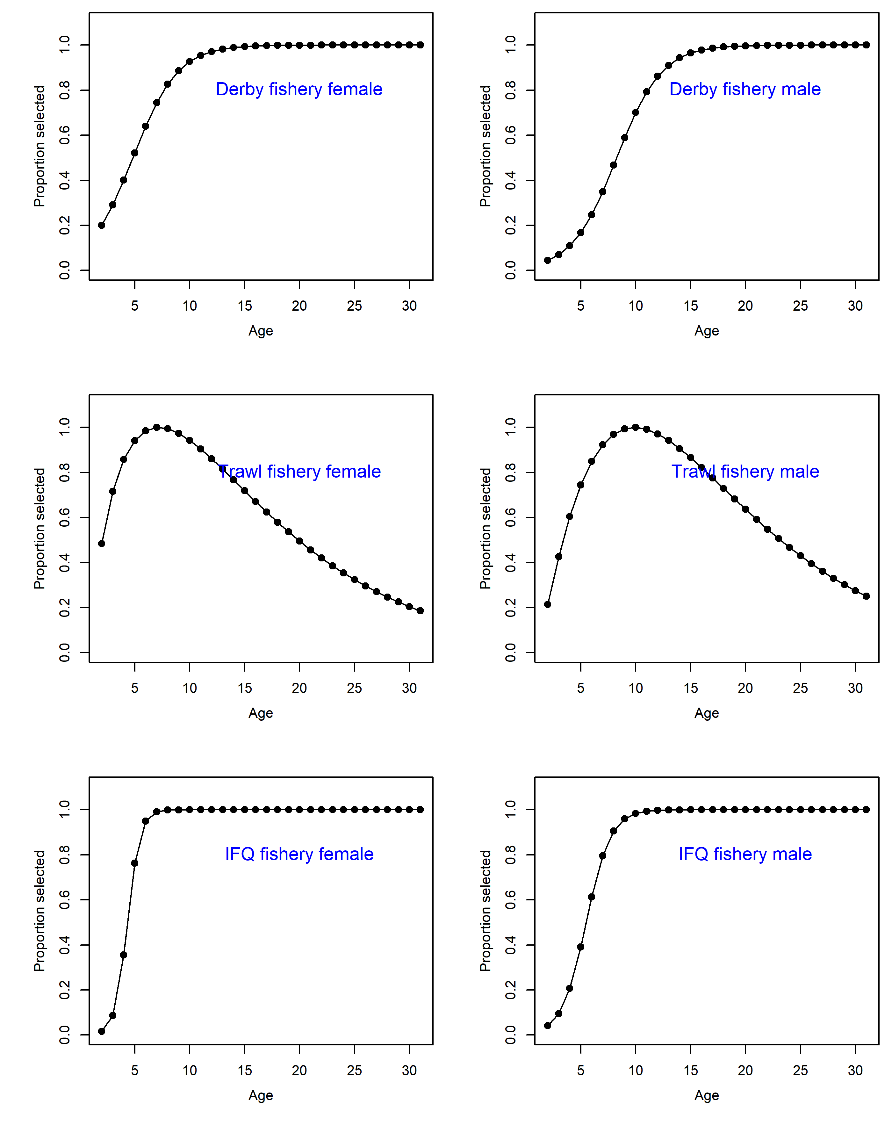

Figure 3.34. Estimated fishery and survey selectivity. The derby longline fishery occurred until 1994, then the fishery switched to an IFQ system in 1995. The recent time block for the IFQ fishery selectivity begins in 2016, as does the recent time block for the domestic longline survey.

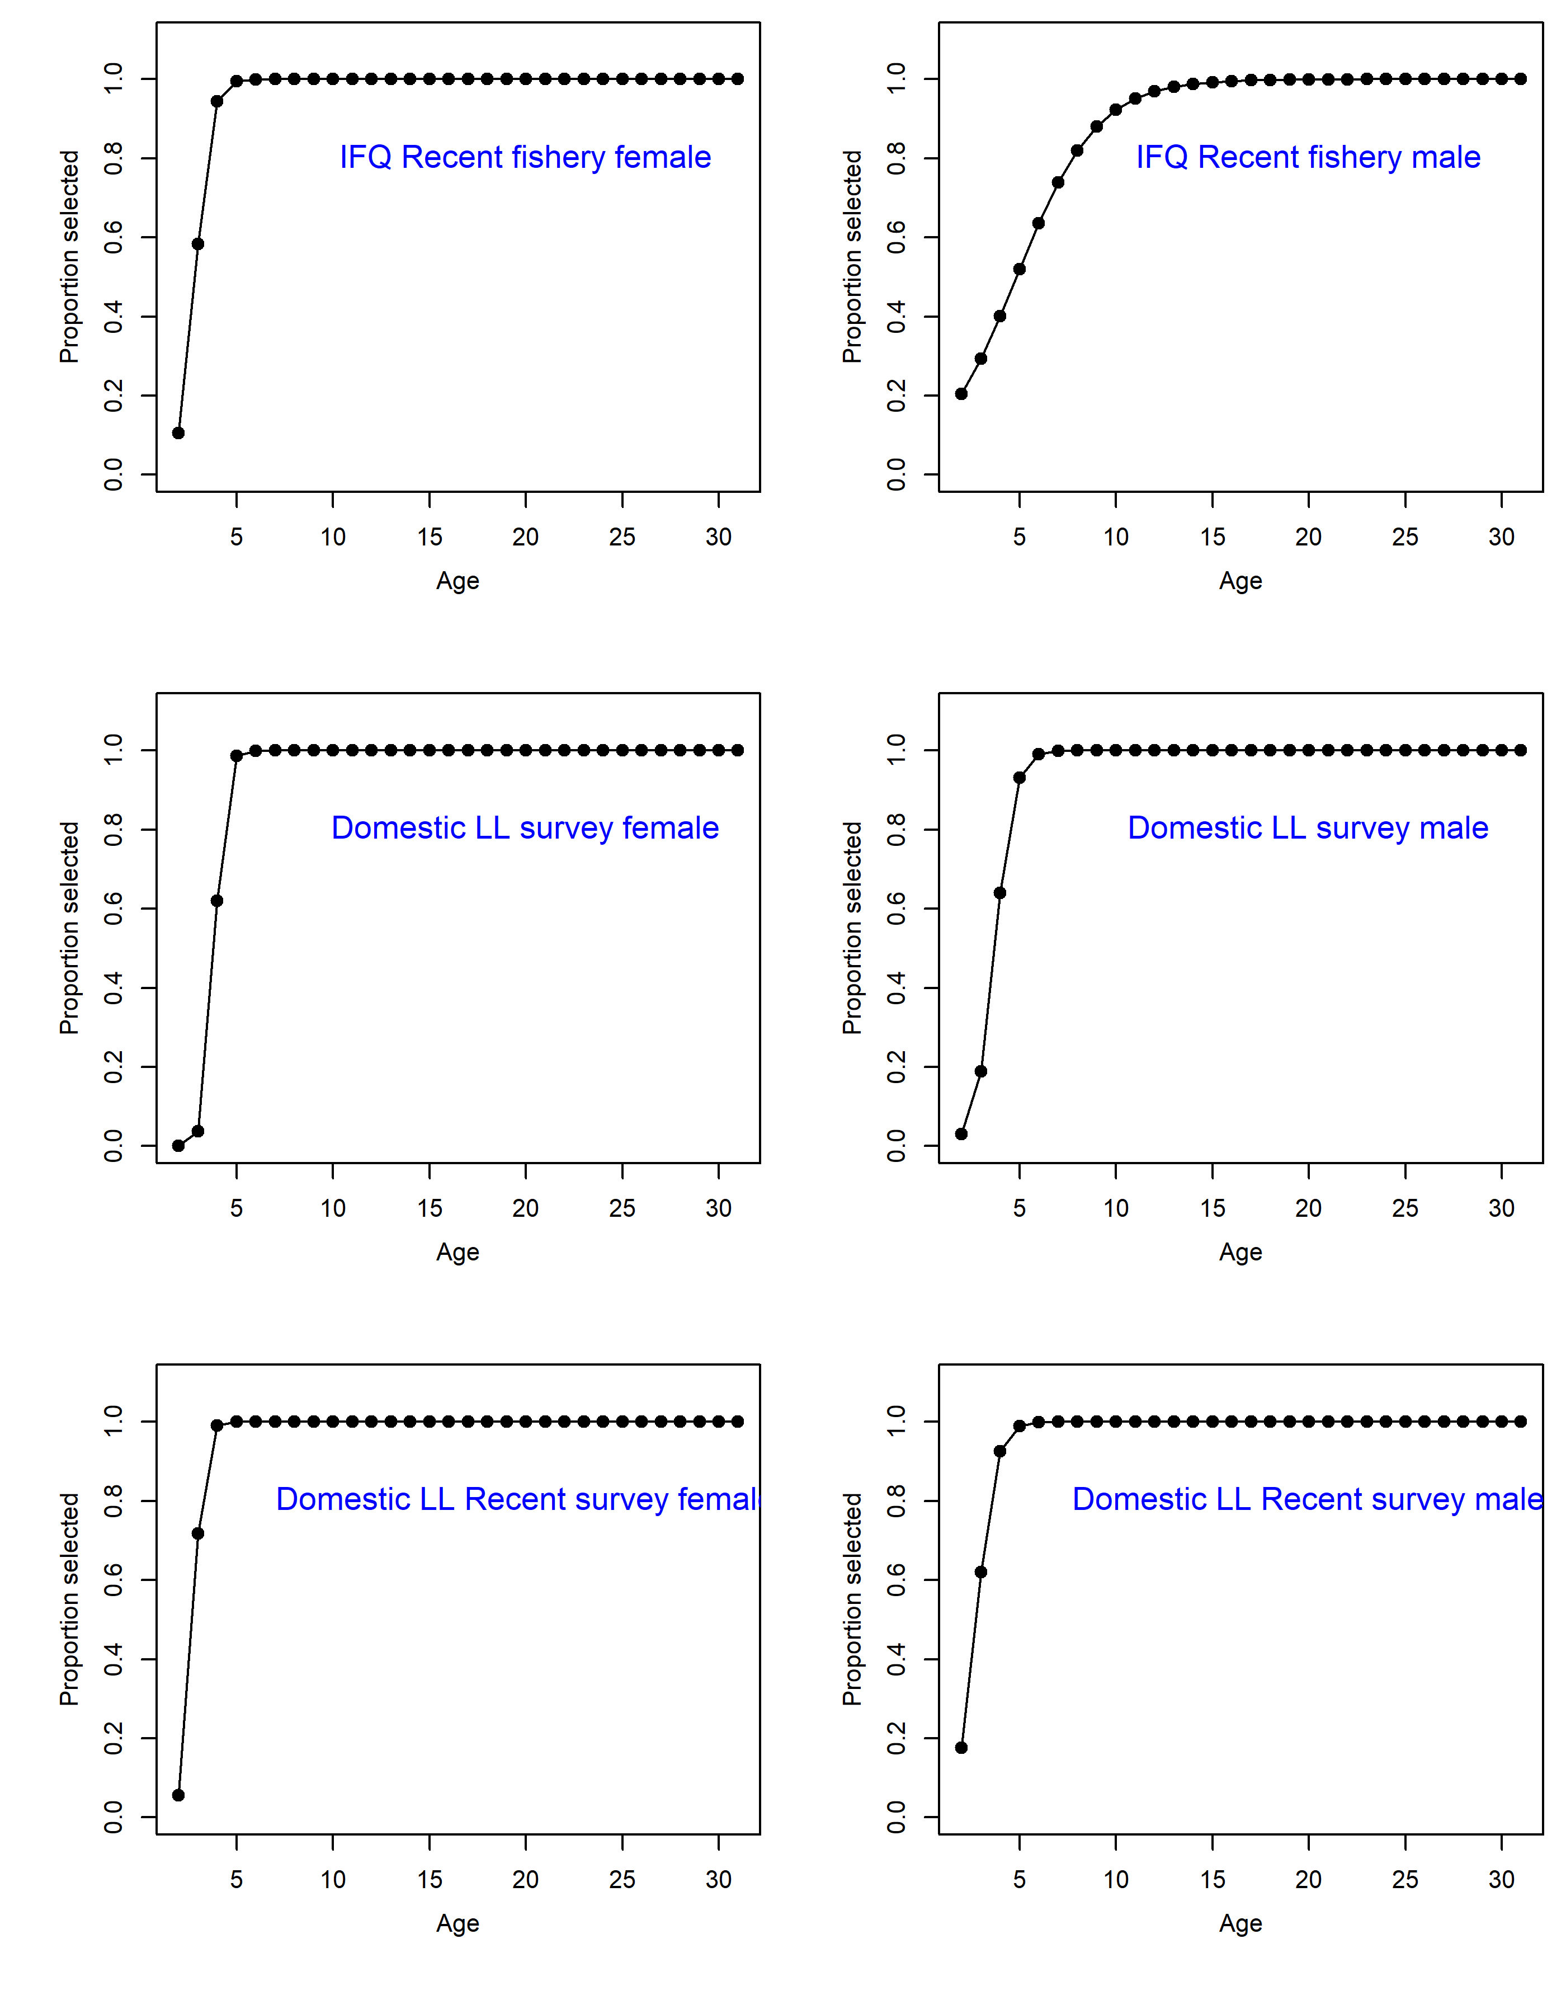

Figure 3.34 (Cont.). Estimated selectivity.

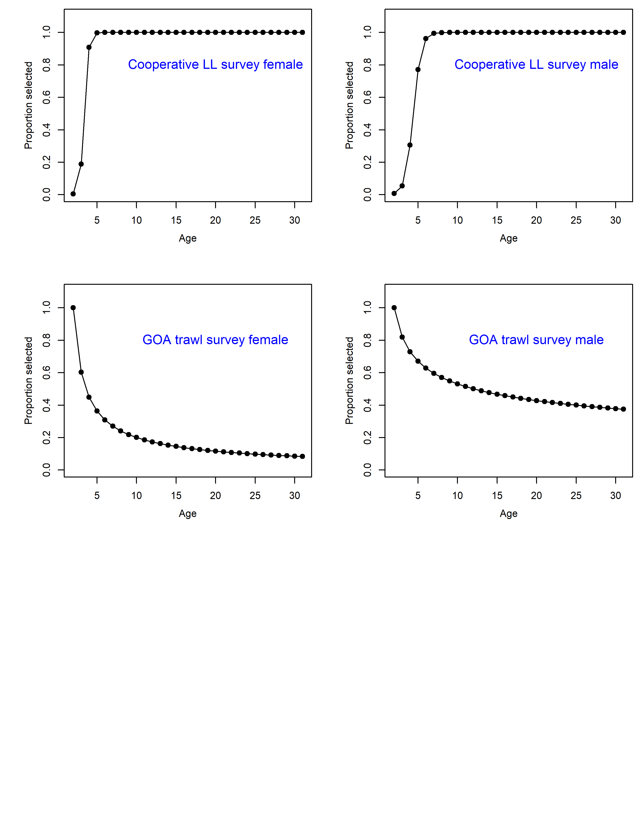

Figure 3.34 (Cont.). Estimated selectivity.

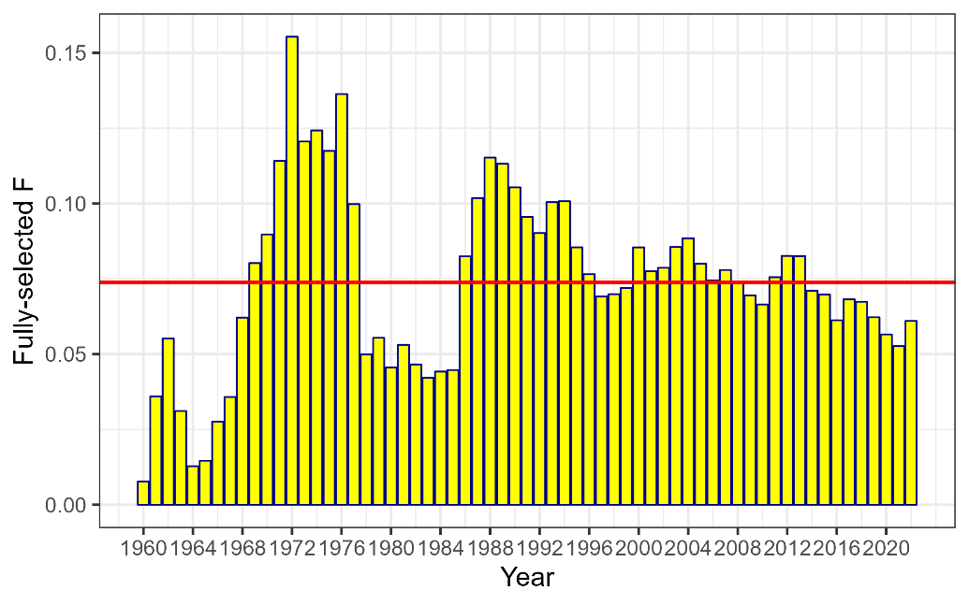

Figure 3.35. Time series of combined fully selected fishing mortality for fixed and trawl fisheries. Red line is the mean fishing mortality for the entire time series.

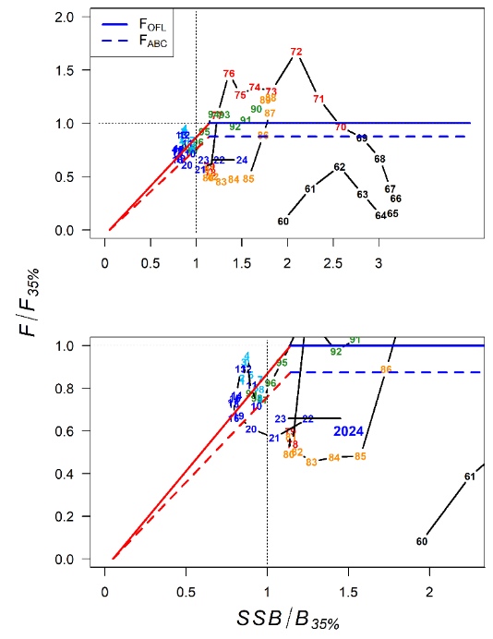

Figure 3.36. Phase-plane diagram illustrating the time series of sablefish estimated spawning biomass relative to the level at B35% and fishing mortality relative to F35% (equal to *FOFL*). *FABC* for the max ABC is equivalent to F40%, which is demonstrated by the dashed lines. The solid line represents fishing at *FOFL*, but with a target of B40%. The bottom panel is zoomed in to examine recent years.

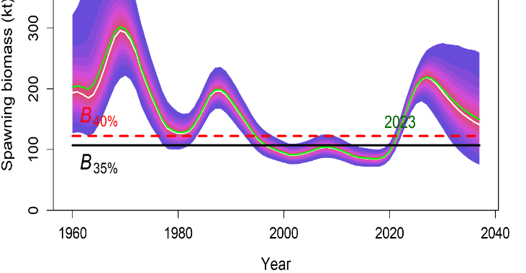

Figure 3.37. Estimates of female spawning biomass (kilotons) and their uncertainty from MCMC runs. The white line is the median and the green line is the mean, while shaded fills are 5% increments of the posterior probability distribution of spawning biomass based on MCMC simulations. Width of shaded area is the 95% credibility interval.

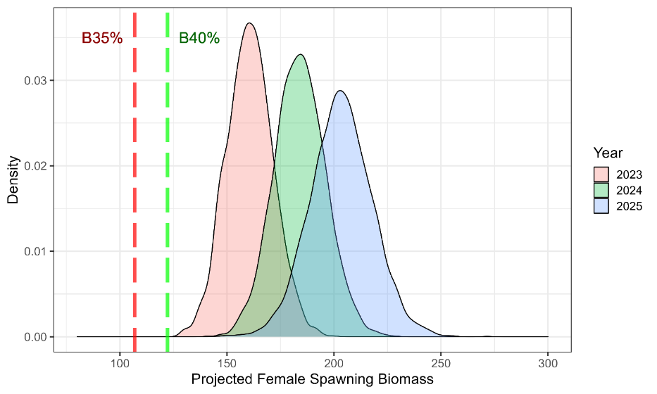

Figure 3.38. Posterior probability distribution for projected spawning biomass (kilotons) in years 2023 – 2025. The dashed lines are estimated B35% and B40%.

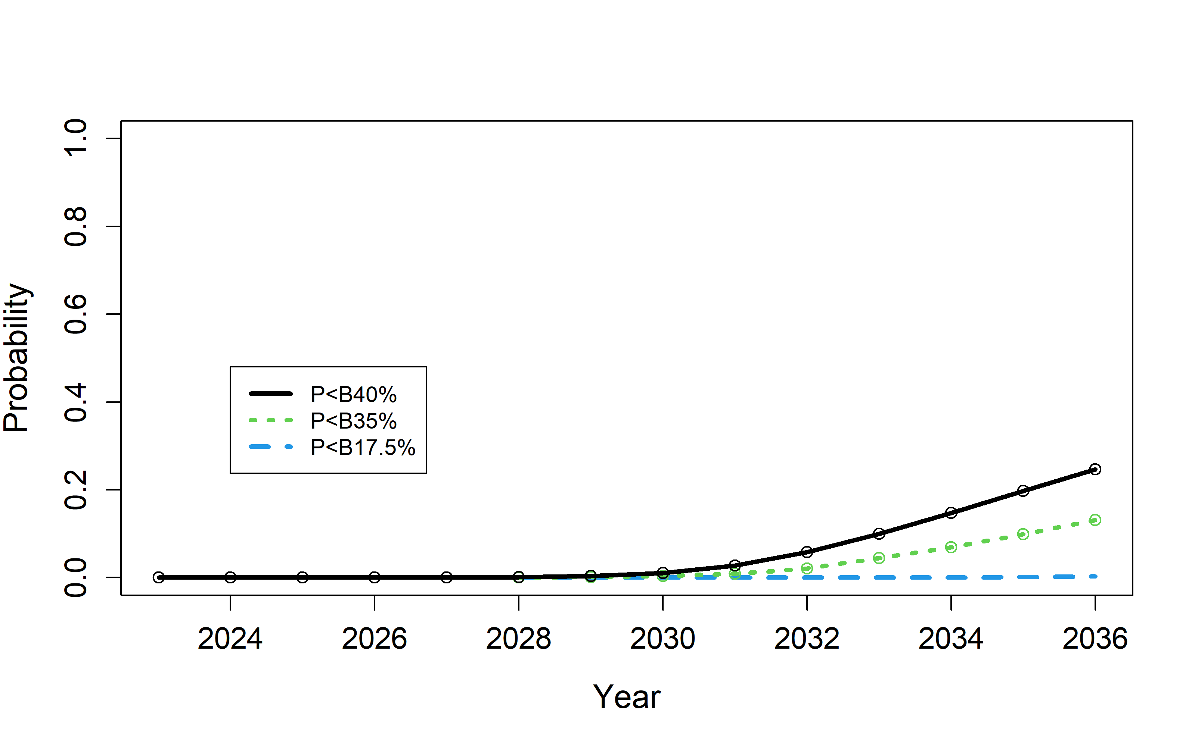

Figure 3.39. Probability that projected spawning biomass in a given projection year (from MCMC) will fall below B40%, B35% and B17.5%.

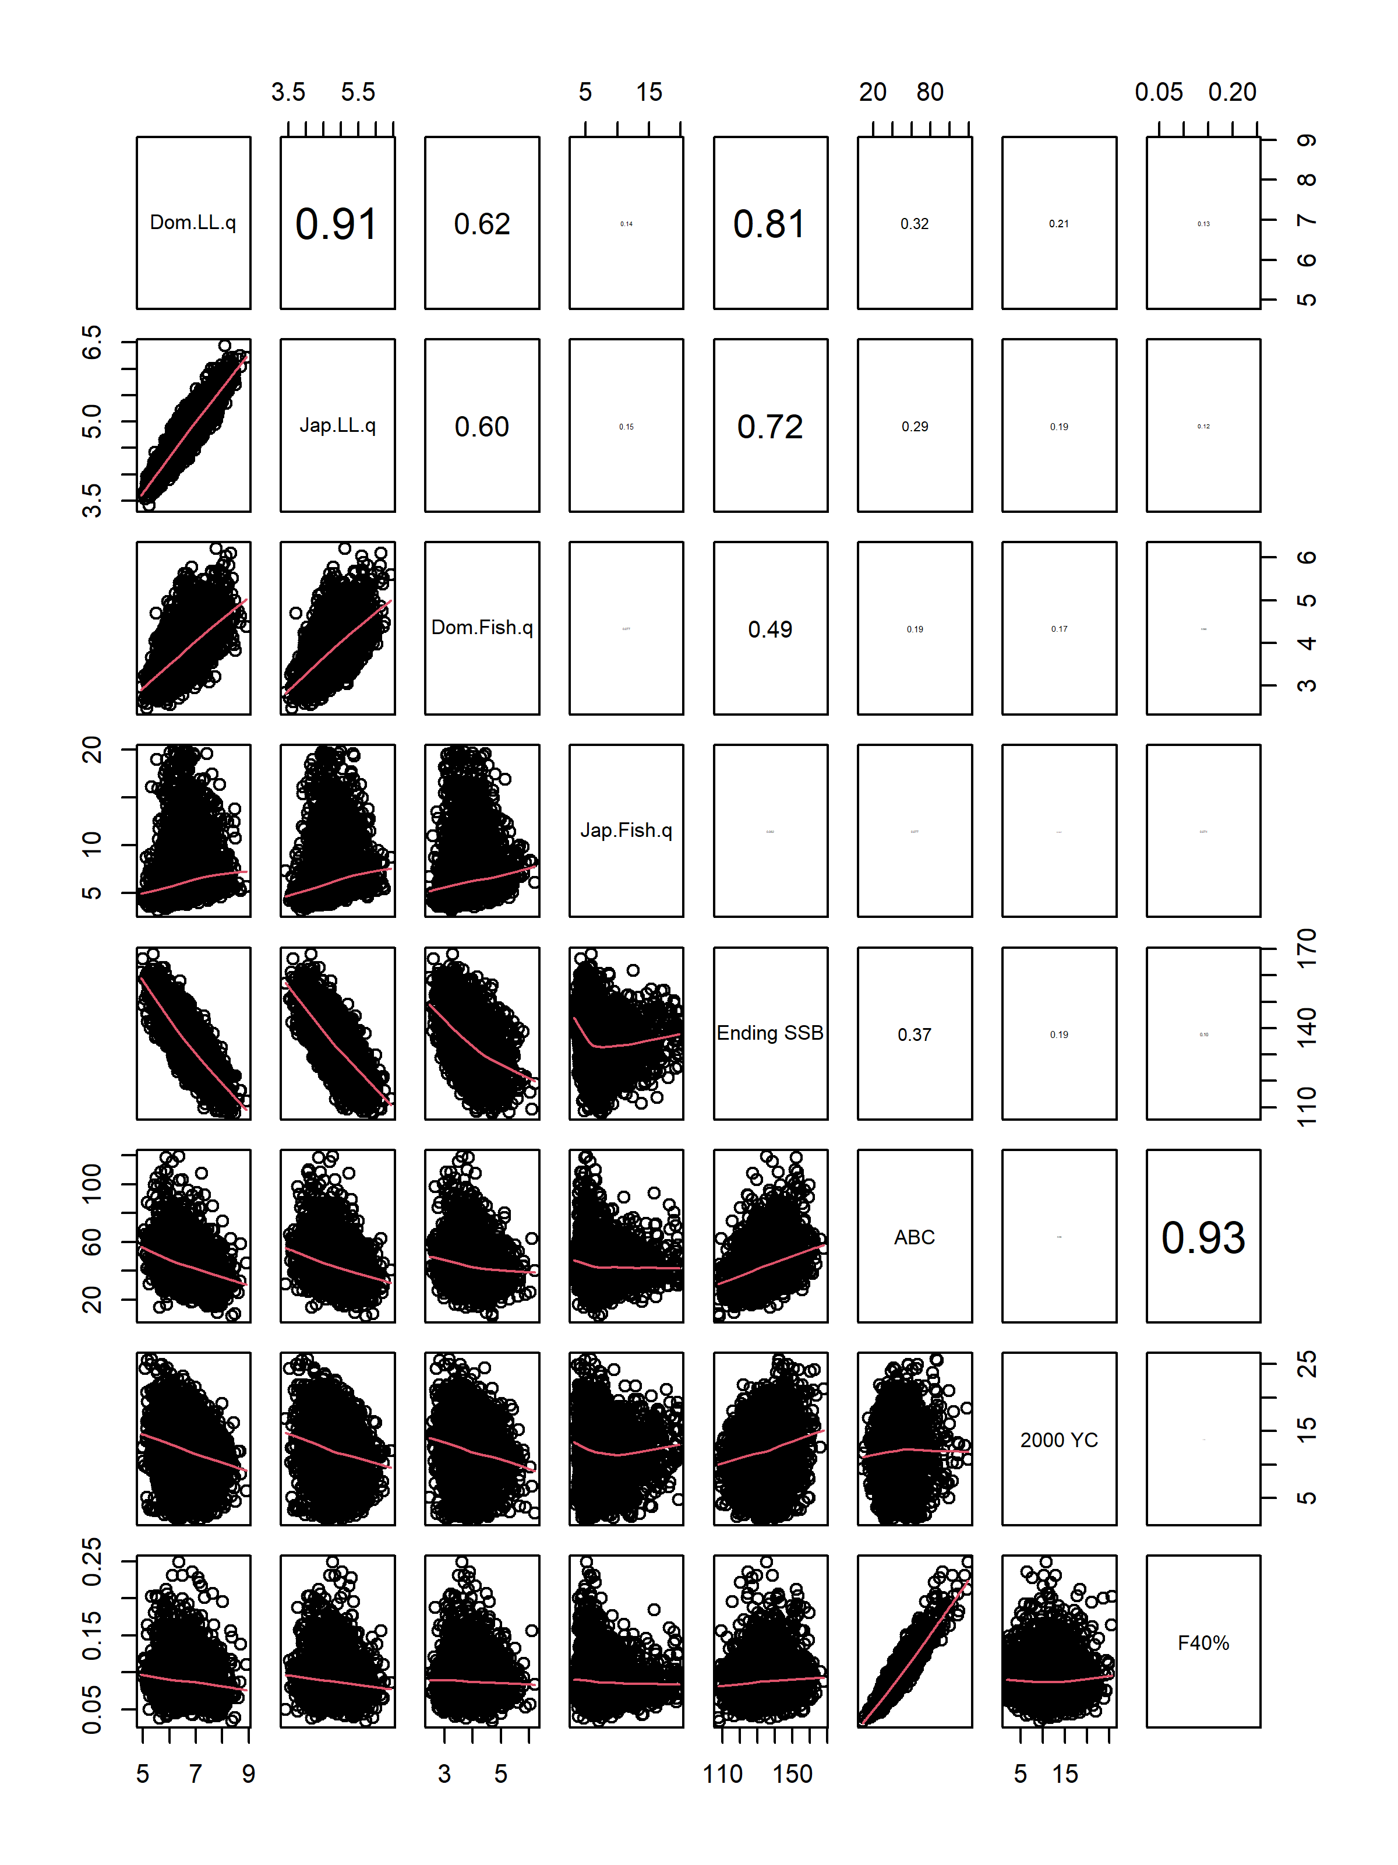

Figure 3.40. Pairwise scatterplots of key parameters from MCMC runs. Red curve is loess smooth. Numbers in upper right hand panel are correlation coefficients between parameters.

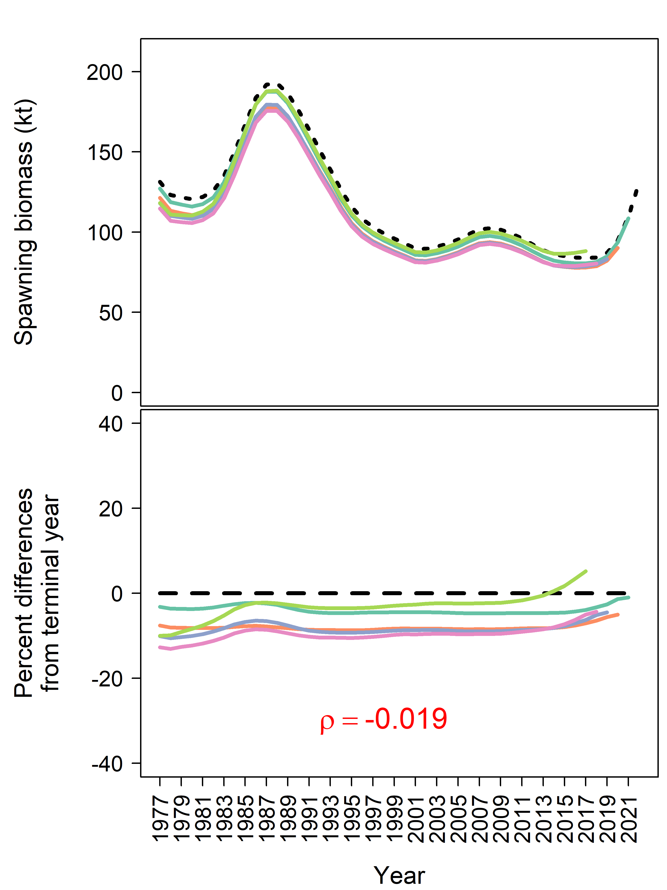

Figure 3.41. Retrospective trends for spawning biomass (top) and percent difference from terminal year (bottom). Mohn’s rho (*ρ*) is provided in red (bottom panel).

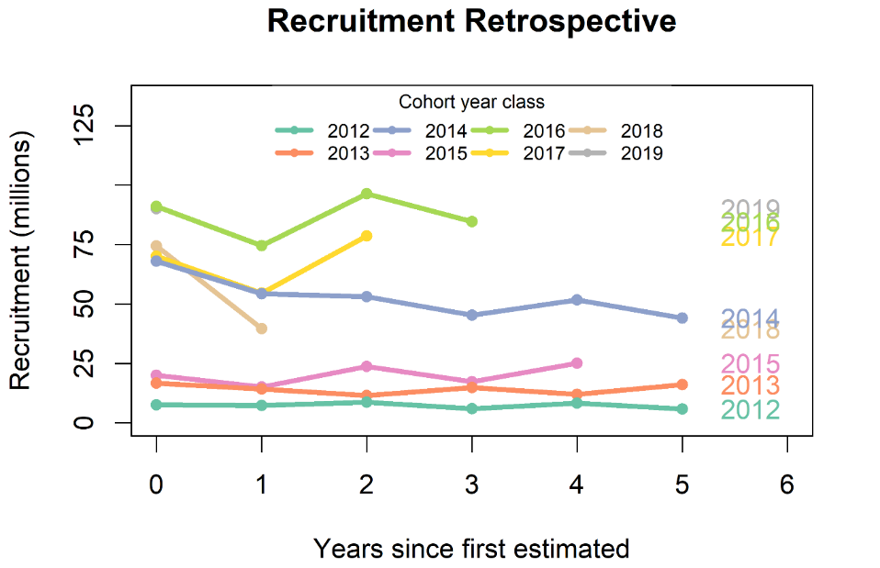

Figure 3.42. Squid plot of subsequent estimates of age-2 recruitment for 2011 to 2019 year classes from retrospective analysis. Number to right of terminal year indicates year class.

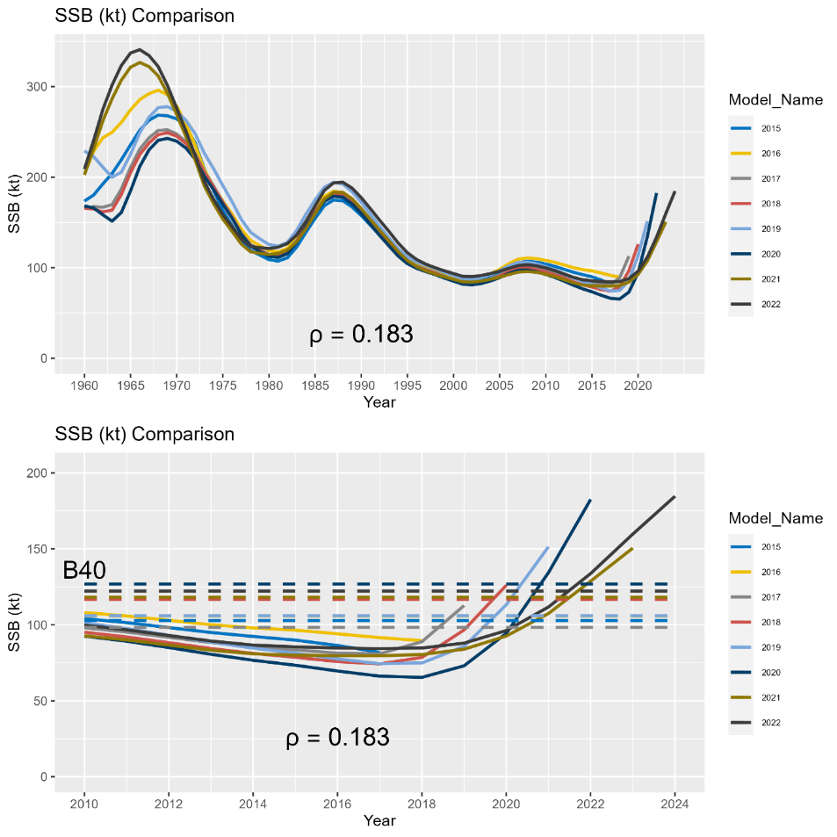

Figure 3.43. Results of the ‘all model’ historical retrospective illustrating estimated and projected (terminal year + 2 year) spawning stock biomass (in kilotons). Results are based on the accepted model in each terminal model year and includes application of the *21.12* model for the 2021 and 2022 model years as well as the *16.5* model for earlier model years. The top panel shows the entire time series of SSB from each assessment model, while the bottom panel shows the same results since 2010 overlaid with corresponding estimates of *B40%*. Mohn’s rho for two year SSB projections is provided below the lines in each plot.

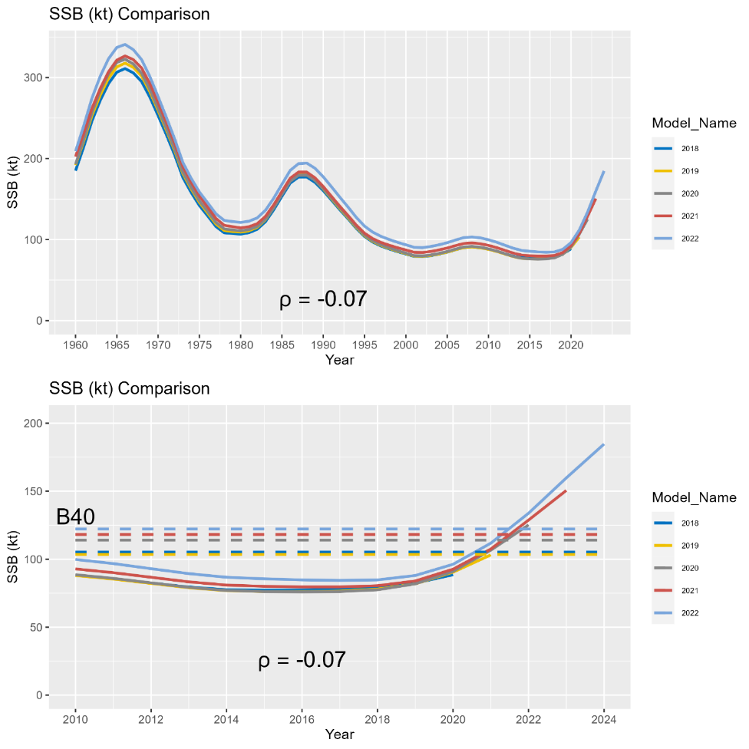

Figure 3.44. Results of the ‘current model’ historical retrospective illustrating estimated and projected (terminal year + 2 year) spawning stock biomass (in kilotons). Results are based on application of the *21.12* model to the available data at the time of the last five sablefish assessments (i.e., terminal model years from 2018 to 2022). The top panel shows the entire time series of SSB from each assessment model, while the bottom panel shows the same results since 2010 overlaid with corresponding estimates of *B40%*. Mohn’s rho for two year SSB projections is provided below the lines in each plot.

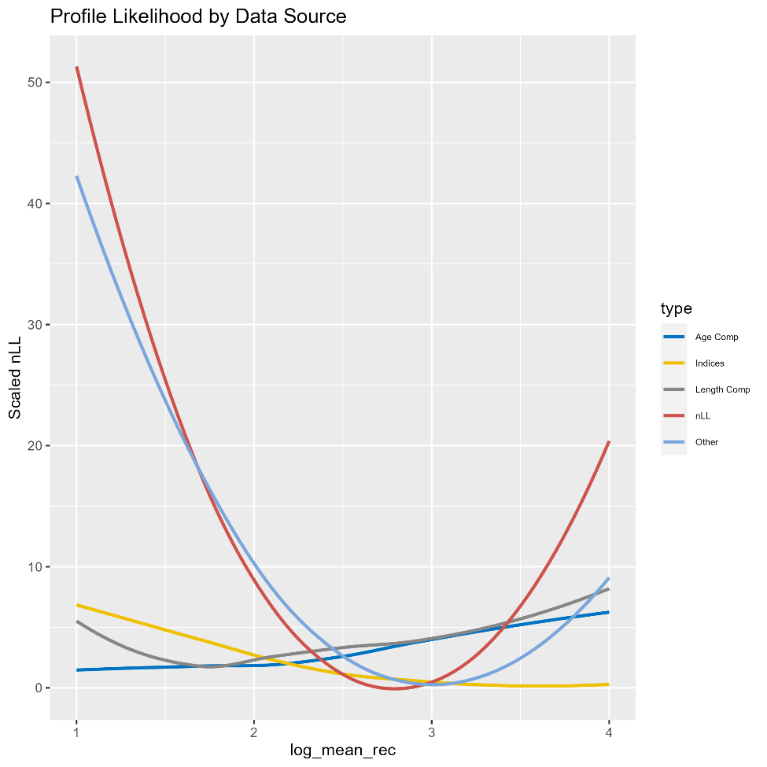

Figure 3.45. Likelihood profiles by data type (line color) for the mean recruitment parameter in logarithmic space.

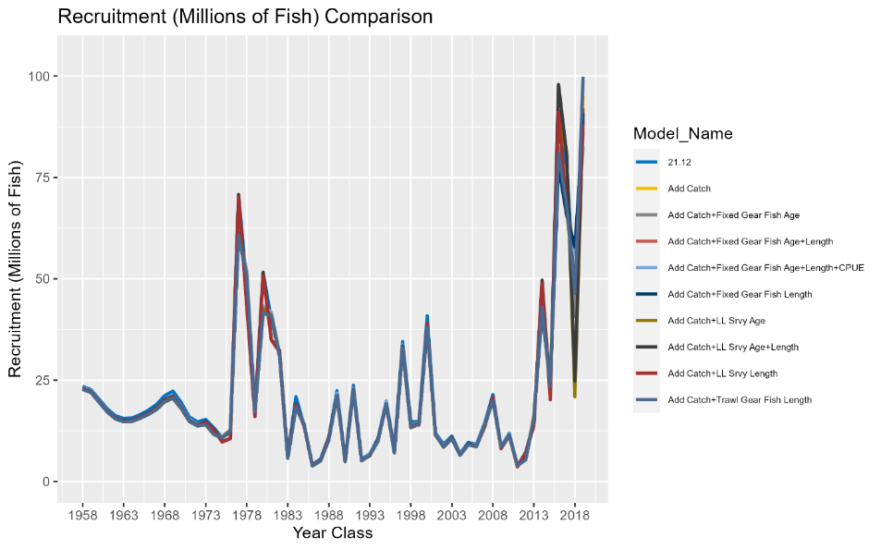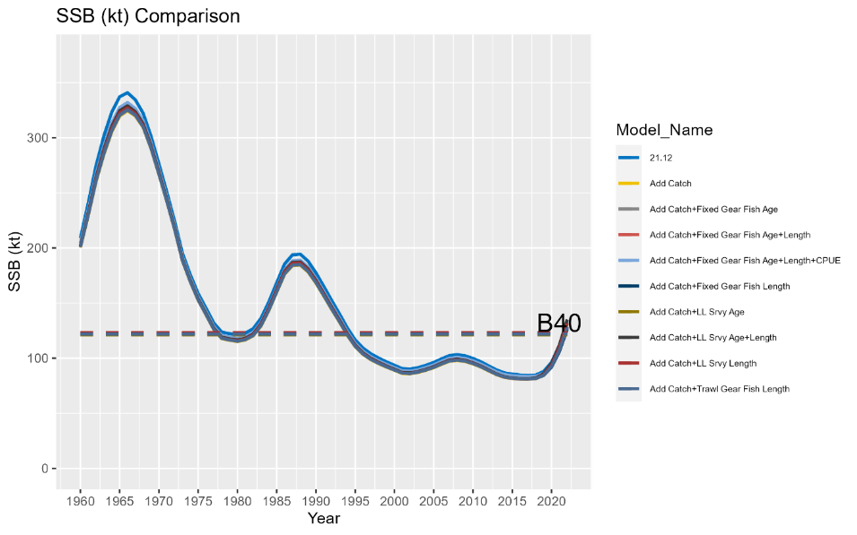

Figure 3.46. Results of an incremental data addition exercise where each new year of data for the 2022 model is added in a step-wise fashion. All model runs include the 2022 fishery catch data. For compositional data associated with fishery independent indices, each run also includes the associated survey index. The top panel illustrates the model estimated recruitment (millions of fish). The bottom panel depicts the time series of *SSB* (kt).

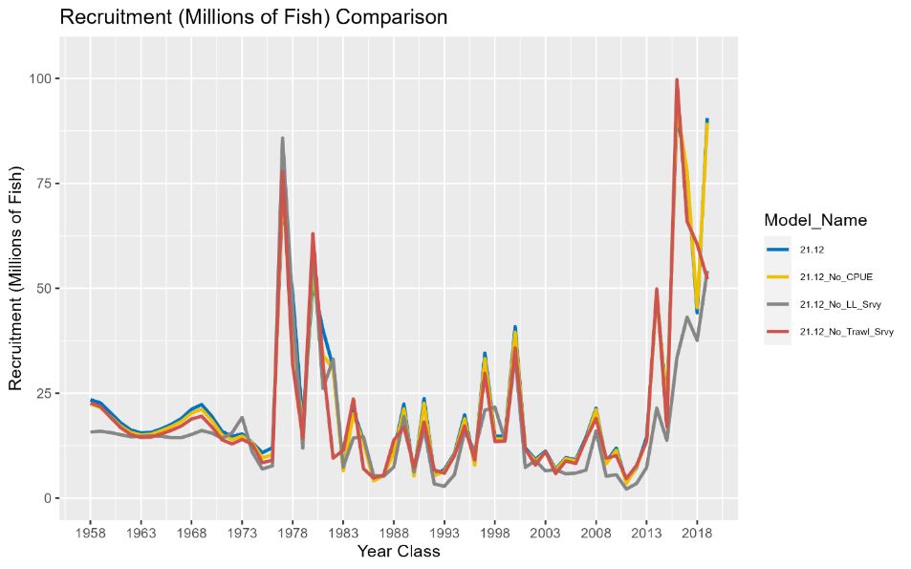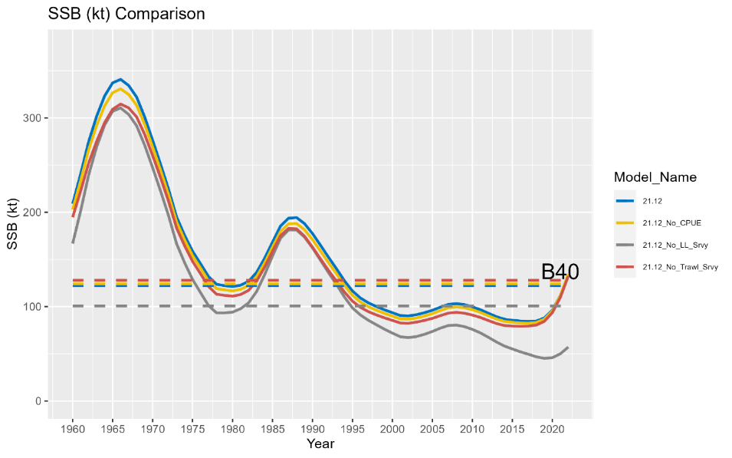

Figure 3.47. Results of an index sensitivity analysis where the model is rerun after removing each index (and any associated compositional data in the case of fishery independent surveys) one at a time. The top panel illustrates the model estimated recruitment (millions of fish). The bottom panel depicts the time series of *SSB* (kt).

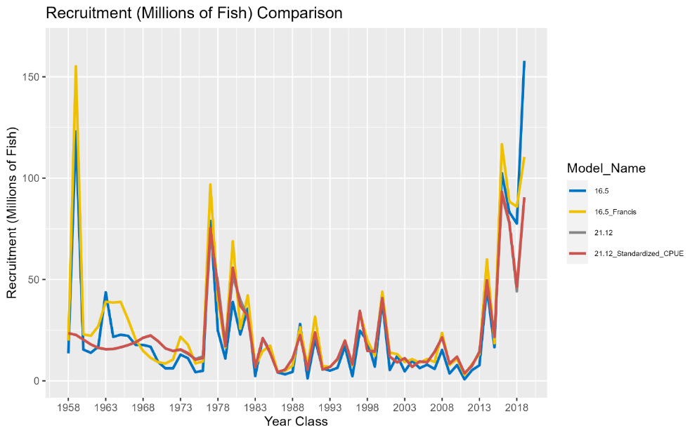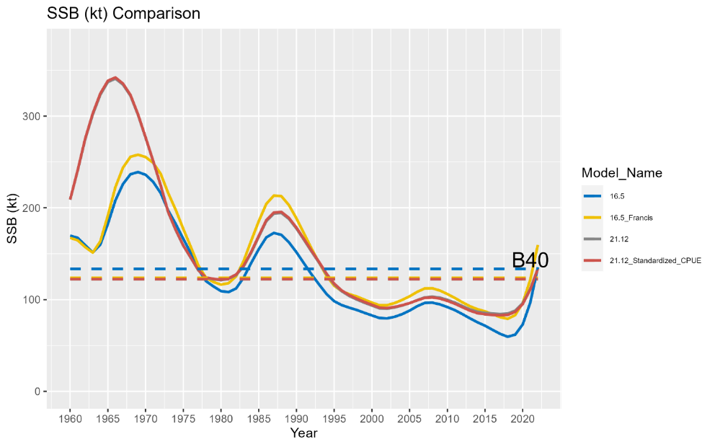

Figure 3.48. Results of select sensitivity runs (colored lines). Model descriptions and names are provided in the main text. The top panel illustrates the model estimated recruitment (millions of fish). The bottom panel depicts the time series of *SSB* (kilotons).

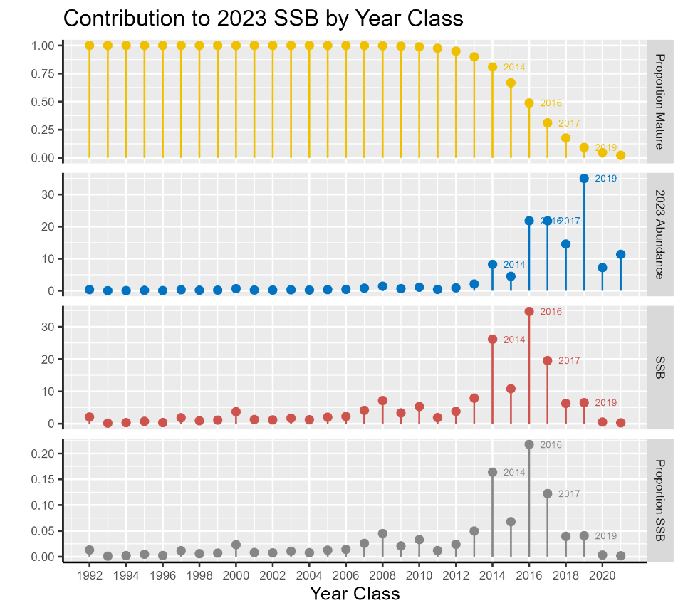

Figure 3.49. Proportion mature (top panel), projected 2023 female (assuming a 50:50 sex ratio) abundance (millions of fish; second panel from top), projected 2023 spawning stock biomass (kilotons; third panel from top), and proportional contribution to 2023 SSB (bottom panel) for each of the last 30 year classes. Note that the 1992 year class represents all contributions from all earlier year classes (i.e., fish in the plus group age). Abundance of the 2020 and 2021 year classes are based on mean recruitment, because these year classes have not yet been estimated in the 2022 assessment model.

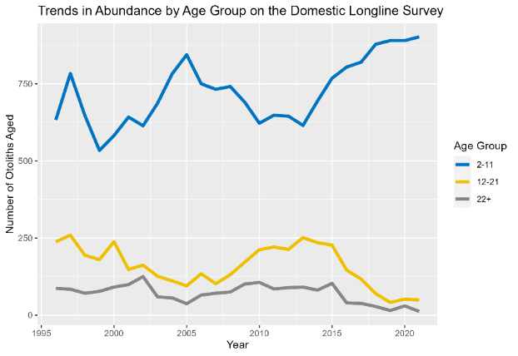

Figure 3.50. Number of otoliths aged on the AFSC domestic longline survey by age group (i.e., number of observed fish within each age group). Groupings are ages 2 to 11, 12 to 21, and 22+.

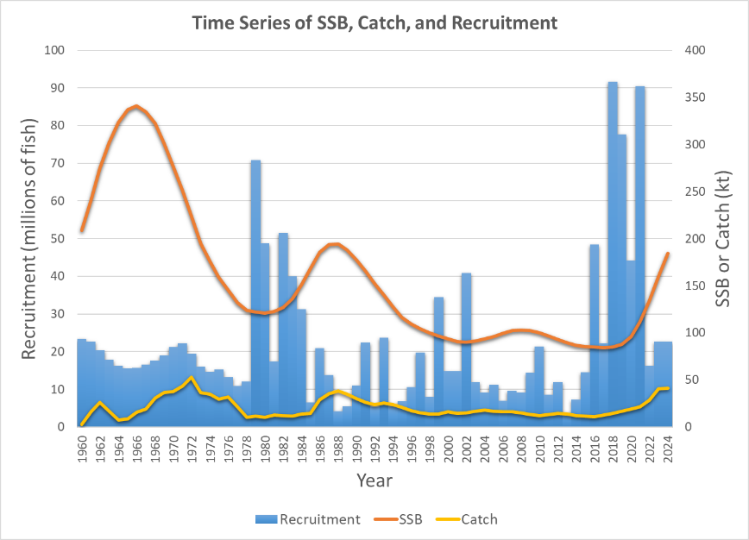

**Figure 3.51**. Time series of sablefish SSB, catch, and recruitment. Projected dynamics for 2023 and 2024 are included based on the maximum permissible ABC and average recruitment. Note the cyclical dynamics associated with spasmodic recruitment. Transitory increases in SSB following periods of strong recruitment are followed by a persistent downward time series trend. Catches often rapidly increase following high recruitment periods, while recruitment eventually reverts back towards average levels.

Appendix 3A. Sablefish Longline Survey: Whale and Fishery Interactions

NMFS has requested the assistance of the fishing fleet to avoid the annual longline survey stations since the inception of sablefish IFQ management in 1995. We request that fishermen stay at least five nm away from each survey station for 7 days before and 3 days after the planned sampling date (3 days allow for survey delays). Survey calendars were mailed to each IFQ holder before the beginning of each fishing season until 2020. A letter was included with the calendar that included details and rationale of the request for the fleet to avoid survey stations. Starting in 2021, the survey calendar was made available online (https://www.fisheries.noaa.gov/resource/document/alaska-sablefish-longline-survey-station-schedule) to reduce printing and mailing expenses. While the survey is being conducted, the skipper of the vessel makes announcements on the radio detailing the planned set locations for the upcoming days. Vessels encountered near survey stations are contacted by the survey vessel captain and interviewed to determine potential effects on survey catches and these interactions are noted (Table 3A.1). Beginning in 1998, we also revised the longline survey schedule to avoid the July 1 rockfish trawl fishery opening as well as other short fisheries.

As discussed in the main text, the number of sets impacted by whales is also tallied (Table 3A.2) and those sets are dropped (for orca interaction) or catch rates inflated using the survey whale inflation factor (for sperm whales; see ‘Whale Depredation Estimation’ section).

History of Interactions

Fishermen cooperation, distribution of the survey schedule to IFQ permit holders, radio announcements from the survey vessel, and discussions of a regulatory rolling closure have had intermittent success at reducing the annual number of longline survey/fishery interactions. During the past several surveys, fishing vessels have been contacted by the survey vessel when they were spotted close to survey stations. Typically, vessels have been aware of the survey and have not been fishing close to survey locations. Vessels usually are willing to communicate where they had set and/or are willing to change their fishing locations to accommodate the survey. Even with communication, there are some instances where survey gear was fished nearby commercial fishing gear or where commercial fishing had recently occurred. There are generally few interactions during the 90-day survey (Table 3A.1). However, in 2022 there were eight instances of vessel interactions that may have impacted survey catch or required the survey vessel to move the day’s sets from their originally intended locations. In the GOA, there were 7 interactions with pot boats (2 in East Yakutat/Southeast, 2 in West Yakutat, and 3 in the Central GOA) and one interaction with a longline vessel in the western GOA. There were no vessel interactions in the eastern Aleutian Islands.

## Recommendation

We have followed several practical measures to alleviate fishery interactions with the survey. Discussions with vessels encountered on the survey indicated an increasing level of “hired” skippers who are unaware of the survey schedule. Publicizing the survey schedule to skippers who are not quota shareholders should be improved. We will continue to work with association representatives and individual fishermen from the longline and trawl fleets to reduce fishery interactions and ensure accurate estimates of sablefish abundance.

## Tables

Table 3A.1 Count of longline survey and fishery vessel interactions by area, fishery gear type, and year.

|  |  |  |  |  |  |  |  |  |  |  |  |  |  |  |  |
| --- | --- | --- | --- | --- | --- | --- | --- | --- | --- | --- | --- | --- | --- | --- | --- |
|  |  |  |  |  | |  |  | | |  |  | | | |  |
|  | **Longline** | | **Trawl** | | **Pot** | | | | **Total** | | | |
| **Year** | **Stations** | **Vessels** | **Stations** | **Vessels** | | **Stations** | | **Vessels** | | **Stations** | | **Vessels** | |
| 1995 | 8 | 7 | 9 | 15 | | 0 | | 0 | | 17 | | 22 | |
| 1996 | 11 | 18 | 15 | 17 | | 0 | | 0 | | 26 | | 35 | |
| 1997 | 8 | 8 | 8 | 7 | | 0 | | 0 | | 16 | | 15 | |
| 1998 | 10 | 9 | 0 | 0 | | 0 | | 0 | | 10 | | 9 | |
| 1999 | 4 | 4 | 2 | 6 | | 0 | | 0 | | 6 | | 10 | |
| 2000 | 10 | 10 | 0 | 0 | | 0 | | 0 | | 10 | | 10 | |
| 2001 | 1 | 1 | 1 | 1 | | 0 | | 0 | | 2 | | 2 | |
| 2002 | 3 | 3 | 0 | 0 | | 0 | | 0 | | 3 | | 3 | |
| 2003 | 4 | 4 | 2 | 2 | | 0 | | 0 | | 6 | | 6 | |
| 2004 | 5 | 5 | 0 | 0 | | 1 | | 1 | | 6 | | 6 | |
| 2005 | 1 | 1 | 1 | 1 | | 0 | | 0 | | 2 | | 2 | |
| 2006 | 6 | 6 | 1 | 2 | | 0 | | 0 | | 7 | | 8 | |
| 2007 | 8 | 6 | 2 | 2 | | 0 | | 0 | | 10 | | 8 | |
| 2008 | 2 | 2 | 2 | 2 | | 0 | | 0 | | 4 | | 4 | |
| 2009 | 3 | 3 | 0 | 0 | | 0 | | 0 | | 3 | | 3 | |
| 2010 | 2 | 2 | 1 | 1 | | 0 | | 0 | | 3 | | 3 | |
| 2011 | 3 | 3 | 0 | 0 | | 0 | | 0 | | 3 | | 3 | |
| 2012 | 5 | 5 | 0 | 0 | | 0 | | 0 | | 5 | | 5 | |
| 2013 | 5 | 5 | 0 | 0 | | 0 | | 0 | | 5 | | 5 | |
| 2014 | 2 | 2 | 0 | 0 | | 0 | | 0 | | 2 | | 2 | |
| 2015 | 3 | 3 | 1 | 1 | | 0 | | 0 | | 6 | | 6 | |
| 2016 | 5 | 5 | 1 | 1 | | 0 | | 0 | | 6 | | 6 | |
| 2017 | 8 | 10 | 3 | 3 | | 3 | | 3 | | 13 | | 16 | |
| 2018 | 9 | 9 | 3 | 3 | | 0 | | 0 | | 12 | | 12 | |
| 2019 | 4 | 4 | 1 | 1 | | 4 | | 4 | | 9 | | 9 | |
| 2020 | 1 | 1 | 1 | 1 | | 3 | | 3 | | 5 | | 5 | |
| 2021 | 0 | 0 | 0 | 0 | | 4 | | 4 | | 4 | | 4 | |
| 2022 | 1 | 1 | 0 | 0 | | 7 | | 7 | | 8 | | 8 | |

Table 3.A2. Count of stations where sperm (S) or killer whale (K) depredation occurred and the number of stations sampled (in parentheses) by management area. Only stations used for RPN calculations are included. Areas not surveyed in a given year are left blank. If there were no whale depredation data taken, it is denoted with an “n/a”. Killer whale depredation did not always occur on all skates of gear, and only those skates with depredation were removed from calculations of RPNs and RPWs.

|  |  |  |  |  |  |  |  |  |  |  |  |  |
| --- | --- | --- | --- | --- | --- | --- | --- | --- | --- | --- | --- | --- |
|  | **BS (16)** | | **AI (14)** | | **WG (10)** | | **CG (16)** | | **WY (8)** | | **EY/SE (17)** | |
| **Year** | **S** | **K** | **S** | **K** | **S** | **K** | **S** | **K** | **S** | **K** | **S** | **K** |
| 1996 |  |  | n/a | 1 | n/a | 0 | n/a | 0 | n/a | 0 | n/a | 0 |
| 1997 | n/a | 2 |  |  | n/a | 0 | n/a | 0 | n/a | 0 | n/a | 0 |
| 1998 |  |  | 0 | 1 | 0 | 0 | 0 | 0 | 4 | 0 | 0 | 0 |
| 1999 | 0 | 7 |  |  | 0 | 0 | 3 | 0 | 6 | 0 | 4 | 0 |
| 2000 |  |  | 0 | 1 | 0 | 1 | 0 | 0 | 4 | 0 | 2 | 0 |
| 2001 | 0 | 5 |  |  | 0 | 0 | 3 | 0 | 0 | 0 | 2 | 0 |
| 2002 |  |  | 0 | 1 | 0 | 4 | 3 | 0 | 4 | 0 | 2 | 0 |
| 2003 | 0 | 7 |  |  | 0 | 3 | 2 | 0 | 1 | 0 | 2 | 0 |
| 2004 |  |  | 0 | 0 | 0 | 4 | 3 | 0 | 4 | 0 | 6 | 0 |
| 2005 | 0 | 2 |  |  | 0 | 4 | 0 | 0 | 2 | 0 | 8 | 0 |
| 2006 |  |  | 0 | 1 | 0 | 3 | 2 | 1 | 4 | 0 | 2 | 0 |
| 2007 | 0 | 7 |  |  | 0 | 5 | 1 | 1 | 5 | 0 | 6 | 0 |
| 2008 |  |  | 0 | 3 | 0 | 2 | 2 | 0 | 8 | 0 | 9 | 0 |
| 2009 | 0 | 10 |  |  | 0 | 2 | 5 | 1 | 3 | 0 | 2 | 0 |
| 2010 |  |  | 0 | 3 | 0 | 1 | 2 | 1 | 2 | 0 | 6 | 0 |
| 2011 | 0 | 7 |  |  | 0 | 5 | 1 | 1 | 4 | 0 | 9 | 0 |
| 2012 |  |  | 1 | 5 | 1 | 5 | 2 | 0 | 4 | 0 | 3 | 0 |
| 2013 | 0 | 11 |  |  | 0 | 2 | 2 | 2 | 3 | 0 | 7 | 0 |
| 2014 |  |  | 1 | 3 | 0 | 4 | 4 | 0 | 6 | 0 | 4 | 0 |
| 2015 | 0 | 9 |  |  | 0 | 5 | 4 | 0 | 6 | 0 | 7 | 0 |
| 2016 |  |  | 1 | 0 | 0 | 3 | 3 | 2 | 5 | 0 | 6 | 0 |
| 2017 | 0 | 11 |  |  | 1 | 2 | 4 | 0 | 3 | 0 | 9 | 0 |
| 2018 |  |  | 0 | 2 | 0 | 3 | 3 | 0 | 7 | 0 | 9 | 0 |
| 2019 | 0 | 10 |  |  | 1 | 4 | 6 | 3 | 6 | 0 | 4 | 0 |
| 2020 |  |  | 0 | 7 | 1 | 5 | 3 | 1 | 4 | 0 | 6 | 0 |
| 2021 | 0 | 10 |  |  | 0 | 1 | 5 | 0 | 1 | 0 | 2 | 0 |
| 2022 |  |  | 0 | 1 | 0 | 4 | 2 | 0 | 1 | 0 | 5 | 0 |

Appendix 3B. Supplemental Catch Data

In order to address NS1 total accounting requirements, non-commercial removals are presented here. This includes removals incurred during research, subsistence, personal use, recreational, and exempted fishing permit activities in federal waters, and does not include removals taken in fisheries other than those managed under the groundfish FMPs. These estimates represent additional sources of removals to the existing Catch Accounting System estimates. The sablefish research removals are substantial relative to the other supplemental catch sources and compared to the research removals for many other species. The majority of these research removals are from a dedicated sablefish NMFS longline survey. Additional sources of significant removals are the NMFS bottom trawl surveys and the International Pacific Halibut Commission’s longline survey. The IPHC survey sablefish removals are released and estimates from mark-recapture studies suggest that these removals are expected to produce low mortality. Total removals from non-commercial activities has ranged from 250 – 500 t since 2010. This represents < 2% percent of the recommended ABC annually. These removals are a low risk to the sablefish stock.

Tables

Table 3B.1. Total removals of sablefish (t) from research surveys in the BSAI and GOA FMPs. Trawl survey sources are a combination of the NMFS GOA, AI, and BS slope bottom trawl surveys (not all occur annually), and occasional short-term research projects. Data above horizontal lines are from the 2010 sablefish stock assessment (Hanselman et al. 2010). Other data were obtained from the Alaskan Regional Office via AKFIN (www.akfin.org) accessed on October 25, 2022.

|  |  |  |  |  |  |  |
| --- | --- | --- | --- | --- | --- | --- |
| **Year** | **Trawl Survey** | **Japan-US Longline Survey** | **Domestic Longline Survey** | **IPHC Longline Survey\*** | **ADFG Sport** | **Total** |
| 1977 | 3 |  |  |  |  | 3 |
| 1978 | 14 |  |  |  |  | 14 |
| 1979 | 27 | 104 |  |  |  | 131 |
| 1980 | 70 | 114 |  |  |  | 184 |
| 1981 | 88 | 150 |  |  |  | 238 |
| 1982 | 108 | 240 |  |  |  | 348 |
| 1983 | 46 | 236 |  |  |  | 282 |
| 1984 | 127 | 284 |  |  |  | 411 |
| 1985 | 186 | 390 |  |  |  | 576 |
| 1986 | 123 | 396 |  |  |  | 519 |
| 1987 | 117 | 349 |  |  |  | 466 |
| 1988 | 15 | 389 | 303 |  |  | 707 |
| 1989 | 4 | 393 | 367 |  |  | 764 |
| 1990 | 26 | 272 | 366 |  |  | 664 |
| 1991 | 3 | 255 | 387 |  |  | 645 |
| 1992 | 0 | 281 | 393 |  |  | 674 |
| 1993 | 39 | 281 | 362 |  |  | 682 |
| 1994 | 1 | 271 | 322 |  |  | 594 |
| 1995 | 0 |  | 388 |  |  | 388 |
| 1996 | 13 |  | 428 |  |  | 441 |
| 1997 | 1 |  | 343 |  |  | 344 |
| 1998 | 26 |  | 292 | 50 |  | 368 |
| 1999 | 43 |  | 298 | 49 |  | 390 |
| 2000 | 2 |  | 269 | 53 |  | 324 |
| 2001 | 11 |  | 311 | 48 |  | 370 |
| 2002 | 3 |  | 396 | 58 |  | 457 |
| 2003 | 16 |  | 272 | 98 |  | 386 |
| 2004 | 2 |  | 276 | 98 |  | 376 |
| 2005 | 18 |  | 256 | 92 |  | 366 |
| 2006 | 2 |  | 287 | 64 |  | 353 |
| 2007 | 17 |  | 261 | 48 |  | 326 |
| 2008 | 3 |  | 256 | 46 |  | 305 |
| 2009 | 14 |  | 241 | 47 |  | 302 |
| 2010 | 3 |  | 271 | 50 | 15 | 339 |
| 2011 | 8 |  | 277 | 39 | 16 | 340 |
| 2012 | 3 |  | 204 | 27 | 38 | 272 |
| 2013 | 4 |  | 178 | 22 | 25 | 229 |
| 2014 | 1 |  | 198 | 32 | 29 | 260 |
| 2015 | 9 |  | 175 | 17 | 46 | 247 |
| 2016 | 2 |  | 200 | 15 | 31 | 248 |
| 2017 | 7 |  | 218 | 11 | 48 | 284 |
| 2018 | 2 |  | 175 | 20 | 50 | 247 |
| 2019 | 15 |  | 249 | 36 | 60 | 360 |
| 2020 | NA |  | 343 | 23 | 16 | 382 |
| 2021 | 18 |  | 393 | 37 | 33 | 481 |

Appendix 3C. Ecosystem and Socioeconomic Profile of the Sablefish stock in Alaska - Report Card

S. Kalei Shotwell, Daniel R. Goethel, Alison Deary, Bridget Ferriss, Katy Echave, Chris Lunsford, Kevin Siwicke, Elizabeth Siddon, Jane Sullivan, Marysia Szymkowiak, and Ben Williams

November 2022

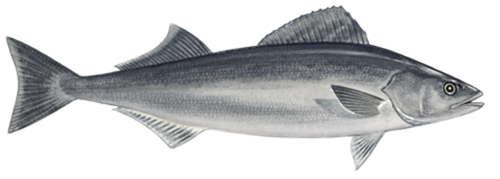

*With Contributions from:*

Mayumi Arimitsu, Steve Barbeaux, Matt Callahan, Curry Cunningham, Dana Hanselman, Ben Fissel, Jean Lee, Jens Nielsen, Krista Oke, Clare Ostle, Patrick Ressler, Cara Rodgveller, Kally Spalinger, Abigail Tyrell, Jordan Watson, and Sarah Wise

Current Year Update

The ecosystem and socioeconomic profile or ESP is a standardized framework for compiling and evaluating relevant stock-specific ecosystem and socioeconomic indicators and communicating linkages and potential drivers of the stock within the stock assessment process (Shotwell et al., *In Review*). The ESP process creates a traceable pathway from the initial development of indicators to management advice and serves as an on-ramp for developing ecosystem-linked stock assessments.

Please refer to the last full ESP and partial ESP documents for further information regarding the ecosystem and socioeconomic linkages for this stock (Shotwell et al., 2019, 2020, available online within the sablefish stock assessment and fishery evaluation report of [Hanselman et al., 2019](https://apps-afsc.fisheries.noaa.gov/refm/docs/2019/sablefish.pdf) (Appendix 3C, pp. 157-202) and [Goethel et al., 2020](https://apps-afsc.fisheries.noaa.gov/refm/docs/2020/sablefish.pdf) (Appendix 3C, pp. 190-218).

Management Considerations

The following are the summary considerations from current updates to the ecosystem and socioeconomic indicators evaluated for sablefish:

* Surface temperatures in the Gulf of Alaska (GOA) and southeastern Bering Sea (SEBS) are warm with average marine heatwave events in the GOA. Bottom temperatures on the slope in the GOA are warm and above average similar to 2017. Chlorophyll *a* biomass is slightly below average in the GOA and above average in the SEBS, while the spring bloom timing is slightly later in the GOA and early in the SEBS.
* Zooplankton community size in the eastern GOA and western GOA was below average, similar to last year and implying a smaller sized community, possibly due to warm temperatures or grazing from meso-zooplankton.
* Growth of YOY sablefish was slightly below average, but mean length was above average.
* Nearshore survey (Alaska Department of Fish and Game, ADF&G) CPUE has declined since the time series peak in 2020, but remains high for juveniles suggesting overwinter and nearshore conditions were favorable, and length frequencies from 2020 to 2022 support a strong 2019 year class similar to 2014.
* Condition of the 2017 year-class was above average in 2021 suggesting sufficient prey resources just prior to maturing, while general condition of adult females on the 2022 survey decreased from 2021 and is now below average.
* Spatial overlap between sablefish migrating to adult slope habitat and the arrowtooth flounder population has increased to slightly above average based on incidental catch in the arrowtooth flounder fishery.
* New standardized fishery CPUE indicators, including an index that combines data from pot and longline gears as well as a pot only index, demonstrate similar trends, with the combined fishery indicator increasing to just slightly below average and the pot fishery index at an all-time high for the time series.
* Catch of sablefish in non-sablefish targeted fisheries remains slightly below average in the GOA and has decreased slightly in the BSAI, but remains high. The decrease in both areas may imply that sablefish are moving off the shelf into adult habitat.
* Condition of adult female sablefish in the GOA fisheries decreased from above average to below average, but sample sizes were small compared to previous years.
* Real ex-vessel value and average price per pound increased slightly in 2021, but remain low, in part due to continued small average fish size from recent large year classes that have not yet grown to marketable sizes.
* Overall, ecosystem and socioeconomic indicators were mixed with physical indicators below average, lower trophic indicators above average, upper trophic indicators at average levels, fishery performance indicators above average, and economic indicators below average.

Modeling Considerations

The following are the summary results from the intermediate and advanced stage monitoring analyses for sablefish:

* The highest ranked predictor variables of sablefish recruitment based on the importance methods in the intermediate stage indicator analysis were the summer juvenile sablefish CPUE from the ADF&G large mesh survey and the incidental catch from the arrowtooth flounder fishery in the GOA (inclusion probability > 0.5)
* New research models are being explored that incorporate environmental or ecosystem components into populations models for sablefish, including: a spatially explicit life cycle model (SILC) that integrates a spatially-explicit assessment model with an early life history individual based model (IBM), a temperature linked projection model, and a spatially explicit, tag-integrated model to aid in the understanding ecosystem drivers of movement and time-variation in natural mortality.

Assessment

Ecosystem and Socioeconomic Processes

Figure 3C.1 provides a life history conceptual model for sablefish that summarizes ecological information and key ecosystem processes affecting survival by life stage. Alaska sablefish, the northern component of sablefish, are assessed as a single population in the federal waters off Alaska from British Columbia to the Bering Sea (McDevitt, 1990, Saunders et al., 1996, Kimura et al., 1998). They have a propensity for large-scale movements (Heifetz and Fujioka, 1991, Hanselman et al. 2015) and adult sablefish are typically encountered between 200 and 1000 m along the continental slope, shelf gullies, and deep-sea canyons (Wolotira et al., 1993; Rutecki et al., 2016). A clear ontogenetic habitat shift occurs between the early juvenile and later juvenile to adult stages with progression from nearshore bays and inlets to the colder continental shelf and slope (Figure 3C.1). Sablefish are highly fecund with spawning occurring around early spring in deep-water. Larvae exhibit an extended spring through summer neustonic (extreme surface) pelagic phase that culminates in nearshore settlement in the early fall of their first year when sablefish are around 300-400 mm (Doyle and Mier 2016; Doyle et al. 2019). At some point following the first winter, sablefish begin movement from their nearshore juvenile habitat to their offshore slope adult habitat arriving between 4 to 5 years later and mature between within 4 and 10 years of age (Rodgveller, 2018). Pelagic eggs in deep water over the slope and basin may provide a relatively stable environment for embryonic development as cold temperatures during winter favor slow development. Relatively large size at hatching (~6 mm) and rapid growth of larvae with good swimming ability likely confers an advantage in terms of larval feeding at the sea surface (Doyle et al., 2019). Peak abundance of larvae (May–June) coincides with advanced development of the spring peak in zooplankton production following the onset of stratification (measured by a shallowing of the mixed layer), which likely means a plentiful supply of prey. Sablefish larvae are characterized by early development of large pectoral fins to assist with swimming ability, but have delayed bone-development in their jaws potentially resulting in non-discriminating prey selection (Matarese et al. 2003; Deary et al., 2019). With the lack of overall ossification of the skeleton, pre-flexion sablefish larvae lack the rigidity in their jaw elements to quickly open and expand their mouths to suck in prey. Sablefish in this preflexion larval stage are only able to pick prey from the water and are thus restricted to prey that are small and prevalent. The temporal match with the onset of the zooplankton bloom suggests a need for sablefish larvae to overlap with the peak in productivity due to their non-discriminating prey selection (Deary et al., 2019).

Throughout the first year, larvae and age-0 fish grow very rapidly up until settlement in the nearshore environment (Sigler et al. 2001). Fish in the pre-settlement to settlement stages have fairly stable lipid content as they are putting energy toward growth and not toward lipid energy storage. Maturing juveniles to adult sablefish have a much higher percent lipid content than the earlier life stages; thus there is an ontogenetic shift that is related to how sablefish store energy and may be related to the size at which fish migrate from nearshore to offshore waters. The variability in lipid content in maturing and adult sablefish could be attributed to some fish being mature and some being immature, while also potentially leading to skipped spawning. For example, relative condition (body weight relative to length) and relative liver size (liver weight related to total weight), are higher in fish that will spawn than in skipped spawning and immature female sablefish (Rodgveller, 2019). The lipid accumulation shifts suggest that the fish in the nearshore are still growing quickly with an associated high energetic cost, but as they move offshore the fish have relatively low energetic demands and can begin to allocate surplus lipid to storage with age as they grow (J. Vollenweider, *pers. commun*.). The juvenile nearshore stage appears to be an energetically demanding period, as all surplus energy is allocated toward growth (protein). A potential alternative explanation for this pattern is that food is a limiting factor and surplus energy is not available. Later during the early offshore residence for juveniles, the energetic constraints are relieved and fish obtain surplus energy that is stored as lipid. In addition to reducing the pressure for rapid growth, the extreme increase in lipid storage may represent considerably better feeding grounds, and/or life history constraints to increase lipid content as the fish move into the deeper depths of the adult habitat as they age.

Sablefish have historically been harvested primarily by catcher vessels in the GOA, which typically account for upwards of 90% of the annual catch. In 2020, the GOA accounted for only 83% of the retained catch as catch levels in the BSAI increased. Most sablefish are caught using the hook-and-line and pot gear type. Starting in 2017, directed fishing for sablefish using pot gear was allowed in the GOA to mitigate whale depredation. While pot gear catches increased in all areas of the GOA, the increase was most pronounced in the western and central GOA. Media reports suggest that the introduction of slinky pots may have been a contributing factor as they offer hook and line fishermen access to pot gear despite limited deck space (A. Stubbs, *pers. commun.*). Historically, the gear codes were not distinguished between slinky pots vs. other pot gear, but starting in 2022 and continuing through 2023, observers are reporting pot gear specifications as part of a special project to quantify the gear types and configurations used in the fishery. Measurements recorded include mesh size, escape ring presence and size, funnel size, dimensions, pot shape, and slinky or hard pot type. These pot metrics will be coupled with the size distribution of the catch. (K. Echave and C. Rodgveller, *pers. commun*.).

Tables 3C.1a-c provide a stock specific summary for Alaska sablefish of the economic information presented in the current Economic SAFE (A. Ableman, *per. commun*.). As a valuable, premium, high-priced whitefish, sablefish is an important source of revenues for GOA catcher vessels. The U.S. accounts for roughly 85-90% of global sablefish catch and Alaska accounts for roughly 70% of the U.S. catch. Canada catches roughly 10% of the global supply. A small amount is also caught by Russia, although this amount has been increasing since 2017. As the primary global producer of sablefish, the significant supply changes in Alaska have market impacts that influence wholesale and export prices. Most sablefish caught are exported, though the domestic market has grown.

An analysis of commercial processing and harvesting data can help examine sustained participation for those communities substantially engaged in a commercial fishery. The Annual Community Engagement and Participation Overview (ACEPO) is a new report that evaluates engagement at the community level and focuses on providing an overview of harvesting and processing sectors of identified highly engaged communities for groundfish and crab fisheries in Alaska (Wise et al., 2021). To date, the most highly engaged communities with the sablefish fishery are Seward, Kodiak, Sitka, and Homer, which account for almost 48% of the regional value landed. An analysis of commercial processing and harvesting data has been conducted at the stock level rather than community level for other ESPs to examine sustained participation for those communities substantially engaged in a commercial fishery. This analysis could be completed for sablefish in the future.

Indicator Suite

The following list of indicators for sablefish are organized by categories, three for ecosystem indicators (physical, lower trophic, and upper trophic) and three for socioeconomic indicators (fishery performance, economic, and community). A short description and contact name for the indicator contributor are provided. For ecosystem indicators, we also include the anticipated sign (i.e., in terms of the influence the indicator has on the sablefish stock dynamics, positive or negative) of the proposed relationship between the indicator and the stock population dynamics where relevant. Please refer to the last full ESP document for detailed information regarding the ecosystem and socioeconomic indicator descriptions for this stock (Shotwell et al., 2019). Time series of the ecosystem and socioeconomic indicators are provided in Figure 3C.2a and Figure 3C.2b, respectively.

This year, the spatial extent of the satellite derived indicators (sea surface temperature, chlorophyll *a* concentration, and peak timing of the spring bloom) was expanded from only the eastern GOA to the whole GOA. The expansion was undertaken to be more consistent with the extent of the sablefish population rather than focusing on the transition area of the eastern GOA. The surface temperatures between the eastern GOA and GOA are highly correlated (r = 0.94) with only a 1.3oC difference in magnitude, on average, which is expected as SST cools from east to west in the GOA. The chlorophyll *a* concentration and the spring peak indicators between the eastern GOA and GOA are not well correlated for the whole time series, but do become well correlated starting in 2014 with the onset of the marine heatwave (r = 0.54 for concentration and r = 0.89 for spring peak). Chlorophyll measures are very patchy and this mismatch over the whole time series may be expected between the eastern GOA and GOA, but the higher correlation since the marine heatwave indicates that the more recent trends are consistent between the two areas.

We have also exchanged the previous GOA longline and BSAI pot catch-per-unit-of-effort (CPUE) fishery performance indicators with a standardized model-based index of abundance. The new standardized relative abundance indices were developed via Generalized Additive Models (GAMs) using both observer and logbook records. Two separate indices are presented here, which include: 1) a combined index of abundance that represents both hook-and-line and pot gear, and 2) an index that only represents pot gear. These standardized indices control for differences in vessel characteristics, data source, spatial distribution of fishing effort, and fishing strategies. Conversely, indices presented in previous ESP’s were not standardized and simply illustrated the nominal CPUE. Thus, standardized abundance indices likely better reflect observations from the fishery as well as underlying abundance trends in the Alaskan sablefish stock (M. Cheng, *pers. commun.*).

#### Ecosystem Indicators

Physical Indicators (Figure 3C.2a.a-d):

* 1. Annual marine heatwave cumulative index over the central GOA (contact: S. Barbeaux). Proposed sign of relationship is positive.
  2. Late spring (May-June) daily sea surface temperatures (SST) for the GOA from the NOAA Coral Reef Watch Program (contact: M. Callahan). Proposed sign of relationship is positive.
  3. Late spring (May-June) daily sea surface temperatures (SST) for the southeastern Bering Sea from the NOAA Coral Reef Watch Program (contact: M. Callahan). Proposed sign of relationship is positive and the time series is not lagged for the intermediate stage indicator analysis.
  4. Summer temperature anomalies at 250 m isobath during the AFSC annual longline survey (contact: K. Siwicke). Proposed sign of relationship is negative.

Lower Trophic Indicators (Figure 3C.2a.e-l):

* 1. Derived chlorophyll *a* concentration during spring seasonal peak (May) in the GOA from the MODIS satellite (contact: M. Callahan). Proposed sign of relationship is positive.
  2. Derived chlorophyll *a* concentration during spring seasonal peak (May) in the southeastern Bering Sea from the MODIS satellite (contact: M. Callahan). Proposed sign of relationship is positive.
  3. Peak timing of the spring bloom averaged across individual ADF&G statistical areas in the GOA region from the MODIS satellite (contact M. Callahan). Proposed sign of relationship is negative.
  4. Peak timing of the spring bloom averaged across individual ADF&G statistical areas in the southeastern Bering Sea from the MODIS satellite (contact: J. Nielsen). Proposed sign of relationship is negative.
  5. Abundance of copepod community size from the continuous plankton recorder (CPR) for the offshore eastern GOA (contact: C. Ostle). Proposed sign of relationship is positive.
  6. Abundance of copepod community size from the continuous plankton recorder (CPR) for the offshore western GOA (contact: C. Ostle). Proposed sign of relationship is positive.
  7. Summer euphausiid abundance from the AFSC acoustic survey for the Kodiak core survey area (contact: P. Ressler). Proposed sign of relationship is positive.
  8. Age-0 sablefish growth rate from auklet diets in Middleton Island (contact: M. Arimitsu). Proposed sign of relationship is positive and the time series is not lagged for the intermediate stage indicator analysis.

Upper Trophic Indicators (Figure 3C.2a.m-t):

* 1. Sablefish catch-per-unit-effort (CPUE) and lengths from the ADF&G large mesh bottom trawl survey of crab and groundfish (contact: K. Spalinger). Proposed sign of relationship is positive and the time series is lagged three years for the intermediate stage indicator analysis.
  2. Summer length compositions extrapolated to the population of juvenile sablefish (<350 mm, likely age-1) collected on AFSC bottom-trawl surveys (contact: K. Shotwell). Proposed sign of relationship is positive.
  3. Mean age of sablefish female spawning stock biomass from the previous year sablefish stock assessment model (contact: D. Goethel). Proposed sign of relationship is positive and the time series is lagged by minus one year for the intermediate stage indicator analysis.
  4. Measure of evenness or concentration of age composition by cohort of female sablefish from the previous year sablefish stock assessment model (contact: D. Goethel). Proposed sign of relationship is positive and the time series is lagged by minus one year for the intermediate stage indicator analysis.
  5. Summer sablefish condition for age-4, immature female sablefish from the GOA AFSC longline survey (contact: J. Sullivan). Proposed sign of relationship is positive.
  6. Arrowtooth flounder total biomass from the previous year stock assessment model (contact: K. Shotwell). Proposed sign of relationship is negative and the time series is lagged three years for the intermediate stage indicator analysis.
  7. Incidental catch of sablefish in the GOA arrowtooth flounder fishery (contact: K. Shotwell). Proposed sign of relationship is negative and the time series is lagged three years for the intermediate stage indicator analysis.
  8. Summer sablefish condition for large adult (>=750 mm) female sablefish from the GOA AFSC longline survey (contact: J. Sullivan). Proposed sign of relationship is positive and the time series is not lagged for the intermediate stage indicator analysis.

#### Socioeconomic Indicators

Fishery Performance Indicators (Figure 3C.2b.a-f):

* 1. Catch-per-unit-effort of sablefish from the combined longline and pot fisheries in Alaska (contact: M. Cheng).
  2. Catch-per-unit-effort of sablefish estimated from the pot fisheries in Alaska (contact: M. Cheng).
  3. Incidental catch estimates of sablefish in the GOA fisheries excluding the sablefish fishery (contact: K. Shotwell).
  4. Incidental catch estimates of sablefish in the Bering Sea fisheries excluding the sablefish fishery (contact: K. Shotwell).
  5. Sablefish condition for large (>= 750 mm) female sablefish from data collected randomly by observers in the GOA fisheries (contact: J. Sullivan).
  6. Sablefish condition for large (>= 750 mm) female sablefish from data collected randomly by observers in the BSAI fisheries (contact: J. Sullivan).

Economic Indicators (Figure 3C.2b.g-h):

* 1. Annual estimated real ex-vessel value of sablefish (contact: J. Lee).
  2. Average real ex-vessel price per pound of sablefish from fish ticket information (contact: J. Lee).

Indicator Monitoring Analysis

There are up to three stages (beginning, intermediate, and advanced) of statistical analyses for monitoring the indicator suite listed in the previous section. The beginning stage is a relatively simple evaluation by traffic light scoring. This evaluates the current year trends relative to the mean of the whole time series, and provides a historical perspective on the utility of the whole indicator suite. The intermediate stage uses importance methods related to a stock assessment variable of interest (e.g., recruitment, biomass, catchability). These regression techniques provide a simple predictive performance for the variable of interest and are run separate from the stock assessment model. They provide the direction, magnitude, uncertainty of the effect, and an estimate of inclusion probability. The advanced stage is used for testing a research-based ecosystem-linked model where output can be compared with the current operational model to understand retrospective patterns, prediction performance, and to compare model output such as terminal spawning stock biomass or mean recruitment. This stage provides an on-ramp for introducing an alternative ecosystem linked stock assessment model to the current operational stock assessment model and can be used to understand the potential reduction in uncertainty by including ecosystem information.

#### Beginning Stage: Traffic Light Test

We use a simple scoring calculation for this beginning stage traffic light evaluation. Indicator status is evaluated based on being greater than ("high"), less than ("low"), or within ("neutral") one standard deviation of the long-term mean. A sign based on the anticipated relationship between the indicator and the stock (generally shown in Figure 3C.1 and specifically by indicator in the Indicator Suite, Ecosystem Indicators section) is also assigned to the indicator where possible. If a high value of an indicator generates good conditions for the stock and is also greater than one standard deviation above the mean, then that value receives a "+1" score. If a high value generates poor conditions for the stock and is greater than one standard deviation above the mean, then that value receives a "-1" score. All values less than or equal to one standard deviation from the long-term mean are average and receive a "0" score. The scores are summed by the three organizational categories within the ecosystem (physical, lower trophic, and upper trophic) or socioeconomic (fishery performance, economic, and community) indicators and divided by the total number of indicators available in that category for a given year. The scores over time allow for comparison of the indicator performance and the history of stock productivity (Figure 3C.3). We also provide five year indicator status tables with a color (ecosystem indicators only) for the relationship with the stock (Tables 3C.2a,b), and evaluate the current year status in the historical indicator time series graphic (Figures 3C.2a,b) for each ecosystem and socioeconomic indicator.

We evaluate the status and trends of the ecosystem and socioeconomic indicators to understand the pressures on the sablefish stock regarding recruitment, stock productivity, and stock health. We start with the physical indicators and proceed through the increasing trophic levels, economic, and community indicators as listed above. Here, we concentrate on updates since the last ESP. Overall, the physical indicators scored below average, the lower trophic indicators were above average, the upper trophic indicators were average, and the fishery performance indicators were above average for 2022 (Figure 3C.3). Compared to last year, this is a drop from average for the physical indicators, an improvement from average for the lower trophic indicators, a drop from above average for the upper trophic indicators, and an improvement for the fishery performance indicators. However, we caution when comparing scores between odd to even years as there are two indicators (one lower, one upper trophic) missing in even years due to the off-cycle year surveys. Also, there have been survey delays due to COVID-19 in 2020 through 2022 that limited production or updating of one indicator. Economic indicators are all lagged by at least one year due to timing of the availability of the current year information and the production of this report. Economic indicators scored below average for 2021 (data received in 2022), which is similar to the score from 2020.

In terms of physical indicators (Table 3C.2a, Figure 3C.2a.a-d), three were neutral and one was above average. The sablefish population is currently experiencing a series of unusually large year-classes, which are concurrent with large shifts in the physical environment. This year, large marine heatwave events were more frequent than last year, but average for the time series. SST in the GOA increased while the southeastern Bering Sea (SEBS) decreased slightly, but SST remains warm, and both areas are still within one standard deviation of the time series mean. Bottom temperatures along the slope environment were above average this year and similar to 2017. The 250-m slope temperature index is in prime sablefish habitat and the magnitude of interannual differences is small compared to surface water temperature fluctuations. However, this index has remained positive for the last six years, a deviation from the historical fluctuations around the mean, suggesting these deeper waters continue to be warmer than average (~0.15°C) since 2017.

For lower trophic indicators (Table 3C.2a, Figure 3C.2a.e-l), four of seven indicators were neutral, one was above average, two are lagged by one year and updated for 2021, and one did not have data available. Estimates of chlorophyll *a* concentration in the GOA (Figure 3C.2a.e) were slightly below average, but above average in the SEBS (figure 3C.2a.f), similar to 2014 and 2015 with the onset of the marine heatwave. Peak timing of the spring bloom was slightly above average in the GOA and below average in the SEBS, but still within one standard deviation of the time series mean and considered neutral (Figure 3C.2a.g-h). Continuous plankton recorder data were updated for 2021 for the oceanic GOA on the eastern and western sides (Figure 3C.2a.i-j), and the community size anomalies were very similar to 2020 in both regions and below average but within one standard deviation of the time series mean. The copepod community size anomaly was mostly negative in all regions in the last 5-7 years. In warm conditions smaller species tend to be more abundant and the copepod community size index reflects this and was mostly negative throughout the marine heat wave periods of 2014-2016, and 2018-2020. There were no updates for the euphausiid abundance index as this is an off-cycle survey year. Sablefish made up 20% of the total biomass in rhinoceros auklet chick diet samples (n = 374) during summer 2022 (date range: Jun 22-Aug 21), which is well above the long-term mean (8.7%). The large proportion of sablefish represented in chick diets (n individuals = 284, catch per unit effort = 0.77 fish/sample, frequency of occurrence = 0.35) during 2022 suggests sablefish were widely available within the ~100 km radius foraging area around Middleton Island. In 2022, the average growth index for sablefish collected from bird diets was 1.54 mm/day (n samples – 306; Figure 3C.2a), which was slightly below the long-term average of 1.88 mm/day. Predicted size on the median sample date was 107 mm, which was 6 mm above the long-term mean (Arimitsu and Hatch, 2022, Figure 3C.2a.l). Age-0 sablefish were notably larger in 2022 than they were in 2021, when predicted size (71 mm) on the median sampling date was 29 mm below the long-term mean, and only six individual sablefish were sampled by seabirds despite above average diet sampling effort. It is unlikely that age-0 sablefish during summer 2021 were large enough to be targeted by seabirds as suitable prey for their chicks, which is why so few individuals were sampled that year (Arimitsu and Hatch, 2022).

For upper trophic indicators (Table 3C.2a, Figure 3C.2a.m-t), one of eight indicators was neutral, one was negative, one was positive, four were updated for 2021 one positive and three negative, and one was not updated. Sablefish CPUE on the nearshore ADF&G large-mesh bottom trawl survey remained at relatively low levels from 1989 until 2015 when it began increasing to a peak in 2020 (figure 3C.2a.m). CPUE has declined the last 2 years, but still above one standard deviation of the time series mean (K. Spalinger, *pers. commun.*, Figure 3C.2a.m). Overall, this survey likely contains a mix of different aged sablefish from age-1 through age-3 or age-4, and so the CPUE index is an index of cohort strength across the previous 3-4 years (Figure 3C.4, top graph). The high CPUE for 2020 through 2022 were largely driven by catches in the Kodiak area, while CPUE in 2018-2019 was up in all areas of the survey. There was also an increase in catches in the eastern Aleutians in 2021 and 2022 (Figure 3C.4, top graph). This is consistent with the main assessment and AFSC longline survey that imply most of the recent population growth is in the western areas of the GOA. When combined with the length frequencies, this survey is useful for identifying continued survival of sablefish throughout their residency in the nearshore before transitioning to the slope adult environment. Length frequencies from 2020 are similar to those in 2015 suggesting a strong 2019 year-class similar to 2014. The length frequencies from 2021 and 2022 match the growth of the 2019 cohort to age-2 and age-3, but do not show any new cohorts at age-1 (Figure 3C.4, bottom graph). There were no updates for juvenile sablefish in the AFSC bottom trawl survey as this was an off-cycle survey year (Figure 3C.2a.n).

Mean age continues to decline, while age evenness is showing a steadily increasing trend, but still below average for the time series (Figure 3C.2a.o-p). This suggests that there is age truncation in the population, which consists primarily of a few large cohorts and is potentially less resilient to future environmental perturbations, particularly as skipped spawning may be more prevalent in younger fish (Rodgveller et al., 2018). Body condition of female sablefish captured on the longline survey can be used to measure the health of fish arriving at the adult habitat. The summer relative condition, based on the length-weight relationship, of age-4 female fish, which are not yet mature, on the AFSC longline survey was well above average in 2021 for the first time since 2014, suggesting the 2017 year class had sufficient prey resources just prior to when a portion of the population will be maturing (Figure 3C.2a.q). This is in contrast to the lower condition of the age-4s for the previous year classes, particularly the 2013-2015 year classes and suggests that the 2016 and 2017 year classes may have better survival than the 2013-2015 year classes. Condition of large adult female sablefish from the AFSC longline survey decreased again in 2022 to below one standard deviation of the time series mean (Figure 3C.2a.t), which is a negative sign given the increasing reliance on the recent large cohorts. Samples sizes for large females have been slowly decreasing over time which may be related to the truncated age structure of the population. Arrowtooth flounder has been considered a primary predator of young sablefish, but this stock has been declining over the past decade and the 2021 biomass estimate from the most recent stock assessment model is now below one standard deviation of the time series mean (Figure 3C.2a.r., Shotwell et al., 2021). Additionally, the incidental catch estimates of sablefish in the GOA arrowtooth flounder fishery have decreased since the high of the time series in 2018 and were slightly above average in 2022, suggesting lower levels of spatial overlap between the arrowtooth flounder and sablefish populations (Figure 3C.2a.s). This suggests that the large sablefish year classes of 2014-2016 have moved off the continental shelf into adult sablefish habitat on the slope and are no longer competing with or experiencing predation by arrowtooth flounder. Thus, the large 2019 year class of sablefish may not have as much overlap with GOA arrowtooth flounder.

For fishery performance indicators (Table 3C.2b, Figure 3C.2b.a-f), standardized relative indices of abundance in 2021 increased by 37% for the combined fishery and 35% for the pot fishery compared to the previous year. For the combined fishery indicator (Figure 3C.2b.a), trends prior to 2017 primarily result from the hook-and-line fishery as they precede the 2017 regulatory shift that allowed for pot gear fishing in the GOA. Prior to this pot gear fishing was only in the BSAI. In contrast, trends from 2017 - 2021 are indicative of both the hook-and-line and pot fishery. Starting in 2020, > 50% of fishery observations originated from pot gear. Beginning in 2017, > 60% of fishery observations originate from the GOA pot fishery. Both the combined and pot fishery indicators do not differentiate between rigid conical pots and "slinky-pots", which may exhibit differences in catchability. Thus, trends should be interpreted with caution. Note that there is no 2015 data point in the pot fishery index due to low sample sizes. Increases in these standardized indices of abundance for the combined and pot fishery are attributed to a variety of factors, such as high recruitment events in recent years. The combined CPUE fishery indicator had been declining since 2008 and has been below one standard deviation of the time series mean beginning in 2015, but in 2021 the index increased to just slightly below average (Figure 3C.2b.a). This trend in the combined fishery is contrasted by the trend in the pot fishery CPUE indicator, which has been increasing steadily since 2014 and is now at the highest value for the time series in 2021 (Figure 3C.2b.b). These contrasting trends are concerning as the current stock assessment model only incorporated longline data and accounts for temporal fluctuations in gear selectivity using three time blocks. However, caution is warranted when interpreting the contrasting trends, because the number of observed trips has been decreasing in recent years due to the increase in electronic monitoring (C. Rodgveller, Appendix 3E).

Sablefish catch in the non-sablefish target fisheries for the GOA and BSAI decreased slightly from 2021 and remained just below average in the GOA and well above on standard deviation from the time series mean in the BSAI (Figure 3C.2b.c-d). These catches are primarily from the rockfish, halibut, and arrowtooth flounder fisheries in the GOA and the rockfish and Kamchatka flounder fisheries in the BSAI. This represents a shift from being primarily caught in the BSAI midwater pollock fishery in 2019-2021 (K. Siwicke and K. Echave, Appendix 3D). Rapid changes of incidental catch may imply shifting distribution of the sablefish population into non-preferred habitat, which could increase competition and predation for sablefish, particularly with the influx of the recent large year classes. Relative condition of adult females, based on the length-weight relationship, in the GOA fisheries is below average in 2021 (Figure 3C.2b.e), but sample sizes of adult females severely declined from 2019 - 2021, potentially due to the increase in electronic monitoring and reduced fishing effort due to low prices, small fish, and COVID-19. The relative condition of females that are of the size and age to spawn by region may provide insight into regional productivity. Condition of these larger females, may be related to maturity, where fish may be mature or could be skip spawning. Condition can also be an indication of habitat quality. Heavier fish for their length will also have a higher value per pound.

For economic indicators (Table 3C.2b, Figure 3C.2b.g-h), ex-vessel value and price have increased since the time series lows of 2020, but still remain below one standard deviation of the time series mean. The price decrease since 2017 is, in part, the result of smaller average fish size as the large cohorts of younger year classes have not fully grown to a higher marketable price. The increased abundance and supply of smaller fish puts downward pressure on the price of small fish, increases the price margin between small and large fish, and lowers the average price. Japan is the primary export market, but its share of export value has decreased and U.S. exports as a share of U.S. production has declined over time indicating increased domestic consumption (Fissel et al., 2020). China’s share of export value has also been generally increasing. The strength of the U.S. dollar puts downward pressure on the price of exported goods as it further increases prices for foreign importers. Additionally, increased global supply, media reports of inventory buildup in Japan, and the small size of fish have put downward pressure on sablefish prices (Fissel et al., 2020). There was a notable decrease in prices for many of the products, such as sablefish, which ultimately go to foodservice sectors as a result of COVID-19 related foodservice closures. This downward pressure on fish product prices in the first-wholesale market coupled with cost pressure from COVID-19 mitigation efforts likely had upstream impacts on ex-vessel prices that decreased significantly.

#### Intermediate Stage: Importance Test

Bayesian adaptive sampling (BAS) was used for the intermediate stage statistical test to quantify the association between hypothesized predictors and sablefish recruitment, and to assess the strength of support for each hypothesis. In this stage, the full set of indicators is first winnowed to the predictors that could directly relate to recruitment and highly correlated covariates are removed. We further restrict potential covariates to those that can provide the longest time series and that are available through the most recent year of recruitment estimation, or the most recent year class that is considered well estimated in the previous year (2021 SAFE) operational stock assessment model (Figure 3C.5a). This results in a model run from 1996 through the 2018 year-class. We then provide the mean relationship between each predictor variable and log sablefish recruitment over time (Figure 3C.5b, left side), with error bars describing the uncertainty (95% confidence intervals) in each estimated effect and the marginal inclusion probabilities for each predictor variable (Figure 3C.5b, right side). A higher probability indicates that the variable is a better candidate predictor of sablefish recruitment. This year the highest ranked predictor variables (inclusion probability > 0.5) based on this process are the summer juvenile sablefish CPUE from the ADF&G large mesh survey (same as last year) and the catch from the arrowtooth flounder fishery in the GOA (same as last year, Figure 3C.5).

#### Advanced Stage: Research Model Test

In the future, highly ranked predictor variables could be evaluated in the third stage statistical test, which is a modeling application that analyzes predictor performance and estimates risk probabilities within the operational stock assessment model. A new Spatially Integrated Life Cycle (SILC) model is in development for sablefish that pairs output from an individual based model (IBM) with a spatial statistical catch-at-age assessment model. The overall objective is to parse the movement and survival of sablefish in their first year and incorporating the impact of spatially explicit environmental and predation processes on juveniles and adults. Increasing the resolution of our assessment of these processes will benefit the ability of the ESP to link with regional environmental processes. The sablefish IBM is currently being updated to include temperature relationships in the early life stages (Gibson et al., *In Review*) as part of the Essential Fish Habitat (EFH) update. Information on connectivity from spawning to nursery areas will likely be used in the SILC model configuration. Once the SILC model is developed and published, regional estimates of recruitment could be generated and linked with appropriate indicators to explain spatial shifts in the sablefish population and tested as an alternative environmentally-linked assessment. The juvenile ADF&G index continues to have a high inclusion probability in the stage 2 test and could be used directly in the model as a survey for age-1 plus sablefish (or a range of ages). Utilizing indicators as indices directly inside the model would have the desirable property of influencing ABC recommendations in a neutral way by reducing uncertainty in the model, whereas risk tables and other adjustments can only reduce ABC.

Another way that the ESP may be used to forward an advanced research model is to include environmental forcing or ecosystem information in future projections. Previous work (Shotwell et al., 2014) had identified SST as a potential driver of recruitment and demonstrated the potential benefits of including these in short-term projections (1-5 years). A new generic projection model has been developed for NPFMC stocks that has been applied using SST for sablefish (M. Veron, *pers. commun.*). This application may be a useful forward indicator in the ESP to compare to the operational projections and perhaps be used as an input into future risk tables.

Finally, the new standardized combined model-based fishery index could be incorporated into the operational stock assessment model in the future. This would use both the observer and logbook records and account for the increases in sample size from pot gear since the regulatory change in 2017. The model-based indices control for differences in how the two data sources are observed and the units of effort in gear types. Additionally, the model-based indices do not appear to differ drastically from the current nominal index (M. Cheng, UAF, *pers. commun.*).

Data Gaps and Future Research Priorities

While the metric and indicator assessments provide a relevant set of proxy indicators for evaluation at this time, there are certainly areas for improvement. Some indicators do not have a current year update and this may cause issues with generating a summary score for the ecosystem or socioeconomic considerations. Continued development of high-resolution remote sensing (e.g., regional surface temperature, transport estimates, mesoscale eddy activity, primary production estimates) or climate model indicators (e.g., bottom temperature, nutrient-phytoplankton-zooplankton variables) may assist with the current year data gap for several indicators, if they sufficiently capture the main trends of the survey data and are consistently and reliably available. Some of the indicators collected for sablefish do not cover the full spatial distribution of the sablefish stock, particularly the zooplankton surveys. A large-scale zooplankton indicator that combines multiple data sources to determine a relative trend by region could potentially be developed to more adequately capture the habitat that sablefish encounter during their first year of life.

Refinements or updates to current indicators may also be helpful. The chlorophyll *a* biomass and timing of the spring bloom indicators were only partially specialized for sablefish. More specific phytoplankton indicators tuned to the spatial and temporal distribution of sablefish larvae as well as phytoplankton community structure information (e.g., hyperspectral information for size fractionation) could be more useful for understanding sablefish larval fluctuations. Laboratory studies are determining the time to starvation in first feeding larvae to determine the resiliency of sablefish to prey patchiness and prey mismatch in the ecosystem. Increased sampling of weights on the longline survey could provide better information for condition indicators. It is also important to consider the causal mechanisms for shifting condition of pre-spawning sablefish in both the survey and the fishery and the potential impact on spawning potential. More data on the relationships between condition and spawning by region would aid in our understanding of the link between body condition and productivity. There are several historical years of diet data collected for sablefish and many other groundfish that have not yet been incorporated into the Ecopath model (Aydin et al., 2007) that initially estimated predation and consumption rates for sablefish and other groundfish and were used in Ecosystem Considerations sections of the SAFE. Once this model is updated, a more detailed synthesis of gut contents could improve the evaluation of these condition indices and potentially generate time series indicators of stomach fullness or energy content per individual sablefish. These could provide inference about competition and predation if other species were also updated in the Ecopath model. It may also be useful to consider morphometric or physiological impacts on condition in pre- versus post-spawning individuals and individuals that exhibit skipped spawning to measure energetic costs of spawning.

Evaluating condition and energy density of juvenile and adult sablefish samples throughout Alaska may be useful for understanding the impacts of shifting spatial distribution. Spatiotemporal comparison of condition may be useful for evaluating whether there are any regional impacts on sablefish condition during spawning. This would be highly dependent on sample sizes from observers for sablefish where otoliths have been collected and aged to be able to examine age-based condition indicators. As noted earlier, the recent, very low sample sizes for adult females may render some of these analyses intractable until abundant year classes age and mature. An evaluation of the spatial and temporal overlap between different fisheries may also provide insight on the potential new predation or competition pressures on the sablefish population. Since sablefish recruitment clearly has a weak relationship with spawning stock biomass, some of these factors may help explain and predict recruitment by determining the quality instead of the quantity of the annual spawning stock.

Outside of the SILC model applications, the sablefish IBM is currently being used to create dynamic spatial distributions of egg and larval EFH (Gibson et al., *In Review*). This information could also be used to spatially tune physical and lower trophic indicators to more accurately reflect sablefish early life history distributions. Additional refinement of the spatially integrated life cycle (SILC) model might also allow for regional estimates of recruitment, and an evaluation of a stock-recruitment relationship by region may provide insight into a selection of relevant indicators by region for future analyses. Summary indicators of tagging data or output from the research spatial model would be helpful for understanding movement dynamics and shifts in the spatial distribution of the stock. Other fishery performance indicators could include additional measures of pot gear (e.g., proportion of the catch, prevalence of the gear) or size grade and price compositions.

We plan to evaluate the information provided in the Economic SAFE and ACEPO report to determine what socioeconomic indicators could be provided in the ESP that are not redundant with those reports and related directly to stock health. This may result in a transition of indicators currently reported in this ESP to a different series of socioeconomic indicators in future ESPs and may include a shift in focus from engagement to dependency. Additional considerations should be given regarding the timing of the economic and community reports that are delayed by 1-2 years depending on the data source from the annual stock assessment cycle. The Scientific and Statistical Committee (SSC) recently recommended that local knowledge, traditional knowledge, and subsistence information may be helpful for understanding recent fluctuations in stock health, shifts in stock distributions, or changes in size or condition of species in the fishery. We could include this information as supportive evidence and perspective on many indicators monitored within the ESP. The SSC also recently requested that information on the historical use of sablefish by coastal communities be included in the next ESP and perhaps the ACEPO report or other types of community reports can help identify avenues for summarizing this information.

As indicators are improved or updated, they may replace those in the current set of indicators to allow for refinement of the BAS model and potential evaluation of performance and risk within the operational stock assessment model. Incorporating additional importance methods in the intermediate stage indicator analysis may also be useful for evaluating the full suite of indicators and may allow for identifying robust indicators for potential use in the operational stock assessment model. The annual request for indicators (RFI) for the sablefish ESP will include these data gaps and research priorities along with a list of potential new indicators that could be developed for the next full ESP assessment.

Literature Cited

Arimitsu M. and S. Hatch. 2022. Age-0 Sablefish size and growth indices from seabird diets at Middleton Island, Gulf of Alaska. Arimitsu (USGS) and Hatch (ISRC), Gulf Watch Alaska Long-term Monitoring Program.

Aydin, K., S. Gaichas, I. Ortiz, D. Kinzey, and N. Friday. 2007. A comparison of the Bering Sea, Gulf of Alaska, and Aleutian Islands large marine ecosystems through food web modeling. U.S. Dep. Commer., NOAA Tech. Memo. NMFS-AFSC-178, 298 p.

Deary, A.L., Porter, S.M., Dougherty, A.B., and Duffy-Anderson, J.T. 2019. Preliminary observations of the skeletal development in pre-flexion Sablefish, Anoplopoma fimbria, larvae. Ichthyological Research. DOI 10.1007/s10228-018-0657-0

Doyle, M.J., and K.L. Mier. 2016. Early life history pelagic exposure profiles of selected commercially important fish species in the Gulf of Alaska. Deep-Sea Res II. 132: 162-193.

Doyle, M.J., S.L. Strom, K.O. Coyle, A.J. Hermann, C. Ladd, A.C. Matarese, S.K. Shotwell, R.R. Hoperoft 2019. Early life history phenology among Gulf of Alaska fish species: Strategies, synchronies, and sensitivities. Deep. Res. PART II-TOPICAL Stud. Oceanogr., 165 (2019), pp. 41-73, 10.1016/j.dsr2.2019.06.005.

Fissel, B., M. Dalton, R. Felthoven, B. Garber-Yonts, A. Haynie, S. Kasperski, J. Lee, D. Lew, A. Santos, C. Seung, and K. Sparks. 2021. Economic status of the groundfish fisheries off Alaska, 2020. In Stock assessment and fishery evaluation report for the groundfish resources of the GOA and BS/AI. North Pacific Fishery Management Council, 605 W 4th Ave, Suite 306 Anchorage, AK 99501.

Gibson, G.A., W.T. Stockhausen, K. Shotwell, A.L. Deary, J.L. Pirtle, K.O. Coyle, A.J. Hermann. *In Review*. Can seamounts in the Gulf of Alaska be a spawning ground for sablefish settling in coastal nursery grounds? Fisheries Research.

Hanselman, D.H., J. Heifetz, K.B. Echave, and S.C. Dressel. 2015. Move it or lose it: Movement and mortality of sablefish tagged in Alaska. Canadian Journal of Fish and Aquatic Sciences. <http://www.nrcresearchpress.com/doi/abs/10.1139/cjfas-2014-0251>.

Hanselman, D.H., C.J. Rodgveller, K.H. Fenske, S.K. Shotwell, K.B. Echave, P.W. Malecha, and C.R. Lunsford. 2019. Assessment of the Sablefish stock in Alaska. Stock assessment and fishery evaluation report for the groundfish resources of the Bering Sea Aleutian Islands and Gulf of Alaska. North Pacific Fishery Management Council, 1007 W 3rd Ave, Suite 400 Anchorage, AK 99501.

Heifetz, J. and J. T. Fujioka. 1991. Movement dynamics of tagged sablefish in the northeastern Pacific Ocean. Fish. Res., 11: 355-374

Kimura, D. K., A. M. Shimada, and F. R. Shaw. 1998. Stock structure and movement of tagged sablefish, *Anoplopoma fimbria*, in offshore northeast Pacific waters and the effects of El Niño-Southern Oscillation on migration and growth. Fish. Bull. 96: 462-481.

Matarese, A.C., Blood, D.M., Picquelle, S.J., and Benson, J.L. 2003. Atlas of abundance and distribution patterns of ichthyoplankton from the northeast Pacific Ocean and Bering Sea ecosystems based on research conducted by the Alaska Fisheries Science Center (1972-1996). U.S. Dep. Commer., NOAA Prof. Paper NMFS 1, 281 pp.

McDevitt, S. A. 1990. Growth analysis of sablefish from mark-recapture data from the northeast Pacific. M.S. University of Washington. 87 p.

Ostle, C. and S. Batten. 2021a. Continuous Plankton Recorder Data from the Northeast Pacific, 2000-2020. *In* Ferriss, B., and Zador, S., 2021. Ecosystem Status Report 2021: Gulf of Alaska, Stock Assessment and Fishery Evaluation Report, North Pacific Fishery Management Council, 1007 West Third, Suite 400, Anchorage, Alaska 99501.

Ostle, C., and S. Batten. 2021b. Continuous Plankton Recorder Data from the Eastern Bering Sea. *In* Siddon, E.C., 2021. Ecosystem Status Report 2021: Eastern Bering Sea, Stock Assessment and Fishery Evaluation Report, North Pacific Fishery Management Council, 1007 West Third, Suite 400, Anchorage, Alaska 99501.

Rodgveller, C. J. 2018. A comparison of methods for classifying female sablefish maturity and skip spawning outside of the spawning season. Marine and Coastal Fisheries. 10(6):563-576. doi:10.1002/mcf2.10053.

Rodgveller, C. J., K. B. Echave, P-J. F. Hulson, and K. M. Coutré. 2018. Age-at-maturity and fecundity of female sablefish sampled in December of 2011 and 2015 in the Gulf of Alaska. U.S. Dep. Commer., NOAA Tech. Memo. NMFS-AFSC-371, 31 p.

Rodgveller, C. J. 2019. The utility of length, age, liver condition, and body condition for predicting maturity and fecundity of female sablefish. Fish. Res. 216:18-28.

Rutecki, T. L., C. J. Rodgveller, C. R. Lunsford. 2016. National Marine Fisheries Service longline survey data report and survey history, 1990-2014. U.S. Dep. Commer., NOAA Tech. Memo. NMFS-AFSC-324, 329 p.

Saunders, M. W., B. M. Leaman, V. Haist, R. Hilborn, and G. A. McFarlane. 1996. Sablefish stock assessment for 1996 and recommended yield options for 1997. Unpublished report available Department of Fisheries and Oceans, Biological Sciences Branch, Pacific Biological Station, Nanaimo, British Columbia, V9R 5K6.

Shotwell, S.K., K., Blackhart, C. Cunningham, E. Fedewa, D., Hanselman, K., Aydin, M., Doyle, B., Fissel, P., Lynch, O. Ormseth, P., Spencer, S., Zador. *In Review*. Introducing the Ecosystem and Socioeconomic Profile, a proving ground for next generation stock assessments.

Shotwell, S.K., B. Fissel, and D. Hanselman. 2019. Ecosystem and socioeconomic profile of the Sablefish stock in Alaska. Appendix 3C In Hanselman, D.H., C.J. Rodgveller, K.H. Fenske, S.K. Shotwell, K.B. Echave, P.W. Malecha, and C.R. Lunsford. 2019. Assessment of the Sablefish stock in Alaska. Stock assessment and fishery evaluation report for the groundfish resources of the Bering Sea Aleutian Islands and Gulf of Alaska. North Pacific Fishery Management Council, 1007 W 3rd Ave, Suite 400 Anchorage, AK 99501. Pp. 157-202.

Shotwell, S.K., D. Goethel, A. Deary, K. Echave, K. Fenske, B. Fissel, D. Hanselman, C. Lunsford, K. Siwicke, and J. Sullivan. 2020. Ecosystem and socioeconomic profile of the Sablefish stock in Alaska. Appendix 3C In D.R. Goethel, D.H., Hanselman, C.J. Rodgveller, K.H. Fenske, S.K. Shotwell, K.B. Echave, P.W. Malecha, K.A. Siwicke, and C.R. Lunsford. 2020. Assessment of the Sablefish stock in Alaska. Stock assessment and fishery evaluation report for the groundfish resources of the Bering Sea Aleutian Islands and Gulf of Alaska. North Pacific Fishery Management Council, 1007 W 3rd Ave, Suite 400 Anchorage, AK 99501. Pp. 190-218.

Shotwell, S.K., Hanselman, D.H., and Belkin, I.M. 2014. Toward biophysical synergy: Investigating advection along the Polar Front to identify factors influencing Alaska sablefish recruitment. Deep-Sea Res. II, 107: 40-53. <http://dx.doi.org/10.1016/j.dsr2.2012.08.024>.

Shotwell, K., I. Spies, J.N. Ianelli, K. Aydin, D.H Hanselman, W. Palsson, K. Siwicke, and E. Yasumiishi. 2021. Assessment of the arrowtooth flounder stock in the Gulf of Alaska. In Stock assessment and fishery evaluation report for the groundfish resources of the Gulf of Alaska. North Pacific Fishery Mngt. Council, 605 W 4th Ave, Suite 306 Anchorage, AK 99501.

Shotwell, S.K., W. Stockhausen, G.A. Gibson, J. Pirtle, A. Deary, and C. Rooper. *In Prep.* Developing a novel approach to estimate habitat-related survival rates for early life history stages using individual-based models.

Sigler, M.F., Rutecki, T.L., Courtney, D.L., Karinen, J.F., and Yang, M.S. 2001. Young of the year sablefish abundance, growth, and diet in the Gulf of Alaska. Alaska Fishery Research Bulletin 8(1): 57-70.

Wolotira, R. J. J., T. M. Sample, S. F. Noel, and C. R. Iten. 1993. Geographic and bathymetric distributions for many commercially important fishes and shellfishes off the west coast of North America, based on research survey and commercial catch data, 1912-1984. NOAA Tech. Memo. NMFS-AFSC-6. 184 pp.

Wise, S., K. Sparks, and J. Lee. 2021. Annual Community Engagement and Participation Overview. Report from the Economic and Social Sciences Program of the Alaska Fisheries Science Center. 57 pp.

Tables

Table 3C.1a. Sablefish ex-vessel data from Alaska Fisheries. Total catch (federal and state) (thousand metric tons), catch in federal fisheries (thousand metric tons), ex-vessel value (million US$), price (US$ per pound), number of vessel, and the proportion of vessels that are catcher vessels, 2012-2016 average and 2017-2021.

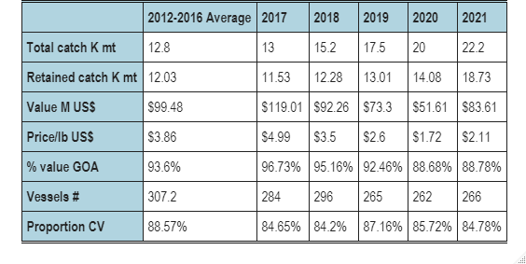

Source: NMFS Alaska Region Blend and Catch-accounting System estimates; NMFS Alaska Region At-sea Production Reports; and ADF&G Commercial Operators Annual Reports (COAR). Data compiled and provided by the Alaska Fisheries Information Network (AKFIN).

Table 3C.1b. Sablefish first-wholesale data from Alaska Fisheries. Production (thousand metric tons), value (million US$), price (US$ per pound), and head and gut share of production, 2012-2016 average and 2017-2021.

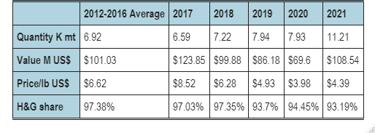

Source: NMFS Alaska Region At-sea and Shoreside Production Reports; and ADF&G Commercial Operators Annual Reports (COAR). Data compiled and provided by the Alaska Fisheries Information Network (AKFIN).

Table 3C.1c. Sablefish global catch (thousand metric tons), U.S. and AK shares of global catch; WA & AK export volume (thousand metric tons), value (million US$), price (US$ per pound) and the share of export value from trade with Japan and China2012-2016 average and 2017-2021.

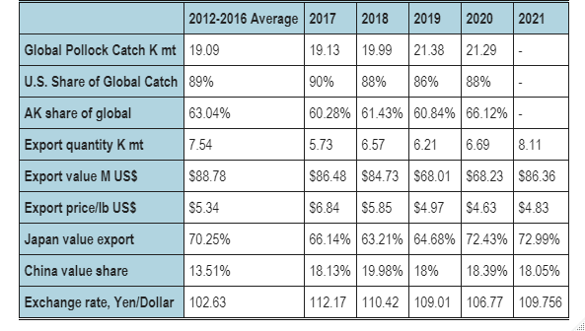

Note: Exports include production from outside Alaska fisheries.

Source: FAO Fisheries & Aquaculture Dept. Statistics <http://www.fao.org/fishery/statistics/en> (Canadian catch for 2018 from personal communication with DFO). NOAA Fisheries, Fisheries Statistics Division, Foreign Trade Division of the U.S. Census Bureau, <http://www.st.nmfs.noaa.gov/commercial-fisheries/foreign-trade/index>. U.S. Department of Agriculture <http://www.ers.usda.gov/data-products/agricultural-exchange-rate-data-set.aspx>.

Table 3C.2a. First stage ecosystem indicator analysis for sablefish, including indicator title and the indicator status of the last five years. The indicator status is designated with text, (greater than = “high”, less than = “low”, or within 1 standard deviation = “neutral” of long-term mean). Fill color of the cell is based on the sign of the anticipated relationship between the indicator and the stock (blue or italicized text = good conditions for the stock, red or bold text = poor conditions, white = average conditions). A gray fill and text = “NA” will appear if there were no data for that year.

| **Indicator category** | **Indicator** | **2018 Status** | **2019 Status** | **2020 Status** | **2021 Status** | **2022 Status** |
| --- | --- | --- | --- | --- | --- | --- |
| Physical | Annual Heatwave GOA Model | neutral | *high* | neutral | neutral | neutral |
| Spring Temperature Surface GOA Satellite | neutral | *high* | *high* | neutral | neutral |
| Spring Temperature Surface SEBS Satellite | *high* | *high* | *high* | neutral | neutral |
| Summer Temperature 250m GOA Survey | neutral | **high** | neutral | neutral | **high** |
| Lower Trophic | Spring Chlorophyll a Biomass GOA Satellite | neutral | **low** | neutral | neutral | neutral |
| Spring Chlorophyll a Biomass SEBS Satellite | neutral | **low** | neutral | neutral | *high* |
| Spring Chlorophyll a Peak GOA Satellite | *low* | **high** | neutral | neutral | neutral |
| Spring Chlorophyll a Peak SEBS Satellite | **high** | *low* | neutral | neutral | neutral |
| Annual Copepod Community Size EGOA Survey | neutral | **low** | neutral | neutral | NA |
| Annual Copepod Community Size WGOA Survey | **low** | *high* | neutral | neutral | NA |
| Summer Euphausiid Abundance Kodiak Survey | NA | neutral | NA | NA | NA |
| Annual Sablefish Growth YOY Middleton Survey | neutral | *high* | neutral | neutral | neutral |
| Upper Trophic | Summer Sablefish CPUE Juvenile Nearshore GOAAI Survey | *high* | *high* | *high* | *high* | *high* |
| Summer Sablefish CPUE Juvenile GOA Survey | NA | neutral | NA | neutral | NA |
| Annual Sablefish Mean Age Female Adult Model | neutral | **low** | **low** | **low** | NA |
| Annual Sablefish Age Evenness Female Adult Model | **low** | **low** | **low** | **low** | NA |
| Summer Sablefish Condition Female Age4 GOA Survey | neutral | **low** | neutral | *high* | NA |
| Annual Arrowtooth Biomass GOA Model | neutral | neutral | *low* | *low* | NA |
| Annual Sablefish Incidental Catch Arrowtooth Target GOA Fishery | **high** | **high** | neutral | neutral | neutral |
| Summer Sablefish Condition Female Adult GOA Survey | *high* | neutral | neutral | neutral | **low** |

Table 3C.2b. First stage socioeconomic indicator analysis for sablefish, including indicator title and the indicator status of the last five years. The indicator status is designated with text, (greater than = “high”, less than = “low”, or within 1 standard deviation = “neutral” of long-term mean). A gray fill and text = “NA” will appear if there were no data for that year.

|  |  |  |  |  |  |  |
| --- | --- | --- | --- | --- | --- | --- |
| **Indicator category** | **Indicator** | **2018 Status** | **2019 Status** | **2020 Status** | **2021 Status** | **2022 Status** |
| Fishery Performance | Annual Sablefish Combined CPUE Alaska Fishery | low | low | low | neutral | NA |
| Annual Sablefish Pot CPUE EBS Fishery | neutral | high | high | high | NA |
| Annual Sablefish Incidental Catch GOA Fishery | high | high | high | neutral | neutral |
| Annual Sablefish Incidental Catch BSAI Fishery | neutral | high | high | high | high |
| Annual Sablefish Condition Female Adult GOA Fishery | neutral | neutral | high | neutral | NA |
| Annual Sablefish Condition Female Adult BSAI Fishery | NA | NA | NA | NA | NA |
| Economic | Annual Sablefish Real Exvessel Value Fishery | neutral | low | low | low | NA |
| Annual Sablefish Real Exvessel Price Fishery | neutral | neutral | low | low | NA |

## Figures

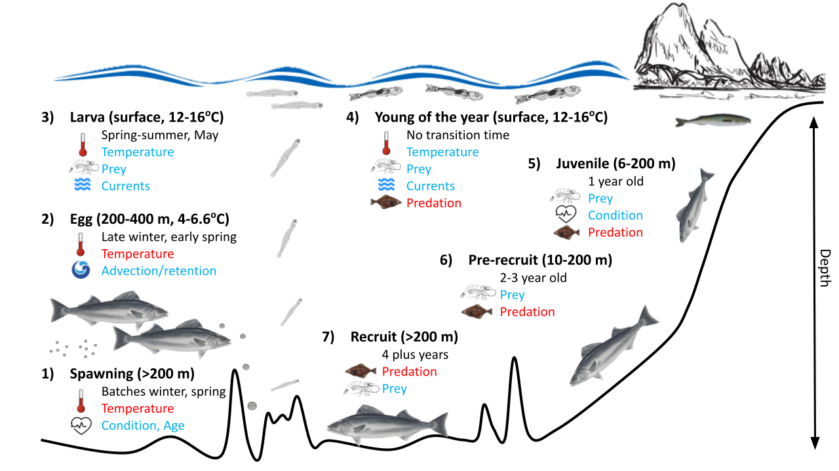

Figure 3C.1. Life history conceptual model for sablefish summarizing ecological information and key ecosystem processes affecting survival by life history stage. Red text indicates that increases in the process negatively affect survival of the stock, while blue text means that increases in the process positively affect survival.

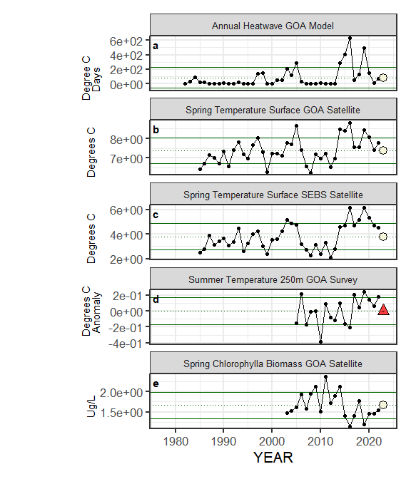

Figure 3C.2a. Selected ecosystem indicators for sablefish with time series ranging from 1977 – present. Upper and lower solid green horizontal lines represent 1 standard deviation of the time series mean. Dotted green horizontal line is the mean of the time series. A symbol appears when current year data are available and follows the traffic light status table designations (triangle direction represents if above or below 1 standard deviation of the time series mean, color represents proposed relationship for stock with blue for good conditions, red for poor conditions, and a white circle is neutral).

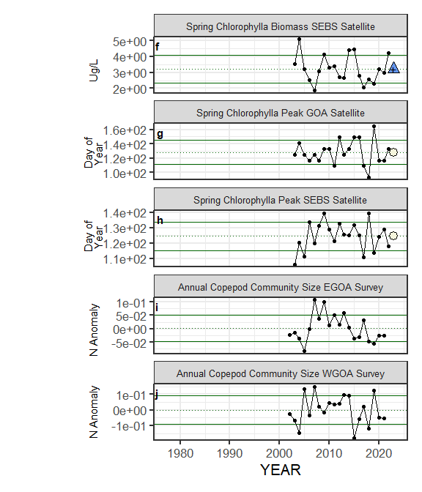

Figure 3C.2a (cont.). Selected ecosystem indicators for sablefish with time series ranging from 1977 – present. Upper and lower solid green horizontal lines represent 1 standard deviation of the time series mean. Dotted green horizontal line is the mean of the time series. A symbol appears when current year data are available and follows the traffic light status table designations (triangle direction represents if above or below 1 standard deviation of the time series mean, color represents proposed relationship for stock with blue for good conditions, red for poor conditions, and a white circle is neutral).

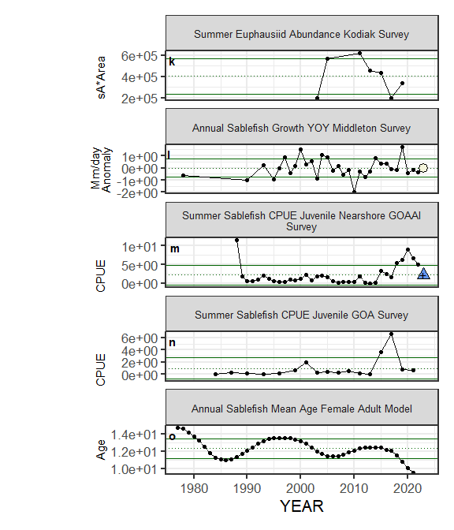

Figure 3C.2a (cont.). Selected ecosystem indicators for sablefish with time series ranging from 1977 – present. Upper and lower solid green horizontal lines represent 1 standard deviation of the time series mean. Dotted green horizontal line is the mean of the time series. A symbol appears when current year data are available and follows the traffic light status table designations (triangle direction represents if above or below 1 standard deviation of the time series mean, color represents proposed relationship for stock with blue for good conditions, red for poor conditions, and a white circle is neutral).

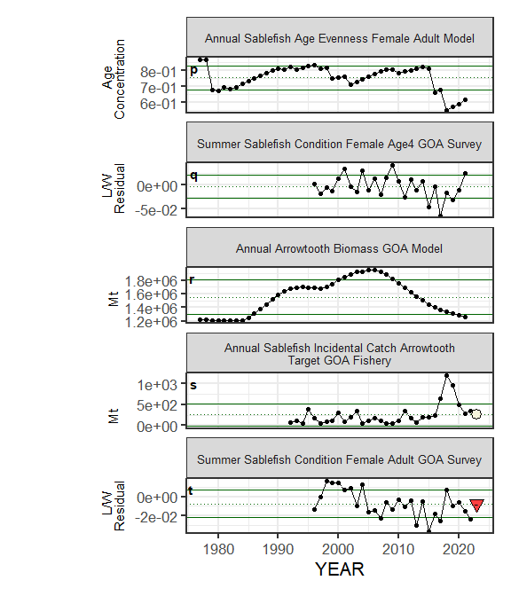

Figure 3C.2a (cont.). Selected ecosystem indicators for sablefish with time series ranging from 1977 – present. Upper and lower solid green horizontal lines represent 1 standard deviation of the time series mean. Dotted green horizontal line is the mean of the time series. A symbol appears when current year data are available and follows the traffic light status table designations (triangle direction represents if above or below 1 standard deviation of the time series mean, color represents proposed relationship for stock with blue for good conditions, red for poor conditions, and a white circle is neutral).

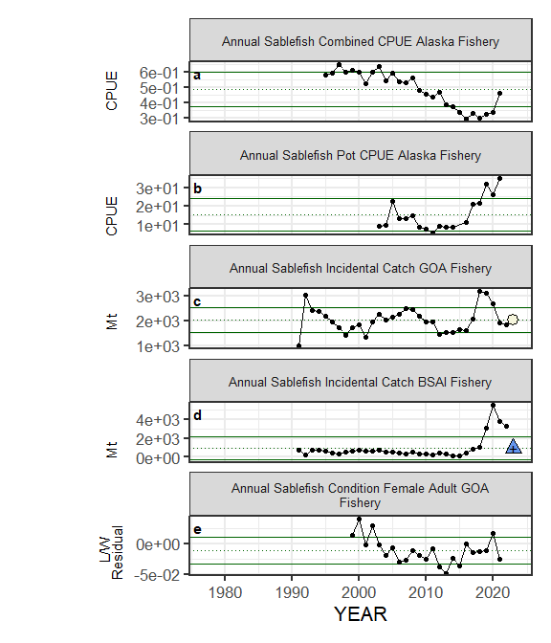

Figure 3C.2b. Selected socioeconomic indicators for sablefish with time series ranging from 1977 – present. Upper and lower solid green horizontal lines represent 1 standard deviation of the time series mean. Dotted green horizontal line is the mean of the time series. A symbol appears when current year data are available and follows the traffic light status table designations (triangle direction represents if above or below 1 standard deviation of the time series mean, color only designates above (blue) or below (red) one standard deviation of the time series mean, no implied relationship with the stock).

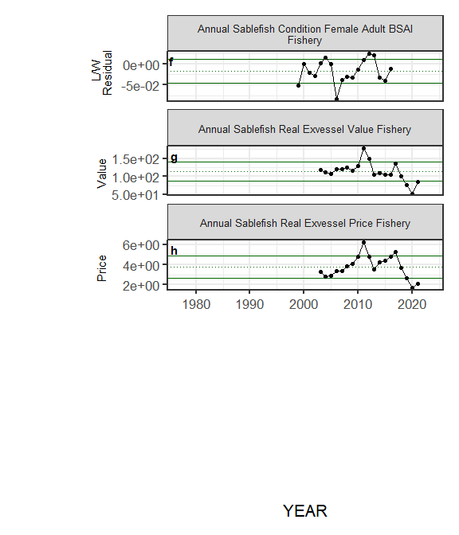

Figure 3C.2b (cont.). Selected socioeconomic indicators for sablefish with time series ranging from 1977 – present. Upper and lower solid green horizontal lines represent 1 standard deviation of the time series mean. Dotted green horizontal line is the mean of the time series. A symbol appears when current year data are available and follows the traffic light status table designations (triangle direction represents if above or below 1 standard deviation of the time series mean, color only designates above (blue) or below (red) one standard deviation of the time series mean, no implied relationship with the stock).

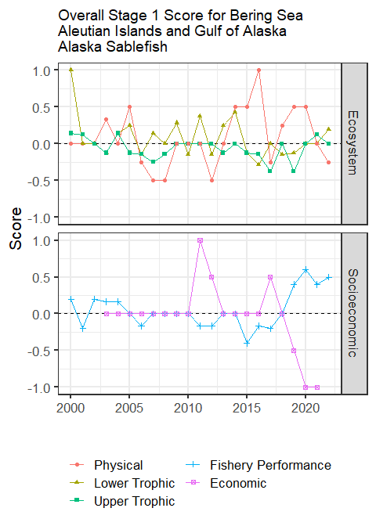

Figure 3C.3. Simple summary traffic light score by category for ecosystem and socioeconomic indicators from 2000 to present.

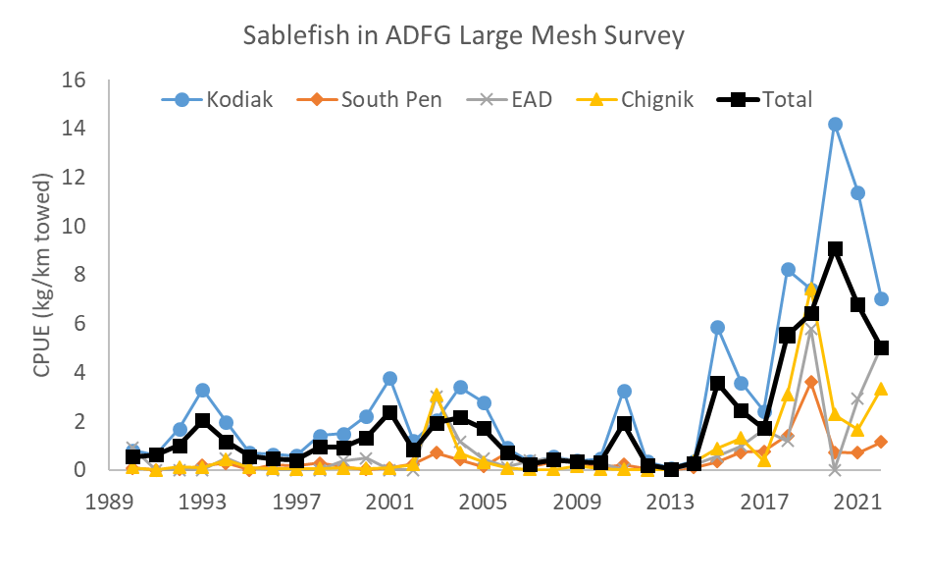

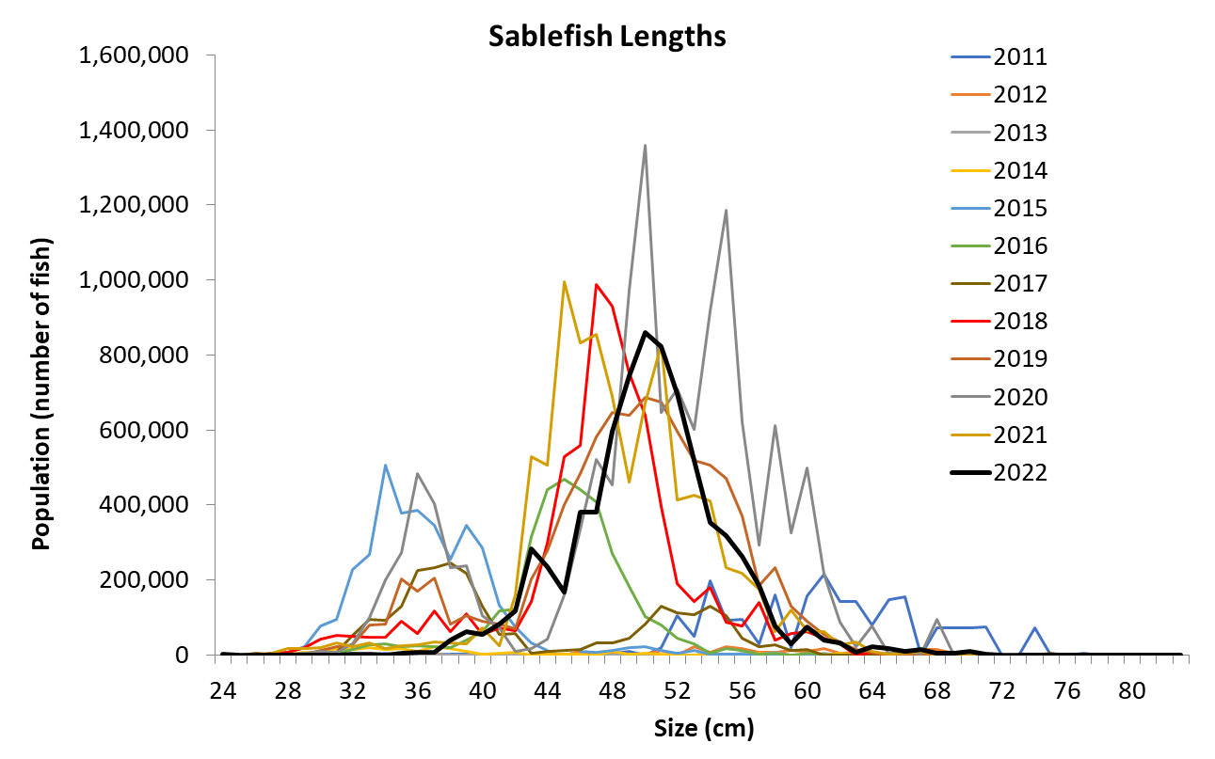

Figure 3C.4. Catch-per-unit-effort from 1990 to present (top graph) and length (cm) composition (bottom graph) from 2011 to present of sablefish in the nearshore ADF&G large-mesh survey (EAD = Eastern Aleutians District).

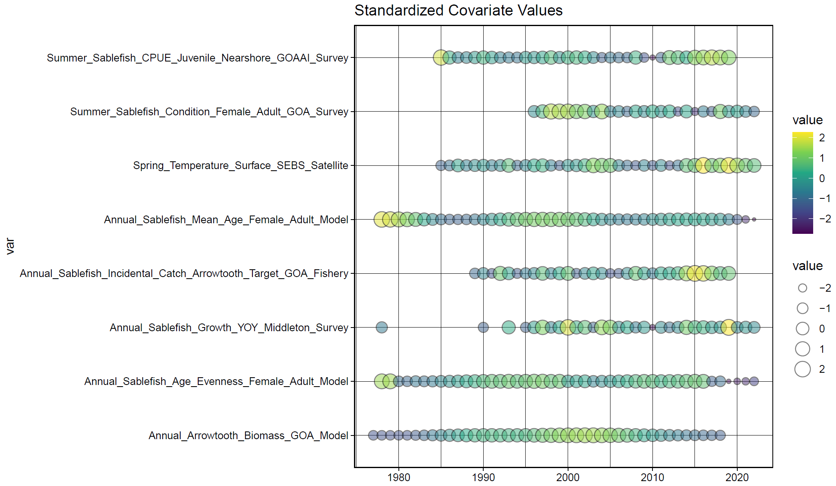

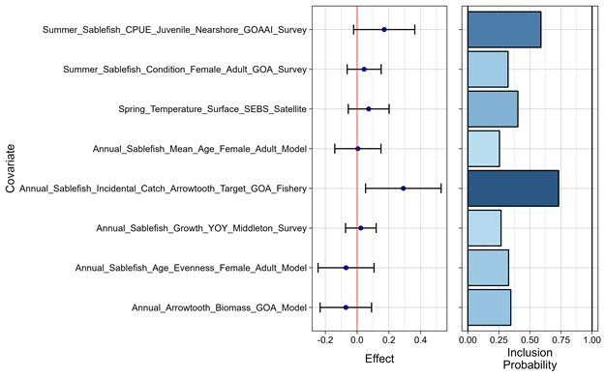

Figure 3C.5. Bayesian adaptive sampling output showing (top graph) standardized covariates and (bottom graph) the mean relationship and uncertainty (95% confidence intervals) with log sablefish recruitment, in each estimated effect (left bottom graph), and marginal inclusion probabilities (right bottom graph) for each predictor variable of the subsetted covariate set.

Appendix 3D. Trawl Catches of Small Sablefish in the Eastern Bering Sea

Kevin Siwicke and Katy Echave

October 2022

In recent years sablefish bycatch has increased in the pelagic and non-pelagic trawl fisheries occurring in the Eastern Bering Sea (EBS; Goethel et al., 2020, appendix 3E). Prior to 2016, sablefish bycatch was relatively low by weight in non-pelagic trawl fisheries, and there was almost no sablefish bycatch in the pelagic trawl fishery (Table 3D.1). Increased sablefish bycatch was particularly high in the pelagic trawl fisheries occurring in the EBS in 2020, with bycatch in 2020 more than 6 times what it was in 2018 (Table 3D.1). In 2021, sablefish bycatch in pelagic trawl fisheries was the third highest for the region, behind 2019 and 2020, while bycatch in the non-pelagic trawl fisheries reached a new peak (Table 3D.1). High bycatch of sablefish in pelagic trawl fisheries in 2020 was hypothesized to include age-1 fish from the 2019 year class (Goethel et al., 2020, appendix 3E). The decrease in pelagic trawl sablefish bycatch in 2021 may be because fish in the previously encountered large year classes have grown and are moving into deeper areas outside of the pelagic trawl fishery, and/or the 2020 year class may not be as large and is therefore not being encountered. Sablefish bycatch in 2022 is already higher than pre-2019 levels in both pelagic and non-pelagic trawl fisheries (Table 3D.1). Previous versions of this appendix (Goethel et al., 2020; Goethel et al., 2021) filtered catch data to observed hauls with greater than 10 sablefish, while this year we include all of the available data, in particular, all samples collected in the pelagic trawl sector during 2015. As a result of this and updated observer databases, some of the numbers in our tables will vary from previous years.

Observer collected lengths provide one way to assess what sizes of fish are encountered and if there have been any changes through time that may indicate the presence of different year classes. In 2020, there was evidence of an influx of small sablefish which were possibly age-1 fish (<40 cm); however, the frequency of occurrence of these small fish was low overall (Figure 3D.1). Small sablefish were not evident in 2021 observer lengths, and as of now do not appear in the length distribution for 2022 (Figure 3D.1). The mean length of measured fish increased from 51.3 cm in 2020 to 52.5 cm in 2021; though incomplete, the current mean length of measured sablefish in 2022 is 53.0 cm (Figure 3D.1). Non-pelagic trawl gear encountered slightly larger sablefish on average compared to pelagic gear in the same years, 2020 – 2022 (Figures 3D.1 and 3D.2). The annual change in length distributions in the non-pelagic gear may also be reflective of large year classes growing in subsequent years. The lengths in 2016 were smaller, and encompass a narrow range of what is likely comprised of the 2014 year class (Figure 3D.2). The length distribution broadens in each subsequent year as more large cohorts are encountered. Beginning in 2018, there is evidence of more than one year class present in the non-pelagic trawl observer data (Figure 3D.2). As time progresses, these large year classes grow and this is reflected in the increase in the average lengths from 2018 to 2022. There appears to be more large sablefish (>70 cm) present in the 2022 non-pelagic lengths so far (Figure 3D.2), but a full accounting of 2022 will not be available until next year.

When there is sablefish catch, the average weight in each observed haul can aid in assessing which year classes were encountered (where the average weight is the extrapolated sablefish weight in a haul divided by the extrapolated number of sablefish). We focused on sablefish catch data in the EBS from 2015 to 2022 for non-pelagic and pelagic trawl fisheries (Table 3D.2). When the average weight for the haul was less than 0.5 kg, we assumed that age-1 sablefish were the predominant age group. The non-pelagic trawl fishery frequently encountered age-1 sablefish in 2015 and 2020, and to a lesser degree in 2017, indicating that the 2014, 2016, and 2019 year classes were more prevalent in the catch than in other years (Figure 3D.3 and Table 3D.2). This is particularly visible in the 0­–100 m depth strata (Figure 3D.3, top row). The pelagic trawl fishery also caught small sablefish in 2015, 2017, and 2020 in the shallow depth strata, which are the 2014, 2016, and 2019 year classes (note that data in 2015 are limited for the pelagic fishery, with less than 10 fish in each haul, and only 16 hauls with sablefish present). Bycatch of small sablefish (length <40 cm or average weight <0.5 kg), usually occurs before mid-April in both pelagic and non-pelagic trawl fisheries (Figure 3D.4). Following the appearance of large 2014 and 2016 year classes as age-1 in 2015 and 2017, the average weight of sablefish removals increased each subsequent year for all depths combined, suggesting that these fish continued to be intercepted as age-2, age-3, and age-4 in each subsequent year (Figure 3D.3). There was a small signal of age-1 sablefish captured by the pelagic trawl fishery between 0 and 100 m (Table 3D.2 and Figure 3D.3). There is not enough information available yet for 2022 to make a determination, but so far, there is no indication of age-1 sablefish comprising much of the bycatch.

In 2022, high sablefish bycatch continues to be prevalent in the non-pelagic trawl fisheries, but appears to decline in the pelagic trawl fishery in the EBS (Table 3D.1). Additionally, the spatial extent of sablefish encountered in both the non-pelagic and pelagic trawl fisheries in the EBS has steadily declined since 2020, particularly in the pelagic fisheries (Figures 3D.5 and 3D.6). Locations of sablefish catch in pelagic trawl gear in 2022 have returned to historical norms, which corresponds to nearshore areas concentrated near Unimak Pass (Figure 3D.6). However, observer data indicates that the majority of sablefish bycatch in the EBS trawl fisheries consists of the ageing 2016 and 2019 year classes (Figures 3D.1 and 3D.2). It is possible that sablefish will continue to be caught in large numbers in the EBS pelagic and non-pelagic trawl fisheries as the 2019 year class ages.

Based on this analysis, we expect that any future increase in small sablefish bycatch (i.e., age-1) to be evident in observer data from the earlier part of the year (first 100 days) and in depths between 0 and 100 m. Additionally, we expect that the spatial extent of sablefish bycatch caught in pelagic gear will be evident along the entire EBS shelf break, and not just near Unimak Pass. Bycatch in weight will not necessarily be large, as the weight per fish is less than 0.5 kg. However, these large year classes will likely result in elevated levels of sablefish bycatch by weight in the subsequent years (i.e., age-2+), at all depths, and during the summer through the end of the year.

## References

Goethel, D. R., D. H. Hanselman, C. J. Rodgveller, K. H. Fenske, S. K. Shotwell, K. B. Echave, P. W. Malecha, K. A. Siwicke, and C. R. Lunsford. 2020. Assessment of the sablefish stock in Alaska. In Stock assessment and fishery evaluation report for the groundfish resources of the GOA and BS/AI. North Pacific Fishery Management Council.

Goethel, D. R., D. H. Hanselman, C. J. Rodgveller, K. B. Echave, B. C. Williams, S. K. Shotwell, J. Y. Sullivan, P. F. Hulson, P. W. Malecha, K. A. Siwicke, and C. R. Lunsford. 2021. Assessment of the sablefish stock in Alaska. In Stock assessment and fishery evaluation report for the groundfish resources of the GOA and BS/AI. North Pacific Fishery Management Council.

Tables

Table 3D1. Sablefish bycatch (t) in the non-pelagic and pelagic trawl fisheries occurring in the eastern Bering Sea. Data provided by the NORPAC catch database accessed via the Alaska Fishery Information Network (AKFIN).

|  |  |  |  |
| --- | --- | --- | --- |
| Year | Non-pelagic | Pelagic | Total |
| 2010 | 29 | <1 | 29 |
| 2011 | 44 | <1 | 44 |
| 2012 | 92 | <1 | 92 |
| 2013 | 133 | <1 | 133 |
| 2014 | 34 | 0 | 34 |
| 2015 | 17 | <1 | 17 |
| 2016 | 238 | 20 | 258 |
| 2017 | 587 | 107 | 694 |
| 2018 | 624 | 424 | 1,048 |
| 2019 | 1,270 | 1,260 | 2,530 |
| 2020 | 1,062 | 2,570 | 3,632 |
| 2021 | 1,383 | 788 | 2,171 |
| 2022 | 731 | 117 | 848 |

Table 3D.2. Number of observed hauls for the Eastern Bering Sea pelagic and non-pelagic trawl fisheries that included sablefish, and the number of hauls with average sablefish weight <0.5 kg, which are assumed to be predominantly age-1 fish, by year. Data provided by the NORPAC catch database accessed via the Alaska Fishery Information Network (AKFIN).

|  |  |  |  |  |
| --- | --- | --- | --- | --- |
|  | Non-pelagic | | Pelagic | |
| Year | Total hauls | Hauls <0.5 | Total hauls | Hauls <0.5 |
| 2015 | 216 | 147 | 16 | 10 |
| 2016 | 455 | 4 | 337 | 3 |
| 2017 | 682 | 23 | 831 | 366 |
| 2018 | 574 | 1 | 900 | 11 |
| 2019 | 1,076 | 12 | 1,693 | 34 |
| 2020 | 920 | 50 | 2,037 | 208 |
| 2021 | 1,158 | 2 | 858 | 20 |
| 2022 | 384 | 0 | 231 | 1 |

## Figures

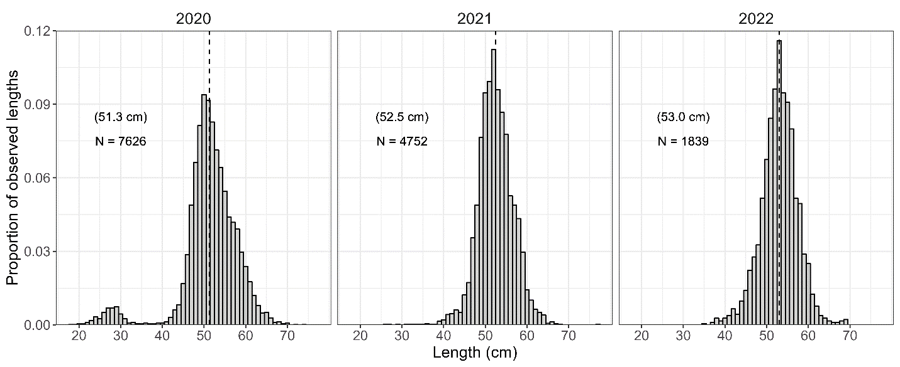

Figure 3D.1. Proportions of sablefish lengths measured by observers in Eastern Bering Sea pelagic trawl fisheries. The vertical dashed line indicates the mean length each year (value shown in parentheses, with sample size, N, below). Note that complete length data taken in 2022 will not be available until next year. Data provided by the NORPAC length database accessed via the Alaska Fishery Information Network (AKFIN).

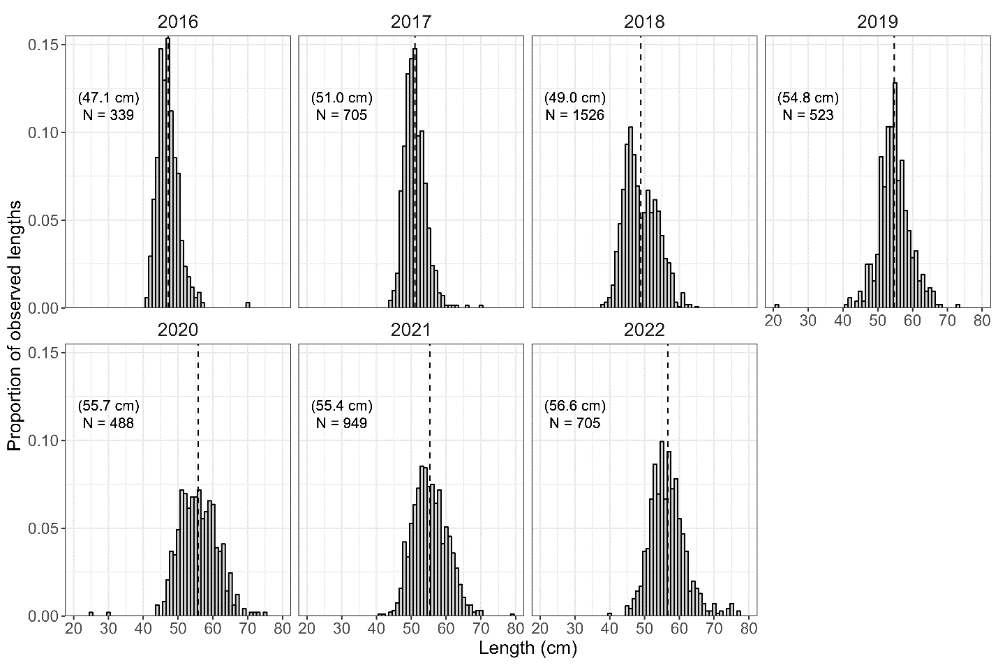

Figure 3D.2. Proportions of sablefish lengths measured by observers in Eastern Bering Sea non-pelagic trawl fisheries. The vertical dashed line indicates the mean length each year (value shown in parentheses, with sample size, N, below). Note that complete length data taken in 2022 will not be available until next year. Data provided by the NORPAC length database accessed via the Alaska Fishery Information Network (AKFIN).

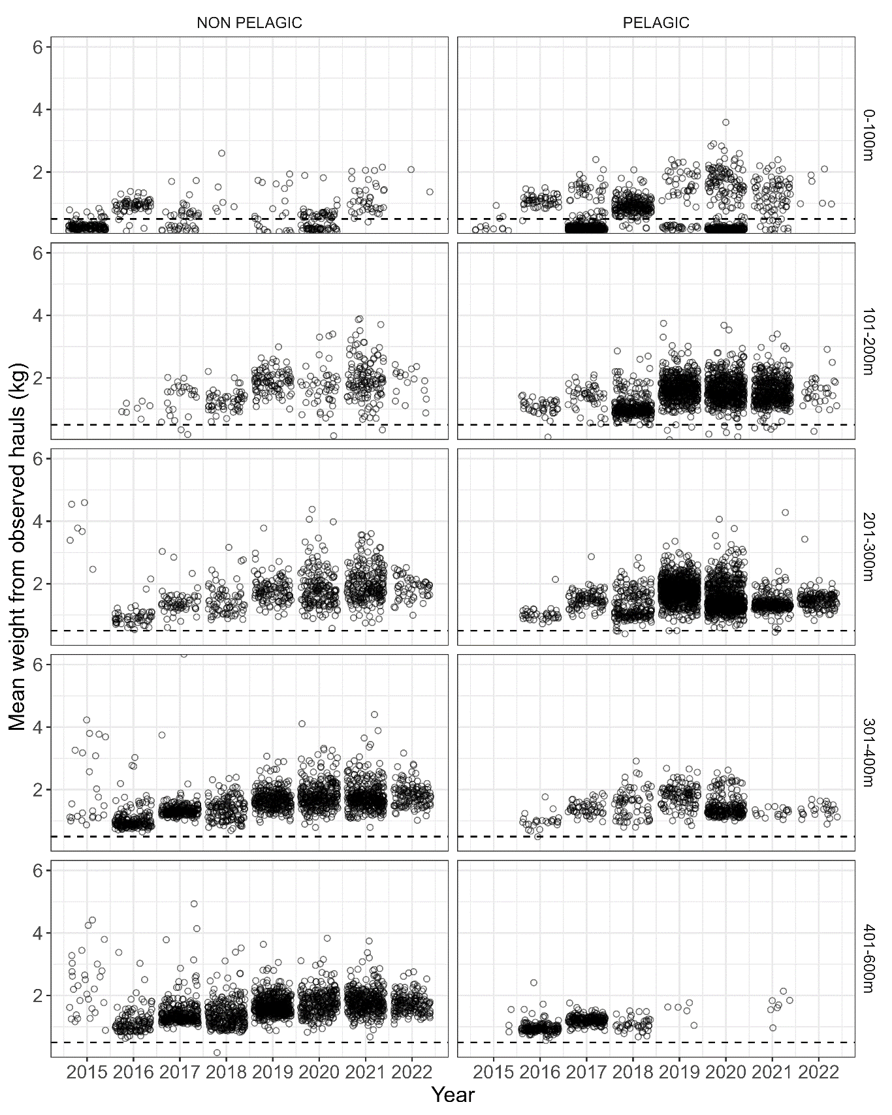

Figure 3D.3. Distributions of the mean weight of sablefish from observed hauls in the Eastern Bering Sea non-pelagic (left) and pelagic (right) trawl fisheries. Catches are binned by 100- or 200-m depth bins (increasing in depth from top to bottom panels). The horizontal dashed lines at 0.5 kg delineate likely age-1 sablefish dominating the catch when more of the distribution is below the line. Catch data from 2022 is incomplete. Data provided by the NORPAC catch database accessed via the Alaska Fishery Information Network (AKFIN).

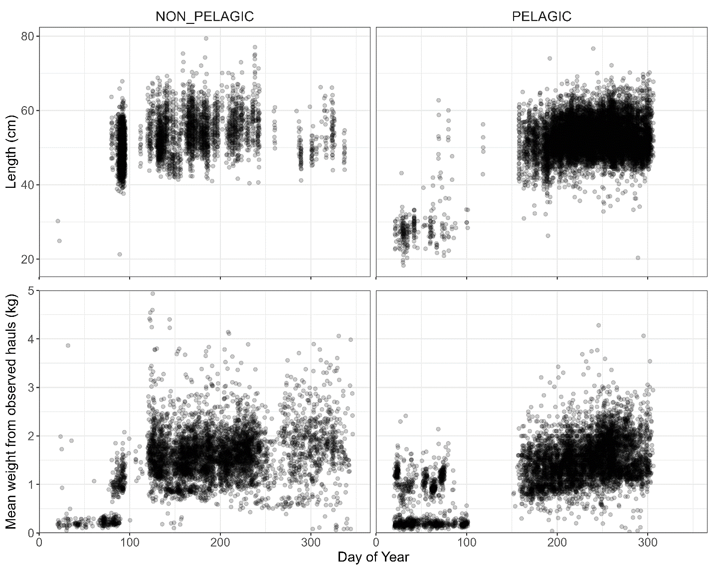

Figure 3D.4. Sablefish bycatch by lengths (top) and average weight (bottom) throughout the year from all available observer data in the Eastern Bering Sea between 2010 and 2022 for non-pelagic (left) and pelagic (right) trawl fisheries. Length and catch data provided by the NORPAC length and catch database accessed via the Alaska Fishery Information Network (AKFIN).

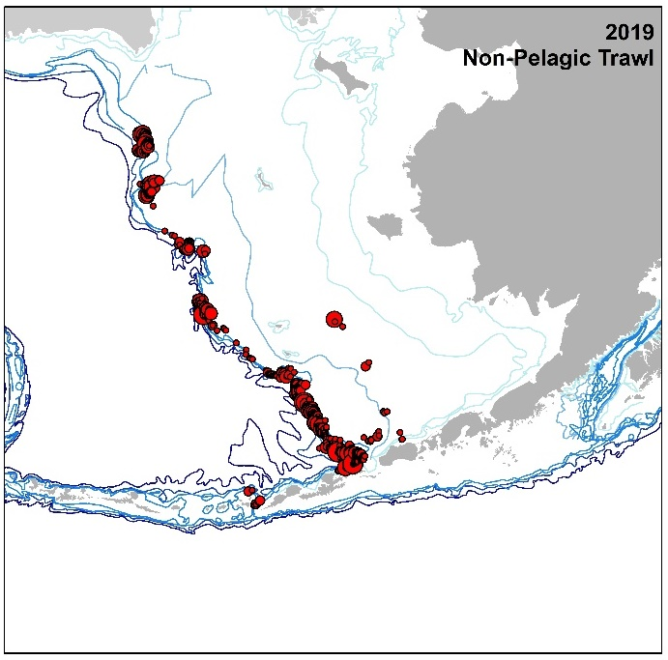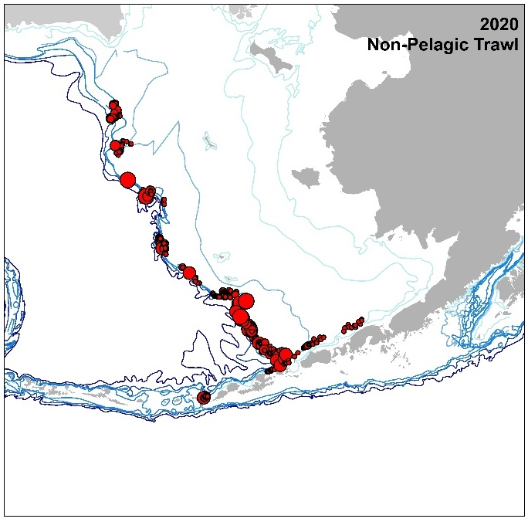

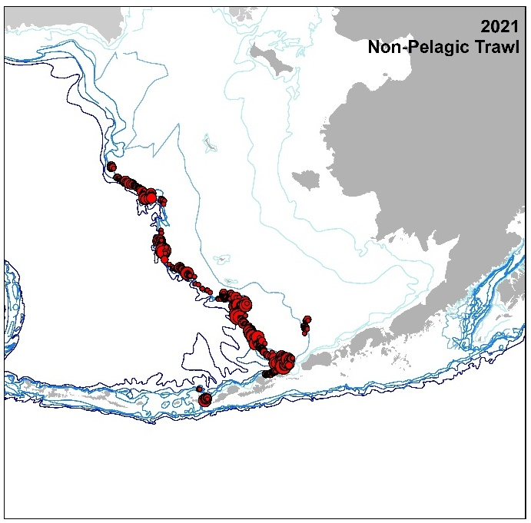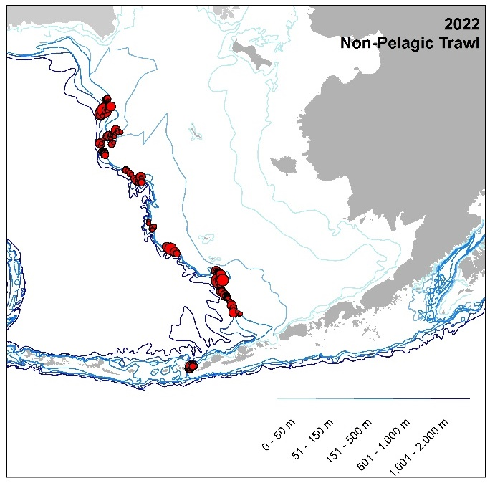

Figure 3D.5. Spatial distribution of observed sablefish bycatch (filled red circles where size reflects weight) occurring in non-pelagic trawl gear in the eastern Bering Sea from 2019 to 2022. Data provided by the NORPAC catch database accessed via the Alaska Fishery Information Network (AKFIN). Locations shown have been generalized to generic center locations of a 20 x 20 sq. km grid if there were 3 or more unique vessels, as per NOAA/NMFS regulations.

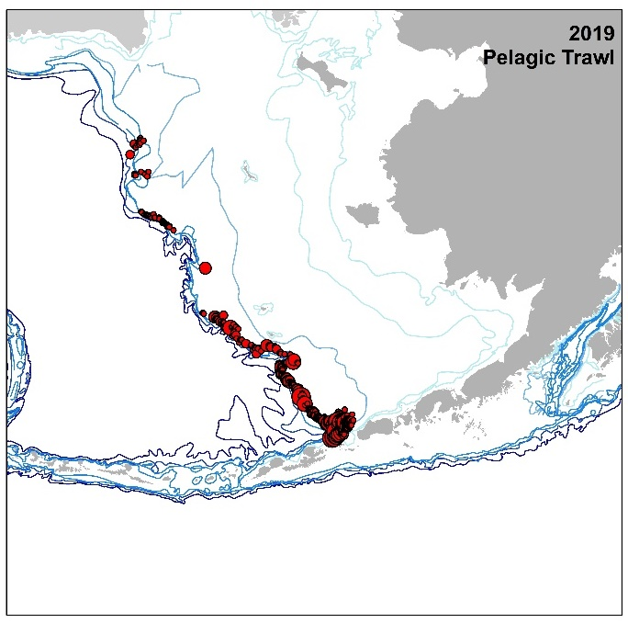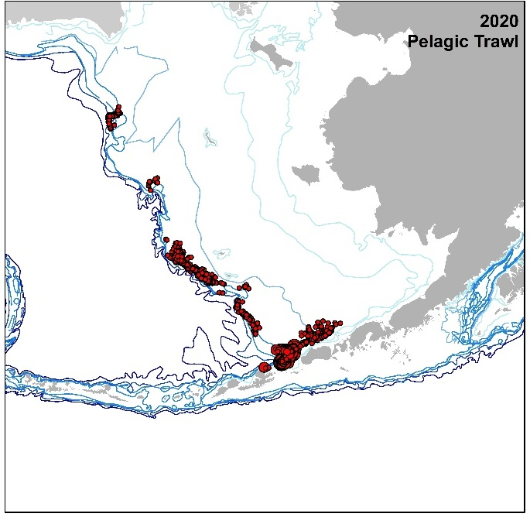

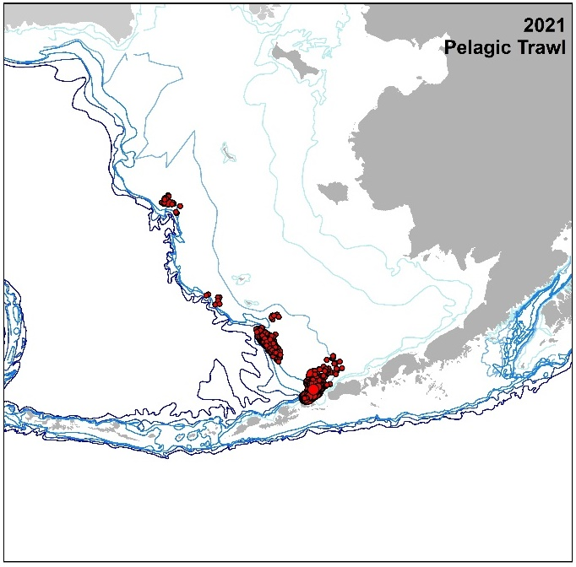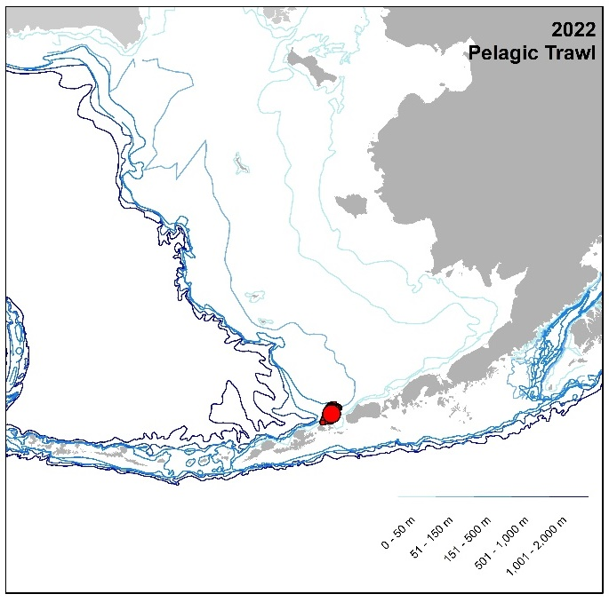

Figure 3D.6. Spatial distribution of observed sablefish bycatch (filled red circles where size reflects weight) occurring in pelagic trawl gear in the eastern Bering Sea from 2019 to 2022. Data provided by the NORPAC catch database accessed via the Alaska Fishery Information Network (AKFIN). Locations shown have been generalized to generic center locations of a 20 x 20 sq. km grid if there were 3 or more unique vessels, as per NOAA/NMFS regulations.

Appendix 3E. Further Analysis of Fishery Dependent Data

Cara Rodgveller

October 2022

Summary

1. The fixed gear fishery has been rapidly switching to pots (comprising 74% of Alaska fixed gear catch in 2021; Table 3E.1, Table 3E.2, Figure 3E.1).
2. Hook and line (HAL) gear sample sizes are down; in recent years there is an absence of data in the BS and AI (Table 3E.3, Figure 3E.2, Figure 3E.3).
3. HAL CPUE trends differ between logbook and observer data in 2020 and 2021, in years and areas where there is enough data for an evaluation (Table 3E.3, Figure 3E.2, Figure 3E.3).
4. HAL CPUE fluctuations do not reflect increases in survey relative population weights, but fishery data is delayed one year and the survey index increased steeply in 2022 (Table 3E.3).
5. Pot CPUE may be increasing in the WGOA, CGOA, and WY (Table 3E.2).
6. In collaboration with UAF, a new, standardized fishery data catch rate index has been developed, which includes pot and HAL gear and observer and logbook data. The results are presented in this appendix and will be used in the sablefish model in the near future (Figure 3E.4).
7. Whale depredation and presence when HAL gear is being hauled is sporadic in observer data and more stable in logbook data. Logbook data shows that sperm whale presence may be decreasing in HAL gear in the EGOA (Figure 3E.5, Figure 3E.6).
8. Whale depredation (presence of whales and damaged fish or gear) of pot gear in the GOA has been documented in logbooks in 2020 and 2021 (Table 3E.4).

Fixed Gear Fishery Dynamics

Recent Trends

The following summarizes recent major events and management measures associated with Alaskan sablefish:

1983 – 1994: the U.S. longline fishery expanded in 1983 and was year-round until it shortened to just 10 days in 1994.

1985: sablefish quota in the GOA was assigned by gear type: 20% to trawl gear in the Western and Central GOA, 5% to trawl gear in the Eastern GOA, and the remainder to fixed gear.

1986 – 1989: pot fishing was banned in the eastern GOA in 1986, the Central GOA in 1987, and the Western GOA in 1989.

1990: sablefish quota in the BS and AI was assigned by gear type: 50% to trawl in the BS and 25% in the AI, with the remainder going to fixed gear.

1992: pot fishing was banned in the BS.

1995: the Individual Fishing Quota (IFQ) and Community Development Quota (CDQ) system was implemented.

1996: pot fishing ban was repealed in the BS.

2000: pot fishing increased in the BSAI.

2017: pot fishing was allowed in the GOA.

2018 – 2022: catch in pots has increased rapidly.

Pot Gear Usage

Since pot fishing became legal in the GOA, it rapidly expanded and in 2021 74% of the fixed gear catch in Alaska was taken in pots, up from 50% in 2020. As of October 3, 2022, 83% of the Alaska-wide fixed gear catch was in pot gear (Figure 3E.1). This rapid transition has been possible because of the development of collapsible, lightweight “slinky pots” that take up less space than rigid pots, have the ability to be fished on smaller vessels, and require less upfront capital investment. Pot fishing has been legal in the BSAI over a much longer period and mainly consists of rigid pots, which are more common on large vessels; however, slinky gear is used in these areas as well. In 2022, slinky and rigid pot categories were added to observer electronic monitoring review, landings, and current observer special projects. Thus, data are just beginning to be collected on the relative frequency of usage of each pot type.

Catch-per-Unit Effort (CPUE) Index Development

Fishery information is available from sets that target sablefish in the IFQ fishery. Records of catch and effort for these vessels are collected by human and electronic observers and by vessel captains in voluntary and required logbooks. Fishery data from the Observer Program are available since 1990. Logbooks have been required by NMFS for vessels 60 feet and over beginning in 1999 and sablefish data may be filled out voluntarily in logbooks for vessels under 60 ft. Only logbook data that is voluntarily given to the International Pacific Halibut (IPHC) port samplers is available. This data is provided by the IPHC to Auke Bay Laboratories for use in the sablefish assessment (i.e., logbooks from vessels of all sizes are turned in voluntarily to IPHC). Some data are included in both data sets if an observer was onboard and a logbook was turned in.

Since 2000, a single, combined HAL longline fishery catch rate index has been derived from data recorded by observers and by captains in logbooks for use in the assessment model and for alternate apportionment strategies. From 1990 – 1999 the index was composed only of observer data. This nominal CPUE index is fit directly in the stock assessment model as an area aggregated index. Data is filtered for quality and the mean catch per unit effort (CPUE) for these sets is scaled to a relative population weight by the total management area size.

In the years when both logbook and observer CPUEs are available, the two sources are combined into one index by weighting each data set by the inverse of the coefficient of variation. Because of larger sample sizes in the logbook data set compared to observer data, logbook confidence intervals are generally narrower and are weighted more heavily in the combined fishery index of abundance. Nominal CPUE is used for the index and it is not standardized, at this time, to account for factors that may affect CPUE. A UAF Ph.D. student (Matt Cheng) is working on a standardized index, which is described further in this appendix. The CPUE index in recent years may be less reflective of the fishery because it currently does not include pot gear, which has accounted for > 50% of the catch since 2020. There have also been sample size limitations for HAL gear as the fishery moves to pot gear.

Electronic monitoring (EM) has replaced human observers on some vessels fishing pot and HAL gear in the sablefish fishery as well as other fixed gear fisheries. A sub-sample of video is reviewed and a count of each species is recorded. Unlike data from sets with human observers, the EM data stream made available to authors does not include measured weights nor a measure of effort, such as the number of hooks and hook spacing. Therefore, at this time we cannot use EM data to estimate HAL CPUE. However, efforts are underway to enter HAL effort data from EM logbooks starting in 2022.

Defining Target

#### Observer Data

For analysis of observed sablefish catch rates in the sablefish directed fishery, we first have to determine the target of the set, because the target is not declared in the observer data set. To do this, we compare the catch of sablefish to other target species that are typically caught on longline gear: Greenland turbot, the sum of several rockfish species, shortspine thornyhead, Pacific halibut, and Pacific cod. Whichever of these target species/groups has the greatest weight in the set is regarded as the set target. Catch rates and sample sizes for observed fishery data presented here only include sets where sablefish were determined to be the target. The final CPUE index excludes sets where there was killer whale depredation in observer data.

#### Logbook Data

Logbooks include the target of the set, so unlike observer data, no calculations are required to determine the target. Sets where there was killer whale depredation are not excluded from catch rate calculations because whale presence and fish damage has only recently been documented in logbooks (starting in 2017).

Hook and Line Analyses

#### Sample Sizes

Pot gear has increased rapidly and has been the dominant gear type since 2021 (Figure 3E.1). As pot catch has increased, fishery data from this sector has also increased (Table 3E.2); conversely, HAL sample sizes in fishery data have decreased (Table 3E.3). This has become problematic in recent years when there was no data in the BS and AI in some years in both the logbook and observer HAL data sets (Table 3E.3). When there is a lack of HAL data in an area, the entirety of the Alaskan sablefish population is not reflected in the index in that year. Excluding areas only in some years introduces variability to the time series that may not be reflective of the Alaska population trend. Starting in 2014 there have been multiple, very large year classes. These young fish generally first appear in larger numbers in the BSAI and WG prior to the rest of the GOA. Due to declining HAL data in the BSAI, we have a paucity of fishery data in these geographic areas during a dynamic time in the sablefish population.

#### Human Observers

The total weight of sablefish catch observed on HAL gear, focusing only on target sets that were used for catch rate analyses, decreased to 1% (295 mt) of the total catch in 2021 from 9% (980 mt) in 2020. Adding HAL hauls with electronic monitoring review, the total weight observed remains at 1%. Sample sizes of targeted sablefish HAL data have decreased in recent years (Table 3E.3), while the fishery has rapidly transitioned to pot gear (Table 3E.1, Figure 3E.1). This is particularly true in the BS and AI; there was no data in the AI in 2020 and 2021 and there was only one vessel in the BS in 2021 (Table 3E.3). In addition to data concerns in the BS and AI, we cannot present CPUE in the AI, BS, WG, or CG because sample sizes for HAL gear were too low to report due to confidentiality requirements (Table 3E.3). At the same time, sample sizes in pot gear overall have increased substantially, particularly starting in 2020 (Table 3E.2).

CPUEs of HAL observer data in the eastern GOA decreased by 10% in WY and 27% in the EY/SE area in 2021 (Table 3E.3, Figure 3E.2). Conversely, there were continued increases in the longline survey relative population weight index in all areas (Figure 3E.3). The longline survey relative population weight index has been increasing steeply in the western areas and the CG since 2020; however, it is just starting to increase in WY and is increasing slowly in EY/SE. Because the fishery data is delayed a year, there may be similar increases in the 2022 observer CPUE data. However, with dwindling HAL sample sizes and a lack of data, CPUEs may become more variable and some areas may not be represented at all in the fishery catch rate index.

#### Logbooks

HAL logbook sample sizes are substantially higher than observer samples sizes in the GOA, especially since 2004 (Table 3E.3). Logbook participation increased sharply in 2004 in all areas, primarily because the International Pacific Halibut Commission (IPHC) started collecting logbooks dockside in all areas. This trend continued to increase through 2018 or 2019, depending on the FMP subarea. This is likely due to the strong working relationship the IPHC has with fishermen and their diligence in collecting logbooks dockside. However, like observer data, recently there has been a lack of data or data from a single vessel in the BS and AI (Table 3E.3). There was also a decrease in data in the WG in 2020 and 2021. After the HAL data was screened, 85% of sets came from vessels under 60 ft., up from 55% in 2020. This may be because vessels over 60 ft. are more likely to fish pot gear. A higher proportion of the catch is documented in logbooks than by observers (7% in 2021; 1,459 mt). This coverage is lower than in past years because pot gear has been the dominant gear type since 2021 and continues to increase each year (Table 3E.1, Figure 3E.1).

Because of larger sample sizes in the logbook data set compared to observer data, logbook confidence intervals are generally narrower (Figure 3E.2) and, therefore, the logbook data has more weight in the CPUE index. Like observer data, the lack of data in western areas disrupts the time series. Unlike the human observer data, CPUE in the CG increased by 63%, 44% in WY, and 20% in EY/SE (Table 3E.3, Figure 3E.2, Figure 3E.3). In general, in both data sets, CPUEs are highest in the EY/SE and WY areas, but in 2021 the CPUE in the CG was within 2 – 3% of the eastern GOA CPUEs. Note that the confidence intervals in the CG are much wider than other years in the time series and includes a high CPUE from one vessel (Figure 3E.2).

Pot Fishery Data

Pot Fishery Catch

In response to increased interest in using pot gear to catch sablefish, partially due to an increase in sperm whale depredation in the GOA, the North Pacific Fishery Management Council (NPFMC) passed a regulation to allow pot fishing in the GOA starting in the 2017 fishery (81 FR 95435, January 27, 2017). Since then the pot fishery has rapidly expanded throughout the Gulf of Alaska and was responsible for 74% of the catch in Alaska in 2021 and, as of October 3, 2022, 83% of the Alaska-wide fixed gear catch in 2022 (Figure 3E.1). The number of vessels fishing pot gear in the Gulf of Alaska and the Bering Sea increased dramatically in 2020 (Table 3E.1). Pot gear deliveries have also climbed steeply, particularly in 2021. At the same time, the delivery weight from HAL vessels is decreasing. The transition to pot gear can also be detected by the number of vessels fishing two gears type, potentially testing pot gear. This increased particularly in the CG, WY, and EY/SE starting in 2020.

The amount of catch in each pot type (hard or slinky) was collected for the first time in 2022. As of 10/28/22, slinky pots made up 33% of the retained catch in the AI, 42% in the BS, 19% in the WG, 67% in the CG, 85% in WY, and 93% in EY/SE. There are more smaller-sized vessels in the WY and EY/SE areas and these vessels are more likely to use slinky pots, as they are easier to store and maneuver in limited space. Pot type will continued to be collected in future years.

Pot Gear Analyses

#### Human Observer

There are now five full years of pot fishing data in the GOA. The number of vessels and sets with observers has increased, particularly in 2020 or 2021, depending on the area (Table 3E.2). It is difficult to have confidence in the observer data CPUE estimates or discern any trends at this time because there are few vessels prior to 2020, which increases uncertainly in annual CPUE. If the increase in observed sets that started in 2020 continues, a time series with reasonable uncertainty may emerge. It is important to account for the catch rates from pot gear given the rapid change in catch from HAL to pot gear.

Logbook

Compared to observer data, the logbook data set contains more vessels and more sets in all areas of the GOA (Table 3E.2). The quantity of data increased steeply in 2020 in the CG, WY, and EY/SE. The number of pot vessels participating in the logbook program is highest in the CG and WY. With higher sample sizes in logbook data, SEs and CVs were generally lower than observer data; therefore, there is more confidence in these estimates of CPUE.

Pot Gear Update

During this rapid increase of pot gear and slinky pot use in the GOA, vessels have experimented with using escape rings to help minimize catch of small sablefish; however, currently no regulations exist requiring the use of escape rings. The use of escape rings and escape ring size affects the size distribution of catch and resultant CPUE, but currently there is no information on the size of escape rings or their prevalence in the fishery.

The following projects have been initiated to explore incorporating pot gear data into the combined CPUE index:

1. EM video review now includes slinky and hard pot categories. This will be an important component, as EM has continued to grow in popularity.
2. Fishery catch now includes pot gear type (slinky or hard).
3. Observers are collecting pot gear specifications as part of a special project to quantify the gear types and configurations used in the fishery. Measurement types include: mesh size, escape ring presence and size, funnel size, dimensions, pot shape, and slinky or hard pot type. This will be coupled with the size distribution of the catch. The project will continue in 2023.
4. In 2021 and 2022, slinky pot CPUE and the size distribution of the catch were compared to data from HAL gear on the AFSC longline survey as preliminary studies (Sullivan et al., 2022). In this exploratory study, few differences were found in CPUE trends and fish lengths.
5. UAF is collaborating with NOAA to develop an approach to combine pot and HAL CPUE data with the goal of developing a single standardized CPUE index.

Combined Gear Fishery Index

ABL is collaborating with PhD candidate, Matt Cheng, and Dr. Curry Cunningham from the University of Alaska-Fairbanks to create a standardized CPUE index. This index includes both HAL and pot gear types, which is critical as pot gear catch continues to increase. The new approach will most likely replace the nominal HAL CPUE index currently used in the 2023 stock assessment. In the standardized model, various candidate explanatory variables were included to control for observed differences in CPUE that are unrelated to interannual variation in sablefish abundance (e.g., geospatial effects, depth, day of year, and fishery management area). Furthermore, explanatory variables for year, vessel length, and gear type controlled for assumed differences in fishery dynamics, where the year variable represents the underlying index of abundance. For the purpose of comparison, we present three indices of abundance: 1) HAL and pot gear (combined index), 2) HAL gear only, and 3) pot gear only.

Across all indices, increases in relative abundance were observed in 2021 (the most recent year with logbook and observer data; Figure 3E.4), which better matches the increasing longline survey trends compared to the existing nominal CPUE index. In general, trends between the combined and HAL only index were fairly similar. However, increases in relative abundance were more pronounced in the combined index, presumably due to the incorporation of pot gear data, which comprise a large portion of the fishery-dependent data in recent years. See the ‘Sensitivity Runs’ section for an example model run using the standardized combined index.

Whales in the Fishery

Hook and Line Fishery

#### Human Observers

Whale depredation data is used to estimate the amount of depredation in the fishery. This is included in the model by adding the depredation to the total catch to get the total sablefish removals. Killer whale depredation has been recorded by observers since 1995. Killer whales typically depredate on longline gear in the BS and WG areas (Figure 3E.5). All sets with killer whale depredation are excluded from CPUE calculations. The percent of sablefish directed sets that are depredated by killer whales is on average 13% in the BS, 2% in the AI, 3% in the WG, and 1% in the CG.

Observers also record sperm whale depredation; however, determining if sperm whales are depredating can be subjective, because they do not leave as much evidence of depredation as killer whales. In the observer data, sperm whale depredation occurs in the GOA and less so in the AI and WG (Figure 3E.5). Depredation in the CG and EY/SE is 6% on average, 1% in the AI, 1% in the WG, and 7% in WY. The percent was highest in the CG in 2021, but the percent decreased in 2022 and cannot be displayed due to confidentiality. Percent sperm whale depredation has increased through time in WY, but there is no clear trend in other areas.

#### Electronic Monitoring

EM video reviewers have noted when there are both whales present and fish depredation, since 2020. This is only noted when the camera provides images of the whales. EM does not provide a wide angle view outside of the hauling area; therefore, EM does not accurately reflect the amount of whale depredation in the fishery. In 2020, there were 12 HAL sets with killer whale depredation and 1 with sperm whale depredation. In 2021, there was 1 HAL set depredated by killer whales. For pot gear, there were 2 sets depredated by killer whales and 4 by sperm whales, in 2021, and 1 set depredated by killer whales in 2022.

#### Logbooks

Since 2017, whale presence and gear depredation were included in logbooks as voluntary fields. All sets with whales on HAL gear are included in data summaries, including sets that were taken out of CPUE analysis for data quality reasons. Whale depredation may be more subjective than presence during hauling and so presence data is discussed. The number of sets decreased substantially in the AI, WG, CG, and WY areas in 2020 and remained depressed in 2021. This coincides with the continuing transition to pot gear.

Reported rates of whale depredation in HAL gear are higher in logbooks than in observer data (Figure 3E.5, Figure 3E.6). Overall, the areas with the most killer whale depredation are in the AI and WG, with rates from 0 – 17%. In the CG, WY, and EY/SE the rates range from 0 – 3%. Sperm whale presence is lowest in the AI and increases as you go east; in the CG, WY, and EY/SE sperm whale depredation ranged from 16 – 42% (Figure 3E.6).

Pot Gear Fishery

#### Human Observers and Electronic Monitoring

There is very little depredation of pot gear documented by observers; a single set was depredated by killer whales in 2020 and again in 2021. EM video reviewers have noted when there are whales present and there is depredation since 2020. This is only noted when the camera provided images of the whales. In 2021, there were 2 sets depredated by killer whales and 4 by sperm whales; 1 set was depredated by killer whales in 2022.

#### Logbooks

There is more data on whales in logbooks than in observer data and logbook trends are less sporadic. Whales were present (not necessarily depredating) when hauling pot gear in all areas, except the BS, where logbook sample sizes are very low. Killer whales were prevalent in the AI, until 2019, when they decreased dramatically from 38% to an average of 8% (Figure 3E.7). Like the HAL data, there were sperm whales present at the highest rates in the CG, WY, and EY/SE areas, where their presence increased in all three areas in 2021.

In logbook data in 2021 there were 45 sets with damaged fish or gear when whales were present and were presumed to be damaged by the observed whale species (Table 3E.4). Most reports were in the CG and included both killer whales and sperm whales. In 2020, there were only 21 pot sets with damaged fish or gear and in 2019 there were none. There have been anecdotal reports that killer whales have bitten or ripped the mesh of slinky pots; however, we do not have data on pot type or descriptions of the events.

Electronic Monitoring Program

Starting in 2019 for pot gear and 2018 for HAL gear, electronic monitoring (EM) has replaced human observers on some vessels fishing pot and HAL gear in the sablefish fishery as well as other fixed gear fisheries. Data from 2015 to 2017 are considered test years. A sub-sample of video is reviewed and a count of each species is recorded. This fish count is extrapolated to the whole set and the extrapolated set weight is calculated as the extrapolated count times the average weight for the vessel strata (i.e., the area, gear, and target species). Unlike data from sets with human observers, the EM data does not include measured weights nor a measure of effort, such as the number of hooks and hook spacing. Therefore, as of this time, EM data cannot be used to estimate HAL CPUE. However, efforts are underway to enter HAL effort data from EM logbooks starting in 2022. There is not enough 2022 data at this time to present.

Table 3E.5 provides the number of sets, vessels, and the extrapolated number and weight of sablefish observed using EM for HAL and pot gear, where there were at least 3 vessels observed in each area/year combination. These sets have been defined as targeting sablefish because they had the highest weight in the set, as defined by the Alaska Regional Office. EM data is most prevalent in the CG, WY, and EY/SE areas (Table 3E.5). The shift to EM was initiated on longline vessels in EY/SE, so higher participation is expected in this area, particularly because small vessels are prevalent in EY/SE, which can have capacity issues for the number of people onboard. The highest number of HAL vessels and sets were in 2018 and 2019. The number decreased in 2020 in the CG and WY areas and again in 2021. The most vessels fishing pot gear with EM are found in the CG and EY/SE. The number increased rapidly in 2020 in the CG and 2021 in the EY/SE area. The number of vessels in WY is approaching EY/SE. This reflects the increase in the catch in pot gear in recent years (Table 3E.1, Figure 3E.1).

References

Sullivan, J., J. A. Dimond, P. Malecha. 2022. Slinky pot and hook-and-line comparison project during the experimental leg of the 2021 AFSC sablefish longline survey. AFSC Processed Rep. 2022-02, 18 p. https://repository.library.noaa.gov/view/noaa/39401

## Tables

Table 3E.1. The count of vessels and the pounds of IFQ sablefish sold by gear type, area, and year. Areas include the Aleutian Islands (AI), Bering Sea (BS), Western GOA (WG), Central GOA (CG), West Yakutat (WY), and East Yakutat/Southeast (EY/SE). The column on the right (Count Vessels with 2 Gears) is the number of vessels that fished both pot and hook and line gear in that area and year. Data is confidential (C) if it reflects fewer than 3 vessels. *Data was queried on October 3, 2022 and does not cover the entire 2022 IFQ fishing season.

|  |  |  |  |  |  |  |
| --- | --- | --- | --- | --- | --- | --- |
|  |  | **HAL** | |  | **Pot** | |
| **FMP Subarea** | **Year** | **Count Vessels** | **IFQ Sold (lbs.)** |  | **Count Vessels** | **IFQ Sold (lbs.)** | **Count Vessels with 2 Gears** |
| **AI** | 2017 | 16 | 429,213 |  | 3 | 265,416 | 0 |
| 2018 | 18 | 431,429 |  | 4 | 269,255 | 0 |
| 2019 | 16 | 396,310 |  | 5 | 358,281 | 0 |
| 2020 | 10 | 221,848 |  | 5 | 377,738 | 0 |
|  | 2021 | 12 | 425,946 |  | 6 | 610,375 | 0 |
|  | 2022* | 9 | 314,527 |  | 7 | 738,897 | 1 |
| **BS** | 2017 | 20 | 115,938 |  | 6 | 488,158 | C |
| 2018 | 19 | 162,074 |  | 7 | 462,033 | 0 |
| 2019 | 17 | 180,040 |  | 7 | 602,809 | 0 |
| 2020 | 15 | 148,579 |  | 12 | 895,506 | 3 |
|  | 2021 | 12 | 70,608 |  | 16 | 2,142,475 | 3 |
|  | 2022* | 8 | 60,760 |  | 19 | 2,768,510 | 3 |
| **WG** | 2017 | 54 | 1,759,939 |  | 6 | 488,243 | 0 |
| 2018 | 50 | 1,599,184 |  | 11 | 781,649 | C |
| 2019 | 41 | 1,523,938 |  | 14 | 876,154 | 3 |
| 2020 | 24 | 393,294 |  | 27 | 2,314,832 | 6 |
|  | 2021 | 13 | 273,419 |  | 38 | 3,592,745 | 4 |
|  | 2022* | 7 | 108,865 |  | 36 | 4,010,015 | 5 |
| **CG** | 2017 | 141 | 6,680,968 |  | 18 | 928,638 | 11 |
| 2018 | 133 | 6,288,084 |  | 17 | 1,187,522 | 5 |
| 2019 | 117 | 5,491,692 |  | 24 | 2,426,375 | 10 |
| 2020 | 85 | 2713925 |  | 72 | 5,557,283 | 39 |
|  | 2021 | 71 | 1,248,595 |  | 98 | 11,377,475 | 38 |
|  | 2022* | 58 | 698,736 |  | 76 | 9,330,852 | 23 |
| **WY** | 2017 | 96 | 2,849,020 |  | 10 | 203,101 | 3 |
| 2018 | 89 | 3,279,769 |  | 9 | 82,317 | 3 |
| 2019 | 83 | 3,068,413 |  | 14 | 318,659 | 7 |
| 2020 | 68 | 2,372,225 |  | 39 | 1,178,772 | 25 |
|  | 2021 | 57 | 1,379,438 |  | 64 | 3,360,961 | 34 |
|  | 2022* | 41 | 800,659 |  | 61 | 4,028,919 | 25 |
| **EY/SE** | 2017 | 164 | 5,411,114 |  | 10 | 285,291 | 4 |
| 2018 | 169 | 5,925,810 |  | 12 | 310,968 | 9 |
| 2019 | 157 | 5,741,841 |  | 14 | 508,811 | 4 |
| 2020 | 143 | 5,420,364 |  | 44 | 1,067,486 | 26 |
|  | 2021 | 125 | 5,334,465 |  | 82 | 2,845,161 | 55 |
|  | 2022* | 86 | 3,551,759 |  | 94 | 4,643,481 | 40 |

Table 3E.2. The number of pot vessels (Vessels), pots fished (Pots), sets, catch per unit effort as lbs. / pot, the standard error (SE), and coefficient of variation (CV) from human observers and logbooks. Data is for the Gulf of Alaska. When there are fewer than three vessels, the data is not shown due to confidentiality concerns (C).

|  |  |  |  |  |  |  |  |  |
| --- | --- | --- | --- | --- | --- | --- | --- | --- |
| **Area** | **Source** | **Year** | **Vessels** | **Pots** | **Sets** | **Lbs. / pot** | **SE** | **CV** |
| CG | Observer | 2017 | 3 | 1,156 | 28 | 28 | 12 | 0.42 |
| 2018 | 7 | 5,230 | 167 | 45 | 14 | 0.32 |
| 2019 | 7 | 3,271 | 97 | 58 | 12 | 0.21 |
| 2020 | 11 | 9,555 | 229 | 48 | 12 | 0.26 |
|  | 2021 | 36 | 28,489 | 582 | 55 | 4 | 0.08 |
| Logbook | 2017 | 9 | 10,398 | 273 | 25 | 4 | 0.18 |
| 2018 | 12 | 18,892 | 533 | 34 | 5 | 0.16 |
| 2019 | 15 | 28,944 | 851 | 40 | 5 | 0.12 |
|  |  | 2020 | 51 | 77,461 | 1906 | 36 | 4 | 0.12 |
|  |  | 2021 | 34 | 77,116 | 1351 | 50 | 4 | 0.08 |
| WG | Observer | 2017 | 3 | 466 | 19 | 74 | 23 | 0.31 |
| 2018 | 3 | 1,800 | 55 | 53 | 15 | 0.28 |
| 2019 | C | - | - | - | - | - |
| 2020 | C | - | - | - | - | - |
|  | 2021 | 11 | 6,730 | 128 | 67 | 10 | 0.14 |
| Logbook | 2017 | 3 | 2,936 | 74 | 49 | 12 | 0.24 |
| 2018 | 8 | 12,628 | 344 | 33 | 9 | 0.27 |
| 2019 | 7 | 11,653 | 246 | 34 | 6 | 0.18 |
|  |  | 2020 | 17 | 33,442 | 759 | 29 | 4 | 0.14 |
|  |  | 2021 | 9 | 14,406 | 318 | 59 | 8 | 0.13 |
| WY | Observer | 2017 | C | - | - | - | - | - |
| 2018 | 5 | 758 | 35 | 64 | 25 | 0.38 |
| 2019 | 4 | 859 | 32 | 70 | 22 | 0.31 |
| 2020 | C | - | - | - | - | - |
|  | 2021 | 16 | 9,786 | 261 | 48 | 5 | 0.11 |
| Logbook | 2017 | 10 | 18,106 | 606 | 26 | 4 | 0.12 |
| 2018 | 11 | 11,655 | 383 | 33 | 7 | 0.21 |
| 2019 | 14 | 17,728 | 585 | 39 | 6 | 0.14 |
|  |  | 2020 | 44 | 61,482 | 1898 | 36 | 8 | 0.21 |
|  |  | 2021 | 40 | 61,451 | 1810 | 49 | 8 | 0.16 |
| EY/SE | Observer | 2017 | C | - | - | - | - | - |
| 2018 | 3 | 358 | 21 | 48 | 20 | 0.43 |
| 2019 | 4 | 1,236 | 54 | 60 | 7 | 0.12 |
| 2020 | 7 | 1,524 | 46 | 44 | 8 | 0.18 |
|  | 2021 | 22 | 7,330 | 219 | 44 | 6 | 0.13 |
| Logbook | 2017 | 8 | 5,133 | 215 | 36 | 6 | 0.18 |
| 2018 | 8 | 4,739 | 196 | 50 | 12 | 0.24 |
| 2019 | 7 | 4,595 | 186 | 42 | 5 | 0.12 |
|  |  | 2020 | 26 | 18,482 | 759 | 30 | 3 | 0.10 |
|  |  | 2021 | 21 | 9,405 | 318 | 48 | 10 | 0.21 |

Table 3E.3. Catch per unit effort (CPUE in pounds/hook) for fishery hook-and-line data by year and region. SE = standard error, CV = coefficient of variation. C = confidential due to less than three vessels or sets. These data are still used in the combined index. NA indicates that there was no data.

**Observer Fishery Data**

|  |  |  |  |  |  |  |  |  |  |  |  |  |
| --- | --- | --- | --- | --- | --- | --- | --- | --- | --- | --- | --- | --- |
| Aleutian Islands-Observer | | | | | |  | Bering Sea-Observer | | | | | |
| Year | CPUE | SE | CV | Sets | Vessels |  | Year | CPUE | SE | CV | Sets | Vessels |
| 1990 | 0.53 | 0.05 | 0.10 | 193 | 8 |  | 1990 | 0.72 | 0.11 | 0.15 | 42 | 8 |
| 1991 | 0.50 | 0.03 | 0.07 | 246 | 8 |  | 1991 | 0.28 | 0.06 | 0.20 | 30 | 7 |
| 1992 | 0.40 | 0.06 | 0.15 | 131 | 8 |  | 1992 | 0.25 | 0.11 | 0.43 | 7 | 4 |
| 1993 | 0.28 | 0.04 | 0.14 | 308 | 12 |  | 1993 | 0.09 | 0.03 | 0.36 | 4 | 3 |
| 1994 | 0.29 | 0.05 | 0.18 | 138 | 13 |  | 1994 | C | C | C | 2 | 2 |
| 1995 | 0.30 | 0.04 | 0.14 | 208 | 14 |  | 1995 | 0.41 | 0.07 | 0.17 | 38 | 10 |
| 1996 | 0.23 | 0.03 | 0.12 | 204 | 17 |  | 1996 | 0.63 | 0.19 | 0.30 | 35 | 15 |
| 1997 | 0.35 | 0.07 | 0.20 | 117 | 9 |  | 1997 | C | C | C | 0 | 0 |
| 1998 | 0.29 | 0.05 | 0.17 | 75 | 12 |  | 1998 | 0.17 | 0.03 | 0.18 | 28 | 9 |
| 1999 | 0.38 | 0.07 | 0.17 | 305 | 14 |  | 1999 | 0.29 | 0.09 | 0.32 | 27 | 10 |
| 2000 | 0.29 | 0.03 | 0.11 | 313 | 15 |  | 2000 | 0.28 | 0.09 | 0.31 | 21 | 10 |
| 2001 | 0.26 | 0.04 | 0.15 | 162 | 9 |  | 2001 | 0.31 | 0.02 | 0.07 | 18 | 10 |
| 2002 | 0.32 | 0.03 | 0.11 | 245 | 10 |  | 2002 | 0.10 | 0.02 | 0.22 | 8 | 4 |
| 2003 | 0.26 | 0.04 | 0.17 | 170 | 10 |  | 2003 | C | C | C | 8 | 2 |
| 2004 | 0.21 | 0.04 | 0.21 | 138 | 7 |  | 2004 | 0.17 | 0.05 | 0.31 | 9 | 4 |
| 2005 | 0.15 | 0.05 | 0.34 | 23 | 6 |  | 2005 | 0.23 | 0.02 | 0.16 | 9 | 6 |
| 2006 | 0.23 | 0.04 | 0.16 | 205 | 11 |  | 2006 | 0.17 | 0.05 | 0.21 | 68 | 15 |
| 2007 | 0.35 | 0.10 | 0.29 | 198 | 7 |  | 2007 | 0.28 | 0.05 | 0.18 | 34 | 8 |
| 2008 | 0.37 | 0.04 | 0.10 | 247 | 6 |  | 2008 | 0.38 | 0.22 | 0.58 | 12 | 5 |
| 2009 | 0.29 | 0.05 | 0.22 | 335 | 10 |  | 2009 | 0.14 | 0.04 | 0.21 | 24 | 5 |
| 2010 | 0.27 | 0.04 | 0.14 | 459 | 12 |  | 2010 | 0.17 | 0.03 | 0.19 | 42 | 8 |
| 2011 | 0.25 | 0.05 | 0.19 | 401 | 9 |  | 2011 | 0.10 | 0.01 | 0.13 | 12 | 4 |
| 2012 | 0.25 | 0.10 | 0.15 | 363 | 8 |  | 2012 | C | C | C | 6 | 1 |
| 2013 | 0.28 | 0.06 | 0.22 | 613 | 7 |  | 2013 | 0.21 | 0.10 | 0.46 | 27 | 5 |
| 2014 | 0.24 | 0.04 | 0.18 | 487 | 6 |  | 2014 | 0.25 | 0.12 | 0.48 | 8 | 3 |
| 2015 | 0.22 | 0.07 | 0.30 | 349 | 3 |  | 2015 | 0.10 | 0.07 | 0.66 | 4 | 3 |
| 2016 | C | C | C | 184 | 2 |  | 2016 | NA |  |  |  | 0 |
| 2017 | C | C | C | 2 | 1 |  | 2017 | 0.12 | 0.03 | 0.22 | 14 | 4 |
| 2018 | C | C | C | 7 | 1 |  | 2018 | C | C | C | 4 | 1 |
| 2019 | C | C | C | 3 | 1 |  | 2019 | 0.33 | 0.01 | 0.03 | 18 | 3 |
| 2020 | NA |  |  |  | 0 |  | 2020 | 0.46 | 0.15 | 0.33 | 10 | 3 |
| 2021 | NA |  |  |  | 0 |  | 2021 | C | C | C | C | 1 |

Table 3E.3 (cont.)

**Observer Fishery Data**

|  |  |  |  |  |  |  |  |  |  |  |  |  |
| --- | --- | --- | --- | --- | --- | --- | --- | --- | --- | --- | --- | --- |
| Western Gulf-Observer | | | | | |  | Central Gulf-Observer | | | | | |
| Year | CPUE | SE | CV | Sets | Vessels |  | Year | CPUE | SE | CV | Sets | Vessels |
| 1990 | 0.64 | 0.14 | 0.22 | 178 | 7 |  | 1990 | 0.54 | 0.04 | 0.07 | 653 | 32 |
| 1991 | 0.44 | 0.06 | 0.13 | 193 | 16 |  | 1991 | 0.62 | 0.06 | 0.09 | 303 | 24 |
| 1992 | 0.38 | 0.05 | 0.14 | 260 | 12 |  | 1992 | 0.59 | 0.05 | 0.09 | 335 | 19 |
| 1993 | 0.35 | 0.03 | 0.09 | 106 | 12 |  | 1993 | 0.60 | 0.04 | 0.07 | 647 | 32 |
| 1994 | 0.32 | 0.03 | 0.10 | 52 | 5 |  | 1994 | 0.65 | 0.06 | 0.09 | 238 | 15 |
| 1995 | 0.51 | 0.04 | 0.09 | 432 | 22 |  | 1995 | 0.90 | 0.07 | 0.08 | 457 | 41 |
| 1996 | 0.57 | 0.05 | 0.10 | 269 | 20 |  | 1996 | 1.04 | 0.07 | 0.07 | 441 | 45 |
| 1997 | 0.50 | 0.05 | 0.10 | 349 | 20 |  | 1997 | 1.07 | 0.08 | 0.08 | 377 | 41 |
| 1998 | 0.50 | 0.03 | 0.07 | 351 | 18 |  | 1998 | 0.90 | 0.06 | 0.06 | 345 | 32 |
| 1999 | 0.53 | 0.07 | 0.12 | 244 | 14 |  | 1999 | 0.87 | 0.08 | 0.10 | 269 | 28 |
| 2000 | 0.49 | 0.06 | 0.13 | 185 | 12 |  | 2000 | 0.93 | 0.05 | 0.06 | 319 | 30 |
| 2001 | 0.50 | 0.05 | 0.10 | 273 | 16 |  | 2001 | 0.70 | 0.04 | 0.06 | 347 | 31 |
| 2002 | 0.51 | 0.05 | 0.09 | 348 | 15 |  | 2002 | 0.84 | 0.07 | 0.08 | 374 | 29 |
| 2003 | 0.45 | 0.04 | 0.10 | 387 | 16 |  | 2003 | 0.99 | 0.07 | 0.07 | 363 | 34 |
| 2004 | 0.47 | 0.08 | 0.17 | 162 | 10 |  | 2004 | 1.08 | 0.10 | 0.09 | 327 | 29 |
| 2005 | 0.58 | 0.07 | 0.13 | 447 | 13 |  | 2005 | 0.89 | 0.06 | 0.07 | 518 | 32 |
| 2006 | 0.42 | 0.04 | 0.13 | 306 | 15 |  | 2006 | 0.82 | 0.06 | 0.08 | 361 | 33 |
| 2007 | 0.37 | 0.04 | 0.11 | 255 | 12 |  | 2007 | 0.93 | 0.06 | 0.07 | 289 | 30 |
| 2008 | 0.46 | 0.07 | 0.16 | 255 | 11 |  | 2008 | 0.84 | 0.07 | 0.08 | 207 | 27 |
| 2009 | 0.44 | 0.09 | 0.21 | 208 | 11 |  | 2009 | 0.77 | 0.06 | 0.07 | 320 | 33 |
| 2010 | 0.42 | 0.06 | 0.14 | 198 | 10 |  | 2010 | 0.80 | 0.05 | 0.07 | 286 | 31 |
| 2011 | 0.54 | 0.12 | 0.22 | 196 | 12 |  | 2011 | 0.85 | 0.08 | 0.10 | 213 | 28 |
| 2012 | 0.38 | 0.04 | 0.11 | 147 | 13 |  | 2012 | 0.74 | 0.07 | 0.09 | 298 | 27 |
| 2013 | 0.34 | 0.02 | 0.06 | 325 | 18 |  | 2013 | 0.51 | 0.05 | 0.10 | 419 | 34 |
| 2014 | 0.41 | 0.06 | 0.15 | 190 | 16 |  | 2014 | 0.56 | 0.03 | 0.05 | 585 | 57 |
| 2015 | 0.36 | 0.07 | 0.18 | 185 | 14 |  | 2015 | 0.52 | 0.04 | 0.08 | 793 | 54 |
| 2016 | 0.21 | 0.02 | 0.09 | 251 | 15 |  | 2016 | 0.44 | 0.03 | 0.06 | 732 | 55 |
| 2017 | 0.41 | 0.10 | 0.24 | 81 | 10 |  | 2017 | 0.42 | 0.04 | 0.11 | 389 | 30 |
| 2018 | 0.39 | 0.06 | 0.16 | 108 | 7 |  | 2018 | 0.31 | 0.03 | 0.11 | 339 | 25 |
| 2019 | 0.45 | 0.05 | 0.12 | 148 | 8 |  | 2019 | 0.44 | 0.05 | 0.12 | 344 | 25 |
| 2020 | 0.59 | 0.06 | 0.10 | 13 | 3 |  | 2020 | 0.44 | 0.07 | 0.15 | 90 | 5 |
| 2021 | C | C | C | 14 | 2 |  | 2021 | C | C | C | 7 | 2 |

Table 3E.3 (cont.)

**Observer Fishery Data**

|  |  |  |  |  |  |  |  |  |  |  |  |  |
| --- | --- | --- | --- | --- | --- | --- | --- | --- | --- | --- | --- | --- |
| West Yakutat-Observer | | | | | |  | East Yakutat/SE-Observer | | | | | |
| Year | CPUE | SE | CV | Sets | Vessels |  | Year | CPUE | SE | CV | Sets | Vessels |
| 1990 | 0.95 | 0.24 | 0.25 | 75 | 9 |  | 1990 | C | C | C | 0 | 0 |
| 1991 | 0.65 | 0.07 | 0.10 | 164 | 12 |  | 1991 | C | C | C | 17 | 2 |
| 1992 | 0.64 | 0.18 | 0.27 | 98 | 6 |  | 1992 | C | C | C | 20 | 1 |
| 1993 | 0.71 | 0.07 | 0.10 | 241 | 12 |  | 1993 | C | C | C | 26 | 2 |
| 1994 | 0.65 | 0.17 | 0.27 | 81 | 8 |  | 1994 | C | C | C | 5 | 1 |
| 1995 | 1.02 | 0.10 | 0.10 | 158 | 21 |  | 1995 | 1.45 | 0.20 | 0.14 | 101 | 19 |
| 1996 | 0.97 | 0.07 | 0.07 | 223 | 28 |  | 1996 | 1.20 | 0.11 | 0.09 | 137 | 24 |
| 1997 | 1.16 | 0.11 | 0.09 | 126 | 20 |  | 1997 | 1.10 | 0.14 | 0.13 | 84 | 17 |
| 1998 | 1.21 | 0.10 | 0.08 | 145 | 23 |  | 1998 | 1.27 | 0.12 | 0.10 | 140 | 25 |
| 1999 | 1.20 | 0.15 | 0.13 | 110 | 19 |  | 1999 | 0.94 | 0.12 | 0.13 | 85 | 11 |
| 2000 | 1.28 | 0.10 | 0.08 | 193 | 32 |  | 2000 | 0.84 | 0.13 | 0.16 | 81 | 14 |
| 2001 | 1.03 | 0.07 | 0.07 | 184 | 26 |  | 2001 | 0.84 | 0.08 | 0.09 | 110 | 14 |
| 2002 | 1.32 | 0.13 | 0.10 | 155 | 23 |  | 2002 | 1.20 | 0.23 | 0.19 | 121 | 14 |
| 2003 | 1.36 | 0.10 | 0.07 | 216 | 27 |  | 2003 | 1.29 | 0.13 | 0.10 | 113 | 19 |
| 2004 | 1.23 | 0.09 | 0.08 | 210 | 24 |  | 2004 | 1.08 | 0.10 | 0.09 | 135 | 17 |
| 2005 | 1.32 | 0.09 | 0.07 | 352 | 24 |  | 2005 | 1.18 | 0.13 | 0.11 | 181 | 16 |
| 2006 | 0.96 | 0.10 | 0.10 | 257 | 30 |  | 2006 | 0.93 | 0.11 | 0.11 | 104 | 18 |
| 2007 | 1.02 | 0.11 | 0.11 | 208 | 24 |  | 2007 | 0.92 | 0.15 | 0.17 | 85 | 16 |
| 2008 | 1.40 | 0.12 | 0.08 | 173 | 23 |  | 2008 | 1.06 | 0.13 | 0.12 | 103 | 17 |
| 2009 | 1.34 | 0.12 | 0.09 | 148 | 23 |  | 2009 | 0.98 | 0.12 | 0.12 | 94 | 13 |
| 2010 | 1.11 | 0.09 | 0.08 | 136 | 22 |  | 2010 | 0.97 | 0.17 | 0.17 | 76 | 12 |
| 2011 | 1.18 | 0.09 | 0.07 | 186 | 24 |  | 2011 | 0.98 | 0.09 | 0.10 | 196 | 16 |
| 2012 | 0.97 | 0.09 | 0.10 | 255 | 24 |  | 2012 | 0.93 | 0.11 | 0.12 | 104 | 15 |
| 2013 | 1.11 | 0.15 | 0.13 | 109 | 20 |  | 2013 | 0.91 | 0.12 | 0.14 | 165 | 22 |
| 2014 | 0.83 | 0.07 | 0.09 | 149 | 22 |  | 2014 | 0.88 | 0.08 | 0.09 | 207 | 33 |
| 2015 | 0.96 | 0.08 | 0.08 | 278 | 39 |  | 2015 | 0.86 | 0.04 | 0.05 | 296 | 51 |
| 2016 | 0.76 | 0.07 | 0.09 | 140 | 25 |  | 2016 | 0.66 | 0.05 | 0.08 | 228 | 46 |
| 2017 | 0.73 | 0.13 | 0.18 | 86 | 18 |  | 2017 | 0.77 | 0.06 | 0.08 | 229 | 38 |
| 2018 | 0.58 | 0.05 | 0.09 | 138 | 19 |  | 2018 | 0.61 | 0.05 | 0.07 | 188 | 28 |
| 2019 | 0.53 | 0.05 | 0.09 | 214 | 24 |  | 2019 | 0.55 | 0.04 | 0.08 | 217 | 33 |
| 2020 | 0.56 | 0.11 | 0.19 | 68 | 6 |  | 2020 | 0.91 | 0.14 | 0.15 | 109 | 17 |
| 2021 | 0.51 | 0.11 | 0.21 | 18 | 7 |  | 2021 | 0.66 | 0.07 | 0.11 | 256 | 23 |

Table 3E.3 (cont.)

|  |  |  |  |  |  |  |  |  |  |  |  |  |
| --- | --- | --- | --- | --- | --- | --- | --- | --- | --- | --- | --- | --- |
| **Logbook Fishery Data** | | | | | | | | | | | | |
| Aleutian Islands-Logbook | | | | | |  | Bering Sea-Logbook | | | | | |
| Year | CPUE | SE | CV | Sets | Vessels |  | Year | CPUE | SE | CV | Sets | Vessels |
| 1999 | 0.29 | 0.04 | 0.15 | 167 | 15 |  | 1999 | 0.56 | 0.08 | 0.14 | 291 | 43 |
| 2000 | 0.24 | 0.05 | 0.21 | 265 | 16 |  | 2000 | 0.21 | 0.05 | 0.22 | 169 | 23 |
| 2001 | 0.38 | 0.16 | 0.41 | 36 | 5 |  | 2001 | 0.35 | 0.11 | 0.33 | 61 | 8 |
| 2002 | 0.48 | 0.19 | 0.39 | 33 | 5 |  | 2002 | C | C | C | 5 | 2 |
| 2003 | 0.36 | 0.11 | 0.30 | 139 | 10 |  | 2003 | 0.24 | 0.13 | 0.53 | 25 | 6 |
| 2004 | 0.45 | 0.11 | 0.25 | 102 | 7 |  | 2004 | 0.38 | 0.09 | 0.24 | 202 | 8 |
| 2005 | 0.46 | 0.15 | 0.33 | 109 | 8 |  | 2005 | 0.36 | 0.07 | 0.19 | 86 | 10 |
| 2006 | 0.51 | 0.16 | 0.31 | 61 | 5 |  | 2006 | 0.38 | 0.07 | 0.18 | 106 | 9 |
| 2007 | 0.38 | 0.22 | 0.58 | 61 | 3 |  | 2007 | 0.37 | 0.08 | 0.21 | 147 | 8 |
| 2008 | 0.30 | 0.03 | 0.12 | 119 | 4 |  | 2008 | 0.52 | 0.20 | 0.39 | 94 | 7 |
| 2009 | 0.23 | 0.07 | 0.06 | 204 | 7 |  | 2009 | 0.25 | 0.04 | 0.14 | 325 | 18 |
| 2010 | 0.25 | 0.05 | 0.20 | 497 | 9 |  | 2010 | 0.30 | 0.08 | 0.27 | 766 | 12 |
| 2011 | 0.23 | 0.07 | 0.30 | 609 | 12 |  | 2011 | 0.22 | 0.03 | 0.13 | 500 | 24 |
| 2012 | 0.26 | 0.03 | 0.14 | 893 | 12 |  | 2012 | 0.30 | 0.04 | 0.15 | 721 | 21 |
| 2013 | 0.26 | 0.06 | 0.22 | 457 | 7 |  | 2013 | 0.20 | 0.04 | 0.18 | 460 | 15 |
| 2014 | 0.25 | 0.07 | 0.27 | 272 | 5 |  | 2014 | 0.34 | 0.05 | 0.15 | 436 | 15 |
| 2015 | 0.30 | 0.14 | 0.46 | 370 | 8 |  | 2015 | 0.20 | 0.03 | 0.13 | 309 | 11 |
| 2016 | 0.22 | 0.04 | 0.16 | 269 | 5 |  | 2016 | 0.16 | 0.02 | 0.15 | 270 | 11 |
| 2017 | 0.15 | 0.03 | 0.18 | 219 | 4 |  | 2017 | 0.14 | 0.03 | 0.23 | 200 | 9 |
| 2018 | 0.18 | 0.02 | 0.13 | 207 | 7 |  | 2018 | C | C | C | 1 | 1 |
| 2019 | 0.25 | 0.07 | 0.26 | 262 | 4 |  | 2019 | NA |  |  |  | 0 |
| 2020 | NA |  |  |  | 0 |  | 2020 | NA |  |  |  | 0 |
| 2021 | NA |  |  |  | 0 |  | 2021 | NA |  |  |  | 0 |

Table 3E.3 (cont.)

**Logbook Fishery Data**

|  |  |  |  |  |  |  |  |  |  |  |  |  |
| --- | --- | --- | --- | --- | --- | --- | --- | --- | --- | --- | --- | --- |
| Western Gulf-Logbook | | | | | |  | Central Gulf-Logbook | | | | | |
| Year | CPUE | SE | CV | Sets | Vessels |  | Year | CPUE | SE | CV | Sets | Vessels |
| 1999 | 0.64 | 0.06 | 0.09 | 245 | 27 |  | 1999 | 0.80 | 0.05 | 0.06 | 817 | 60 |
| 2000 | 0.60 | 0.05 | 0.09 | 301 | 32 |  | 2000 | 0.79 | 0.04 | 0.05 | 746 | 64 |
| 2001 | 0.47 | 0.05 | 0.10 | 109 | 24 |  | 2001 | 0.74 | 0.06 | 0.08 | 395 | 52 |
| 2002 | 0.60 | 0.08 | 0.13 | 78 | 14 |  | 2002 | 0.83 | 0.06 | 0.07 | 276 | 41 |
| 2003 | 0.39 | 0.04 | 0.11 | 202 | 24 |  | 2003 | 0.87 | 0.07 | 0.08 | 399 | 45 |
| 2004 | 0.65 | 0.06 | 0.09 | 766 | 26 |  | 2004 | 1.08 | 0.05 | 0.05 | 1676 | 80 |
| 2005 | 0.78 | 0.08 | 0.11 | 571 | 33 |  | 2005 | 0.98 | 0.07 | 0.07 | 1154 | 63 |
| 2006 | 0.69 | 0.08 | 0.11 | 1067 | 38 |  | 2006 | 0.87 | 0.04 | 0.05 | 1358 | 80 |
| 2007 | 0.59 | 0.06 | 0.10 | 891 | 31 |  | 2007 | 0.83 | 0.04 | 0.05 | 1190 | 69 |
| 2008 | 0.71 | 0.06 | 0.08 | 516 | 29 |  | 2008 | 0.88 | 0.05 | 0.06 | 1039 | 68 |
| 2009 | 0.53 | 0.06 | 0.11 | 824 | 33 |  | 2009 | 0.95 | 0.08 | 0.08 | 1081 | 73 |
| 2010 | 0.48 | 0.04 | 0.08 | 1297 | 46 |  | 2010 | 0.66 | 0.03 | 0.05 | 1171 | 80 |
| 2011 | 0.50 | 0.05 | 0.10 | 1148 | 46 |  | 2011 | 0.80 | 0.06 | 0.07 | 1065 | 71 |
| 2012 | 0.50 | 0.04 | 0.08 | 1142 | 37 |  | 2012 | 0.79 | 0.06 | 0.07 | 1599 | 82 |
| 2013 | 0.35 | 0.03 | 0.07 | 1476 | 32 |  | 2013 | 0.48 | 0.03 | 0.07 | 2102 | 73 |
| 2014 | 0.39 | 0.03 | 0.08 | 1008 | 28 |  | 2014 | 0.52 | 0.04 | 0.08 | 2051 | 72 |
| 2015 | 0.33 | 0.04 | 0.13 | 980 | 31 |  | 2015 | 0.44 | 0.03 | 0.06 | 2119 | 71 |
| 2016 | 0.29 | 0.03 | 0.12 | 936 | 29 |  | 2016 | 0.37 | 0.03 | 0.08 | 2313 | 72 |
| 2017 | 0.35 | 0.04 | 0.11 | 618 | 25 |  | 2017 | 0.35 | 0.03 | 0.08 | 1958 | 59 |
| 2018 | 0.35 | 0.02 | 0.07 | 565 | 21 |  | 2018 | 0.33 | 0.02 | 0.06 | 2256 | 62 |
| 2019 | 0.35 | 0.03 | 0.08 | 565 | 17 |  | 2019 | 0.32 | 0.02 | 0.06 | 2343 | 58 |
| 2020 | 0.32 | 0.05 | 0.15 | 104 | 7 |  | 2020 | 0.38 | 0.04 | 1.00 | 471 | 26 |
| 2021 | C | C | C | 18 | 2 |  | 2021 | 0.62 | 0.16 | 0.27 | 183 | 13 |

Table 3E.3 (cont.)

**Logbook Fishery Data**

|  |  |  |  |  |  |  |  |  |  |  |  |  |
| --- | --- | --- | --- | --- | --- | --- | --- | --- | --- | --- | --- | --- |
| West Yakutat-Logbook | | | | | |  | East Yakutat/SE-Logbook | | | | | |
| Year | CPUE | SE | CV | Sets | Vessels |  | Year | CPUE | SE | CV | Sets | Vessels |
| 1999 | 1.08 | 0.08 | 0.08 | 233 | 36 |  | 1999 | 0.91 | 0.08 | 0.08 | 183 | 22 |
| 2000 | 1.04 | 0.06 | 0.06 | 270 | 42 |  | 2000 | 0.98 | 0.08 | 0.08 | 190 | 26 |
| 2001 | 0.89 | 0.09 | 0.11 | 203 | 29 |  | 2001 | 0.98 | 0.09 | 0.09 | 109 | 21 |
| 2002 | 0.99 | 0.07 | 0.07 | 148 | 28 |  | 2002 | 0.83 | 0.06 | 0.07 | 108 | 22 |
| 2003 | 1.26 | 0.10 | 0.08 | 104 | 23 |  | 2003 | 1.13 | 0.10 | 0.09 | 117 | 22 |
| 2004 | 1.27 | 0.06 | 0.05 | 527 | 54 |  | 2004 | 1.19 | 0.05 | 0.04 | 427 | 55 |
| 2005 | 1.13 | 0.05 | 0.04 | 1158 | 70 |  | 2005 | 1.15 | 0.05 | 0.05 | 446 | 77 |
| 2006 | 0.97 | 0.05 | 0.06 | 1306 | 84 |  | 2006 | 1.06 | 0.04 | 0.04 | 860 | 107 |
| 2007 | 0.97 | 0.05 | 0.05 | 1322 | 89 |  | 2007 | 1.13 | 0.04 | 0.04 | 972 | 122 |
| 2008 | 0.97 | 0.05 | 0.05 | 1118 | 74 |  | 2008 | 1.08 | 0.05 | 0.05 | 686 | 97 |
| 2009 | 1.23 | 0.07 | 0.06 | 1077 | 81 |  | 2009 | 1.12 | 0.05 | 0.05 | 620 | 87 |
| 2010 | 0.98 | 0.05 | 0.05 | 1077 | 85 |  | 2010 | 1.04 | 0.05 | 0.05 | 744 | 99 |
| 2011 | 0.95 | 0.07 | 0.07 | 1377 | 75 |  | 2011 | 1.01 | 0.04 | 0.04 | 877 | 112 |
| 2012 | 0.89 | 0.06 | 0.06 | 1634 | 86 |  | 2012 | 1.00 | 0.05 | 0.05 | 972 | 102 |
| 2013 | 0.74 | 0.06 | 0.07 | 1953 | 79 |  | 2013 | 0.86 | 0.05 | 0.06 | 865 | 88 |
| 2014 | 0.73 | 0.04 | 0.06 | 1591 | 74 |  | 2014 | 0.88 | 0.05 | 0.05 | 797 | 83 |
| 2015 | 0.67 | 0.04 | 0.06 | 1921 | 80 |  | 2015 | 0.78 | 0.04 | 0.05 | 972 | 84 |
| 2016 | 0.48 | 0.03 | 0.06 | 2094 | 77 |  | 2016 | 0.63 | 0.03 | 0.05 | 846 | 80 |
| 2017 | 0.51 | 0.04 | 0.07 | 1792 | 73 |  | 2017 | 0.66 | 0.04 | 0.06 | 968 | 81 |
| 2018 | 0.45 | 0.03 | 0.08 | 2219 | 72 |  | 2018 | 0.57 | 0.03 | 0.05 | 1429 | 85 |
| 2019 | 0.42 | 0.03 | 0.07 | 2100 | 63 |  | 2019 | 0.52 | 0.02 | 0.05 | 1490 | 80 |
| 2020 | 0.41 | 0.03 | 0.07 | 1405 | 53 |  | 2020 | 0.51 | 0.03 | 0.06 | 1285 | 65 |
| 2021 | 0.59 | 0.05 | 0.09 | 653 | 40 |  | 2021 | 0.61 | 0.04 | 0.06 | 993 | 58 |

Table 3E.4. The number of logbook pot gear sets (sets) with damaged gear or fish and the whale species present. The whale species is either killer whale (K) or sperm whale (S). Areas are the Central Gulf (CG), West Yakutat (WY), or East Yakutat/Southeast (EY/SE). “Sets with data” are all pot gear sets with whale presence data collected (including no marine mammals present). Data has not been filtered for CPUE calculations.

|  |  |  |  |  |
| --- | --- | --- | --- | --- |
| Year | Area | Whale Species | Damaged | Sets |
| 2019 | - |  |  | 0 |
| Sets with data |  |  |  | 2,178 |
| 2020 | CG | S | Gear | 1 |
|  | CG | S | Sablefish | 3 |
|  | WY | S | Gear | 6 |
|  | WY | S | Sablefish | 5 |
|  | WY | S | halibut | 3 |
|  | WY | S | unknown | 3 |
| Total |  |  |  | 21 |
| Sets with data |  |  |  | 5,059 |
| 2021 | CG | K | sablefish | 14 |
|  | CG | S | sablefish | 22 |
|  | EY/SE | K | gear | 1 |
|  | EY/SE | S | gear | 1 |
|  | WY | S | gear | 3 |
|  | WY | S | sablefish | 4 |
| Total |  |  |  | 45 |
| Sets with data |  |  |  | 4,194 |

Table 3E.5. The number of vessels and sets observed by electronic monitoring (EM) by year, FMP sub-area, and the extrapolated weight and number of sablefish in all EM sablefish directed sets as of October 3, 2022. Data is listed separately for hook-and-line and pot gear. C indicates that the data is confidential, because there are fewer than three vessels.

|  |  |  |  |  |  |  |  |  |  |  |
| --- | --- | --- | --- | --- | --- | --- | --- | --- | --- | --- |
|  |  | Longline | | | |  | Pot | | | |
| Sub-area | Year | Vessels | Sets | Extrap. Wt | Extrap. # |  | Vessels | Sets | Extrap. Wt. | Extrap. # |
| AI | 2018 | C | - | - | - |  | No data | - | - | - |
| 2020 | C | - | - | - |  | No data | - | - | - |
|  | 2021 | C |  |  |  |  | No data | - | - | - |
|  |  |  |  |  |  |  |  |  |  |  |
| BS | 2020 | C | - | - | - |  | No data | - | - | - |
|  | 2021 | C | - | - | - |  | C | - | - | - |
|  |  |  |  |  |  |  |  |  |  |  |
| WG | 2015 | No Data | - | - | - |  |  |  |  |  |
| 2016 | No Data | - | - | - |  |  |  |  |  |
| 2017 | C | - | - | - |  | No data | - | - | - |
| 2018 | C | - | - | - |  | No data | - | - | - |
| 2019 | 4 | 20 | 4,386 | 2,372 |  | No data | - | - | - |
| 2020 | C | - | - | - |  | 6 | 26 | 18,185 | 10,087 |
| 2021 | C | - | - | - |  | C | - | - | - |
|  |  |  |  |  |  |  |  |  |  |  |
| CG | 2015 | C | - | - | - |  |  |  |  |  |
| 2016 | 3 | 71 | 39,697 | 13,078 |  |  |  |  |  |
| 2017 | 4 | 50 | 23,018 | 7,679 |  | No data | - | - | - |
| 2018 | 19 | 159 | 79,679 | 30,844 |  | No data | - | - | - |
| 2019 | 21 | 161 | 68,255 | 31,299 |  | 5 | 100 | 94,046 | 47,314 |
| 2020 | 6 | 29 | 18,062 | 8,461 |  | 14 | 55 | 34,344 | 18,698 |
| 2021 | 3 | 9 | 4,045 | 2,358 |  | 15 | 84 | 80,478 | 26,956 |
|  |  |  |  |  |  |  |  |  |  |  |
| WY | 2015 | C | - | - | - |  |  |  |  |  |
| 2016 | 3 | 23 | 32,014 | 9,769 |  |  |  |  |  |
| 2017 | 3 | 16 | 30,214 | 9,434 |  | No data | - | - | - |
| 2018 | 9 | 37 | 41,882 | 14,423 |  | C | - | - | - |
| 2019 | 12 | 46 | 33,065 | 12,988 |  | C | - | - | - |
| 2020 | 8 | 23 | 23,241 | 8,649 |  | 7 | 36 | 12,609 | 5,296 |
| 2021 | 7 | 20 | 10,884 | 5,126 |  | 10 | 62 | 73,705 | 24,313 |
|  |  |  |  |  |  |  |  |  |  |  |
| EY/SE | 2015 | 5 | 32 | 59,762 | 15,662 |  |  |  |  |  |
| 2016 | 12 | 77 | 97,363 | 27,204 |  |  |  |  |  |
| 2017 | 12 | 64 | 61,560 | 19,328 |  | C | - | - | - |
| 2018 | 26 | 84 | 81,985 | 24,512 |  | No data | - | - | - |
| 2019 | 30 | 137 | 121,810 | 37,127 |  | 5 | 64 | 29,921 | 16,532 |
| 2020 | 30 | 95 | 93,696 | 31,278 |  | 7 | 23 | 12,465 | 4,484 |
| 2021 | 26 | 80 | 86,327 | 27,395 |  | 12 | 53 | 41,489 | 15,513 |

## Figures

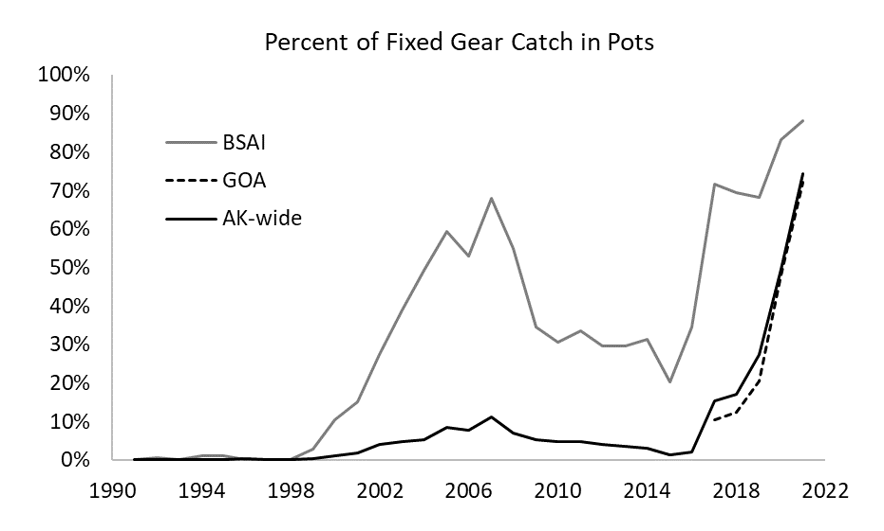

Figure 3E.1. The percent of sablefish catch caught using pot gear in either Alaska (AK total), the GOA (Gulf of Alaska), or the BSAI (Bering Sea and Aleutian Islands).

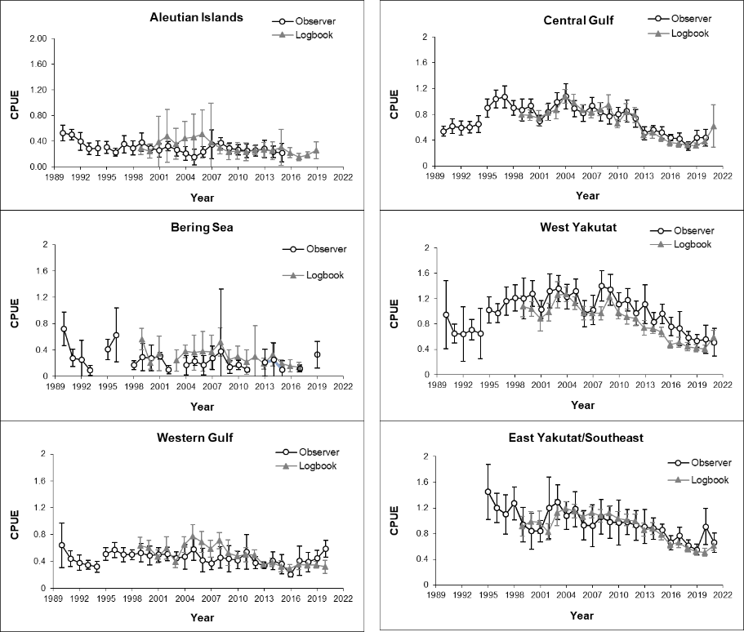

Figure 3E.2. Average hook-and-line gear fishery catch rate (CPUE in pounds/hook) and associated 95% confidence intervals by region and data source. The fishery switched from open-access to individual quota management in 1995. Due to confidentiality concerns, data is not presented for years when there were fewer than three vessels reporting data.

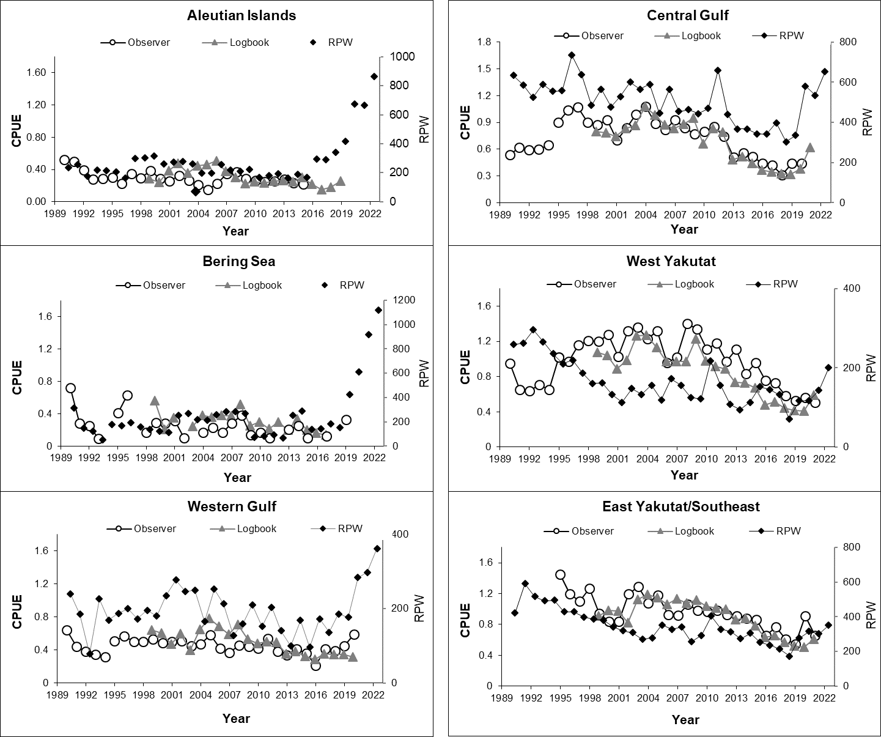

Figure 3E.3. Average hook-and-line fishery catch rate (CPUE in pounds/hook) by region and data source and the AFSC hook-and-line longline survey relative population weight (RPW) index. The fishery switched from open-access to individual quota management in 1995. Due to confidentiality concerns, data is not presented for years when there were fewer than three vessels.

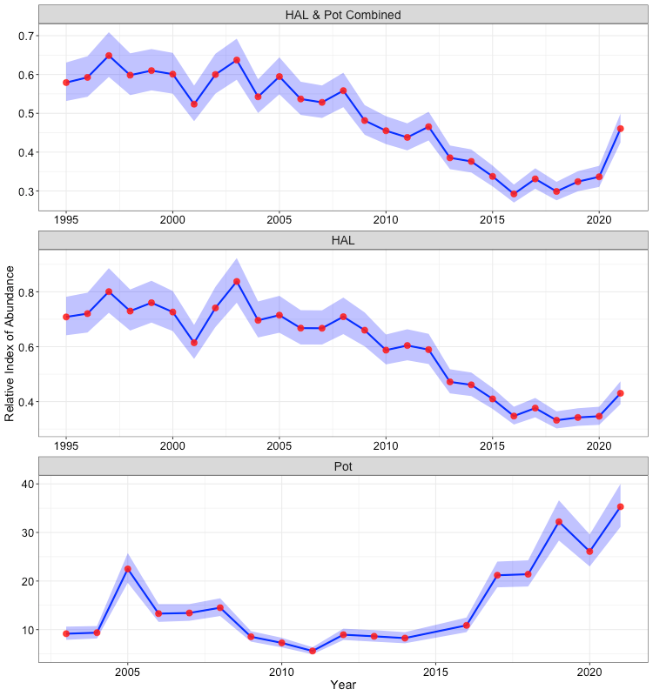

Figure 3E.4. Standardized indices of abundance developed using general additive models. All 3 indices are developed using data from both observer and logbook data sources. Blue shading represents approximate 95% confidence intervals. The top panel represents an index that combines HAL and pot gear data, the middle panel represents an index that only utilizes HAL data, and the bottom panel is an index that only utilizes pot gear data. Note that for the pot gear only index, the time-series is truncated and year 2015 is missing due to data sparsity during these time periods. Pot data prior to 2017 only includes BSAI data.

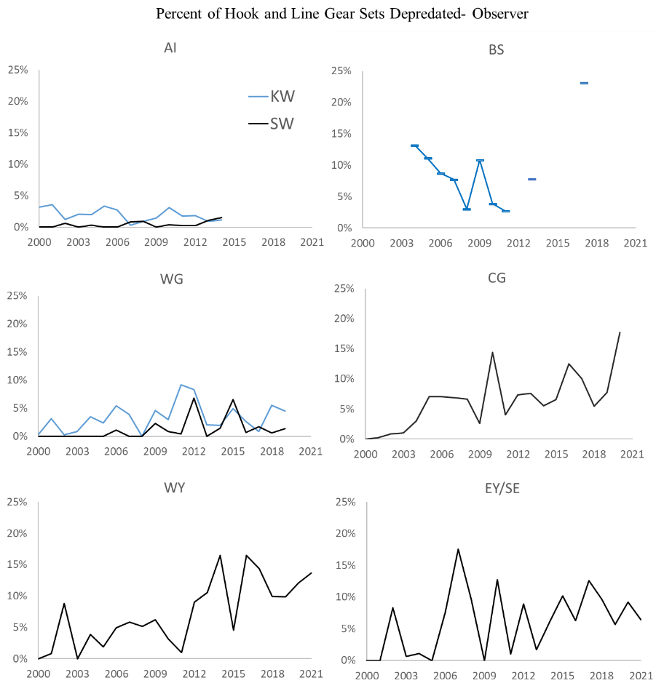

Figure 3E.5. Percent observed hook and line sets depredated by killer whales (KW) or sperm whales (SW). Management areas include the Aleutian Islands (AI), Bering Sea (BS), Western Gulf of Alaska (WG), Central Gulf of Alaska (CG), West Yakutat (WY), and East Yakutat/Southeast (EY). Data in some years is missing due to small sample sizes and confidentiality requirements or an absence of data. Years with fewer than three vessels were not included due to confidentiality.

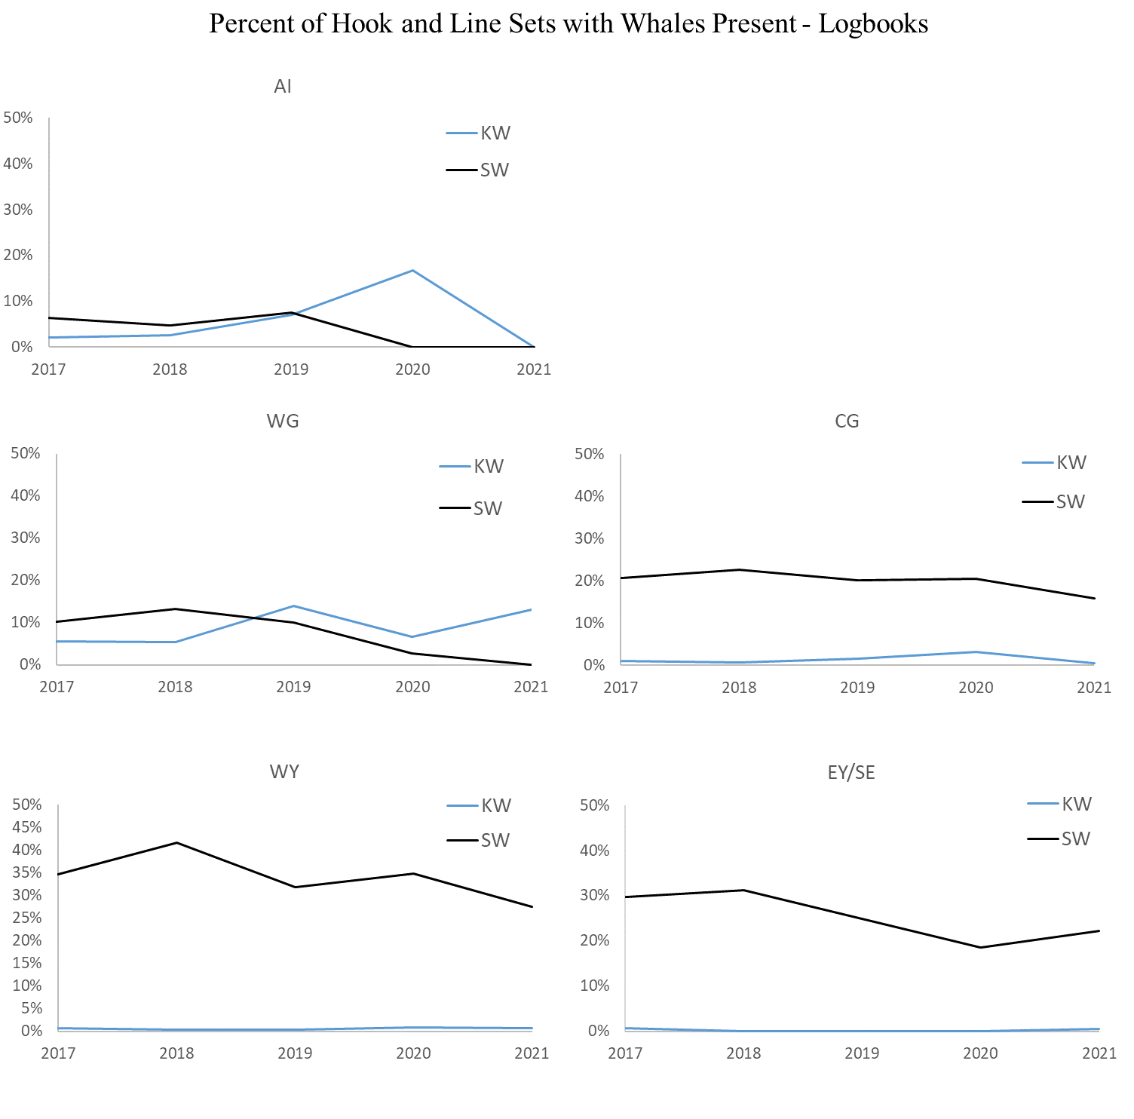

Figure 3E.6. Percent of hook-and-line sets recorded in logbooks with killer whales (KW) or sperm whales (SW) present during hauling, where the total number of sets include those with marine mammal data. Management areas include the Aleutian Islands (AI), Bering Sea (BS), Western Gulf of Alaska (WG), Central Gulf of Alaska (CG), West Yakutat (WY), and East Yakutat/Southeast (EY). No data is presented for the Bering Sea due to small sample sizes and confidentiality concerns.

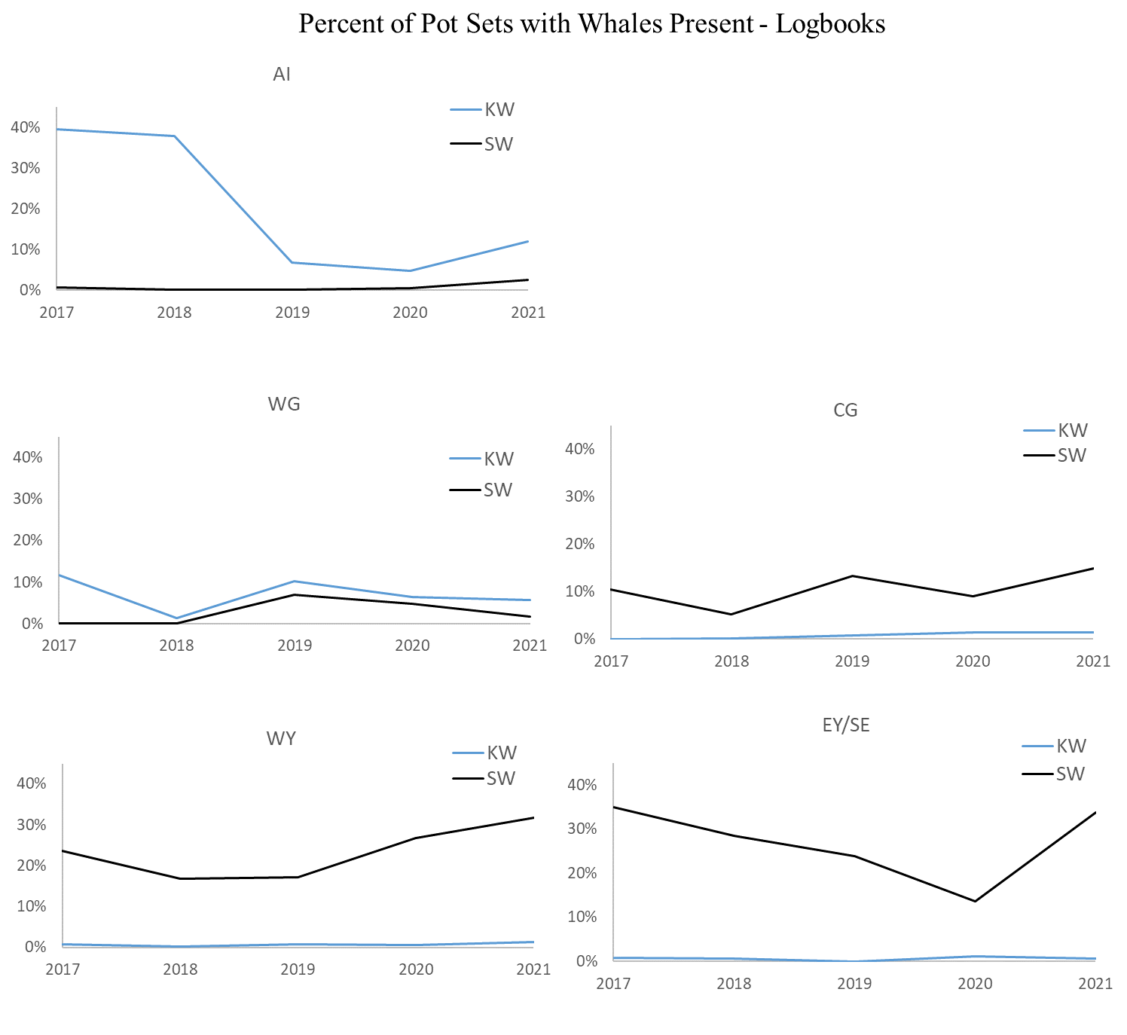

Figure 3E.7. Percent of pot sets recorded in logbooks with killer whales (KW) or sperm whales (SW) present during hauling, where the total number of sets include those with marine mammal data. Management areas include the Aleutian Islands (AI), Bering Sea (BS), Western Gulf of Alaska (WG), Central Gulf of Alaska (CG), West Yakutat (WY), and East Yakutat/Southeast (EY). No data is presented for the Bering Sea due to small sample sizes and confidentiality concerns.

Appendix 3F. Summary of AFSC Sablefish Tagging Database

Katy Echave

October 2022

Introduction

The purpose of this document is to provide a brief review of the sablefish tag data that is available from various tagging efforts in Alaskan waters. Spatial distribution and movement of sablefish has been studied by the Alaska Fisheries Science Center (AFSC) by using both traditional anchor tags and electronic archival tags, and most recently pop off satellite tags. Since 1972, approximately 400,000 sablefish have been tagged in Alaska waters, of which over 38,500 have been recovered.

Tagging Data

Tag Releases

The AFSC has been tagging and releasing sablefish in Alaska waters since 1972. Tagging effort in Alaska has been centered in three main areas: 1) adult sablefish in offshore waters of the GOA, BS, and AI; 2) adult sablefish in the southeast Alaska inside waters of Chatham and Clarence Straits; and 3) juvenile sablefish in interior bays of southeast Alaska (Table 3F.1). To date, there have been approximately 400,000 tagged sablefish released (Table 3F.1). Tag release data includes: tag number, release date, release location, size at release, depth at release, and gear type. Interactive maps of tag release data can be accessed at <https://apps-afsc.fisheries.noaa.gov/maps/tagmap/tagmap-v2/combined.php>.

#### Adult Tag Releases in Offshore Waters

Almost all GOA, BS, and AI tags have been released during the NMFS annual domestic longline survey (Rutecki et al. 2016). Figure 3F.1 shows the major release and recovery areas discussed in this document, as well as the location of the annual longline survey stations. During the years of the Japan-U.S. Cooperative Longline Survey (1978 – 1994), all tagging was done aboard Japanese vessels by Japanese and U.S. scientists working together. The NMFS annual domestic longline survey began in 1987 and replaced the Cooperative Survey in 1995. Since 1997, tagging in offshore waters has been done aboard chartered commercial vessels during the NMFS annual domestic longline survey. Approximately 5% of the longline survey catch of sablefish are tagged and released each year, which generally equals about 3,000 – 3,500 fish per year. Offshore tagging includes conventional anchor tags, internally implanted electronic archival tags, and externally attached pop off satellite tags. To date, approximately 362,460 adult fish have been tagged with conventional anchor tags, 684 electronic archival tags have been implanted in adult sablefish, and 174 sablefish have been tagged with pop off satellite tags on the NMFS annual domestic longline survey in offshore waters.

#### Adult Tag Releases in Southeast Alaska Inshore Waters

Most of the nearly 70,000 tags released by NMFS in Chatham and Clarence Straits (southeast Alaska inside waters; Figure 3F.1) have been released from various NOAA research vessels. The State of Alaska has jurisdiction over fisheries in these waters, and many of the tag releases were made in cooperation with the Alaska Department of Fish and Game (ADFG). Adult sablefish have not been tagged in southeast Alaska inside waters by NMFS since 1989.

#### Tag Releases of Juvenile Sablefish

Juvenile sablefish in southeast Alaska make up a third group of NMFS tag releases (Table 3F.1). Juvenile sablefish (mostly age-1) have been tagged in varying numbers since 1985 with traditional anchor tags and internal electronic archival tags in a number of bays and inlets in southeast Alaska, ranging from Ketchikan to Juneau. Since 1987, the majority of the tagging has occurred in St. John Baptist Bay (SJBB) near Sitka, Alaska on Baranof Island, because juvenile sablefish have consistently been found there (Figure 3F.2). Recent tagging efforts have occurred in the Central Gulf of Alaska (CGOA; 2015) in response to reports of high catch in this area (Figure 3F.3). Widespread reports of high catches of juvenile sablefish is often indicative of a larger than average year class. Approximately 41,115 juvenile sablefish have been tagged and released with conventional tags to date. An additional 1,082 electronic archival tags have been implanted and released in juvenile sablefish from the 2002 – 2012 year classes in St. John Baptist Bay, and the 2014 year class in Kachemak and Resurrection Bay of the Kenai Peninsula (CGOA). The average length of an age-1 juvenile sablefish tagged in southeast Alaska is 31 – 35 cm.

Because of the known-age (age-1) of juvenile sablefish, these tagging studies are especially unique and provide valuable information that differs from the tagging of adults on the longline survey. Tagging of known-age juveniles before they leave coastal areas offers an opportunity to document age-specific movement, that is, recoveries of known-age fish provide information on the age at which fish become available to the fishery (Maloney and Sigler 2008). Recoveries of electronic archival tags from known-age juveniles are especially useful for this purpose. These tags store depth and temperature readings taken at preset time intervals, providing information about inshore-offshore migration at known ages, daily depth movements, and temperature. Recoveries of known-age fish can also provide evaluation of ageing methods, such as otolith reading (Heifetz et al. 1999; Hanselman et al. 2012).

Movement and Tag Recoveries

Accurate recovery position information helps identify major migration pathways. If recovery dates are available, it is possible to calculate movement rates as well as migration routes. Analysis of tag data is the primary method used to study sablefish movement.

Several tagging studies have shown sablefish to be highly migratory for at least part of their life cycle (Bracken 1983; Sasaki 1985; Fujioka et al. 1988; Heifetz and Fujioka 1991; Maloney and Heifetz 1997; Hanselman et al. 2015), with the pattern of movement related to fish size and age. It had previously been reported that sablefish traveled primarily in a counter clockwise direction around the GOA; small, immature fish tagged in shallow inshore waters of the eastern GOA travel north and westward from their release sites on the continental shelf and eventually end up as adults in the deeper waters of the continental slope, where spawning takes place (Heifetz and Fujioka 1991; Maloney and Heifetz 1997; Maloney 2002). Large fish tagged in the western areas of the GOA would move eastward, and large fish tagged in the eastern areas of the GOA had a tendency to remain there (Heifetz and Fujioka 1991; Maloney 2002). Young sablefish would routinely undertake migrations of a thousand miles or more, and older fish would commonly travel the same distance on a return journey.

However, recent work by Hanselman et al. (2015) has reported that sablefish mobility has increased over time, that the directionality of movement may contradict the previous ontogenetic paradigm, and that annual movement probabilities differ greatly between areas. Hanselman et al. (2015) re-estimated annual movement rates for all three size groups of tagged sablefish among regulatory areas using tag recovery data (over 300,000 tag releases in Alaska and 27,000 recoveries) from 1979 – 2009, as well as tag release data from the inside waters of Southeast Alaska from the ADFG. Direction of movement changed the most for small sablefish. Small sablefish (41 – 56 cm) typically leave the current area of residence (except if residing in the EGOA), and to move predominately eastward; whereas previous studies showed that they moved westward. Medium (57 – 66 cm) and large (> 66 cm) fish demonstrated increasing rates of movement over time, and large sablefish retained a tendency to move east rather west. Overall, if the CGOA is considered the center of distribution of Alaska sablefish, it is more likely for all size groups to move east than west.

Tag recovery data includes: tag number, release date, recovery date, release location, recovery location, sex, size at release, size at recovery, depth at release, depth at recovery, gear type of release, gear type of recovery, calculated great circle distance traveled, and time at liberty. Interactive maps of tag recovery data can be accessed at <https://apps-afsc.fisheries.noaa.gov/maps/tagmap/tagmap-v2/combined.php>.

#### Tagged Juvenile Recoveries

To date, approximately 2,580 tagged juvenile sablefish have been recovered: 2,545 with conventional tags and 36 with electronic tags (Table 3F.1). Figure 3F.4 displays movement by age and size of 862 juvenile sablefish tagged in southeast Alaska, for which recovery size was available. In the panel displaying recoveries 0 – 2 years following release (1 – 3 year olds), the majority of fish are still in the small size group, and very few fish have been recaptured in outside waters. Most fish captured within two years following tagging are sport caught in inside southeast Alaska waters. Over half of the tagged juvenile sablefish recaptured 3 – 4 years following tagging (4 – 5 year olds) have become medium sized fish, and 33% remain small sized fish (Figure 3F.4). These small fish are likely males, as they grow slower than females (Echave et al. 2012). By this age/size, most of the sablefish have moved out of the shallow inshore bays into offshore waters where they have become vulnerable to commercial fishing gear. The majority of recoveries are in the EGOA and CGOA. By the time fish are recovered 5 – 6 years following tagging (6 – 7 year old fish; Figure 3F.4), the great majority are in the medium to large size class. At this point, the number of recoveries in the WGOA, AI, and BS are increasing, but the EGOA and CGOA still have the highest catch. This could also be a result of higher fishing effort in these areas. At age 8 and older, the majority of recoveries were large fish (Figure 3F.4). In addition, there were far more recoveries of tagged juveniles 7+ years following tagging, re-emphasizing that these are the sizes and ages when the majority of sablefish are caught in the commercial fishery.

Juvenile sablefish tagged in the CGOA (Resurrection Bay, Kachemak Bay, and Kodiak Island) appear to move offshore and into deeper waters more quickly than juveniles in inside Southeast waters (Figure 3F.5). All tag recoveries, except for two that were caught within days of tagging, moved at least 20 nm onto the shelf. Additionally, it appears that most juveniles move westward following tagging, and possibly return east at age 5+: 92% of fish recovered within the first year of tagging were recovered in the CGOA, 73% of fish recovered within the second and third years following tagging were recovered in the WGOA, AI, and BS, and 92% of fish recovered 4 + years following tagging were recovered in the CGOA and EGOA (Figure 3F.4).

Results of studies on known-age tagged fish confirm that sablefish move to deeper water with age. Sablefish availability to the commercial fishery increases rapidly for fish of younger ages, peaking at age 5 to 6, and then gradually declines as sablefish move deeper with age (Maloney and Sigler 2008). The average time at liberty of a tagged juvenile sablefish from Southeast Alaska recovered in the commercial fishery is 4 years, which equates to a 5-year-old fish. This number is slightly lower because of the inclusion of Chatham and Clarence Strait recoveries, which are generally recovered much sooner following release than in outside waters, approximately 1.3 and 1.8 years, respectively. If Chatham and Clarence Strait juvenile tag recoveries are removed from the analysis, the average time at liberty of tagged juvenile sablefish recovered in the commercial fishery (in offshore waters) becomes 6.3 years (approximately 7 years old).

#### Tagged Adult Recoveries

To date, 33,614 adult tagged sablefish have been recovered: 33,235 with conventional tags and 217 with electronic tags (Table 3F.1). Analysis of released tags from the EGOA verifies the modeled movement pattern presented by Hanselman et al. (2015): all size groups of both male and female tagged sablefish from the EGOA have a tendency to remain in the EGOA. Fish released in EGOA waters moved less than fish in other areas, demonstrating a 55% probability of residence. The same holds true for fish released in Chatham Strait. Over half of the recovered fish that were released in Chatham Strait were later recovered in Chatham; therefore, it is no surprise that fish in Chatham Strait have a low annual probability of moving (10 – 14%; Hanselman et al. 2015). Clarence Strait sablefish appear to be more directly connected geographically to the GOA than Chatham Strait, showing about a 30% probability of moving, mainly into the EGOA and BC waters (Hanselman et al. 2015). Close to half (47%) of the recovered federally tagged fish from Clarence Strait releases were recovered in Clarence Strait, however, a high percentage (26%) were also recovered in BC (Hanselman et al. 2015). In summary, the EGOA is the largest recipient of moving fish (Hanselman et al. 2015). Chatham Strait is a recipient of sablefish from federal waters, while Clarence Strait is a source of sablefish to federal waters (Hanselman et al. 2015).

The CGOA is considered a mixing zone of small and large sablefish, as well as being the location of the second highest number of tag releases in federal waters. In the CGOA, it is more likely for all size groups to move east than west; however, the probability of fish moving west is higher from this area than others (Hanselman et al. 2015). This coincides with the original movement model describing a counterclockwise movement by sablefish around the GOA (Maloney 2002). The probability of fish moving west or east from the CGOA is 29% and 39% for small sablefish, respectively, and 22% and 47% for large sablefish, respectively (Hanselman et al. 2015). Fish recovered in the CGOA may have originated in the EGOA and were still traveling westward or they may have already been out west and were returning east when captured (assuming the counterclockwise ontogenetic movement pattern is accurate). Fish tagged (all sizes combined) in the CGOA were most likely to be recovered in the CGOA (44%) and EGOA (26%).

It appears that the WGOA is a transition zone for all sized sablefish, as there is between an 80 – 90% probability of movement (Hanselman et al. 2015). However, fish tagged at a small size in the WGOA tend to remain in the western areas (WGOA, AI, and BS) longer than large fish, before heading east (Maloney 2002). The majority of small sized sablefish released in the WGOA were caught in the WGOA, AI, and BS 0 – 3 years following tagging. However, the majority of small fish recovered 5+ years following tagging were primarily caught in the CG, EG, and BC. Large sized sablefish have a tendency to move from the WGOA immediately, and appear to move eastward. The majority of large tagged sablefish from the WGOA were soon (1 – 4 years following tagging) recovered in the CG, EG, and BC. Since sablefish tagging was initiated, only eight large tagged fish in the WGOA have been recovered in the BS and only nine in the AI. Nearly similar percentages of recoveries from WGOA released fish (all size groups and years at liberty combined) were found in the WGOA (25%), EGOA (24%), and CGOA (21%). The pattern of movement from this area is strikingly different from other areas in the GOA, where the majority of fish remained in their release area. It should be noted that there are not as many large sized sablefish tagged in the WGOA. Length frequency data from the longline survey show that there are an increased number of smaller sized sablefish caught in the WGOA than in other areas. For example, during the longline survey, 59 cm is the most frequent length of sablefish caught within the Shumagin management area (within the WGOA) compared to 67 cm within the Kodiak management area (within the CGOA).

Fish that are tagged further west in the BS and AI are more likely to move out of the area in which they were tagged and into areas further east. Equally high percentages of recoveries from AI released fish were found in the EGOA (27%), AI (26%), and BC (18%); and a high percentage of recoveries from BS released fish were found in the EGOA (29%), CGOA (20%), and BS (19%). Small fish appear to remain in the BS the first three years following tagging, and then move east from the area. Five to ten years following tagging in the BS, an increasing proportion of small fish appear in the CGOA and EGOA. Large fish tagged in the BS are more likely to stay there, but a large proportion of fish are still recovered in the EGOA and BC within ten years of tagging. Unlike the Bering Sea, small fish in the AI show a high probability of remaining in the area during the first five years following tagging. Five to ten years following tagging, there are increasing numbers of small sablefish recovered in the EGOA. The majority of large sablefish tagged in the AI move immediately. Tag data indicates that most fish (small and large sized) leaving the AI do not move eastward by way of the BS. Only 3.5% of the recoveries of AI releases were made in the BS. Tagged sablefish released in the AI travel the furthest, on average, before being recaptured.

Estimated fishery tag-reporting rates for sablefish in the commercial fishery in Alaska from 1980 – 1998 were the following, in descending order: CGOA (0.385), EGOA (0.315), WGOA (0.269), AI (0.174), and BS (0.169). The tag reporting rate pooled over all areas was estimated to be 0.276 (Heifetz and Maloney 2001).

Discussion

The AFSC sablefish tag program has one of the longest time series of groundfish tag data in the nation. This data has been utilized for many purposes, including growth analysis and ageing verification. Spatial dynamics and potential implications of climate change and marine heatwaves on the sablefish resource are not well understood. Recent initiated work to develop a spatially explicit tag integrated assessment for sablefish should help improve general understanding of sablefish spatial dynamics, and the plethora of tagging data will be helpful to parametrize the model and aid estimation of movement. Further information on the tagging program and the data can be found in the most recent report to industry on the sablefish tag program (Echave et al. 2013) and at the AFSC groundfish tag website found at <https://apps-afsc.fisheries.noaa.gov/maps/tagmap/tagmap-v2/combined.php>.

References

Beamish, R. J., and G. A. McFarlane. 1988. Resident and dispersal behavior of adult sablefish (*Anoplopoma fimbria*) in the slope waters off Canada’s west coast. Can J. Fish. Aquat. Sci. 45:152-164.

Bracken, B. 1983. Sablefish migration in the Gulf of Alaska based on tag recoveries. Proceedings of the International Sablefish Symposium. Alaska Sea Grant Report 83-8.

Echave, K. B., D. H. Hanselman, M. D. Adkison, M. F. Sigler. 2012. Inter-decadal changes in sablefish, *Anoplopoma fimbria*, growth in the northeast Pacific Ocean. Fish. Bull. 210:361-374.

Echave, K. B., D. H. Hanselman, and N. E. Maloney. 2013. Report to industry on the Alaska sablefish tag program, 1972 - 2012. U.S. Dep. Commer., NOAA Tech. Memo. NMFS-AFSC-254, 47 p.

Fujioka, J. T., F. R. Shaw, G. A. McFarlane, T. Sasaki, and B. E. Bracken. 1988. Description and summary of the Canadian, Japanese, and U. S. joint data base of sablefish tag releases and recoveries. U. S. Dep. Commer., NOAA Tech. Memo. NMFS F/NWC-137, 34 p.

Goethel, D.R., D. H. Hanselman, C. J. Rodgveller, K. B. Echave, B. C. Williams, S. K. Shotwell, J. Y. Sullivan, P. F. Hulson, P. W. Malecha, K. A. Siwicke, and C. R. Lunsford. 2021. Assessment of the sablefish stock in Alaska.  *In* Stock assessment and fishery evaluation report for the groundfish resources of the GOA and BS/AI. North Pacific Fishery Management Council, 605 W 4th Ave, Suite 306 Anchorage, AK 99501.

Hanselman, D.H., J. Heifetz, K.B. Echave, and S.C. Dressel. 2015. Move it or lose it: Movement and mortality of sablefish tagged in Alaska. Canadian Journal of Fish and Aquatic Sciences. <http://www.nrcresearchpress.com/doi/abs/10.1139/cjfas-2014-0251>

Hanselman, D. H., W. G. Clark, J. Heifetz, and D. M. Anderl. 2012. Statistical distribution of age readings of known-age sablefish (Anoplopoma fimbria). Fish. Res. 131-133:1-8.

Heifetz, J., and J. T. Fujioka. 1991. Movement dynamics of tagged sablefish in the northeastern Pacific. Fish. Res. 11:355-374.

Heifetz J., J. T. Fujioka, and T. J. Quinn II. 1997. Geographic apportionment of sablefish, *Anoplopoma fimbria*, harvest in the northeastern Pacific Ocean, p. 229-237. In M. E. Wilkins and M. W. Saunders (editors), Biology and management of sablefish, *Anoplopoma fimbria*. U.S. Dep. Commer., NOAA Tech. Rep. NMFS-130.

Heifetz, J., D. Anderl, N. E. Maloney, and T. L. Rutecki. 1999. Age validation and analysis of ageing error from marked and recaptured sablefish, *Anoplopoma fimbria*. Fish. Bull. 97:256-263.

Heifetz, J., and N. E. Maloney. 2001. Estimation of tag-reporting rates for sablefish in the northeastern Pacific Ocean. Alaska Fish. Res. Bull. 8(1): 1-11.

Kimura, D. K., A. M. Shimada, and F. R. Shaw. 1998. Stock structure and movement of tagged sablefish, *Anoplopoma fimbria*, in offshore northeast Pacific waters and the effects of El Niño-Southern Oscillation on migration and growth. Fish. Bull. 96: 462-481.

Maloney, N. E., and J. Heifetz. 1997. Movements of tagged sablefish released in the eastern Gulf of Alaska. *In* M. E. Wilkins and M. W. Saunders (eds.), Biology and management of sablefish, *Anoplopoma fimbria*, p. 115-121. U. S. Dep. Commer., NOAA Tech. Rep. NMFS 130.

Maloney, N. E., and M. F. Sigler. 2008. Age-specific movement patterns of sablefish (*Anoplopoma fimbria*) in Alaska. Fish. Bull. 106, 305-316.

McDevitt, S. A. 1990. Growth analysis of sablefish (*Anoplopoma fimbria*) from mark-recapture data from the northeast Pacific. M. S. thesis, Univ. Washington, Seattle, WA, 87 p.

Rutecki, T. L., and E. R. Varosi. 1997. Distribution, age, and growth of juvenile sablefish, *Anoplopoma fimbria*, in southeast Alaska. *In* M. E. Wilkins and M. W. Saunders (eds.), Biology and management of sablefish, *Anoplopoma fimbria*, p. 45-54. U.S. Dep. Commer., NOAA Tech. Rep. NMFS 130.

Sasaki, T. 1985. Studies on sablefish resources in the North Pacific Ocean. Bull. Far Seas Fish. Res. Lab. 22: 1-108.

Sigler, M. F., T. L. Rutecki, D. L. Courtney, J. F. Karinen, and M-S. Yang. 2001. Young-of-the year sablefish abundance, growth, and diet. Alaska Fish. Res. Bull. 8(1):57-70.

Tables

Table 3F.1. Annual number of traditional and electronic tag releases and recoveries for juvenile and adult sablefish.

|  |  |  |  |  |  |  |  |  |
| --- | --- | --- | --- | --- | --- | --- | --- | --- |
|  | Juvenile | | | | Adult | | | |
|  | RELEASE | | RECOVERY | | RELEASE | | RECOVERY | |
| Year | Traditional | Electronic | Traditional | Electronic | Traditional | Electronic | Traditional | Electronic |
| 1972 |  |  |  |  | 2,403 |  | 60 |  |
| 1973 |  |  |  |  | 7,000 |  | 83 |  |
| 1974 |  |  |  |  |  |  | 75 |  |
| 1975 |  |  |  |  | 476 |  | 73 |  |
| 1976 |  |  |  |  | 162 |  | 63 |  |
| 1977 |  |  |  |  |  |  | 21 |  |
| 1978 |  |  |  |  | 7,709 |  | 42 |  |
| 1979 |  |  |  |  | 24,430 |  | 344 |  |
| 1980 |  |  |  |  | 16,894 |  | 381 |  |
| 1981 |  |  |  |  | 27,501 |  | 813 |  |
| 1982 |  |  |  |  | 26,344 |  | 795 |  |
| 1983 |  |  |  |  | 25,851 |  | 1,029 |  |
| 1984 |  |  |  |  | 14,201 |  | 1,150 |  |
| 1985 | 6,183 |  | 655 |  | 17,274 |  | 1,489 |  |
| 1986 | 1,166 |  | 13 |  | 17,131 |  | 1,431 |  |
| 1987 | 7,918 |  | 80 |  | 16,547 |  | 1,092 |  |
| 1988 | 3,907 |  | 42 |  | 12,891 |  | 1,378 |  |
| 1989 | 528 |  | 82 |  | 15,116 |  | 1,159 |  |
| 1990 |  |  | 103 |  | 5,985 |  | 1,429 |  |
| 1991 | 3,373 |  | 66 |  | 10,054 |  | 1,114 |  |
| 1992 | 1,658 |  | 92 |  | 4,076 |  | 1,113 |  |
| 1993 | 611 |  | 96 |  | 4,019 |  | 1,115 |  |
| 1994 | 1,199 |  | 63 |  | 3,490 |  | 854 |  |
| 1995 | 987 |  | 103 |  | 1 |  | 1,349 | 2 |
| 1996 | 1,737 |  | 79 |  | 2 |  | 801 |  |
| 1997 | 58 |  | 80 |  | 3,860 |  | 708 |  |
| 1998 | 1,174 |  | 63 |  | 3,303 | 190 | 707 | 1 |
| 1999 | 867 |  | 81 |  | 4,644 |  | 688 | 8 |
| 2000 | 738 |  | 53 |  | 4,055 | 142 | 730 | 11 |
| 2001 | 105 |  | 56 |  | 5,179 | 133 | 591 | 8 |
| 2002 | 477 |  | 48 |  | 4,399 | 134 | 527 | 14 |
| 2003 | 686 | 74 | 67 |  | 8,156 |  | 575 | 18 |
| 2004 | 211 | 80 | 59 |  | 4,129 |  | 542 | 14 |
| 2005 | 613 | 86 | 50 |  | 3,594 |  | 634 | 16 |
| 2006 | 18 | 66 | 21 |  | 3,931 |  | 560 | 7 |
| 2007 | 62 | 99 | 25 |  | 3,825 |  | 594 | 7 |
| 2008 | 338 | 121 | 24 | 3 | 3,294 |  | 579 | 7 |
| 2009 | 236 | 75 | 24 | 1 | 3,375 | 14 | 523 | 7 |
| 2010 | 101 | 126 | 31 | 1 | 3,739 |  | 587 | 6 |
| 2011 | 822 | 120 | 27 | 2 | 4,315 | 6 | 616 | 5 |
| 2012 | 522 |  | 30 | 1 | 2,998 | 43 | 717 | 11 |
| 2013 | 602 | 101 | 22 | 2 | 2,590 | 27 | 706 | 28 |
| 2014 | 123 |  | 29 | 2 | 2,778 | 43 | 639 | 18 |
| 2015 | 1,000 | 134 | 55 | 6 | 2,493 | 62 | 614 | 12 |
| 2016 | 960 |  | 59 | 9 | 3,311 | 50 | 477 | 3 |
| 2017 | 410 |  | 47 | 3 | 3,319 |  | 551 | 6 |
| 2018 | 284 |  | 35 | 1 | 3,612 | 12 | 558 | 6 |
| 2019 | 719 |  | 27 | 2 | 5,407 | 2 | 376 | 1 |
| 2020 | 417 |  | 20 |  | 1,232 |  | 268 |  |
| 2021 | 143 |  | 25 | 2 | 6,147 |  | 208 | 2 |
| 2022 | 195 |  | 6 |  | 5,332 |  | 78 |  |
| Unknown |  |  | 7 |  |  |  | 8 |  |

Figures

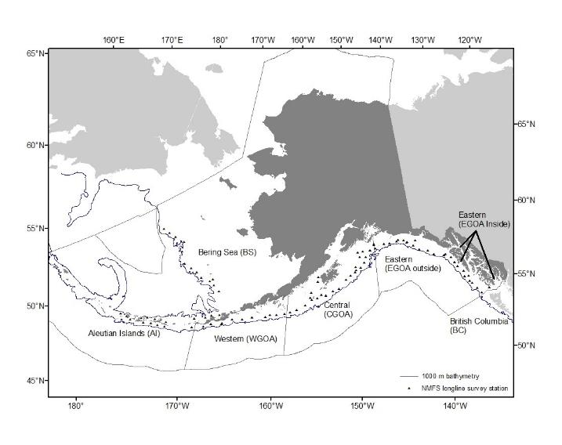

Figure 3F.1. Map depicting the NMFS annual longline survey stations (triangles) and management areas: the Bering Sea (BS), Aleutian Islands (AI) and the Gulf of Alaska (GOA). Tags are deployed at all stations in the GOA each year, and in alternating years in the BS and AI. Eastern Gulf of Alaska (GOA) Inside consists of Chatham and Clarence Straits.

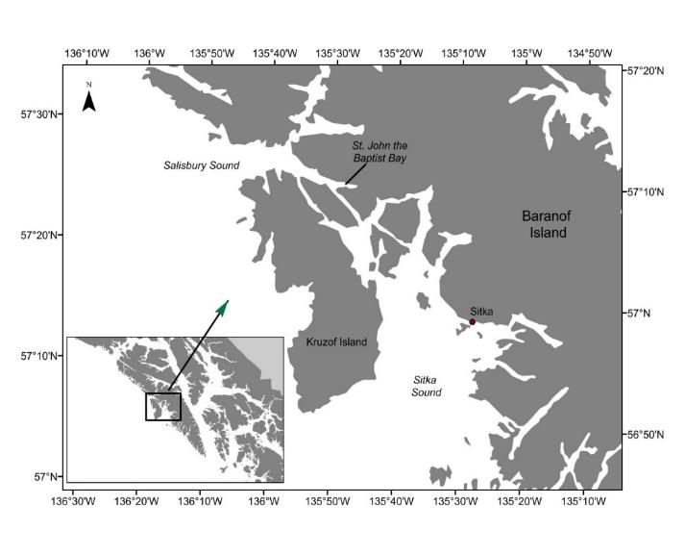

Figure 3F.2. Map of location of juvenile sablefish tagging in St. John Baptist Bay on Baranof Island in Southeast Alaska.

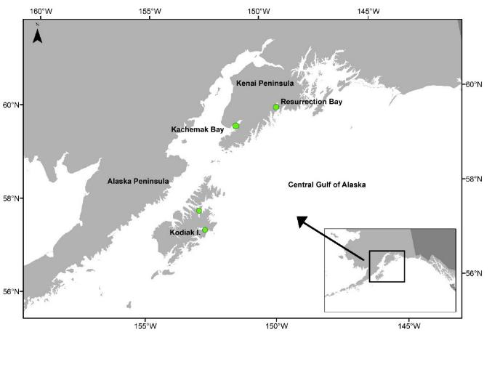

Figure 3F.3. Map of tagging locations of juvenile sablefish in the Central Gulf of Alaska: Kodiak Island, Kachemak Bay, and Resurrection Bay.

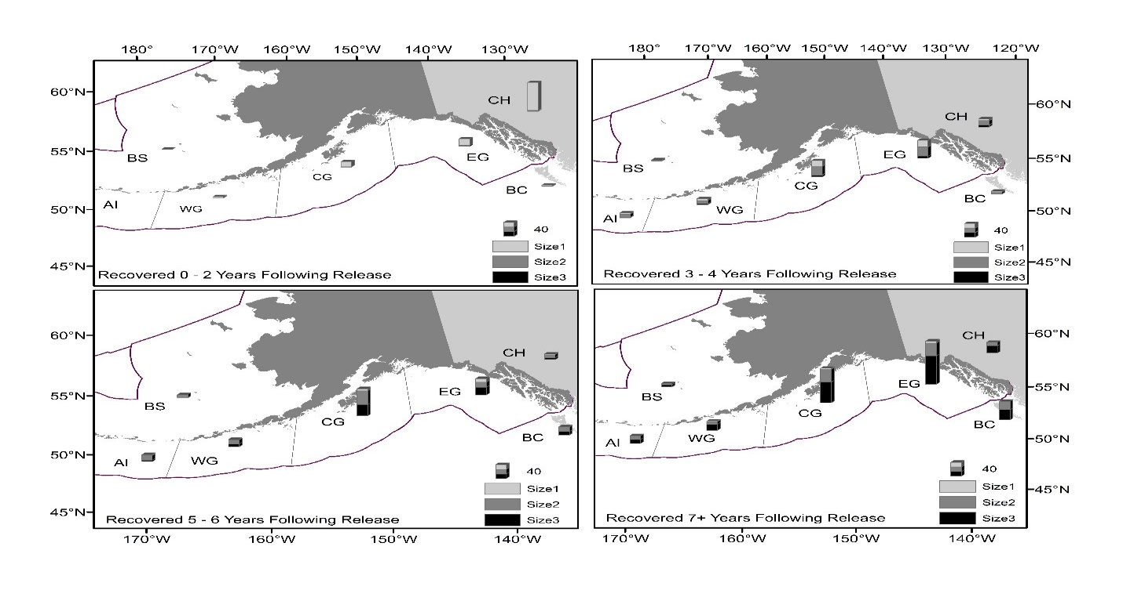

Figure 3F.4. Recoveries of known-age tagged juveniles released in St. John Baptist Bay (eastern Gulf of Alaska) by recovery size and recovery area, recovered 0 – 2 years following release (top left panel), recovered 3 – 4 years following release (top right panel), recovered 5 – 6 years following release (bottom left panel), and recovered 7+ years following release (bottom right panel). BC = British Columbia, EG = Eastern Gulf of Alaska (GOA), CG = Central GOA, WG = Western GOA, AI = Aleutian Islands, and BS = Bering Sea. Size 1 = 41-56 cm, size 2 = 57-66 cm, and size 3 >66 cm.

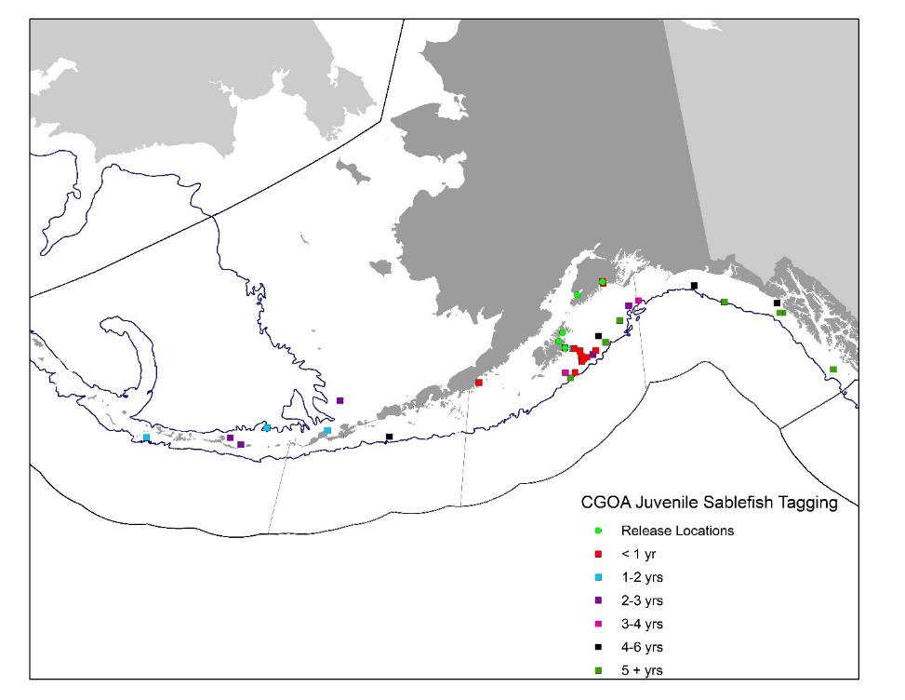

Figure 3F.5. Locations of release (green circles) and recovery of tagged sablefish in the Central Gulf of Alaska (CGOA). Different colored squares depict recoveries within each specified amount of time following tagging: <1 year, 1-2 years, 2-3 years, 3-4 years, 4-6 years, and 5+ years.